Improvement Plan of Coldchain Management
based on EVSM Report in 2009 - 2010
Indonesia has conducted EVSM tools for monitoring quality of vaccine and cold chain management since 2002. The monitoring of vaccine and cold chain using EVSM tool has been done especially at provincial level. Training on EVSM tools also has carried out for EPI manager at provincial level so that provincial can do EVSM for district level.
In 2009 and 2010, EPI conducted EVSM in 26 provinces, the assessment was done in provincial vaccine storage (cold room). The provinces are:
  - Aceh Province
  - Bali Province
  - Banten Province
  - Bengkulu Province
  - Central Java Province
  - Central Kalimantan Province
  - Central Sulawesi Province
  - DI. Yogyakarta Province
  - East Java Province
  - East Kalimantan Province
  - East Nusa Tenggara Province
  - Jambi Province
  - Maluku Province
  - North Maluku Province
  - North Sulawesi Province
  - North Sumatera Province
  - Riau Province
  - South Kalimantan Province
  - South Sulawesi Province
  - South Sumatera Province
  - Southeast Sulawesi Province
  - West Kalimantan Province
  - West Nusa Tenggara Province
  - West Papua Province
  - West Sulawesi Province
  - West Sumatera Province

The EVSM assessment tools have 8 components to assess every aspect involving in vaccine storage management, The assessment will look during 12 month.
Component -1
This component will assess whether the delivering procedure from central storage will be received at provincial storage in good condition.
On this component, only 8 provinces achieved more than 80% score. All deliveries have been companied with standard documents: VAR and delivery voucher (SP/SBBK). All provincial health workers have known that the documents have to completed immediately after vaccine received but some provinces did not fill the form completely and return it to central storage timely (within 3 working days).
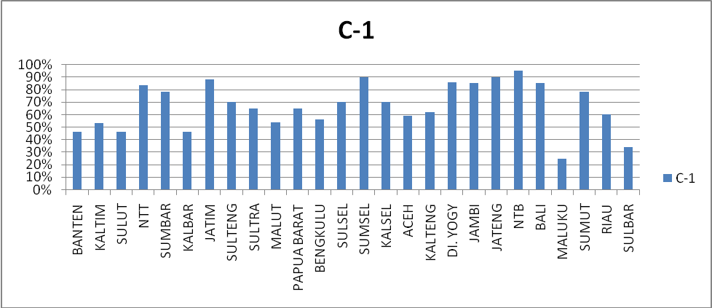

Component -2
This component will look whether vaxxine has been kept at the temperature standard range (WHO recommended). Some provinces have been achieved the standard, all the staff who involve in vaccine management have known the correct standard temperature range and know how to take action if the emergencies occurred. However, the vaccine damaged and missing have not been recorded, the documentation of temperature record has not kept accordingly (the document should be kept for 3 years). The thermometers have not been calibrated.

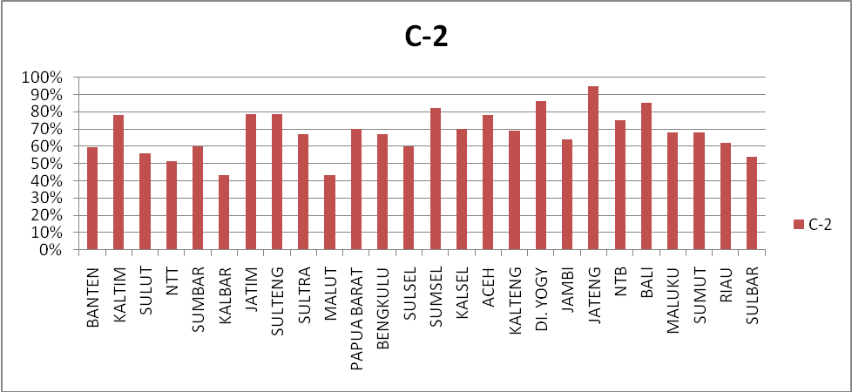

Component -3
This component will assess the capacity of provincial storage to keep maximum demand during prior of 12 months. All province have been met the storage capacity, however, some provinces did not have capable staff to calculate the volume of vaccine package needed to predict space needed in storage room.

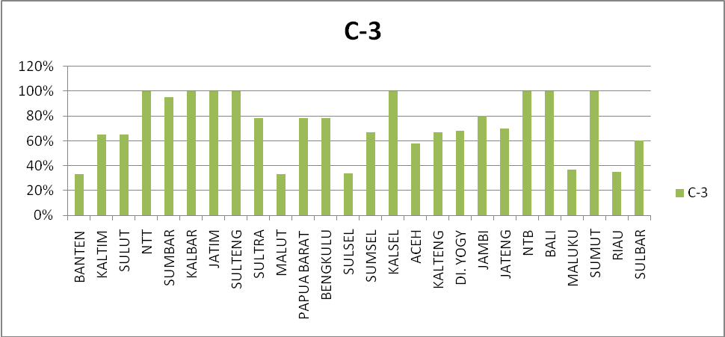
Component -4
This component will assess vaccine storage including, building standard, lay out of equipment placing, and transportation to support effective cold room during period of 12 months. Only five provinces have met the all standard, all provinces already have permanent building for vaccine store with adequate transportation system, and all cold chain and cold room equipment are CFC free. But, there are some provinces do not have special storage for the consumable goods such as diluents, dropper, ADS, safety box, etc. There is found insufficient power supply in some provinces.

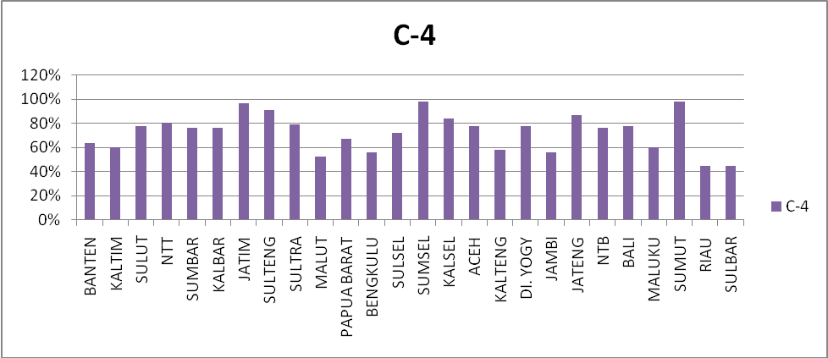

Component -5
This component will assess about the routine maintenance of all equipment, transport equipment and building during period time 12 months,. There are 5 provinces achieved the standard score. All building, transportation and other equipment are in good condition and working properly. The maintenance plan and activities are not documented or reported in a written document. The maintenance budget in some provinces has not adequate provided.

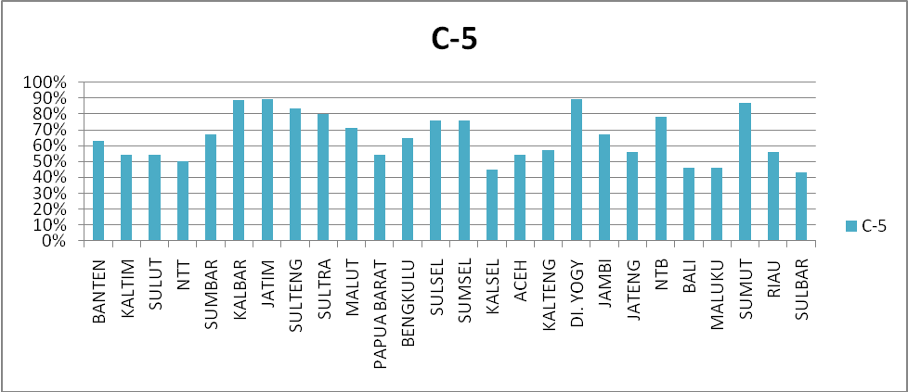

Component -6
This component will assess about effective stock management during period of 12 months. All provinces have recorded the vaccine deliveries, however the vaccine is not recorded in dose basis, some VVM record are missing and the delivery schedule has not been plan well. The vaccine request letter already provided in all provinces. The stock out still occurred especially in the early year, so in 2011 MOH increases vaccine stock to anticipate the stock out. The diluents and other consumable goods has not recorded properly.

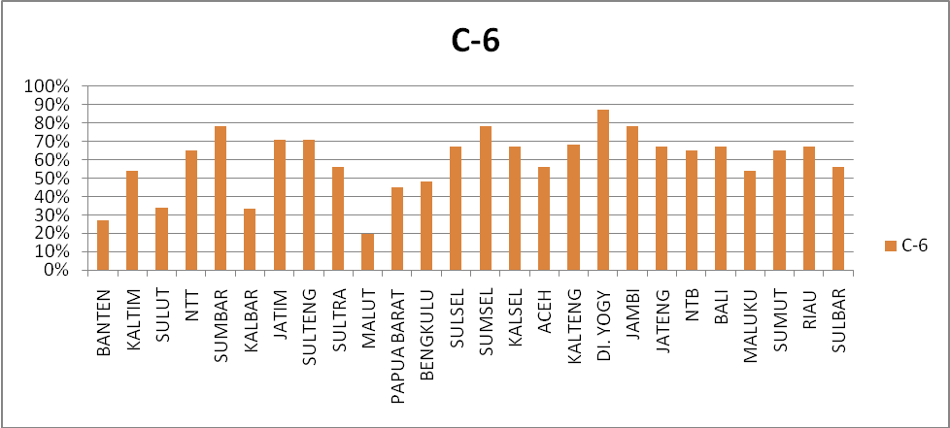

Component - 7
This component will assess delivering vaccine and consumable goods to district level should be on time, in sufficient volume by using bundling rule. There are no fixed plan and schedule for vaccine deliveries. Distribution of vaccine based on requesting from province.

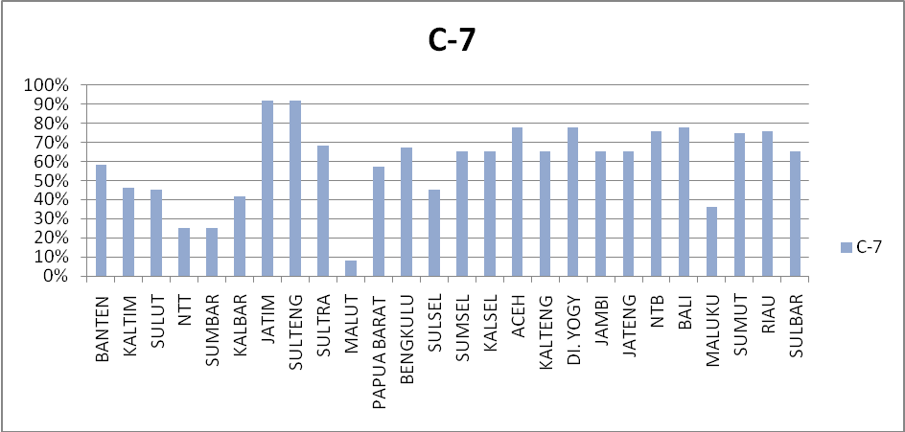

Component -8
This component will assess whether if there is damaged of vaccine during distribution. All the deliveries of vaccine always included with temperature exposure indicator (freeze and heat). There is no record for shake test of the damaged vaccine.

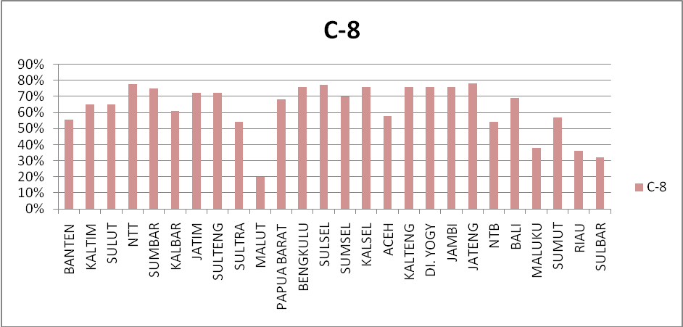

Conclusions:
- There is still lack of stock management including RR, completeness of VAR and voucher.
- The temperature monitoring device and its calibration have not done properly and routinely.
- There is still not adequate management of vaccine storage including capacity, maintenance and the alternative power supply.

Improvement Plan of Cold Chain Management based on EVSM report in 2009 to 2010:

- Conducting training of vaccine management for provincial and district level to increase the skill of immunization staff including simple regular maintenance ability. We assume province and district will fund this activity.
- Increasing vaccine stock and other logistics management by the technical assistant and computerize RR vaccine stock and other logistics.
- To make sure that the temperature has been kept at the standard range, we plan to conduct calibration of temperature monitoring device regularly. The calibration will be done by Medical Equipment Calibration Centre
- To ensure temperature will be kept within standard range, at province levels, automatic temperature monitoring device (thermograf/multilog) and the alternative power supply will be install.
- To replace the old and break cold chain equipment including cold room and spare part, the procurement will be used central and district budget.

In this year, supported by Unicef to introduce EVM tool by some activities including training for EPI staff at central and province level. To increase the staff ability, the assessment in 5 provinces (East Java, Banten, DKI Jakarta, Central Java, and West Java province) will be conducted and workshop meeting to plan improvement program of vaccine and cold chain management.

