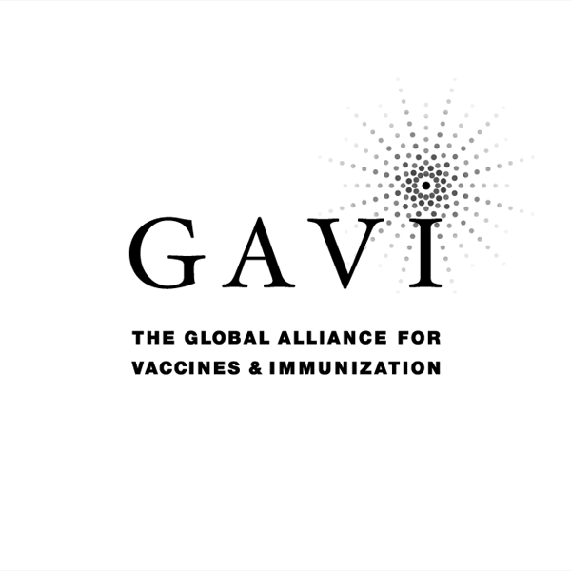
Proposal for support submitted to the

Global Alliance for Vaccines and Immunization (GAVI)

and The Vaccine Fund

by

the Republic of Djibouti

5 October 2005

Section 1. Impact of country and health system context on Immunization program costs, financing and financial management

Djibouti faces serious economic and social challenges, which affect the health sector and its efforts to improve the general health situation nationwide.

This section gives a brief background of the country's economy efforts to improve it and an overview of the current economic performance and its key indicators. Future projections within the overall development framework are illuminated in addition to their impact on the health system as whole and the immunization program in particular.
An overview of the health system is also given in this section mentioning the major characteristics of the national system coupled with indicators. It details the current reform efforts and its implications on the immunization program. The section gives a description of the health system finance, flow of funds and future projections. The implications of the existing budgeting and planning system are clarified and their relation to the health system with emphasis on the immunization program.

1.1 Country profile (geography and demography)

Djibouti, the smallest country in the Horn of Africa, has an area of 23 000 square kilometres. It is bordered by Somalia to the south-east, by Ethiopia to the west and south and by Eritrea to the north. The climate is hot, especially in the summer months when activity slows down and vegetation withers. The official languages are French and Arabic. Two other languages (Afar and Somali) are also spoken in the country.
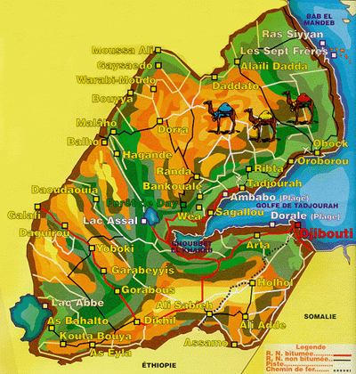

The last census was held in 1983. In 2000, the population was estimated at 678 352. On the occasion of the national campaign of 2003, it was decided to hold a count of the general population of Djibouti on a door to door basis. This produced a figure of 572 000 inhabitants, distributed as follows: 66.4% for the district of Djibouti, 2.3% for the district of Arta, 10.2% for the district of Ali Sabieh, 9.2% for the district of Dikhil, 8.5% for Tadjourah and 3.4% for the district of Obock. Calculated on this basis, the number of children aged between 0 and 5 years is 80 114 (14% of the general population).

District | Population
District | General |  | Target 0-5 years
Djibouti | 380 192 | 66.4% | 53 227
Arta | 13 000 | 2.3% | 1 820
Ali Sabieh | 58 120 | 10.2% | 8 137
Dikhil | 52 640 | 9.2% | 7 370
Tadjourah | 48 820 | 8.5% | 6 835
Obock | 19 460 | 3.4% | 2 725
Total | 572 232 | 100% | 80 114

The neighbouring countries, including particularly Ethiopia where poliomyelitis is endemic, have little in the way of medical services and, in times of drought, people tend to move over the border into the health zones served by the five rural districts of Djibouti. However, it should be noted that the operation of the Expanded Programme of Immunization (EPI) in these districts remains rudimentary, with shortages of material, cold chain equipment and human resources.

The populations of the villages and encampments in the five districts (Ali Sabieh, Arta, Dikhil, Obock and Tadjourah) are nomadic in origin and are constantly on the move with their cattle, searching for grazing at home and even over the border. For this reason, they may well fail to appear for the monthly immunization sessions and vaccination coverage in the area is correspondingly low. In the interior and particularly in the border regions, there is no system of routine immunization and, since October 2003, vaccinations are administered only once a month when the mobile teams make their round in the health units.

The measles coverage rate for children aged 12-23 months is only 18.4%, as against 71.2% in urban areas.

According to the vaccination book data, coverage for polio 3 is 65.2% for urban and rural areas combined.

1.2 General economic situation of Djibouti

With a gross national product (GNP) per capita of USD 780 per annum, the Republic of Djibouti ranks as one of the least developed countries. Nearly half the population lives below the poverty threshold, defined by the World Bank in monetary terms as USD 1 225 per annum. Of the sedentary population, 45% of households are classified as poor and 9.8% as indigent. If nomads and persons of no fixed abode are included, the figure rises to 60%.

The industrial sector does not meet the needs of the population. The level of industrialization is low and the rural population subsists mainly on livestock raising. The country has few natural resources and they remain under-exploited. Almost 95% of Djibouti's food is imported from Europe and neighbouring countries. Agriculture supplies only around 10% of the country's fruit and vegetable requirements. There is little arable land and it is of poor quality. Moreover, only a small part of the cultivable area is exploited. Though fishing could constitute an important resource, its development is held back by the lack of production resources in the sector.

The economic development of Djibouti has been declining since the mid-1980s. There are various reasons for this:

- The economy is based on maritime transport and, as this sector failed to adapt to technological developments, it has been declining.
- The number of refugees has been increasing at a rate of 2.5% per annum.
- The exodus from the land has been exacerbated by climatic problems.
- The armed conflict at the beginning of the 1990s had an adverse impact on social and economic development.

To stimulate economic growth and social development, the country has drawn up a strategic plan to reduce poverty.

1.3 The health system in Djibouti

1.3.1 Organisation

The health system in Djibouti comprises four sectors:

- Public sector financed by tax revenues, foreign aid and charges for certain services.
- Health insurance sector financed by contributions from employers and employees
- Private sector
- Armed forces and police sector.
Djibouti's health policy is based on primary health care. The administration of health care is free of charge for everyone. The health system is organized on three levels:

- the higher level, represented by the Peltier General Hospital which provides specialist care
- the intermediate level, consisting of the medical-hospital centres in the districts
- the peripheral level, consisting of the health centres and health posts.

1.3.2 The infrastructure

Apart from the dispensaries in the refugees camps and five private medical practices, the Republic of Djibouti has 44 health structures (24 in urban and 20 in rural areas), including private clinics.

Figure 1: Organization chart of the Ministry of Health

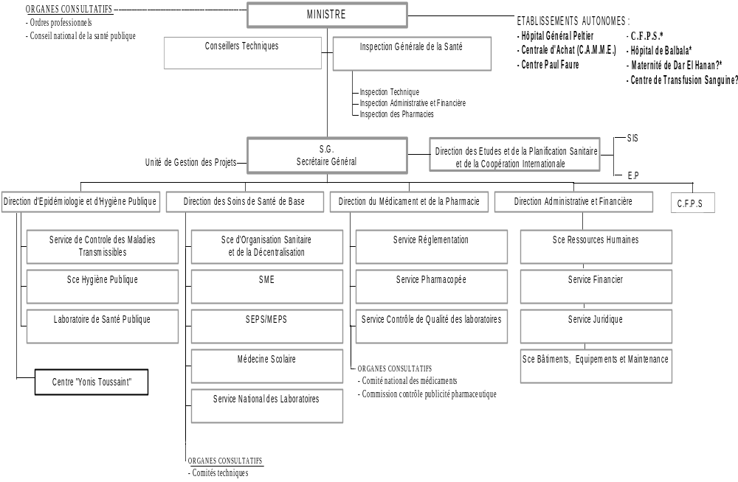

CONSULTATIVE BODIES |  |  | MINISTER |  | AUTONOMOUS ESTABLISHMENTS
-Professional bodies  - Nation Council for Public Health |  |  |  |  | -Peltier GH  -Central Purchasing  -Paul Faure Centre | - CFPS  - Balbala Hospital  -Dar El Hanan maternity  -National Blood Transfusion Centre
 |  | Technical Advisers |  | Health Inspectorate General
-Technical In.
-Admin.+ Financial Ins.
- Pharmacy Ins.
 |  |  | SECRETARY GENERAL | Directorate of Studies, Health Planning and International Cooperation |  | - SIS  - EP
Directorate of Epidemiology and Public Hygiene | Directorate of Basic Health Care |  |  | Directorate of Medicines and Pharmacy | Administrative and financial Directorate | CFPS
Control of transmissible diseases department | Health Organization and Decentralization Department |  |  | Regulation Department | Human resources Department
Public Hygiene Department | Essential Medicines Department |  |  | Pharmacopia Department | Financial Department
Public Health Laboratory | SEPS / MEPS |  |  | Quality Control of Laboratories Department | Legal Department
"Yonis Toussaint" Centre | Medical Education |  |  |  | Buildings, Infrastructure and Maintenance Department
 | CONSULTATIVE BODIES  - Technical Committees |  |  | CONSULTATIVE BODIES  - National Medicines Committee  - Drug Advertizing Control Commission

Breakdown of human resources in the Republic of Djibouti:

- 100 doctors, i.e. approximately 1 doctor per 6 600 inhabitants
- 440 nurses, i.e. approximately 1 per 1 500 habitants
- 53 midwives, i.e. approximately 1 per 12 300 inhabitants
- 9 dentists, i.e. approximately 1 per 68 000 habitants
- 8 pharmacists, i.e. approximately 1 per 70 000 habitants
- 51 laboratory technicians, i.e. approximately 1 per 13 200 habitants

The distribution for all categories of medical personnel combined shows the predominance of the capital.

1.3.3 The state of health

The main causes of morbidity and mortality are malnutrition and communicable diseases connected with an insalubrious environment and living conditions and lack of clean water. The country is threatened by the rise in sexually transmitted diseases and particularly the rapid and constant increase in AIDS.

Table 1.Major Indicators (2002)
Year of last census | 1983
Total population in 2002 | 572 232
Annual population growth rate | 3.00%
Life expectancy | 50 years
Birth rate (% of total population) | 4.20%
General mortality rate | 17.7 per mille
Infant mortality rate | 114 per mille
Infant-juvenile mortality rate | 165 per mille
Pregnant women with anaemia | 70.00%
Women of child-bearing age (% of total population) | 27.00%
Fertility rate | 50 years
Health care coverage | 40.00%

The majority of the population suffer from an unbalanced diet and lack of food. Most women and children suffer from chronic malnutrition and their situation seems to have been getting progressively worse.

1.4 Total health spending (THS)

Information on this subject is confined to a single document: (National Health Accounts 2002- Dr Chokri Arafa)

1.4.1 Financing of the health sector

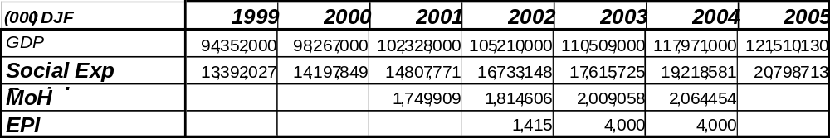The national health accounts (NHA) for the year 2002 show that the health sector is financed from three main sources: (i) the government or state, (ii) households and the private sector and (iii) foreign donors or the rest of the world. The contribution of the State to the financing of the health sector varies between 10% and 12% of social expenditure.

Source: Ministry of Health

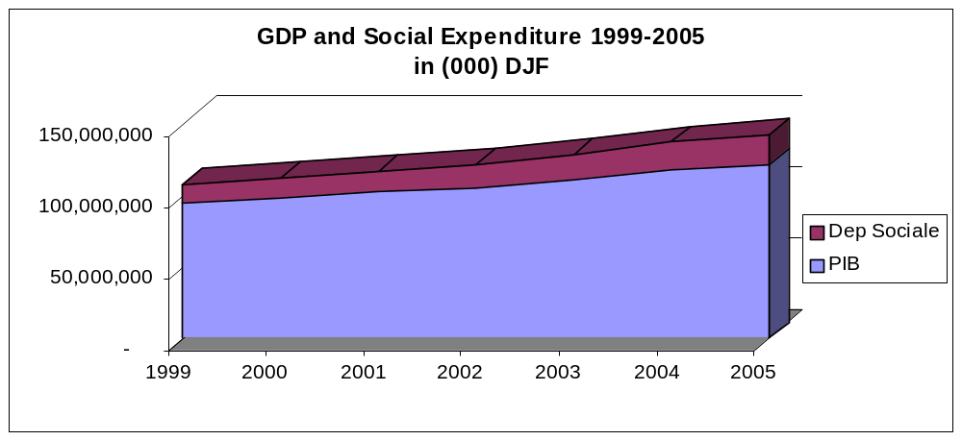

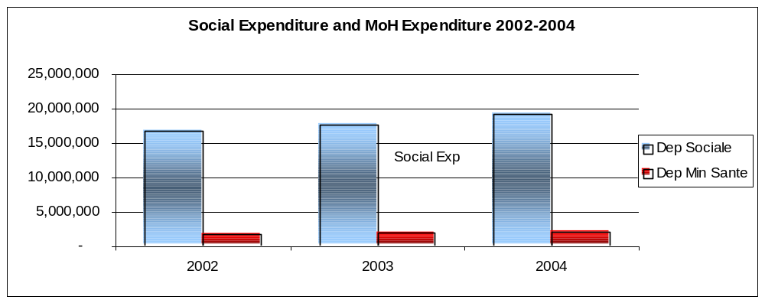

According to the national health accounts, the total amount allocated to health was DJF 4 874 195 495. The sources of health financing were as follows:

Public sector
  - State : 29.28%
  - Public employers: 1.76 %

Private sector
- Private employers: 17.81 %
- Households: 13.78 %

Rest of the world: 37.37 %
(of which 25.21 % from bilateral cooperation)

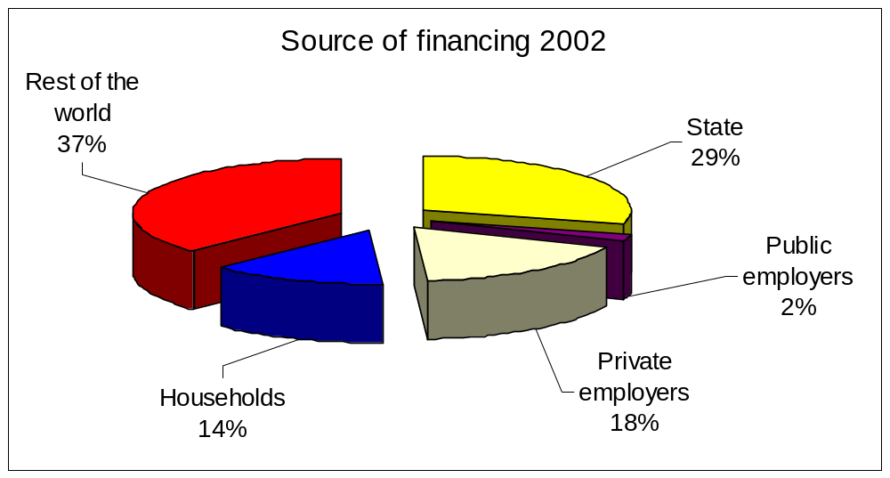 Source: Draft National Health Accounts 2002 - Dr Chokri Arafa

1.4.2 Financial contributors to the health sector
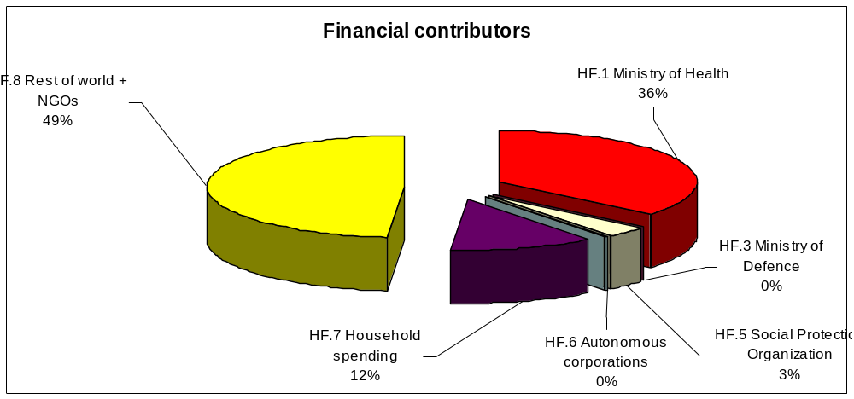 Source: Draft National Health Accounts 2002 - Dr Chokri Arafa)

1.4.3 Care providers

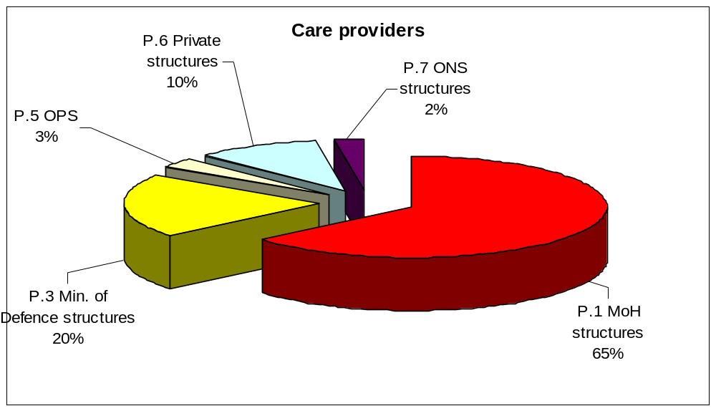 Source: Draft National Health Accounts 2002 - Dr Chokri Arafa)
[OPS = Social Protection Organization, ONS = ?]

1.4.4: Health expenditure ratios (National Health Accounts 2002)

Expenditure ratios | 2002
Expenditure ratios | Amount | %
Total health expenditure (THE) as % of GDP | 4 874 195 495 | 5.02%
Public health expenditure (PHE) as % of THE | 2 615 870 123 | 53.67%
Public health insurance (PHI) as % of PHE | 1 188 724 597 | 45.44%
Tax-financed health expenditure (TFHE)as % of PHE | 1 427 145 527 | 54.56%
External resources (ER) as % of THE | 1 827 705 672 | 69.87%
Private health expenditure (PrHE) as % of THE | 1 176 287 247 | 24.13%
Private health insurance (PrHI) as % of PrHE | 0 | 0.00%
Direct expenditure of households (DEH) as % of PrHE | 436 518 700 | 37.11%
Source: Draft National Health Accounts 2002 - Dr Chokri Arafa)

1.5. Planning and development

1.5.1 Planning and development of the health system

With the national economy facing unfavourable conditions throughout the 1990s, the health sector had ever greater difficulty in supplying the population with proper access to health care.

The social-health indicators bear witness to a gradual deterioration in the situation. In the field, the deplorable conditions in both Djibouti town and the health districts of the interior were attributable to a number of constraints: the steady deterioration of medical infrastructures and equipment, the general disorganization of the sector, the lack of motivation of the personnel, frequent shortages of reagents and medicines, etc.

Thus, the public health situation during the 1990s was very serious, marked by the effects of the civil war (1991-1994) and the economic crisis and the Structural Adjustment Programme (SAP).

Various sectoral studies were carried out or updated with the assistance of the World Bank during the six-month period August 2001 to January 2002. This work enabled the Ministry to draw up a medium and long-term national health development programme (NHDP) set forth in two documents:

- the medium-term health development plan 2002-2006 ;
- the long-term health development plan 2002-2011 ;

1.5.2 Institutional progress of the reform :

In addition to the central departments provided for in the old organization chart, the following structures were established to adapt the organization of the Ministry to the new orientation of health policy :

- Department of Studies, Planning and International Cooperation (including a Health Information Service)
- Medicines and Pharmaceutical Department
- General Health Inspectorate
- Project Management Unit
- Prevention and Public Health Department
- a Health Department at the level of each administrative district.

The pharmacy sector was boosted by the effective establishment of the Pharmacy Inspectorate and the appointment of a full-time Pharmacy Inspector.

Furthermore, the new orientation of health policy granted a considerable degree of autonomy to the main hospital care establishments, namely :

- the Peltier general hospital ;
- the Centre for Purchasing Essential Medicines and Materials (CPEMM).
- the Dar El Hanan maternity hospital ;
- the Paul Faure pneumo-phtisiology hospital ;
- the National Blood Transfusion Centre ;

The public health services sector includes the structures belonging to the Ministry of Health, the Ministry of the Interior, the Ministry of Defence and the French Military Cooperation hospital. The para-public sector consists of the structures belonging to the Social Protection Organization. The private sector consists solely of health professionals established in private practice.

1.5.3 Reform of the health system

Since 1995, the Ministry of Health has been engaged in a process to reform the health system with financial support from the World Bank. The main elements of this reform are as follows :

- the strengthening of the planning capacity of the Ministry of Health by the establishment of a studies and planning office ;
- the decentralization of the health system ;
- the introduction of the cost-recovery system ;
- the improvement of mother and child health by the establishment for the first time of a department responsible for planning, executing, monitoring and evaluating activities relating to mother and child health ;
- the strengthening of the prevention system by the establishment of a prevention and hygiene department which, apart from the epidemiological surveillance and public hygiene units, includes the mother and child health services and the health education service ;
- the addition of Ag and boosters to the immunization schedule ;
- the participation of the private sector in routine immunization.

In the light of the recommendations of the various assessments, Djibouti drew up a multi-year strategic plan (MYSP) for its immunization programme, covering the period 2002-2006. This plan and the programme assessment were communicated to the members of the Inter-Agency Coordinating Committee (ICC) and discussed on the occasion of their meetings.

Section 2
Immunization Services Support (ISS)
Characteristics of the Programme, Objectives and Strategies

This section briefly presents information on the EPI program, its aims and objectives as well as its ongoing strategies. An overview of the program achievements over the past recent years and future approaches is highlighted in addition to the related role of development partners.

2.1 Introduction and characteristics of the programme

The foundation of the policy of the Ministry of Health of Djibouti is basic health care. Thus, ever since independence, Djibouti has sought to extend its primary level health structures, while at the same time strengthening and consolidating the second and third level structures. It is planned that further health centres will be constructed at the primary level in the near future. As indicated in Section 1, there are 24 structures at the primary level, 5 at the second level and 3 at the third level. When the dispensaries located in the refugee camps are added in, the country has a total of around 46 health structures, 24 urban and 22 rural (excluding the private sector).

The National Immunization Programme (NIP) introduced in Djibouti in the 1980s succeeded in achieving immunization coverage of 90% to 95%. However, with the breakout of the civil war and the emergence of the economic crisis, the coverage plummeted to less than 30%.
.
The launch of the programme to strengthen immunization in April 2000 has resulted in a substantial improvement in immunization coverage for children under the age of one - up from 26% in 1999 to 63% in 2003 for routine immunization.

To achieve these rates, it was necessary :
- to strengthen the management capability of the National Immunization Programme ;
- to conduct a complete overhaul of the cold chain in the capital and in the district administrative centres ;
- to reorganize the system of supplying vaccines and vaccination equipment ;
- to strengthen the cold chain ;
- to train the personnel involved in the programme ;
- to improve the monitoring and supervision of activities ;
- to organize mini-campaigns combined with the anti-polio campaigns and to make use of mobile teams in the rural zones.

2.2 Assessment of the immunization services

The main obstacles to the organization of vaccination activities in the other health structures are the dilapidated state of the premises, the absence of any cold chain and the lack of qualified personnel. The plan is to strengthen the immunization programme by solving these problems and then to increase the number of facilities providing immunization services.

The Ministry of Health, concerned for the health of the population, has committed itself to taking all necessary steps to protect those at risk from infection. For its part, the National Immunization Programme has set itself targets for immunization coverage and the surveillance of target diseases. The aim is to achieve a coverage rate of more than 70% for children under the age of one by the year 2006. The achievement of this target will require the commitment of additional resources in terms of vaccines, injection supplies and cold chain equipment. Moreover, additional stocks of syringes and needles will be needed for the organization of the annual National Immunization Days.

Since 1995, the Ministry of Health has been engaged in a reform of the health system with the financial support of the World Bank. The main aspects of the reform are as follows:

- the strengthening of the planning capacity of the Ministry of Health by the establishment of a studies and planning office ;
- the decentralization of the health system ;
- the introduction of the cost-recovery system ;
- the improvement of mother and child health by the establishment for the first time of a department responsible for planning, executing, monitoring and evaluating activities relating to mother and child health ;
- the strengthening of the prevention system by the establishment of a prevention and hygiene department which, apart from the epidemiological surveillance and public hygiene units, includes the mother and child health services and the health education service ;
- the addition of Ag and boosters to the immunization schedule;
- the participation of the private sector in routine immunization.

Although the private sector is small, the Ministry of Health encourages its involvement in immunization in general and the surveillance of the target diseases in particular.

In general, these reforms can only help in the development of immunization, which remains the most effective and least expensive means of prevention.

2.3 Immunization services support

The Republic of Djibouti was approved for support in May 2002 after making a second submission. However, the first payment (support for immunization services and injection safety) was not transferred until February 2003.
Utilization of the funds began in March 2003 in close cooperation with the Inter-Agency Coordinating Committee and particularly the WHO and UNICEF, the members most involved in immunization activities.
The main areas covered by the GAVI support funds are cold chain maintenance, transport (fuel and vehicle maintenance), personnel training, personnel motivation and improving data quality.
Funds are withdrawn from this account against the signatures of the Administrative and Financial Director of the Ministry of Health and the Secretary General of Health. These two persons each retain a copy of the supporting documentation concerning the use of the funds.
In the initial report submitted on 19 October 2003, we presented our use of a first tranche of the GAVI funds (USD 23 430 out of a total of USD 39 300).

The strengthening of the National Immunization Programme was continued during 2003 and all of the activities scheduled in the annual plan of action were carried out. During this period, it was a question of building on the achievements of the multi-antigen campaigns of 2002 and 2003, in the course of which children under the age of five received 3 doses of OPV (91 049 children – 97.07%), 3 doses of DTP (73 101 children- 77.93%) and measles (77 565 children –82.69%).

Routine immunization is carried out by means of the fixed strategy in the urban areas of the country and by means of the mobile strategy in the rural areas. Within this framework, the following activities were carried out:

- drawing up of a detailed plan of action at the district level and a half-yearly assessment of the progress achieved by the programme's central team;
- strengthening of management capability (ordering and distribution) for vaccines and vaccination materials at the level of each district by making available appropriate management tools and providing management staff with initial and continuous training;
- providing continuous training for all categories of immunization staff combined (focal points of the urban districts and health centres and the service-providers);
- establishing an integrated mobile team per district to improve access to the immunization service.

In 2003, thanks to the reinforcement activities carried out, there was an increase in the immunization coverage of children under the age of one both for DTP and for measles. As indicated in the joint WHO / UNICEF report of 2003, DTP3 coverage rose from 61.71% in 2002 to 68.25% and coverage for measles rose from 62.07% to 65.57%. Analysis of the immunization coverage per district shows that it is over 50% for both DTP3 and measles in the 5 districts making up the country, that it is between 50% and 59% in one district, between 60% and 69% in two districts and between 70% and 79% in one district.

2.4 Strategic multi-year plan for the period 2002-2006

The strategic multi-year plan of the NIP for Djibouti covers the period 2002-2006 and forms part of the strategic plan for the health sector. It has been implemented following various assessments of the NIP which identified weaknesses in the programme. The ambitious targets of the plan of action reflect the government's commitment to boosting the NIP and the continuous support of the international partners, including particularly the WHO and UNICEF. It is envisaged that this plan will also be submitted to GAVI for possible support in implementation.

2.4.1 The targets of the multi-year plan:

The plan is intended to ensure the continuous and sustainable improvement of the National Immunization Plan (NIP) through the adoption of certain strategies adapted to the conditions of the country. It takes into account the shortcomings identified in the various external assessments of the NIP. The main targets to be achieved by the end of 2006 are as follows:

- to achieve an immunization coverage of 85 % for DTP3
- to eradicate poliomyelitis by the end of 2005
- to eliminate neonatal tetanus
- to reduce the mortality and morbidity connected with measles.
- to prevent vitamin A deficiency by administering the vitamin with the vaccination
- to ensure injection safety and the safe disposal of wastes
- to improve the system of surveillance for the target diseases of the NIP
- to improve the management of the NIP
- to strengthen the capacities of the NIP personnel
- to develop sustainable social mobilization activities
- to improve the cold chain and logistics
- to strengthen vaccine management
- to ensure sustainable financing for the NIP
- to introduce immunization against hepatitis B and haemophilus influenzae type B in the routine immunization in 2004

2.4.2 Introduction of new vaccines

It is possible to prevent the transmission of the hepB virus from mother to child by administering a dose of the hepB vaccine to the newborn as soon as possible after birth. Despite the lack of information in Djibouti on the proportion of the infection acquired during the peri-natal period, the high rate of chronic hepatitis cases (>10%) makes vaccination at birth essential.

The Inter-Agency Coordinating Committee (ICC) works in close cooperation with the inter-sectoral committees and the national committee for the certification of the eradication of poliomyelitis. Thus, the ICC examined the application during the course of its meeting on 1 March 2005. The ICC amendments related, inter alia, to the drawing up of a summary of the NIP financing plan for the coming years with the quantified commitments of all the partners. These amendments were submitted to the members of the ICC prior to signature of the present application.

The socio-economic data, which constituted a real problem, were gathered by the ministries and the agencies concerned. The estimate of the target population is a particular difficulty in Djibouti, as in many other developing countries. The carrying out of a quick census with the assistance of the World Bank and the country's partners is indispensable to obtain a true assessment of the investment in the NIP, the high rate of coverage failing to appear due to the fact that the target population seems to have been overestimated.

The multi-year plan of action cannot be implemented with the government resources currently available. Djibouti is looking for partners to support its programme and is submitting this application to GAVI with a view to "financial support for the introduction of new vaccines against hepatitis B and Hib".

2.4.3 Immunization schedule

Vaccine | Ages for administration  (by the systematic immunization services) | Insert an "X" if the vaccination is administered in |  | Comments
Vaccine |  | the whole country | only part of the country | Comments
BCG | At birth | X
OPV | At birth, 6 weeks,  10 weeks, 14 weeks | X
DTP | 6 weeks, 10 weeks,  14 weeks | X
Measles | 9 months | X
HepB | At birth , 6 weeks, 10 weeks,  14 weeks | X |  | For HepB and Hib, the country plans to introduce the new vaccines throughout the country in 2006. However, the cold chain is inadequate in some of the peripheral centres. Thus, until the cold chain is fully rehabilitated at the end of 2006, the vaccines will be supplied bi-monthly from the central chain to the peripheral centres .
Hib | 6 weeks, 10 weeks,  14 weeks | X
Vitamin A

Routine vaccines:

Vaccine | Age of vaccination
BCG, zero dose of OPV | Within the 1st week
DPT1/OPV1/HBV1* | At 6 weeks old
DPT2/OPV2/HBV2 | At 10 weeks old
DPT3/OPV3 | At 14 weeks old
1st dose Measles/HBV3 & Vit A | At nine months old
2nd dose Measles** | At 18 months of age

Section 3

Current Programme Expenditures and Financing

This section gives an overview on the total cost of the EPI and a breakdown by cost category and financial source. The information is presented in the form of a comparison between a Pre-Vaccine Fund and Vaccine Fund Year.

3.1 Quantitative information - pre-vaccine fund programme

3.1.1 National Immunization Programme:

The National Immunization Programme (NIP) is financed by the Ministry of Health with the technical and financial support of the WHO, UNICEF, USAID and other partners. To permit the the NIP to be placed progressively on a sustainable long-term basis, the Ministry of Health is called on to extend its contribution to other areas, hitherto covered by the international organizations. To this end, various procedures have been tested throughout the world. Commitment in this perspective constitutes an integral part of the process of restructuring the programme.

It is up to the WHO, UNICEF and the other NGOs to help the Republic of Djibouti to establish its immunization programme on a long term basis. This has already begun through the participation of the state in financing certain activities. Support for the costs of a part of the vaccine requirements could constitute a strategic entry point on the road to vaccine independence.

The following table illustrates the contribution of each of the parties concerned.

 | Ministry of Health | WHO | UNICEF | USAID
Health infrastructure | X |  |  | X
Building maintenance | X |  |  | X
Salaries of health professionals | X
Recurrent costs | X
Purchase of vaccines and vaccination equipment |  |  | X | X
Cold chain |  |  | X
Social mobilization | X | X | X | X
Training of health professionals | X | X | X | X
Technical support |  | X |  | X
Drawing up and printing the information system | X | X | X | X
Surveillance of AFPs | X | X
Acquisition of means of transport | X | X | X
Fuel | X | X | X
Supervision allowances | X | X | X | X

3.1.2 National Immunization Days (NIDs)

The annual organization of National Immunization Days against poliomyelitis and measles is one of the main strategies for the eradication of these diseases. The complete eradication of poliomyelitis within the deadlines fixed by the WHO and UNICEF is a target that must be maintained until eradication is certified.
To ensure effectiveness and efficiency, it is desirable to study the possibility of using the coming NIDs to deliver certain additional services (e.g. the administration of the measles vaccine and vitamin A to children under the age of five and the anti-tetanus vaccine to women of child-bearing age). The NIDs are also an excellent opportunity to catch up with all the children who have slipped through the routine programme net, as well as drop-outs among children under the age of five and women of child-bearing age. This strategy could serve as a strategic window to reconcile the population with the health system. The addition of these two antigens would help to improve immunization coverage and prepare the way for the system to embark on a strategy first for the control and then for the elimination of neonatal tetanus.
Such an initiative will enable us to consolidate our gains and to create the conditions for the success of the acceleration phase of the programme.
To preserve the gains that have been made, the opportunity presented by the NIDs should be used to inform the population and raise awareness of the importance of routine immunization and compliance with the existing national immunization schedule. The vaccination campaign is a brief, ad hoc operation with a well-defined target. It cannot in any way be considered a substitute for the routine immunization strategy.

3.2 Sources of financing of the NIP

3.2.1 Ministry of Health payments for the NIP (2002 – 2004)

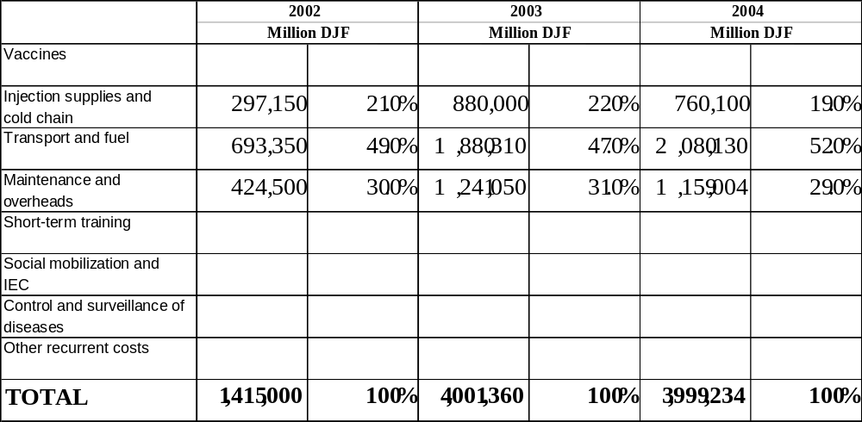

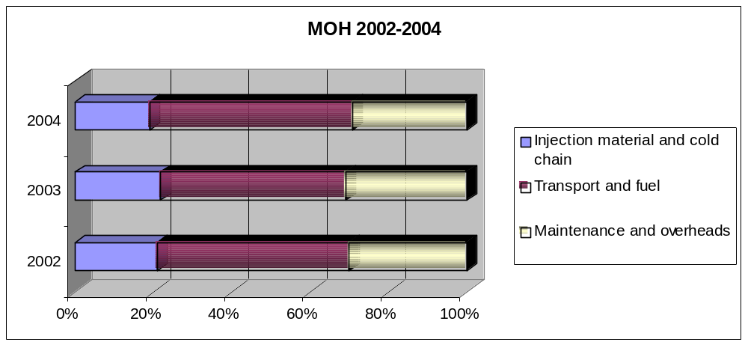

3.2.2 Sources of EPI funds
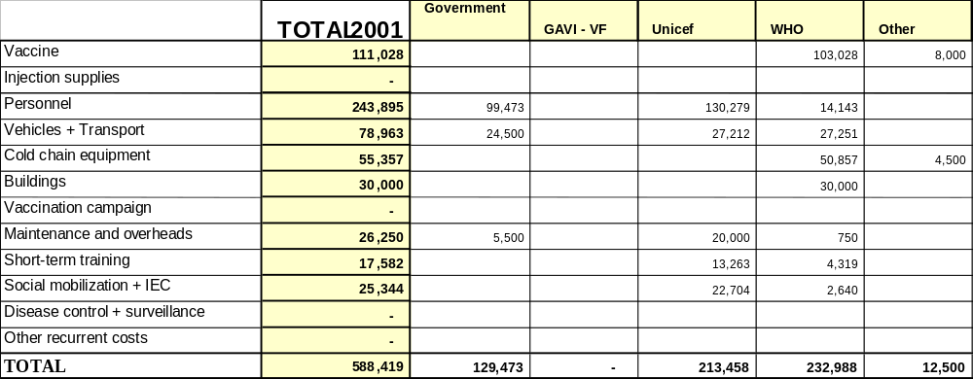

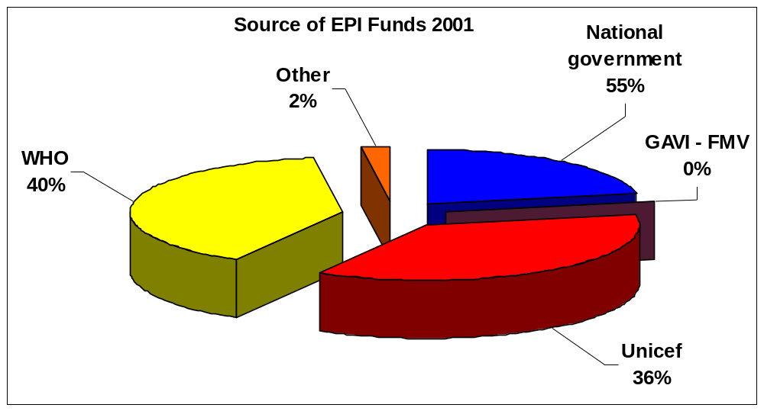

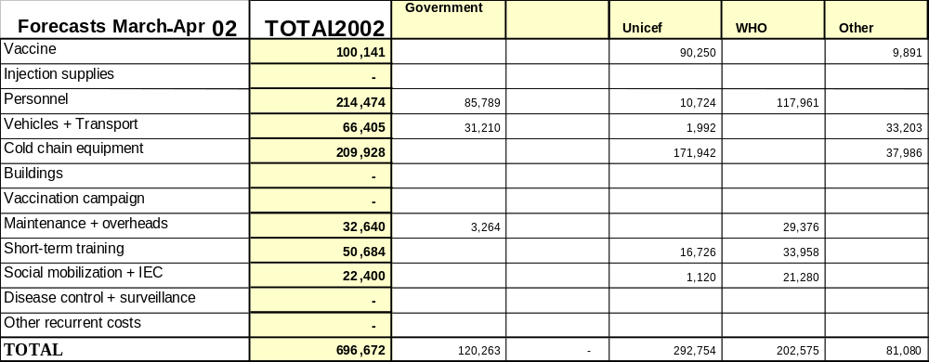

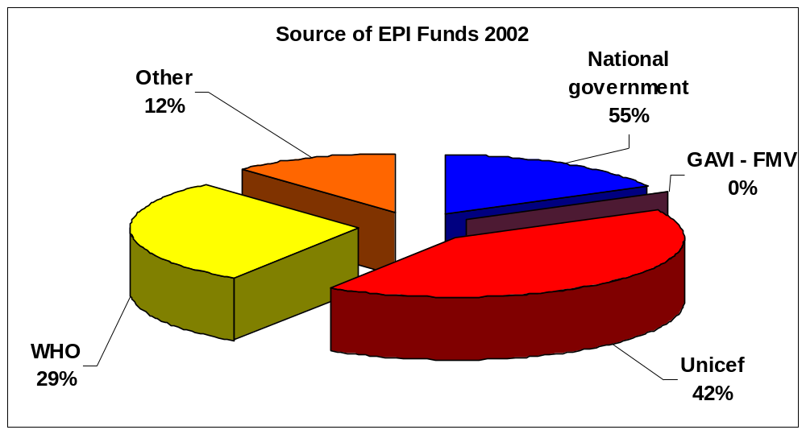

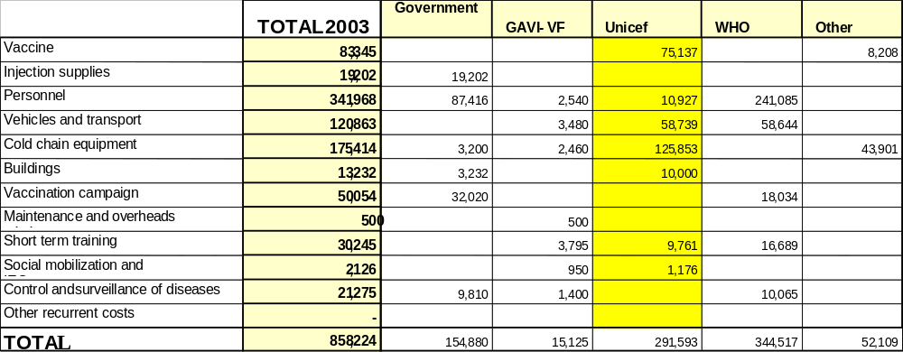

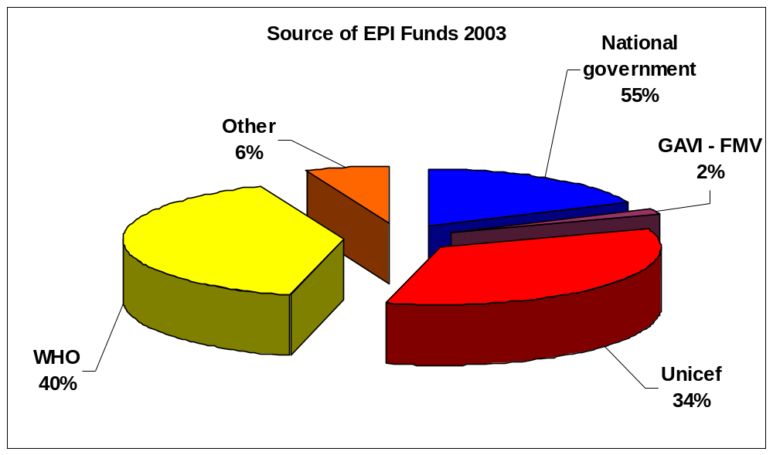

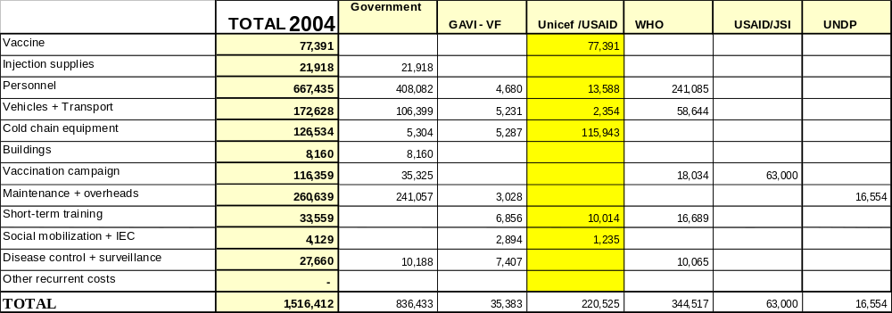

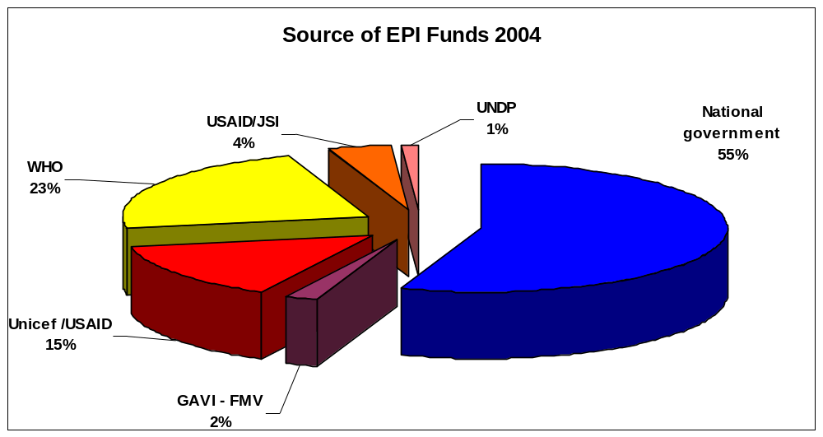

Section 4
Projections of future resource requirements

This section estimates and analyzes the gap between future resource requirement and available financing to achieve the programs targets and strategies explained in section 2 over the current commitment year and for few years after.

4.1 Introduction

To estimate and analyze the gap between future resource requirements and available financing the starting point is set as the multiyear financial plan. The method of estimation is:

- Measurement of the current available resources of EPI by types of inputs (vaccines, personnel, etc) the activity or approach used (routine or supplemental) and who is expected to contribute (Government and donors)
- Determination of the additional resources required over several years
- Identification of the funding available to match these additional requirements
- Estimation and clarification of the cause of the funding gaps.

4.2 Projection of future needs

4.2.1 Routine immunization
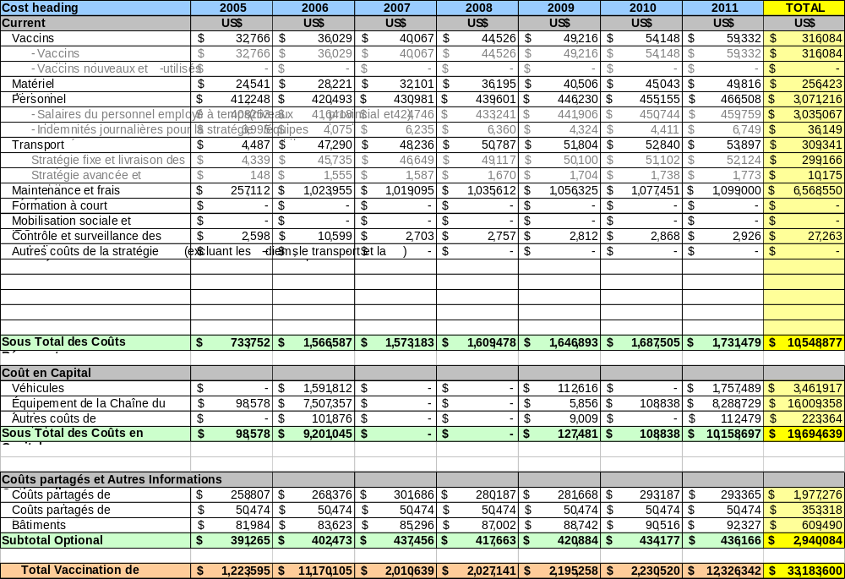

Cost heading
Current
Vaccines
- vaccine supplies
- new and under-used vaccines
Personnel
- salaries of staff employed on [fixed term contracts?]
- per diems for the [mobile strategy teams]
Transport
- fixed strategy and delivery of [ ]
- advanced strategy and []
Maintenance and overheads
Short term training
Social mobilization and IEC
Disease control and surveillance
Other costs of the strategy
Cost subtotal
Capital costs
Vehicles
Cold chain equipment
Other [capital] costs
Cost subtotal
Shared costs and other information
- shared costs for []
- shared costs for []
- Buildings
Optional subtotal
Total immunization []

4.2.2 Immunization campaigns

Cost heading | 2005 | 2006 | 2007 | TOTAL
Immunization campaigns
Polio | $ 320,000 | $ 320,000 | $ 320,000 | $ 960,000
Vaccines | $ 64,000 | $ 20,271 | $ 20,879 | $ 105,150
Other operating costs | $ 256,000 | $ 299,729 | $ 299,121 | $ 854,850
Measles |  | $ 20,710 | $ - | $ 20,710
Vaccines |  | $ 13,742 | $ - | $ 13,742
Injection supplies |  | $ 6,968 | $ - | $ 6,968
Total Immunization campaigns | $ 320,000 | $ 340,710 | $ 320,000 | $ 980,710
Source: Dr Kamel

4.3 Source of financing for the projection
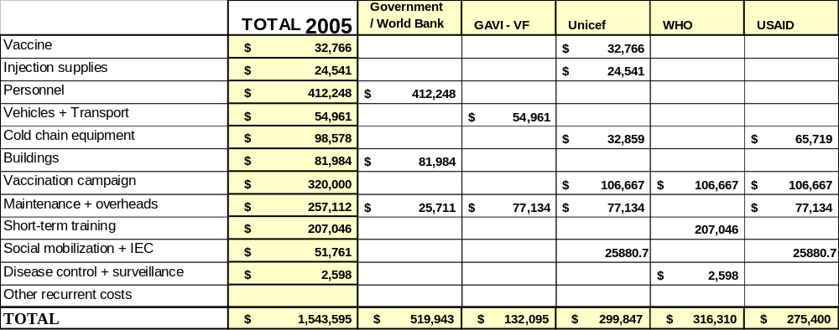

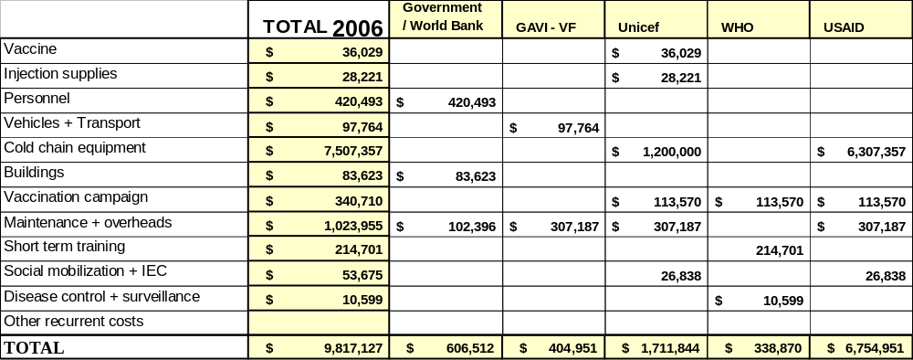

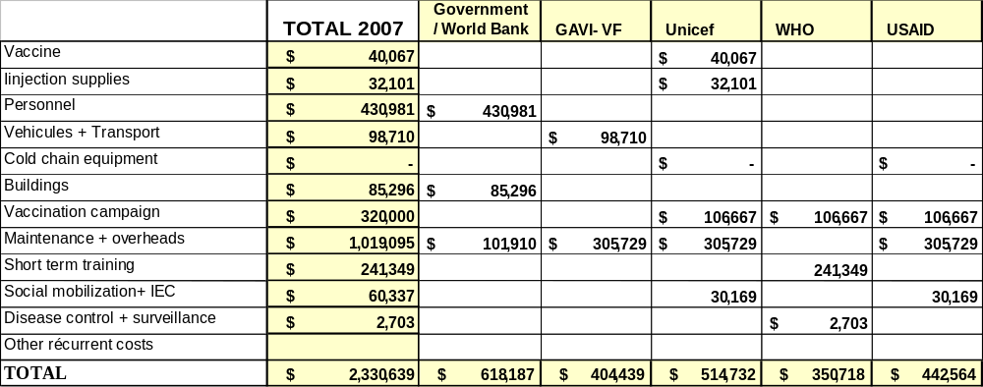
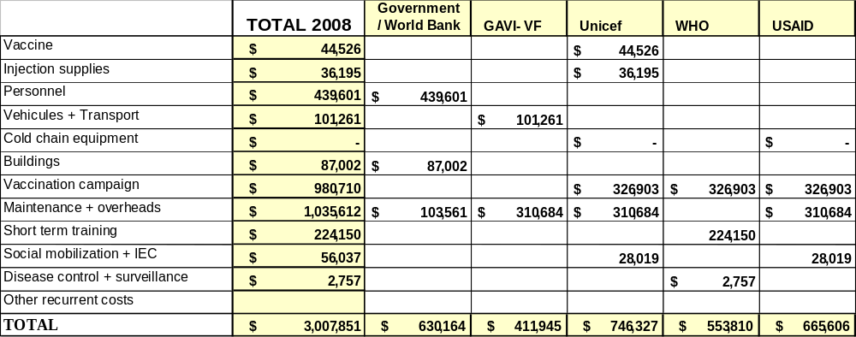

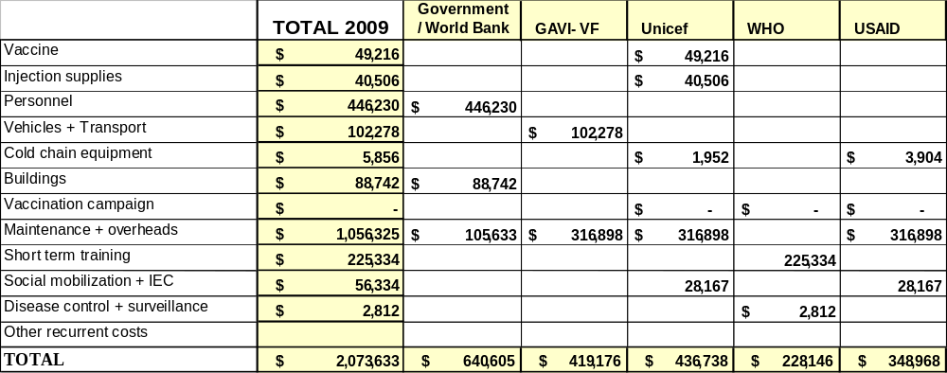

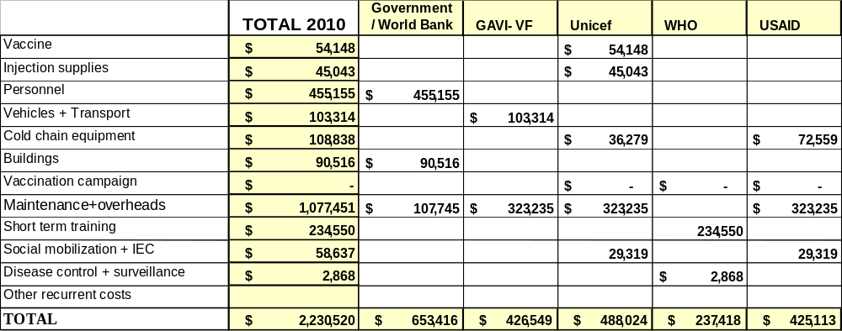
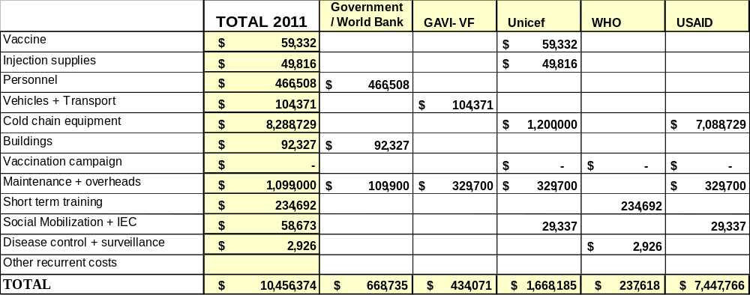

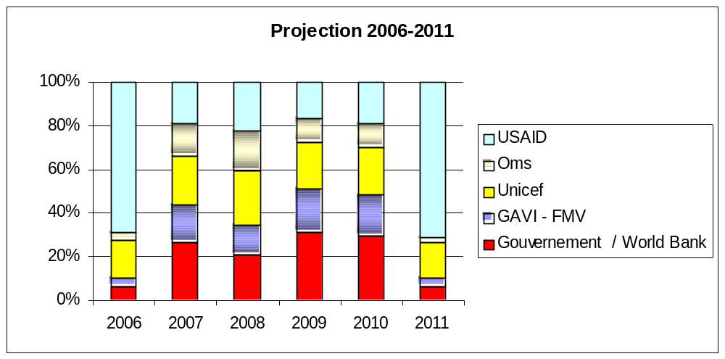

Section 5

Sustainable Financing Strategy, Action and Indicators

This section deals with the strategies and steps to be taken towards financial sustainability. This is based on prior analysis and the feasibility of embarking on these options. It also includes a set of targets and selected evaluation indicators to be employed to achieve these targets.

5.1 Planning of immunization coverage

The improvement of immunization coverage depends on the following main points :

- improving access of the target population to immunization by strengthening routine vaccination activities in all of the health structures in the country and organizing vaccination activities under the advanced strategy;
- organizing acceleration and catch-up activities;
- improving the use of the immunization services by the population by establishing a programme to inform and raise awareness and ensuring that the community plays an active and effective role in all immunization activities ;
- strengthening the information and disease surveillance system and ensuring that it is effective at all levels of the health system

The eradication of poliomyelitis remains one of the priorities of the programme and we hope that it will be achieved by the end of 2006. To this end, apart from activities relating to the improvement of routine vaccination coverage, supplementary activities will be organized in the form of National Immunization Days (up to 2008) or mopping-up operations in the areas at risk. At the same time, we will be reinforcing the epidemiological surveillance of AFPs. The obstacles to be overcome include (i) financial difficulties, (ii) the relative inaccessibility of certain populations, especially the nomads and (iii) the possibility of the virus being introduced from across the permeable borders with neighbouring countries such as the Afar and Somali regions of Ethiopia and Somalia, where polio eradication activities are far from advanced.

5.1.1 Constraints :

- low level of coverage of the routine programme
- inadequacy of the surveillance system for AFPs
- shortcomings in taking charge of cases and their documentation
- lack of any active search for cases
- lack of registers for consultation
- negligence of local managers
- late reporting and lack of communication
- problem of staff transfers
- lack of a special system for sending samples to the central unit
- lack of understanding of AFPs by the community (who have recourse to traditional healers, believing that the disease is the work of the devil or the wind)
- statistically, Djibouti-Town is the area most affected

5.1.2 Planning :

- holding National Immunization Days
- strenthening the system of surveillance for AFPs
- developing training and supervision
- strengthening social mobilization for the NIDs
- having AFP cases studied and analyzed regularly by the committee for certification of the eradication of poliomyelitis
- retraining personnel
- training new staff (introducing AFP surveillance into the curriculum for the training of nurses)
- ensuring greater involvement of doctors
- improving feedback from the health centres
- raising the awareness and sense of responsibility of officials, especially at district level
- drawing up a circular or sending a reminder to this end
- making the vaccination card a requirement for school registration
- strengthening the central team
- improving active surveillance (increased numbers of supervisions at stated frequencies, as well as register checks)
- broadcasting health education programmes by radio
- involving state and religious schools in finding suspected cases of AFP and declaring them to the nearest centre
- making use of traditional healers
- planning the sending of samples to the laboratory in Nairobi.

Various planned activities have been implemented in the course of a programme plan of action.

5.2 Inter-Agency Coordinating Committee (ICC)

Various agencies and partners (including NGOs and Research Institutions) that are supporting immunization services are co-ordinated and organised through an inter-agency co-ordinating mechanism which is referred to in this document as ICC.

5.2.1 Profile of the ICC

- Name : Inter-Agency Coordinating Committee
- Date of establishment in current ICC : 1/03/2001
- Frequency of meetings : Quarterly and as necessary
- Composition:
- UNICEF
- UNDP
- UNFPA
- UNHCR
- EUROPEAN UNION
- FRENCH COOPERATION
- ITALIAN COOPERATION
- ROTARY CLUB
- ASSOCIATION OF MEDICAL DOCTORS OF ASIA

5.2.2 Main functions and responsibilities of the ICC:

- to share in drawing up the strategies defined for the strengthening of the various components of the National Immunization Programme, namely routine immunization, epidemiological surveillance, social mobilization, eradication of poliomyelitis, control of measles and elimination of neonatal tetanus;
- to examine and validate the various plans of action drawn up by the National Immunization Programme and to make suggestions with a view to their finalization;

- to ensure the follow-up of the application of the strategies drawn up by mutual agreement with the national officers of the National Immunization Programme;

- to mobilize funds for the implementation of the planned activities, after approval of the micro-planning;

- to provide technical support in the implementation of the strategies and performance of activities relating to immunization, including particularly training, social mobilization and the organization of various types of campaigns;

- to conduct a regular assessment of the performance of the programme in terms of planning and the monitoring of immunization activities in the field and the vaccination coverage results;

- to take part in the planning and preparation of activities through meetings held regularly and at least once every six months.

GLOBAL ALLIANCE FOR VACCINES AND IMMUNIZATION |  |  |  |  |  | Banking Form
SECTION 1 (To be completed by payee)
In accordance with the decision on financial support made by the Global Alliance for Vaccines and Immunization and the Vaccine Fund dated . . . . . . . . . . . . . . . . . . . . . . . . . . . . . . . . . . . . ,
the Government of . . . . . . . . . . . . . . . . . . . . . . . . . . . . . . . . . . . . . . . . . . . . . . . . . . . . . . . . . . . . . . . . . . . . . . . . . . . . ,
hereby requests that a payment be made, via electronic bank transfer, as detailed below:

Name of Institution:
(Account Holder)

Address:

City – Country:
Telephone No.: |  |  |  | Fax No.:
Amount in USD: |  | (To be filled in by GAVI Secretariat) |  |  | Currency of the bank account:
For credit to: Bank account’s title
Bank account No.:
At: Bank’s name
Is the bank account exclusively to be used by this programme? |  |  |  |  |  |  | YES ( ) NO ( )

By whom is the account audited?

Signature of Government’s authorizing official:

Name: |  |  |  |  |  |  |  |  | Seal:

Title:

Signature:
Date:

SECTION 2 (To be completed by the Bank)
FINANCIAL INSTITUTION |  |  |  | CORRESPONDENT BANK  (In the United States)
Bank Name:
Branch Name:
Address:

City – Country:
Swift code:
Sort code:
ABA No.:
Telephone No.:
Fax No.:
I certify that the account No. . . . . . . . . . . . . . . . . . . . . . . . . . . . . . . . . . . . . is held by (Institution name) . . . . . . . . . . . . . . . . . . . . . . . . . . . . . . . . . . . . . . . .at this banking institution.
The account is to be signed jointly by at least …… (number of signatories) of the following authorized signatories: |  |  | Name of bank’s authorizing official:
1 Name:  Title: |  |  | Signature:
1 Name:  Title: |  |  | Date:
2 Name:  Title: |  |  | Seal:
3 Name:

Title:
4 Name:

Title:

COVERING LETTER
(To be completed by UNICEF representative on letter-headed paper)

TO: GAVI – Secretariat

Att. Dr Julian Lob-Levyt

Executive Secretary
C/o UNICEF
Palais des Nations
CH 1211 Geneva 10
Switzerland
On the ……………………………… I received the original of the BANKING DETAILS form, which is attached.
I certify that the form does bear the signatures of the following officials:
 |  | Name |  |  | Title
Government’s authorizing official
Bank’s authorizing official
Signature of UNICEF Representative:

Name
Signature
Date

Signatures of the Government and the Inter-Agency Coordinating Committee

The Government of …… the Republic of Djibouti ……..undertakes to develop the national immunization services on a sustainable basis in accordance with the multi-year plan submitted with this document. The results of the districts with regard to immunization will be examined each year through a monitoring system that satisfies the transparency requirements. The Government requests the Alliance and its partners to provide financial and technical assistance in order to support the vaccination of children as described in this proposal.

Signature: …… Dr. SALEH BANOITA TOURAB...

Title: …….. SECRETARY GENERAL – MINISTRY OF HEALTH ………...

Date: …………………………………………...

The GAVI Secretariat is unable to return submitted documents and attachments to individual countries. Unless otherwise specified, documents may be shared with the GAVI partners and collaborators.

The undersigned, members of the Inter-Agency Coordinating Committee, approve this proposal on the basis of the reference documents attached hereto. The signatures endorsing this proposal do not in any way constitute a financial (or legal) commitment on the part of the partner institution or individual:

Institution/Organization | Name / Title | Date Signature
WHO | Chairman
UNICEF | Member
UNDP | Member
UNFPA | Member
UNHCR | Member
FRENCH COOPERATION | Member
ITALIAN COOPERATION | Member
ROTARY CLUB | Member
Association of Medical Doctors of Asia (AMDA) | Member
USAID | Member

If the GAVI Secretariat has any questions concerning this proposal, the person to contact is:

Name : Dr. SALEH BANOITA TOURAB

Title / address: Secretariat General, Ministry of Health of Djibouti

Tel: (253) 35 19 31

Fax: (253) 35 63 00

email: Salehbanoita@yahoo.fr

Date : Signature

THE FOLLOWING CLARIFICATIONS WERE RECEIVED ON THE ABOVE PROPOSALS IN THESE REVIEW ROUNDS:
    - PR-2006.01
    - PR-2006.02
******************************************************************************
1) Report of the Ministry of Health of Djibouti on the
clarifications requested by the GAVI Alliance

In response to the clarifications forming the subject of your letter of 5/01/06, and following the surveys carried out to this end by Mrs. Koné Soleimane and Mojtaba Haghgou from 12 to 20 February 2006 on the evaluation of the cold chain and vaccine management, and by Mr. Patrick Lyddon from 16 to 24 April 2006 on the financial sustainability, I would like to reply as follows:

1. Rehabilitation of the cold chain

The recommendations of Mrs. Koné and Haghgou concerned all the components of vaccine management and the cold chain and emphasized the aspects to be improved:

- Storage capacities at all levels are sufficient for both routine immunization and the campaigns. Nevertheless, they recommended the construction of a 5 m³ cold room, which has been scheduled for 2007. The technical specifications are being prepared.
- The reliability of the cold chain is satisfactory in the large towns where an electric power source is available. For the rural areas, USAID (JSI) has programmed the rehabilitation of the solar panels for 2006 and 2007. For this reason, introduction of the pentavalent will be effected in stages: initially in 2007 in the towns where the cold chain meets the norms then, in 2008, the pentavalent will be put into general use throughout the country when the solar panels are operational.
- Shortcomings were mentioned in regard to the storage system, control of wastage and adequate use of diluents. To rectify these shortcomings, the Ministry has proceeded to train personnel in vaccine management (mission of the USAID consultant Mr. Michel Othepa in March 2006) and has standardized the use of stock cards and vaccine orders. A NIP logistics officer, responsible for vaccine management, has also been appointed. This officer participated in the vaccine management course organized by WHO at Bamako in May 2006.
- The policy regarding opened vials is being made official.

- Financial analysis

The financial analysis formed the subject of Mr. Patrick Lyddon’s mission from 16 to 24 April 2006. In fact, in his report, Mr. Lyddon replied to all the clarifications requested, namely:

  - Analysis of the current and projected costs of the programme for the coming years:

In paragraph 3 of his report, Mr. Lyddon indicated that, in the base year 2005, the immunization expenditure amounted to $ 1.1 million, of which one quarter was reserved for the polio and measles campaigns. The NIP objectives for 2007-2010 were determined on the following basis:

- The demographic data and the level of immunization coverage were based on the GAVI annual report of April 2006 and the level of immunization coverage.
- The pentavalent will be introduced in two stages: in 2007 in the towns where the cold chain is operational, and subsequently throughout the country in 2008.
- Two polio campaigns in 2007 and 2008 and a measles campaign in 2009 have been scheduled.
- The salaries were estimated on the same basis as in the FSP, taking into account the increase in the number of health centres and the reinforcement of the advanced and mobile strategies.
- Renewal of the means of transport and the cold chain.

Based on these criteria, NIP needs for 2007-2010 were evaluated at $ 6 million, of which 5.5 million are for the routine EPI accounting for an average of 1.1 million per year. There is, nevertheless, a notable peak in 2010 for the renewal of means of transport and the cold chain.

The following table shows the financial needs for vaccines (in dollars):

 | 2005 | 2007 | 2008 | 2009 | 2010 | 2011 | 2007-2011
Traditional vaccines | 28,280 | 22,892 | 20,488 | 20,144 | 20,391 | 21,199 | 105,115
Pentavalent vaccines | - | 177,657 | 215,591 | 218,161 | 232,730 | 247,976 | 1,092,115
Total | 28,280 | 200,549 | 236,079 | 238,305 | 253,122 | 269,175 | 1,197,230

The pentavalent vaccine increases the immunization costs by 30%; the proportion of the total NIP costs allocated to routine vaccines rises from 4% to 20% and the advanced and mobile strategies represent 30% of the costs of routine immunization.

2.2 Resource funding planned for the same period:

In paragraph 4, Mr. Lyddon showed the status of NIP funding from 2007 to 2011.

* Secured funding:
- State contribution: salaries, programme operation, maintenance of equipment: $ 320,000-360,000.
- Participation of GAVI (ISS): $ 30,000 up to 2007.
- Funding assured by UNICEF, WHO and USAID.

* Probable funding:

- State contribution: traditional vaccines until 2009: $ 20,000 per year.
- Tacit renewal of the previous allocations for routine immunization funded by UNICEF, WHO and USAID, USAID intervention being channelled through WHO and UNICEF.
- GAVI funds for the pentavalent vaccine and the final instalment of ISS funding.

Hence, the relative percentage of each provider of NIP funding (secured and probable) between 2007 and 2011 is as follows:

Government: 37%
GAVI: 28%
UNICEF: 20%
WHO: 15%
Resource needs and various funding scenarios (secured and probable)

 | 2007 | 2008 | 2009 | 2010 | 2011 | 2007-2011
Resource needs | 1,073,804 | 1,144,489 | 1,395,023 | 1,239,549 | 1,166,306 | 6,019,171
Resource needs (routine immunization) | 980,054 | 1,046,216 | 1,082,364 | 1,239,549 | 1,166,306 | 5,514,489
Total funding secured | 720,648  Govt.+UNICEF +WHO +GAVI | 346,500  Govt.  +UNICEF | 344,361  Govt.  +UNICEF | 360,438  Govt.  +UNICEF | 371,047  Govt.  +UNICEF | 2,142,994
Financial deficit | 353,156 | 797,989 | 1,050,662 | 879,111 | 795,259 | 3,876,177
Percentage deficit | 33% | 70% | 75% | 71% | 68% | 64%
Probable total funding | 232,299  UNICEF +GAVI (NV) | 621,131  UNICEF +GAVI +WHO | 657,106  UNICEF +GAVI +WHO | 633,490  UNICEF +GAVI +WHO | 615,275  UNICEF +GAVI +WHO | 2,759,300
Financial deficit | 120,857 | 176,858 | 393,556 | 245,622 | 179,984 | 1,116,877
Percentage deficit | 11% | 15% | 28% | 20% | 15% | 19%

3. Action to be taken by the Government to ensure better immunization coverage and financial sustainability of the NIP

The Ministry has taken several measures to improve the state of immunization coverage by 2010, including:

- Rehabilitation of health centres: improvement and increase in the number of centres, especially in large urban areas and inaccessible and remote zones.
- Increase in the number of qualified personnel at immunization centres and units; gradual replacement of “volunteers” and auxiliaries by qualified nurses.
- Introduction of the RED approach and multiplication of scenarios to reach all districts and reduce the number of dropouts and missed opportunities.
- Improvement of the data management and coverage monitoring system, using the tools developed by WHO.
- Improvement of vaccine management, using the tools developed by WHO, with a view to achieving certification.
- Improvement in the surveillance of transmissible diseases that can be avoided by immunization.
- Promotion of research in order to better understand the incidence and impact of each EPI target disease and to act in a rational and effective manner.
- Integration and coordination of the activities of the various programmes in order to make the most cost-effective use of human and material resources and improve primary care coverage.
- Improvement in the state of health of children and the population as a whole: finally eradicate polio, eliminate measles and neonatal tetanus and reduce the prevalence of hepatitis B and the incidence of meningitis.

All these activities will be developed in the multi-year plan that is being formulated and will be transmitted to you before the end of 2006.

4. Additional information

The clarifications requested in your e-mail FW GAVI of 23 May 2005, concerning the supply of injection safety materials by UNICEF and the needs for pentavalent and other vaccines from 2007 to 2008, are as follows:

- UNICEF will continue to supply injection safety materials for vaccines other than pentavalent.
- It should be noted that the pentavalent will be introduced in stages, initially in the towns in 2007 (80% of the target population) and subsequently in all the centres in 2008.
- Since the prevalence of chronic carriers of HBs AG is estimated at 10%, HBV immunization will be introduced at birth. Bearing in mind that the proportion of deliveries in maternity clinics is only 60%, the need for HBV vaccine solely for newborn infants, after adding 10% for wastage and 25% for reserves, is estimated at 17,563 doses in 2007 and 17,900 doses in 2008.

 | 2006 | 2007 |  |  | 2008
Denominators
Births | 20,540 | 21,165 |  |  | 21,800
Infant deaths | 2,075 | 2,137 |  |  | 2,202
Surviving infants | 18,473 | 19,028 |  |  | 19,598
Number of children to be vaccinated with DTP1 | Obj: 80%  14,470 | Obj: 85%  3,234
Number of children to be vaccinated with DTP3 | Obj: 77%  14,225 | Obj:  3,044
New vaccines
Number of children to be vaccinated with a first dose |  | 12,940 |  |  | 17,640
Number of children to be vaccinated with a third dose |  | 12,178 |  |  | 16,660
Wastage rate: no previous data but, since it is a question of a single dose, the wastage can be estimated at 10%
Injection safety for the pentavalent only (+ 10% wastage + 25% reserves)
Auto-disable syringes |  |  | 34,538 | 47,163
Safety boxes |  |  | 467 | 650
Pregnant women to be vaccinated with TT | Obj: 60%  11,970 |  | Obj: 65%  13,757 | Obj: 70%  15,260
Infants to be vaccinated with BCG | Obj: 85%  17,459 |  | Obj: 85%  17,990 | Obj: 90%  19,620
Infants to be vaccinated against measles | Obj: 90%  16,625 |  | Obj: 90%  17,125 | Obj: 95%  18,620

**********************************************************
2) Replies to the clarifications requested by GAVI
on the introduction of the new vaccines

- Storage capacity at the national and district levels

Level | Target population | Supply | Positive capacity in litres | Negative capacity in litres | Mixed capacity in litres  (solar refr.) | Total capacity in litres
National depot | 19 032 | Twice yearly | 1 129 | 684 |  | 1 813
District of Djibouti | 12 368
10 health centres + 2 maternity clinics |  | Once monthly | 1 008 | - | - | 1 008
District of Arta | 931
District depot |  | Once monthly | 144 | 108 | - | 252
2 rural health centres |  | Once monthly | 144 |  |  | 144
District of Ali Sabieh | 2 268
District depot |  | Once monthly | 144 | 108 |  | 252
5 rural health centres |  | Once monthly |  |  | 200 | 200
District of Dikhil | 1 560
District depot |  | Once monthly | 216 | 108 |  | 324
5 rural health centres |  | Once monthly | 144 |  | 150 | 294
District of Tadjourah | 1 212
District depot |  | Once monthly | 216 | 108 |  | 324
5 rural health centres |  | Once monthly | 72 |  | 150 | 222
District of Obock | 693
District depot |  | Once monthly | 216 | 108 |  | 324
5 rural health centres |  | Once monthly |  |  | 200 | 200
Total |  |  | 3 433 | 1 224 | 700 | 5 357

2. Target population and annual objectives

Year | Total population | Births | Surviving children | Rate of coverage by Penta 1 | Children to be immunized
2007 | 604 471 | 21 165 | 19 031 | 80 % * | 10 467
2008 | 62 285 | 21 800 | 19 598 | 81 % | 15 874
2009 | 64 508 | 22 578 | 20 298 | 84 % | 17 050
2010 | 66 443 | 23 255 | 20 907 | 87 % | 18 189
2011 | 68 437 | 23 953 | 21 534 | 90 % | 19 380

* 80 % of the children in the city of Djibouti and the district centres

3. Indicators

- Hepatitis 0 immunization coverage of newborn infants in public and private maternity clinics
- Immunization coverage of children aged 6-14 weeks by district and health centre (centres run by the Ministry of Health and other public and semi-public institutions providing immunization services): monthly report and monitoring curve
- Calculation and monitoring of drop-out rates per health centre: monthly report and monitoring curve
- Rate of wastage of vaccine per centre: monthly report and vaccine order forms
- Monthly summary of cases of Hepatitis B
- Weekly summary of cases of bacterial meningitis in the pilot centres: paediatric departments and bacterial laboratories in the city of Djibouti
- Monthly summary of suspected cases of bacterial meningitis in the district Hospital Medical Centres
- Extent of compliance with the supervisory plan of action: supervision provided/supervision planned at the district and national levels
- Number of ICC meetings on the assessment of progress made in immunization activities in conformity with the joint plan of action
- Rate of completion of personnel training activities: training courses held/courses planned.

