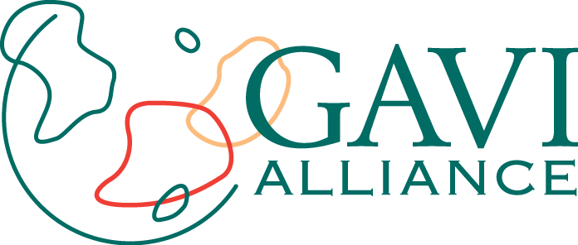

APPLICATION FORM FOR COUNTRY PROPOSALS

to obtain support for:

Conjugated meningococcal A vaccine

Submitted by the
Government of Senegal

Reviewed in March, 2011

For the 2011 application submission session

Please send this electronic application along with its attachments (including the signature page) to the following address: proposals@gavialliance.org

Information from: proposals@gavialliance.org or from the representatives of a GAVI partner agency. The attached proposal must be presented in English or French.

Please be sure the GAVI Secretariat receives the application before or at the latest on the deadline date.

The GAVI Secretariat is unable to return documents and items which may have been sent to it to individual countries. Unless otherwise specified, documents may be shared with the GAVI partners or the public.

Abbreviations

ANSD : Agence Nationale de la Statistique et de la Démographie/National Agency for Statistics and Demography
BCG : Bacillus of Calmette and Guérin
BS : Sharps Box
ICC : Interagency Coordination Committee
DSE : Division de la Surveillance Epidémiologique [Epidemiological Monitoring Division]
DTP : Diphtérie Tétanos Coqueluche (immunisation against diphtheria, tetanus and pertussis)
EDS : Enquête Démographique et de Santé [Demographic and Health Survey]
GAVI : Global Alliance for Vaccines and Immunisation
Hib : Haemophilus inflaenzae B
LUXDEV : Luxembourg Agency for Development Cooperation
APVS : Adverse Post-vaccination Symptom
MCS : Cerebrospinal meningitis
WHO : World Health Organization
EPI : Expanded Program on Immunization
MISPCL : National Plan for Health Development
cMYP : Complete Multiyear Plan for Vaccination
AWP : Annual Work Plan
ALS : Auto lock syringe
VSS : Vaccination Services Support
UNICEF : United Nations Children's Fund
USAID : United States Agency for International Development
OPV : Oral Polio Vaccine
JICA : Japan International Cooperation Agency
CC : Cold chain
CIB : Consolidated Investment Budget
ECOWAS : Economic Community of West African States
HIPC : Highly Indebted Poor Countries
RMT : Regional Management Team
DMT : District Management Team

Table of Contents
Abbreviations 1
Table of Contents 2
1. Executive Summary 3
2. Signatures by the Government and national bodies
3. Data Regarding the Vaccination Program 11
4. Request for Meningococcal A conjugate vaccine 18
5. Procurement and Management of New and Under-Used Vaccines 26
6. Grants for the Operational Cost for Vaccination Campaigns 28
7. Additional comments and recommendations from the National Coordinating Body (ICC/HSCC) 31
Signature of the authorised government representative: 33
FINANCIAL INSTITUTION

Executive Summary

Senegal is located in the African “meningitis belt.” It is regularly affected by meningitis epidemics ; this is particularly true in eight of its regions : Diourbel, Fatick, Kaolack, Kaffrine, Tambacounda, Kédougou, Kolda and Sédhiou. Serogroup A meningitis is the most common strain found in these epidemic flare-ups.
In accordance with its Comprehensive Multi-Year Plan (cMYP) for 2012-2016, the government of Senegal plans to organize a mass vaccination campaign during the fourth quarter of 2012 in cooperation with MenAfriVac, in order to prevent epidemics in these eight high-risk regions.
To this end, Senegal is submitting this request to the GAVI Secretariat. The Ministry of Health coordinated its preparation by a national Technical committee with support from various partners (WHO and UNICEF). It was approved by the Inter-Agency Coordinating Committee on May 11, 2011.
This campaign will enable prevention of serogroup A meningitis epidemics in Senegal.
In terms of the cold chain, the available storage capacities at all levels will allow the introduction of MenAfriVac in Senegal in 2012.
All injections will be performed using auto-lock syringes, which will be collected in sharps boxes in accordance with national directives.
All districts will write or update a waste management plan describing the collection, transportation, security and disposal of sharps boxes. Districts that have De Montfort incinerators or electric incinerators will destroy sharps boxes locally; otherwise they will be transported to a private incineration location (an industrial location such as an oil factory or a cement factory), hospitals and neighboring districts.
Senegal has acquired extensive experience through prior vaccination campaigns, and has learned a great deal about the introduction of new vaccines. In the context of this campaign, the primary strategic axes will be:
- Improved communication/social mobilization, especially in terms of locally-based communications with the involvement of local leaders;
- Training of local stakeholders in the various components of the vaccination campaign;
- Efficient supply of vaccines, input items and tracking of their use;
- Improved pharmaco-vigilance, specifically in terms of post-vaccination adverse events (PVAEs) and how to properly manage them;
- Improved case-by-case monitoring, taking experiences with measles, yellow fever and polio into account and using knowledge gained from the first countries to introduce MenAfriVac.
The projected target population is 3,948,878 people between 1 and 29 years of age. The total required quantity of vaccines is 4,936,102 doses.
The campaign will be composed of one phase during the last quarter of 2012.

The plan’s overall total cost is US $5,325,140.53, or US $1.34 per person vaccinated and the operational cost (including investment) is US $2,017,952.19, or US $0.51 per person vaccinated (the unit cost of the vaccine plus injection materials is estimated at US $0.67).
.

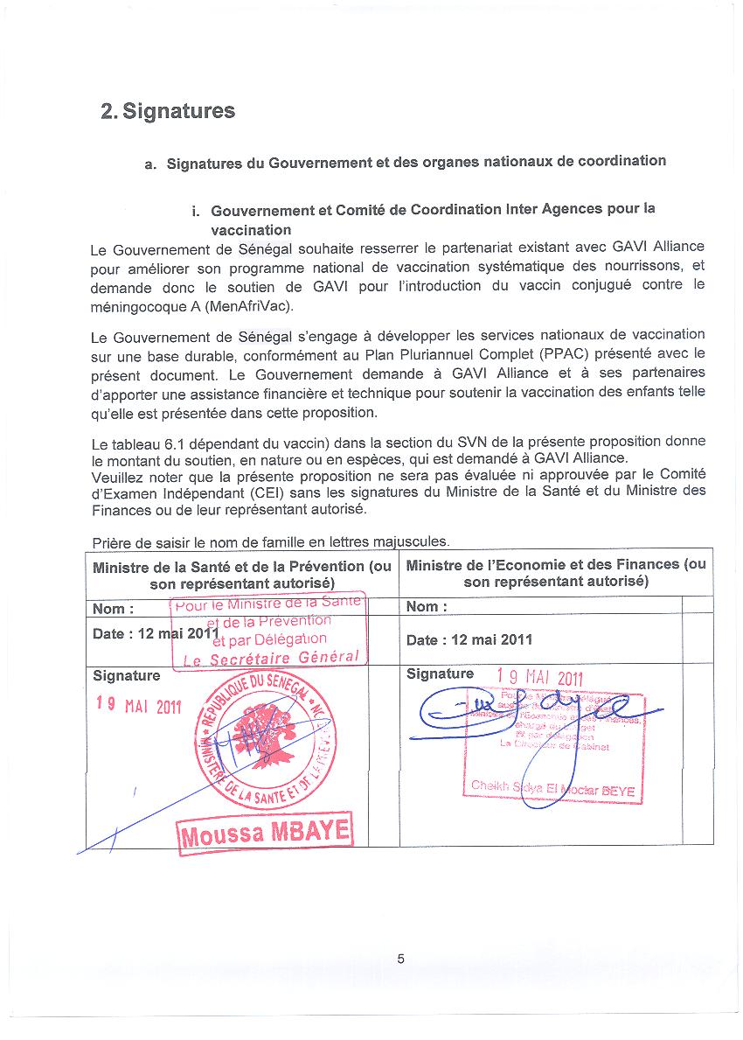
This document was prepared by:
Note: To add lines, please click on the New field icon in the Action column. Use the Delete field icon to delete a line.
Please enter the last name in capital letters.

Full name: | Post | Telephone no.: | E-mail: | Actions
Dr Aboubacry FALL | Direction de la Prévention Médicale [Medical Prevention Department] | +(221) 33 869 42 31 | guelewy@gmail.com

The Ministry of Health coordinated the preparation of this request by a national Technical committee with support from various partners (WHO and UNICEF). It was approved by the Inter-Agency Coordinating Committee on May 11, 2011.
National Coordinating Body: Inter-Agency Coordinating Committee for Vaccination

We undersigned, members of the ICC/HSCC, met on May 11, 2011 to examine this proposal. At that meeting we endorsed this proposal on the basis of the supporting documentation which is attached.

  - The endorsed minutes of this meeting are attached as Document Number 3:

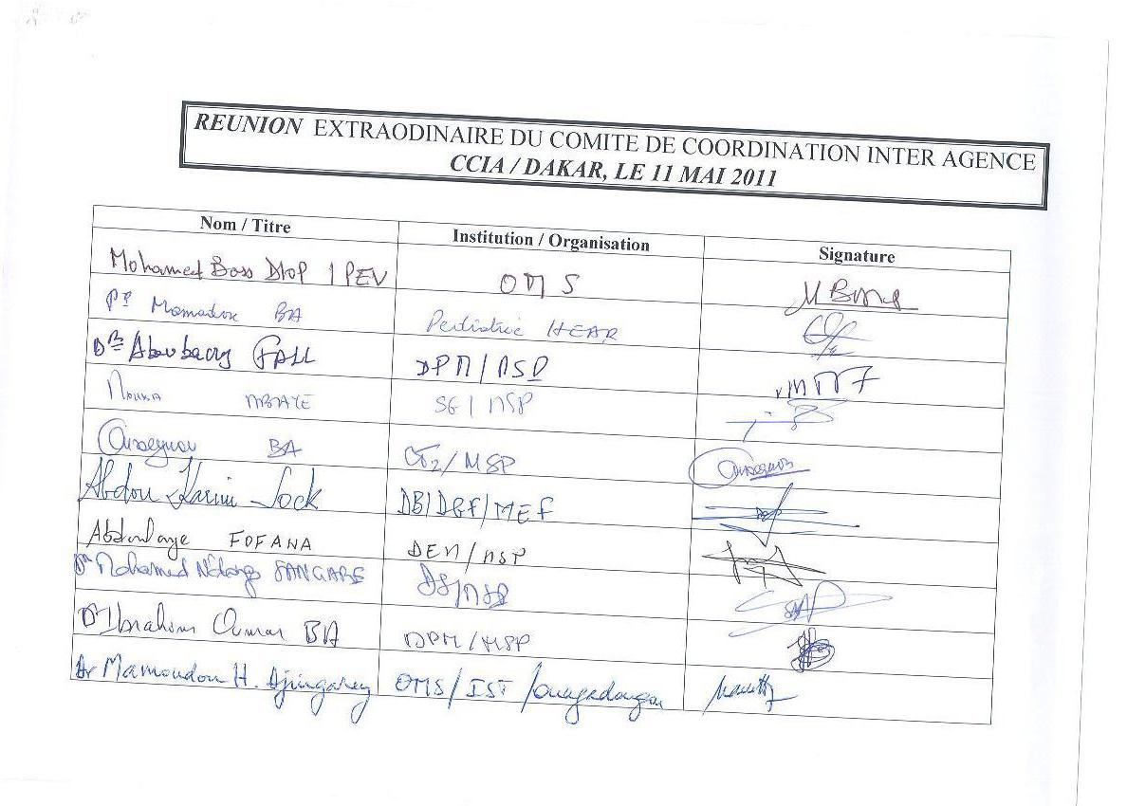
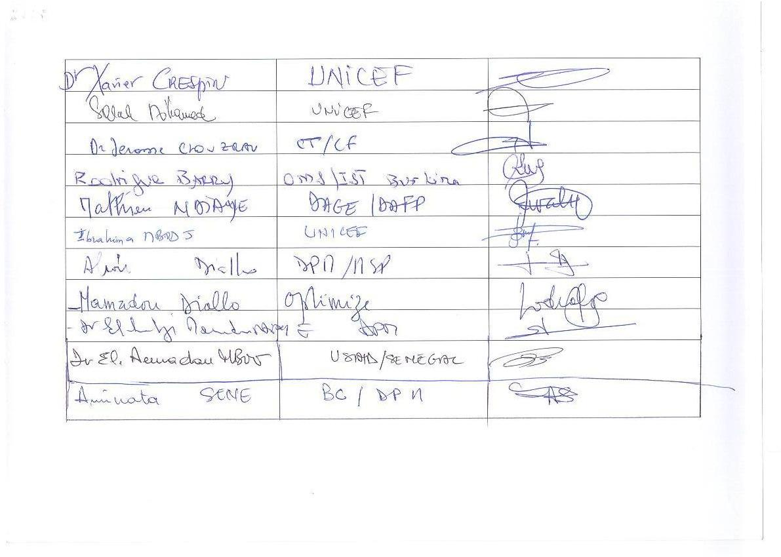

In case the GAVI Secretariat has queries on this submission, please contact:

Name: Dr El Hadji Mamadou NDIAYE | Title: Director of the Immunisation Division
Tél. (+221) 33 869 42 31 / (+221) 77 634 40 57 | Address: Ministry of Health and Prevention, Rue Aimé Césaire, Fann Résidence Dakar
Fax no.: : (+221) 33 869 42 37 | ……………………………………
E-mail: mamamorph@yahoo.fr | ……………………………………

.

Inter-Agency Coordinating Committee for Vaccination

Agencies and partners (including development partners and CSOs) supporting immunization services are coordinated and organized through an inter-agency coordinating mechanism (ICC/HSCC). The ICC/HSCC are responsible for coordinating and guiding the use of the GAVI ISS and NVS support. Please provide information about the ICC/HSCC in your country in the spaces below.

Description of the ICC:

Name of ICC: Inter-Agency Coordinating Committee
Date of constitution of the current ICC/HSCC:....................................................................... 1999
Structure (for example subcommittee, autonomous body): Stand-alone body
Frequency of meetings: Four (4) statutory meetings per year and extraordinary meetings
Composition:
Post | Title / Organization | Name
Chair | Minister of Health and Prevention | Mr. Modou DIAGNE Fada
Secretary | Direction de la Prévention Médicale [Medical Prevention Department] | Dr Aboubacry FALL
Members | - Representative of the WHO  - Representative of UNICEF  - USAID Representative  - PATH Representative  - JICA Representative  - French Development Agency Representative  - IPD Representative | Dr Jeanne Alimata DIARRA- NAMA Ms. Barberis GIOVAME  Dr El Hadji Amadou MBOW  Mr. Mamadou DIALLO  Ms. Reiko HAYASHI  Mr. Jérôme CLOUZEAU  Dr Mbayame Ndiaye. NIANG

Major functions and responsibilities of the ICC/HSCC:

The mission of the ICC is to define the main directions and general objectives of the Expanded Program on Immunization (EPI). In this role, the ICC is in particular charged with:
- Preparing and implementing the national Expanded Program on Immunization policy
- Coordinating, harmonizing and overseeing the consistency of all the actions of the various partners
- Adopting the Expanded Program on Immunization's annual action plans and the associated budgets
- Mobilizing the resources necessary for the Expanded Program on Immunization's activities
- Coordinating and tracking the implementation of the activities from the various Expanded Program on Immunization's components
- Tracking the performance of the action plans
- Evaluating the implementation of the Expanded Program on Immunization.

Three major strategies to enhance the ICC/HSCC's role and functions in the next 12 months:
- Improving the coordination of partner involvement
- Strengthening of Advocacy and resource mobilization
- Tracking/evaluating the implementation of plans (PTA, cMYP)

3. Data Regarding the Vaccination Program

Please complete the tables below, using data from available sources. Please identify the source of the data, and the date. Where possible use the most recent data, and attach the source document.

  - Please refer to the cMYP and the meningitis A vaccine introduction plan. Please attach a complete copy (with an executive summary) as document number 01.

  - Please refer to Health Sector Strategy documents, budgetary documents, and other reports, surveys etc, as appropriate.

Table 3.1: Basic facts for the year 2011... (the most recent; specify dates of data provided)

 | Number |  | Year | Source
Total population | 12 862 587 |  | 2011 | Agence Nationale de la Statistique et de la Démographie/National Agency for Statistics and Demography
Infant mortality rate (per 1,000) | 61 |  | 2005 | EDS 2005
Surviving Infants* | 501 641 |  | 2011
GNI per capita (US$) | 840 |  | 2006 | World Bank Report
Percentage of GDP allocated to Health | 6,39 | % | 2005 | National Health Statistics
Percentage of Government expenditure on Health | 10 | % | 2005 | National Health Statistics

* Surviving infants = Infants surviving the first 12 months of life

Please provide some additional information on the planning and budgeting context in your country:

Please indicate the name and date of the relevant planning document for health

The National Health Development Plan (NHDP) is the current planning document. It is updated every 10 years. The current NHDP covers the period ranging from 2009 to 2018.

Is the cMYP consistent with this document (schedule, content, etc.)?

Yes, 2012-2016 cMYP.

Please indicate the national planning budgeting cycle for health

The National Health Development Plan (NHDP) is prepared every 10 years.
Annual work plans (AWP) are created from it. The National Assembly votes on their budgets.

Please indicate the national planning cycle for vaccination

The cMYP is prepared every 5 years and the EPI annual work plans are created from it.

Please indicate whether data broken down by sex are reported in conjunction with routine vaccination reporting.

No

Please indicate whether gender related aspects have been incorporated in this vaccine's introduction plan:

No All target individuals will benefit equally from the vaccine, regardless of their gender.

Table 3.2 Current vaccination schedule : Traditional, New Vaccines and Vitamin A Supplement (page 15 of the cMYP)

Vaccine  (do not use trade name) | Ages of administration  (by routine immunisation services) | Indicate by an "x" if given in: |  | Comment
Vaccine  (do not use trade name) | Ages of administration  (by routine immunisation services) | entire country | Only part of the country | Comment
BCG, polio 0 | At birth | X
Pentavalent 1/ Polio 1 | 6 weeks | X
Pentavalent 2/ Polio 2 | 10 weeks | X
Pentavalent 3/ Polio 3 | 14 weeks | X
Measles | 9 months | X
Yellow Fever | 9 months | X

Table 3.3: Trends of vaccination coverage and disease burden
(as described in the last two annual WHO/UNICEF Joint Reporting Forms on Vaccine Preventable Diseases)

Trends of vaccination coverage (in percentage) |  |  |  |  |  |  | Vaccine preventable disease burden
Vaccine |  |  | Reported |  | Survey |  | Disease | Number of reported cases
 |  |  | 2009 | 2010 | 2009 | 2010 |  | 2009 | 2010
BCG |  |  | 97 | 80 | Not app. | 95 | Tuberculosis | 10 501 | 8 394
Pentavalent | Penta 1: |  | 94 | Not app. | Not app. | 93,7 | Diphtheria | Not app. | Not app.
Pentavalent | Penta 3: |  | 86 | Not app. | Not app. | 74,1 | Whooping cough | Not app. | Not app.
Polio 3 |  |  | 83 | 70 | Not app. | Not available | Polio | 0 | 18
Measles |  |  | 79 | 60 | Not app. | Not available | Measles | 367 | 428
TT2+ (Pregnant women) |  |  | 78 | 60 | Not app. | 52 | Neonatal tetanus (NT) | 16 | 12
Hib3 |  |  |  |  |  |  | Hib | Not app. | Not app.
Yellow Fever |  |  | 71 | 60 |  | 77 | Yellow Fever | 0 | 1
HepB3 |  |  |  |  |  |  | hepB sero-prevalence* | Not app. | Not app.
Vit A supplement |  | Mothers  (<6 weeks from delivery)
Infants
(>6 months)

.
Table 3.4: Vaccination Coverage Trends during Recent Broad Vaccination Campaigns

Number
Number |  | Baseline year  2006 | Year 1  2007 | Year 2 2008 | Year 3 2009 | Year 4 2010 | Year 5 2011
Polio | Target | 2 417 562 | 2 420 561 | 2 435 972 | 2 201 792 | 2 187 096
Polio | Vaccinated | 2 678 165  (111%) | 2 546 168  (105%) | 2 547 212  (104,6%) | 2 382 473  (108%) | 2 373 270  (108,5%)
Measles | Target |  | 5 071 954 |  | 1 916 870
Measles | Vaccinated |  | 4 575 044  (90%) |  | 1 782 689  (93%)
TT2+ women of child-bearing age | Target |  |  |  |  | 444 911
TT2+ women of child-bearing age | Vaccinated |  |  |  |  | 394 986  (89%)
Yellow Fever | Target | Not app. | Not app. | Not app. | Not app. | Not app. | Not app.
Yellow Fever | Vaccinated | Not app. | Not app. | Not app. | Not app. | Not app. | Not app.

Note: Administrative data from the most recent national campaigns for each year.

If survey data is included in the table above, please indicate the years the surveys were conducted, the full title and if available, the age groups the data refers to:

December 2010 study of infants aged 12-23 months.

Table 3.5: Estimated annual funding and goals

Please refer to the cMYP and the meningitis A vaccine introduction plan which contain a summary of the estimates of funds and annual objectives in order to complete the mandatory calculation sheet (Annex 1).

Tables 3.6 and 3.6 bis below summarize the current and future vaccination budgets, broken down by strategy and by financing source.

Please list in the tables below the funding sources for each type of cost category (if known). Please try and indicate which vaccination program costs are covered by the Government budget, and which costs are covered by development partners (or the GAVI Alliance), and name the partners.

Table 3.6: Summary of Current and Future Financing and Funds' Origin (cMYP: Annexe Sénégal_cMYP_Costing_Tool_Vs.1.3_Fr. Sheet 4. Financing)

Number | Baseline year | Baseline and targets
Number | 2010 | 2012 | 2013 | 2014 | 2015 | 2016
Total number of births | 475 815 | 501 856 | 515 406 | 529 322 | 543 614 | 558 296
Total number of infant deaths | 29 025 | 30 613 | 31 440 | 32 289 | 33 160 | 34 056
Total number of surviving infants | 446 790 | 471 243 | 483 966 | 497 033 | 510 454 | 524 240
Total number of pregnant women | 475 815 | 501 856 | 515 406 | 529 322 | 543 614 | 558 296
Number of infants vaccinated (or to be vaccinated) with BCG | 193 197 | 451 670 | 489 636 | 502 856 | 516 433 | 530 377
BCG coverage (%) | 41% | 90% | 95% | 95% | 95% | 95%
Number of infants vaccinated (or to be vaccinated) with OPV | 196 580 | 424 118 | 459 768 | 472 182 | 484 931 | 499 024
OPV3 coverage (%)) | 44% | 90% | 95% | 95% | 95% | 95%
Number of infants vaccinated (or to be vaccinated) with first dose of DTP | 196 958 | 451 670 | 489 636 | 502 856 | 516 856 | 530 377
Number of infants vaccinated (or to be vaccinated) with DTC | 196 070 | 451 670 | 486 636 | 502 856 | 516 433 | 530 377
DTP3 coverage (%)) | 44% | 96% | 101% | 101% | 101% | 101%
Wastage rate in base-year and planned thereafter for DTP (%) | 5% | 5% | 5% | 5% | 5% | 5%
Wastage rate in base-year and planned thereafter for DTP (%) | 1,05 | 1,05 | 1,05 | 1,05 | 1,05 | 1,05
Target population vaccinated with first dose of pneumococcus vaccine | Not available | 424 118 | 472 182 | 484 931 | 499 024
Target population vaccinated with third dose of pneumococcus vaccine | Not available | 424 118 | 459 768 | 472 182 | 484 931 | 499 024
Pneumococcus vaccine coverage (%) | 0% | 90% | 95% | 95% | 95% | 95%
Number of infants vaccinated (or to be vaccinated) with first dose of measles vaccine | 147 855 | 376 994 | 411 371 | 447 330 | 459 408 | 471 812
Measles vaccine coverage (%) | 33% | 80% | 85% | 90% | 90% | 90%
Pregnant women vaccinated with tetanus + | 157 248 | 401 485 | 438 095 | 476 390 | 489 252 | 502 462
Tetanus + coverage (%) | 33% | 80% | 85% | 90% | 90% | 90%
Vitamin A supplements for mothers within 6 weeks following delivery | Not available
Vitamin A supplements for infants older than 6 months | Not available
Annual non-completion rage for DTP[ ( DTP1 - DTP3 ) / DTP1 ] x 100^{[5]} | 0% | 0% | 1% | 0% | 0% | 0%

Table 3.6 bis: Summary of Current and Future Financing and Funds' Origin (cMYP: Annexe Sénégal_cMYP_Costing_Tool_Vs.1.3_Fr. Sheet 4. Financing)

 |  | Estimated financing per annum in US$ (,000)
Budget Line Item | Funding source | Baseline year | Year 1  2012 | Year 2 2013 | Year 3 2014 | Year 4 2015 | Year 5 2016
Budget Line Item | Funding source | 2010
Recurring costs
 | National government | 2597202 | 4636631 | 5711562 | 9588698 | 8183532 | 10268383
 | WHO | 1709637 | 613367 | 3024102 | 3883986 | 2481927 | 5239705
 | UNICEF | 994340 | 1168759 | 1374173 | 1669591 | 3338316 | 2447380
 | GAVI | 1363923 | 6053203 | 13634375 | 11952828 | 13146643 | 11191393
 | Community | 1299227 | 1536757 | 2063799 | 1648545 | 868156 | 1224318
 | Local government |  | 598 642 | 1627394 | 1147831 | 981642 | 471518
 | USAID |  |  | 129419
Equipment Costs
1. | National government | 119581 | 94502 | 300772 | 293782 | 218664 | 272944
3. | WHO | 41004 | 25428 | 74149 | 25178 | 9795 | 13255
4. | UNICEF | 277740 |  | 405599 | 377677 | 146898 | 198837
5. | GAVI | 54435 | 56430 | 60525 | 56570 | 24483 | 25411
6. | Community | 13609 |  |  |  | 41272
7. | USAID |  | 190710 | 194819 | 188839 | 73449 | 98068
8. | JICA |  | 317851 | 365049 | 201073 | 122415 | 165694
9. | European Union |  | 7140
10. | Luxembourg |  | 165282 | 189825 | 16544 | 63656
11. | World Bank |  | 26430 | 12485 |  | 24483 | 7278
Campaigns
1. | National government |  | 714272
2. | WHO | 2575998 | 2109356 | 2238411 | 1799370 | 1710667 | 2149307
3. | UNICEF | 5241518 | 10180 279 | 7567200 | 5951146 | 5177792 | 3743086
4. | GAVI |  | 3478 480
5. | Community |  | 112 508 | 75240 | 41456 | 151171 | 54483
GRAND TOTAL

4. Request for Meningococcal A conjugate vaccine

Please summarize the cMYP and/or the Meningitis A vaccine introduction plan. Emphasize important points that have information on the decision-making process (data taken into consideration).
.
Senegal’s 2011 population is estimated at 12.862.587; the country is divided into 14 administrative regions. Its area is 196.722 km².

The country is divided into 14 Medical Regions and 75 health districts. The operational territory is composed of health districts, each of which has at least one Health Center and health posts.
The Expanded Program on Immunization (EPI) is conducted at the district level, through this entity’s structures. It targets nine diseases: tuberculosis, poliomyelitis, diphtheria, tetanus, whooping cough, hepatitis A, Hemophilus Influenzae B, yellow fever and measles.
Injection safety plays an important role in the routine EPI and in vaccination campaigns. All injections are performed using auto-lock syringes which are immediately collected in sharps boxes. All of the sharps boxes are incinerated at the district level or in industrial facilities.
The Epidemiologic Surveillance Division is responsible for tracking PVAEs. With the exception of a few new employees, the health staff has been trained or retrained in PVAE management. PVAE notification forms are available within each health entity.

In Senegal, cerebrospinal meningitis is one of the potentially epidemic diseases that is being monitored. Unfortunately, bacteriologic confirmation still needs to be improved.

The monitoring system that has been implemented is primarily related to three entity levels : Health districts, medical regions and the national level.

At the district level, all of the entities are involved in monitoring potentially epidemic diseases. The district is notified of all "suspicious cases" by the Surveillance Coordinator. Cerebrospinal fluid is drawn and then quickly sent to a laboratory for confirmation.
On the regional level, district and hospital notification forms are collected by the Surveillance Coordinator who then analyzes them before sending them on to the national level after notifying the Regional Medical Director. The medical region provides feedback from the national level to the districts.
On the national level, all forms that are received are then analyzed and sent to the entities or departments that need to be informed. This feedback is sent by e-mail and fax, in addition to the regular Weekly Epidemiologic Bulletin.

Senegal is part of the 'meningitis belt.' Epidemics follow an 8-12 year cycle. The geographic area that is regularly affected includes eight regions: Diourbel, Kaolack, Fatick, Kaffrine, Tambacounda, Kédougou, Kolda and Sédhiou.
Table 4.1: Population of the eight regions at high risk for cerebrospinal meningitis in Senegal, 2011 and 2012.
Regions | Total population in 2011 | Total population in 2012 | Population aged 1-29 in 2012
DIOURBEL | 1 399 221 | 1 437 000 | 1 020 270
Fatick | 770 191 | 790 987 | 561 601
Kaolack | 816 856 | 838 912 | 595 628
Kaffrine | 572 734 | 588 198 | 417 621
Tambacounda | 660 396 | 678 227 | 481 542
Kédougou | 133 457 | 137 061 | 97 314
Kolda | 620 014 | 636 755 | 452 097
Sédhiou | 442 701 | 454 654 | 322 805
Total | 5 415 570 | 5 561 794 | 3 948 878

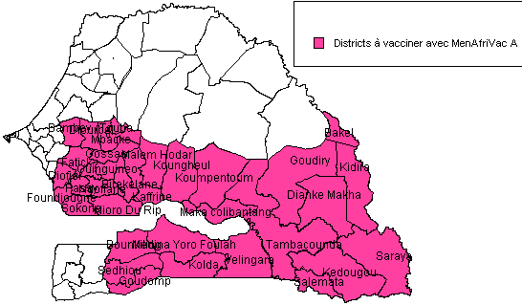
Figure4.1: Districts at high risk of cerebrospinal meningitis, selected for Senegal’s 2012 MenAfriVac A campaign.
The most recent major epidemic was in 1999, with 6,870 incident cases and 635 deaths, which translates into a mortality rate of 9%. Suspected case declarations from 1999-2010 is shown in figures 1 and 2 below.

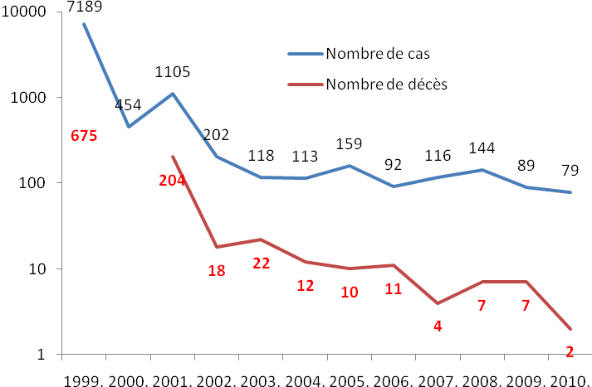
Figure 4.2: Change in the number of suspected cases of cerebrospinal meningitis and associated deaths in Senegal, 2002-2010.

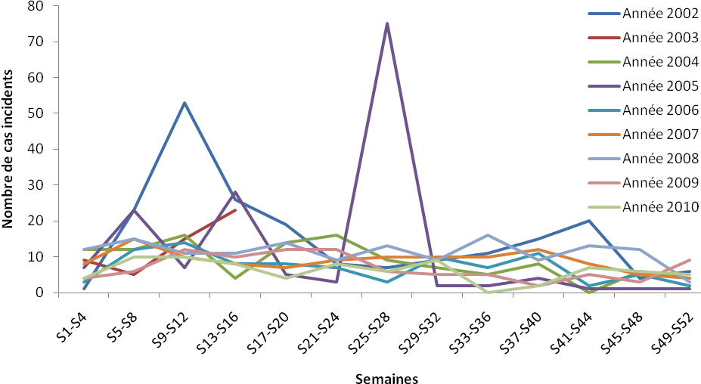
Figure 4.3: Change in the number of suspected cases of cerebrospinal meningitis and associated deaths in Senegal, 2002-2010.
In 2002, there was a spike in suspected cases between weeks 9 and 12. Fifty-three cases were declared, including 24 in Saint Louis.
Hospital-based surveillance (ref Am. J. Trop. Med. Hyg., 83(6), 2010, pp. 1330-1335) of bacterial meningitis was conducted in Senegal on children under 5 years old. This occurred after the Haemophilus influenzae B (Hib) vaccine was introduced into the routine EPI in July, 2005. From 2006-2008, exactly 1,711 samples were analyzed. 214 were positive; this made it possible to isolate Streptococcus pneumoniae in 50% of cases, Hib in 20% and Neisseria meningitidis in 6%.
Note that after an analysis of epidemic risk, preventive vaccination campaigns with the AC vaccine are regularly conducted; the most recent were completed in 2008 and 2010. This might partially explain the lull in cases that has been observed since 1999.

This mass vaccination campaign is warranted in Senegal, because it is located in the African “meningitis belt.”

Eight regions (Diourbel, Fatick, Kaolack, Kaffrine, Tambacounda, Kédougou, Kolda and Sédhiou) are affected by the various epidemic flare-ups. They are considered as being high-risk. In Senegal, experience shows that major epidemics occur every 8-12 years, with the most recent occurring in 1999 (6,870 incident cases and 635 deaths). The probability of an epidemic occurring between 2008 and 2012 is therefore high. Vaccination with the non-conjugate A+C vaccine with a theoretical coverage of three years, six regions out of eight are at risk as of the end of 2011, meaning an estimated population of 5.,77,050. In the two remaining regions, there is an elevated risk in 2012 because of the low vaccination coverage in the most recent campaign and the unaffected districts, which are at particularly high risk.
In addition, Senegal participated in the MenAfriVac clinical trial in Niakhar (Fatick Region).
In June, 2010, it was preselected by the WHO; this procedure guarantees that the vaccines meet international standards for quality, safety and effectiveness.
Finally, the potential of having a conjugate vaccine with a 10 year protection period, that provides herd immunity, that can be used on pregnant women and that is affordable (US $0.4 per dose) is an opportunity not to be missed in the fight against meningococcus A epidemics.

The overall goal is to protect the inhabitants of eight regions in Senegal against meningitis A.
The specific objectives are:
- Administering the conjugate meningitis A vaccine to 95% of subjects between 1 and 29 years of age in the regions of Diourbel, Kaolack, Fatick, Kaffrine, Tambacounda, Kédougou, Kolda and Sédhiou before December 31, 2012;
- Destroying 100% of waste produced by the meningitis A preventive vaccination campaign in the regions of Diourbel, Kaolack, Fatick, Kaffrine, Tambacounda, Kédougou, Kolda and Sédhiou, no more than 30 days after the campaign.
- Giving notice of 100% of PVAEs observed during the meningitis A preventive vaccination campaign in the regions of Diourbel, Kaolack, Fatick, Kaffrine, Tambacounda, Kédougou, Kolda and Sédhiou, no more than 60 days after the campaign.
- Implementing a cas—by-case meningitis surveillance system in the regions of Diourbel, Kaolack, Fatick, Kaffrine, Tambacounda, Kédougou, Kolda and Sédhiou beginning in January 2012, and investigating at least 80% of suspected meningitis cases in the laboratory.

Briefly describe (1) the vaccine waste management plan, and (2) the cold chain capacity and indicate whether it is sufficient to store the new vaccines. Please indicate whether the acquisition of vaccines for this campaign will have consequences on the delivery and storage capacity for traditional vaccines and indicate how this situation will be managed.

In the context of waste management, all injections will be given with auto-lock syringes. All service locations will have technical sheets on injection safety available. Safe usage procedures will be followed: one auto-lock syringe per person, one dilution syringe per vial of antigen, no pre-filling or re-capping of syringes, etc.
The used syringe-needle set will be immediately placed into a sharps box. Fill procedures for the sharps boxes will be strictly followed: once the box is 3/4 full, it must be closed, taped shut, labeled and kept in a secure location. All districts will write or update a waste management plan describing the collection, transportation, security and disposal of sharps boxes.
All of the country’s 75 districts must have an incinerator as specified in the cMYP. In the 35 districts involved in the campaign, incinerators must be built in order to avoid having to transport waste (sharps boxes) to an incineration location (industrial locations such as oil plants, cement plants, hospitals, neighboring districts, etc.).

Vaccine storage capacities have been evaluated.
In 2009, a national cold chain inventory describing the type of equipment used and its condition was completed, and an improvement program was put in place. In order to ensure that the cold chain has sufficient operational capacity, the multi-year plan for 2012-2016 assessed the impact that the introduction of the pneumococcus, Rota virus and meningococcus A vaccines would have on the cold chain at all levels and over a 5 year period. This included a supply frequency of twice per year at the national level, and the target population growth rate.
For meningogoccus A, there will be one supply delivery for a campaign in the last quarter of 2012.

At the central level, three positive cold rooms with a net total capacity of 31, 250 liters and a 6,250 negative cold room are available. All of the cold rooms are equipped with two condensers as required. There is a 107 KVA electricity generator to compensate for power cuts.
As part of the improvement plan, installation of three cold rooms with a net capacity of 12,500 liters each is planned.
The positive cold chain needs will therefore be covered for the MenAfriVac campaign without changing the supply frequency at the central level, as shown below.

Table 4.2: Vaccine storage capacity at the central level, 2012

 | Required capacity (liters) | Available capacity  (liters) | Additional capacity (liters)
Routine 2012 (+ Pneumo) | 35 924 | 31 250 | 4 674
Routine 2012 (+ Pneumo) + Meningococcus A | 35 924 +17 422=  53 346 | 31 250 | 4 674 + 17 422 =  22 096

Regional, district and vaccination unit level

- At the regional level, installation of 17 TCW3000s in 2011 made it possible to meet needs.

- At the district level, needs are largely covered in terms of the supply frequency during the campaign and the acquisitions that are planned for 2011.

- At the vaccination unit level, after the installation of 350 RCW50 refrigerators in 2001, thanks to support from partners (LUXDEV, UNICEF, GAVI), there is sufficient storage capacity until 2016.
The Senegal government is obviously committed to the fight against poverty and to meeting the MDGs. In the Political, Economic and Social Document for 2011-2015, health is strongly emphasized and the NHDP considers vaccination as one of the most effective strategies for fighting disease and especially for reducing mortality in children under 5.
In the context of fighting meningitis, Senegal regularly purchases vaccines against meningococcus A and C in order to conduct preventive vaccination campaigns.
Senegal is accustomed to conducting mass vaccination campaigns and to introducing new vaccines. The Pentavalent was introduced in 2004, with a decrease in HIB meningitis occurrence from 21.5 to 1.4 per 100,000.

Table 4.3: Capacity and Cost (for Positive Storage)
 |  | Formula | Year 1 | Year 2 | Year 3 | Year 4 | Year 5 | Year 6 | Year 7 | Year 8
 |  | Formula | 2012 | 2013 | 2014 | 2015 | 2016
A | Yearly positive volume needs, including the new vaccine (liters) | Product of total vaccine doses times unit packed volume of the vaccine | 53 346 | 48 817 | 50 135 | 51 489 | 52 879
B | Yearly positive capacity, including the new vaccine  (liters) | # | 31 250 | 31 250 | 31 250 | 31 250 | 31 250
C | Estimate of minimum number of annual shipments required for actual cold chain capacity | A / B | 2 | 2 | 2 | 2 | 2
D | Number of consignments/shipments per year | Based on national vaccine shipment plan | 2 | 2 | 2 | 2 | 2
E | Difference (where applicable) | ((A / D) - B) | - 4577 | - 6841 | - 6182 | - 5505 | - 4811
O | Cost $ |  | 77 776

Please briefly describe how your country plans to move towards attaining financial sustainability for the new vaccines you intend to introduce, how the country will meet the co-financing payments, and any other issues regarding financial sustainability you have considered (refer to the cMYP):
The composition of the financial differences reveals a financing gap of some 1,4 million FCFA, not including shared costs and taking probable financing into account. Vaccines will be covered principally by GAVI and by the state. However, costs related to purchasing logistical items (cold chain and vehicles) which are often covered by the government and even more so by partners, result in the largest funding gap. In this case, it is on the order of $1.09 million. In order to close this gap, the government must increase the budget envelope for logistics (vehicles and cold chain) or convince other partners to invest more heavily in that area.
For recurring costs, the gap is approximately $389,336, for a yearly average of $77.8 thousand. This small gap is related to the fact that these activities are most often funded by partners such as the WHO and UNICEF.
For the actual vaccination campaigns, the gap is $28.5 million for the total plan period. This gap almost disappears ($42,021) if we take probable financing into account. The strategy which must be employed to buffer this deficit is to defend the program to probable financiers such as Japan and Luxembourg.
On the whole, the EPI is financially viable. Future resource needs vary from 7.4% to 9.5% of total health spending. The financial gap is less than 0.4% of total health spending except for 2012, for which the gap is estimated at 0.6%. Per capita health spending is $54.72 on average during the plan. Per capita resource needs for the EPI will be US $2.70 and do not amount to even 0.18% of national resources (gross domestic product).
We have identified the following strategies to improve the program’s viability:
- real increases of the budget line item for "vaccines and consumables" beginning in 2012; freeing these funds up in a timely manner.
- Use of a part of the budget designed for BCI-state for vaccines
- Making available to the EPI additional resources that come from the increase of the health budget, which will be increased to 15% of the operating budget of the state, in conformity with the recommendations of the summit of heads of state of the ECOWAS in 2001 (currently 8%)
- Using resources from the highly indebted poor countries fund (resources related to debt relief) by completing the Political, Economic and Social Document;
- Targeting of the EPI as part of budgetary support
- Appealing for financial participation of the local collectivities in the financing of the program under the transfer of authority involved in decentralisation. Local municipalities’ budgets include an 8% budget allocation for health; their current contributions rarely top 4%;
- Involvement of the private sector in financing of the EPI;
- Seeking alternative sources of financing rom GAVI

Note: This proposed budget includes US $1,292,777 to improve the cold chain. The difference (US $238,749 is currently being acquired from the government budget. The second 80m3 (gross) cold room has already been ordered, so it is not taken into account in the table above or in the campaign's budget.

MenAfriVac studies are ongoing, and an indication for use in children under one year of age is expected to be issued in January, 2014. Briefly describe when your country plans to introduce the conjugate Meningococcus A vaccine into the systematic vaccination schedule, how your country plans to fulfil its co-financing options for systematically introducing the Meningococcus A vaccine and other issues related to the systematic introduction that you are considering. (Refer to the cMYP)

Table 4.4: Evaluation of the Meningococcus Disease Burden:

Disease | Title of the assessment | Date | Outcomes
Meningitis | Annual meningitis surveillance report | 2011-sem16 | Suspected cases: 19  Deaths: 2  Mortality: 0,1%
Meningitis | Annual meningitis surveillance report | 2010 | Suspected cases: 79  Deaths: 2  Mortality: 0,6 %
Meningitis | Annual meningitis surveillance report | 2009 | Suspected cases: 89  Deaths: 7  Mortality: 0,7 %

If new or under-used vaccines have already been introduced in your country or if you have already conducted vaccination campaigns, please give details of the lessons learned from the experience related to storage capacity, protection from accidental freezing, staff training, cold chain logistics, drop out rate, wastage rate, etc. and suggest improvements on these points:

Table 4.5: Lessons learned from previous vaccination campaigns

Lessons Learned | Measures taken
Change in storage capacities | Advance inventory completed to identify and remedy gaps
Risk of vaccine freezing | A directive was written, forbidding the freezing of all types of vaccines on the intermediate and remote levels
Personnel capacity building | Preparation of guides and technical assistance, trickle-down training on all aspects (vaccine handling, PVAE monitoring, etc.) and supervision
PVAE investigations | Implementation of an expert panel for accountability
Handling of operational costs | Financial contribution of the central covernment for measles and yellow fever vaccination campaigns

5. Procurement and Management of New and Under-Used Vaccines

a) Please show how the support will be implemented and managed, including the purchase of vaccines (GAVI expects that the countries will buy their vaccines and injection supplies through UNICEF):

Note: The pneumococcus vaccine (PCV) absolutely must be purchased through UNICEF
- a) Please show how the support will operate and be managed including procurement of vaccines (GAVI expects that most countries will procure vaccine and injection supplies through UNICEF):
Vaccines have always been purchased through UNICEF in the context of an agreement with Senegal.
- b) If an alternative mechanism for procurement and delivery of supply (financed by the country or the GAVI Alliance) is requested, please document:
- Other vaccines or immunisation commodities procured by the country and description of the mechanisms used.
- The functions of the National Regulatory Authority (as evaluated by WHO) to show they comply with WHO requirements for procurement of vaccines and supply of assured quality.
Not applicable
- c) Please describe the introduction of the vaccines (refer to cMYP)
The campaign will last 10 days. It will consist of one phase and will target people from 1-29 years of age in 8 high-risk regions (35 districts).
Vaccination will be conducted using permanent, advanced and mobile strategies.
- d) Please indicate how funds should be transferred by the GAVI Alliance (if applicable)
Funds will be wired into the Department of Prevention’s account (Ministry of Health and Prevention).
- e) Please indicate how the co-financing amounts will be paid (and who is responsible for this)
The central government will wire the money into the bank accounts of the medical regions in question; this will constitute its portion of the financing in order to handle additional operational costs on top of GAVI’s support.
- f) Please outline how coverage of the new vaccine will be monitored and reported (refer to cMYP)
Coverage will be monitored via vaccination activity reports and by the vaccination coverage study at the end of the campaign.

b) Please indicate when you intend to plan the conduct of the campaign (month and date) and how the campaign will be deployed, e.g. different phases or one single time)

Vaccination will be conducted using permanent, advanced and mobile strategies.
The vaccination teams will consist of 4 people: 2 qualified health agents with experience in the EPI; they will reconstitute and administer the antigen using an intramuscular injection into the left deltoid. They will be assisted by 2 volunteers.
Each team will be responsible for vaccinating an average of 250 people per day.
The campaign will last 10 days.

f) Please describe how the new vaccine's coverage will be monitored and declared (refer to the cMYP and the Meningitis A vaccine introduction plan)

- Administrative tracking (estimate of daily coverage)
- Daily monitoring (during the campaign) by supervisors in areas that use advanced and mobile strategies
- Evaluation of vaccination coverage using WHO methodology in the 35 districts in question.

6. Grants for the Operational Cost for Vaccination Campaigns

Table 6.1: calculation of lump-sum

Year of New Vaccine introduction | Goals: 1-29 years of age  (See Table 4) 1) | Amount per person in US $ | Total in US$
2012 | 3 948 878 | 0,30 | 1 184 663,40

In the following tables, please indicate how this amount will be used for financing the vaccination campaign introduction cost and also other essential activities. GAVI support will not be sufficient to cover all the needs, consequently please indicate in the following table how the remaining needs will be met and by whom (refer to the cMYP and/or to the Meningitis A conjugate vaccine introduction plan).

Table 6.2: Campaign Cost (and Financing; US$)

No. | Headings | Total needs |  | GAVI Support |  | Other source:
No. | Headings | F CFA | $ US | F CFA | $ US | F CFA | $ US
 | Manual preparation session | 887 500 | 1 905,69 | 887 500 | 1 905,69 |  | 0
 | Manual approval session | 335 000 | 719,33 | 335 000 | 719,33 |  | 0
 | District micro-planning session | 5 747 000 | 12 340,30 | 5 747 000 | 12 340,30 |  | 0
 | Regional micro-planning session | 17 697 869 | 38 001,91 | 17 697 869 | 38 001,91 |  | 0
 | National microplan approval session | 460 000 | 987,74 | 460 000 | 987,74 |  | 0
 | Training of ECRs and ECDs | 5 685 940 | 12 209,19 | 5 685 940 | 12 209,19 |  | 0
 | Training of national supervisors | 197 000 | 423,01 | 197 000 | 423,01 |  | 0
 | Training vaccinators, volunteers and supervisors at the district level | 28 771 000 | 61 778,79 | 28 771 000 | 61 778,79 |  | 0
 | Copying vaccination cards and management tools | 72 194 905 | 155 021,16 | 72 194 905 | 155 021,16 |  | 0
 | Implementation of resources | 5 762 680 | 12 373,97 | 5 762 680 | 12 373,97 |  | 0
 | Managing vaccinators, volunteers and supervisors during implementation | 312 260 400 | 670 503,96 | 312 260 400 | 670 503,96 |  | 0
 | Evaluation of districts | 5 222 000 | 11 212,99 | 5 222 000 | 11 212,99 |  | 0
 | Evaluation of regions | 2 508 200 | 5 385,76 | 2 508 200 | 5 385,76 |  | 0
 | Evaluation of national level | 3 691 160 | 7 925,88 | 3 691 160 | 7 925,88 |  | 0
 | Waste management | 10 040 000 | 21 558,48 | 10 040 000 | 21 558,48 |  | 0
 | Building incinerators | 175 011 480 | 375 794,98 |  | 0,00 | 175 011 480 | 375794,98
 | Social mobilization and awareness-raising | 29 900 000 | 64 203,04 |  | 0,00 | 29 900 000 | 64203,0448
 | Handling PVAEs | 800 000 | 1 717,81 | 800 000 | 1 717,81 |  | 0
 | Handling fuel and ongoing presence at the national level | 4 098 380 | 8 800,28 | 4 098 380 | 8 800,28 |  | 0
 | Supplying regions and districts with fuel | 21 160 000 | 45 436,00 | 21 160 000 | 45 436,00 |  | 0
 | Supplying districts and hospitals with lumbar puncture needles | 500 000 | 1 073,63 |  | 0,00 | 500 000 | 1073,62951
 | 5 training sessions for laboratory technicians | 35 000 000 | 75 154,07 |  | 0,00 | 35 000 000 | 75154,0658
 | Supplying districts and hospitals with laboratory materials | 148 000 000 | 317 794,34 |  | 0,00 | 148 000 000 | 317794,336
 | Supporting district and hospital laboratories with reagents | 53 850 000 | 115 629,90 | 53 850 000 | 115 629,90 |  | 0
 | Total | 939 780 514 | 2 017 952,19 | 551 369 034 | 1 183 932,13 | 388 411 480 | 834020,055

  - Please complete the banking form (annex 1) if necessary

Please briefly describe who will finance the operational costs not financed by GAVI. If the government is the source of financing, please confirm that this is in fact entered in the health budget. If you are looking for other sources of financing, please indicate and confirm their commitments.

Operational costs will be handled using central government funds allocated for health, but also by partners such as UNICEF.

Table no. 6.3 : Operational cost status for the campaign; funds needed

Target | Total operational cost | GAVI | Country’s expected contribution | Stated contribution | Funds needed
3 948 878 | 2 017 952,19 | 1 183 932,13 | 834 020,06 | 515 152,09 | 318 867,97

7. Additional comments and recommendations from the National Coordinating Body (ICC/HSCC)
- Integrate maintenance issues into operational procedures
- Take into account expenses that will result from epidemiologic surveillance activities, in particular by laboratories
- Continue human resources management efforts for proper implementation.
- Review the memo between GAVI and Senegal in the context of strengthening the health system in order to ease the procedures for getting resources to beneficiaries
- Taking the cMYP into account when preparing the COMPACT (in collaboration with the CAS/PNDS) and continue advocacy with partners that are interested in vaccination in order to close financing gaps (for example the local HHA group)

Table no. 7.1 : documentation references
Documents required for each type of support | DOCUMENT NUMBER | Duration *
Complete Multiyear Plan (CMYP) | 01 | 2012-2016
MenAfriVac introduction plan | 02 | 2012
Endorsed minutes of the National Coordinating Body meeting where the GAVI proposal was reviewed and approved | 03 | 11 May 2011
Minutes of the three most recent ICC/HSCC meetings | 03, 04, 05 | Oct 14 2010,  Oct 28 2010,  November 19 2010
ICC/HSCC workplan for the next 12 months | Not available
The calculation sheet required for the vaccine | 06 | 2010-2016

* Please indicate the duration of the plan / assessment / document where appropriate
Annex 1 - Banking Form

Annex 2: GAVI Alliance general terms

FINANCING USED SOLELY FOR APPROVED PROGRAMMES
The candidate country ("Country") confirms that any financing granted by the GAVI Alliance in conjunction with this application will be used and allocated solely for the purpose of conducting the program(s) described in this application. Any significant change to the approved program(s) must be examined and approved by the GAVI Alliance in advance. Any financing decision on this proposal is made at the discretion of the GAVI Alliance council and depends on the IEC process and funds availability.

AMENDMENT OF THIS PROPOSAL
The Country shall inform the GAVI Alliance through its Annual Status Report of its desire to propose a modification of any kind to the description of the program(s) in this proposal. The Country shall produce documents supporting any modification approved by the GAVI Alliance and this proposal will be amended as a consequence.

RESTITUTION OF THE FUNDS
The Country agrees to return to the GAVI Alliance any financing amount which is not used on behalf of the program(s) described in this proposal. Unless the GAVI Alliance decides otherwise, reimbursement must be made by the Country in US dollars within sixty (60) days following receipt by the Country of the request from the GAVI Alliance and will be deposited in the account(s) indicated by the GAVI Alliance.

SUSPENSION/TERMINATION
GAVI Alliance may suspend all or part of its financing to a Country if it has reason to suspect that the funds have been used for any purpose other than for the programs described in this proposal or an amendment to this proposal approved by GAVI Alliance. GAVI Alliance reserves the right to terminate its support to the Country for the programs described in this proposal if GAVI Alliance receives confirmation of abusive use of the funds granted by GAVI Alliance.

ANTICORRUPTION
The Country confirms that the funds provided by the GAVI Alliance will not be offered to a third party by the Country and the country will not seek on the basis this proposal a gift, payment or other direct or indirect advantage which could be interpreted as an illegal practice or an act of corruption.

AUDITS AND RECORDS
The Country will conduct a financial audit annually and share the results with the GAVI Alliance on the first request. The GAVI Alliance reserves the right for itself or through an agent to conduct audits or any other form of evaluation of the financial management in order to assure itself of the financial accountability for the funds deposited on behalf of the Country.

The Country shall retain precise accounting records which documents the manner in which the GAVI Alliance funds were used. The Country will keep up to date accounting records in accordance with its government-approved accounting standards for at least three years after the date of last disbursement of GAVI Alliance funds. In case of recourse for abusive use of the funds, the Country will retain these records until the final conclusion of the audit. The Country agrees not to raise privilege with the GAVI Alliance over the documents in conjunction with any audit.

CONFIRMATION OF LEGAL VALIDITY
The Country and the signatories for the government confirm that this proposal is accurate and correct and constitutes an irrevocable legal obligation on the Country, under the terms of the Country's laws, to conduct the programs described in this proposal.

CONFIRMATION OF COMPLIANCE WITH THE GAVI ALLIANCE ACCOUNTING TRANSPARENCY AND RESPONSIBILITY POLICY
The Country confirms that it is been informed of the GAVI Alliance accounting transparency and responsibility (ATR) policy and will comply with its requirements.

ARBITRATION
Any dispute between the Country and the GAVI I Alliance which arises from this proposal or refers to this proposal and cannot be amicably resolved in a reasonable interval will upon the request of either the GAVI Alliance or the country be subject to arbitration. The arbitration will be conducted according to the UNCITRAL Arbitration Rules in force at that time. The parties agree that they shall be bound by the arbitration sentence as a definitive settlement of the dispute. The forum shall be Geneva, Switzerland. The language of the arbitration shall be English.

For any dispute involving a contested amount which is less than or equal to US$100,000, the single arbitrator shall be designated by the GAVI Alliance. For any dispute whose contested amount is over US$100,000, three arbitrators shall be designated as follows: The GAVI Alliance and the Country shall each designate one arbitrator and these two arbitrators shall by mutual agreement designate a third arbitrator who will preside over the panel.

The GAVI I Alliance shall not be responsible to the Country for any recourse or loss relative to the programs described in this proposal, including (list not exhaustive) financial losses, appeal on suspicion, property damage, physical lesions to people or death. The Country is solely responsible for all aspects of managing and implementing the programs described in this proposal.

Inter-agency coordinating committee or health sector coordinating committee, depending on the situation
Support will be calculated based on $US 0.30 per annual birth, with a minimum amount of US $100,000

