

For:

Global Alliance on Vaccine and Immunisation Health System Strengthening (GAVI HSS) Support

Submitted by The Republic of The Gambia, September 2008

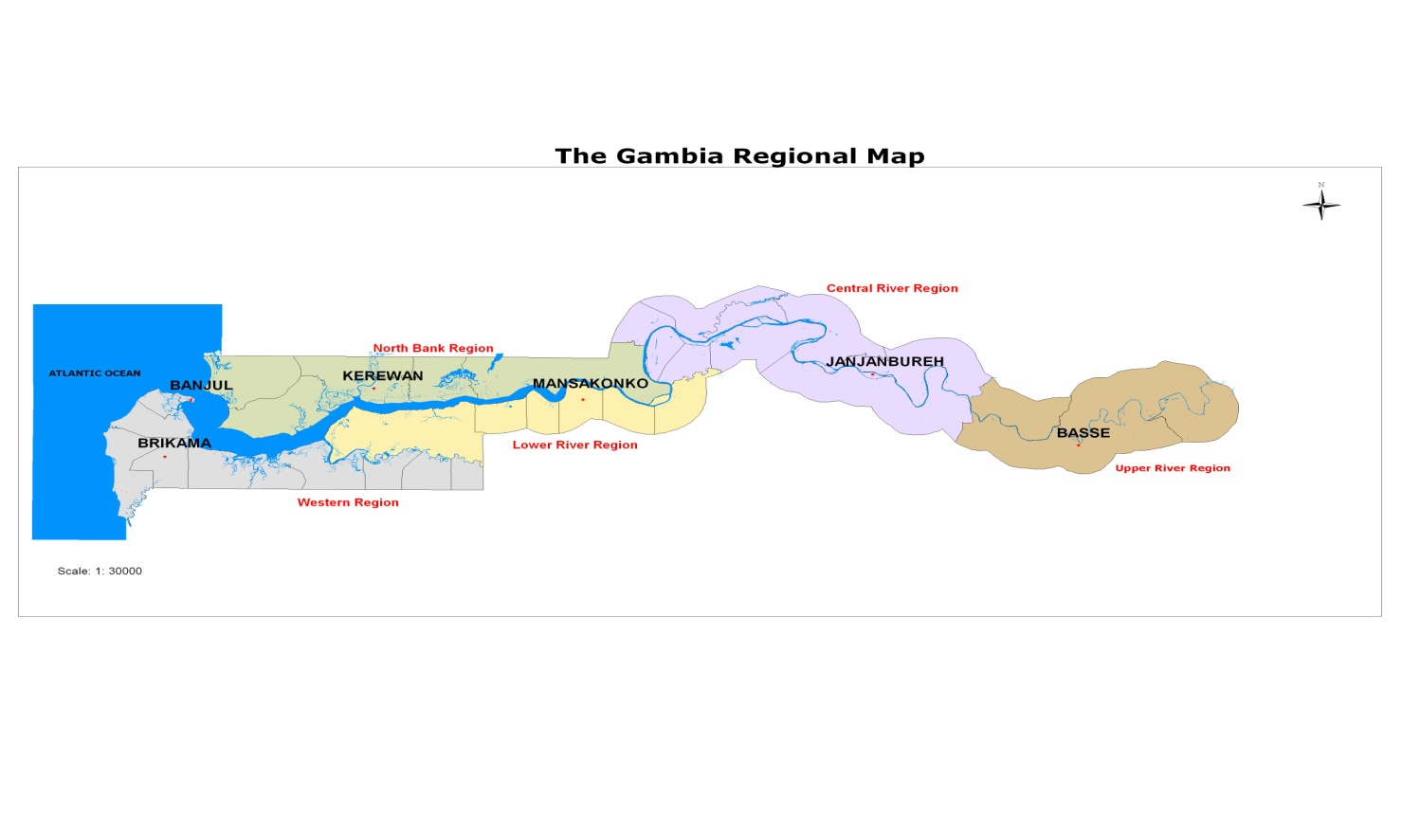

Table of Contents
Page
Abbreviations and Acronyms 3
Executive Summary 6
Section 1: Application Development Process 9
Section 2: Country Background Information 13
Section 3: Situation Analysis / Needs Assessment 20
Section 4: Goals and Objectives of GAVI HSS Support 24
Section 5: GAVI HSS Activities and Implementation Schedule 25
Section 6: Monitoring, Evaluation and Operational Research 32
Section 7: Implementation Arrangements 38
Section 8: Costs and Funding for GAVI HSS 43
Section 9: Endorsement of the Application 48
ANNEX 1 Documents submitted in Support of the GAVI HSS Application 48
ANNEX 2 : Banking Form 48
ANNEX 3: Additional Information to Clarify the Issues Raised by IRC …………………..62-66

List of Tables
Table 1.1 Brief timeline of activities that led to the proposal resubmission. 12
Table 1.2: Roles and responsibilities of key partners (NCG members and others) 13
Table 3.1 Recent Health System Assessments 21
Table 7.6: Technical assistance requirements 43
Table 8.1: Cost of implementing GAVI HSS activities 44
Table 8.2: Calculation of GAVI HSS country allocation 47
Table 8.3: Sources of all expected funding for health systems strengthening activities 48

Abbreviations and Acronyms

ADB African Development Bank
ANC Ante Natal Care
APR Annual Progress Report
ART Anti Retroviral Treatment
BAFROW The Foundation for Research on Women’s Health, Production and the Environment
BCG Bacille Calmette Guerin
BI Bamako Initiative
BP Blood Pressure
CAC Catchment Area Committees
CBO Community Based Organizations
CCF Christian Children Fund
CHN Community Health Nurse
cMYP Comprehensive Multi Year Plan
CBR Crude Birth Rate
CRD Crude Death Rate
CPR Contraceptive Prevalence Rate
DOSA Department of State for Agriculture
DOCIT Department of State for Communications and Information Technology
DOSE Department of State for Education
DOSFEA Department of State for Finance and Economic Affairs
DOSH Department of State for Health & Social Welfare
DOTS Directly Observed Treatment Short course
DPI Directorate of Planning and Information of DOSH
DPT Diphtheria, Pertussis and Tetanus
DRF Drug Revolving Fund
EMCH Emergency Maternal and Child Health
EPI Expanded Programme on Immunization
GAVI Global Alliance on Vaccines and Immunization
GBOs Gambia Bureau of Statistics
GFPA Gambia Family Planning Association
GFATM Global Fund for AIDS, Tuberculosis and Malaria
GLF Gambia Local Funds
GNC Gambia National Census
GNI Gross National Income
GoTG Government of The Gambia
GPPA Gambia Public Procurement Authority
HARRP HIV/AIDS Rapid Response Project
Hb Haemoglobin
HMIS Health Management Information System
HMN Health Metrics Network
HMP Health Master Plan
HRH Human Resources for Health
HSCC Health Strategy Coordination Committee
HSS Health System Strengthening
ICC Inter-Agency Coordinating Committee (for EPI)
IDB Islamic Development Bank
IEC Information, Education and Communication
IFMIS Integrated Financial Management Information System
IMR Infant Mortality Rate
IMF International Monetary Fund
IPT Intermittent Preventive Treatment
IRC International Review Committee
ITN Insecticide Treated Net
KNCV Netherlands Tuberculosis Foundation
LLIN Long-lasting Insecticidal Net
LRR Lower River Region
MDG Millennium Development Goals
M&E Monitoring and Evaluation
MHCP Minimum Health Care Package
MICS Multiple Indicator Cluster Survey
MMR Maternal Mortality Rate
MOU Memorandum of Understanding
MR Mortality Rate
MRC Medical Research Council
NaNA National Nutrition Agency
NCG National Consultative Group
NHA National Health Accounts
NHDCC National Health Development Coordination Committee
NHP National Health Policy
NHS National Health Services
NGO Non Governmental Organisation
NLR Netherlands Leprosy Relief
NPC National Planning Commission
PHC Primary Health Care
PLWHA People Living with HIV/AIDS
PMU Project Management Unit of DOSH
PPTCT Prevention of Parent to Child Transmission
PRSP Poverty Reduction Strategy Paper
PS Permanent Secretary
RCH Reproductive and Child Health
RED Reach Every District
RFH Riders for Health
RHT Regional Health Team
RVTH Royal Victoria Teaching Hospital
SMC Senior Management Committee (of DOSH)
SPSS Statistical Package for Social Sciences
SWAp Sector Wide Approach
TANGO The Association of Non Governmental Organisations (in The Gambia)
TB Tuberculosis
TBA Traditional Birth Attendant
TFR Total Fertility Rate
TORs Terms of References
TOT Training of Trainers
UN United Nations
UNDP United Nations Development Program
UNFPA United Nations Population Fund
UNICEF United Nations Children’s Fund
URR Upper River Region
VCT Voluntary Counselling and Testing
VDC Village Development Committee
VHS Village Health Service
VHW Village Health Worker
WEC World-Wide Evangelical Crusade
WHO World Health Organization
WB The World Bank
WR Western Region

Executive Summary

Background

The Gambia has a total population of 1.5 million (2007) with the Crude Birth (CBR) and Crude Death (CDR) Rates estimated at 46.2 and 19.2 per 1000 population respectively. Infant Mortality Rate (IMR) and Under-5 Mortality Rate (>5 MR) are reported as 93 and 131 per 1000 live births respectively (MICS 2005/6), while the Maternal Mortality Rate (MMR) has shown a significant decline to 556/100,000 live births for 2007 from 730/100,000 in 2001. The country is listed among the poorest countries in the world, with a per capita Gross National Income of US$320 in 2007 (World Bank Indicators Database, July, 2008). 61.2% of the population live below the poverty line with a marked variation between urban and rural populations.

The current levels of the core MDG indicators such as poverty, maternal, infant, and under-5 mortality rates are taken by Government as being unacceptably high. Therefore, these require accelerated action that would lead to the timely achievement of The Gambia’s Millennium Development Goals (MDGs) related targets as reflected explicitly in key policy/strategy documents, notably, the National Health Policy, 2007-2020 (NHP), the Health Master Plan, 2007-2020 (HMP) and the Gambia Poverty Reduction Strategy Paper, 2007-2011(PRSP II).

Various reviews undertaken to assess the performance of the health sector have shown that despite the progress realised over the period, achieving the sector goal is still beset by a number of sector-wide challenges.

Among the barriers identified in these assessments are:

- Inadequately delivered outreach services due to poor physical infrastructure and equipment at Primary Care level.
- Weak Health Management Information System (HMIS) (poor data management at all levels: central, regional and health facility)
- Weak monitoring and supervision at central and regional levels.
- High attrition of health care workers.
- Limited staff motivation.
- Inadequate number of reliable transport for service delivery.
- Lack of vaccine stores in two of the regions.
- Inadequate number of functional cold chain equipment at health facility level.
- High level of uncoordinated off-site in-service training leading to staff being away from work, affecting health system performance.
- Inadequate operational funds at central and regional levels.
- Slow access to funds at central and regional levels.

The Government of The Gambia is fully committed to improving the health and welfare of the entire population and has formulated policies and strategies for achieving this national goal. Increasing access to the national minimum health care package through improved access to quality preventive, promotive and curative health services (particularly for pregnant women, lactating mothers and young children) are core components of both the PRSP II and the Health Master Plan. The Reproductive and Child Health (RCH) services are provided through the primary and secondary levels (RCH clinics at the major and minor health centres and their outreach/trekking stations). These remain the main providers of heath services for the majority of the population.

Goals and Objectives of the GAVI HSS proposal

The goal of the GAVI HSS application is to contribute towards strengthening the capacity of the health system to deliver and sustain essential health care services with a view to attaining the health related MDGs. The goal will be realised through the implementation of activities for achieving the following objectives:

Objectives of GAVI HSS Support

- To increase the number of outreach posts with adequate facilities (national standards) from 89 to 179 (35% to 70%) by 2011.

- To ensure timely, accurate and complete quarterly HMIS reports from all six regions by
2011
- To strengthen monitoring and support supervision through the provision of logistics at central level and in three of the six regions.

NB

By national standards, an outreach post is said to have adequate facilities when it has the following materials/equipment in place:

Five (5) tables | One (1) sphygmomanometer | One (1) thermometer
Ten (10) benches | One (1) stethoscope | One (1) vaccine carrier
One (1) couch | One (1) standing scale | One (1) bathroom scale
Ten (10) chairs | One (1) salter scale | One (1) Hb meter and its accessories
One (1) cupboard | One (1) tape measure | Two (2) Pinnard stethoscope

The main activities to be implemented at the primary care level include, refurbishment of RCH outreach posts, training of health personnel at the regional level on data management, production of data collection tools, development of reporting guidelines, procurement of equipment for the periphery and transport and logistics for improved support supervision.

The expected outcome from these activities is improved access to and utilisation of quality reproductive and child health services that would contribute to improved levels of maternal and child survival in The Gambia.

The identified indicators for monitoring the impact of implementing the proposed GAVI HSS activities, within the implementation of the overall national strategic plan, include:

- National DPT3 coverage(0-11months) - baseline 82.4% (2005/6, MICSIII); target 90% (2011 )
- Number of regions achieving ≥ 80% DPT3 Coverage (0-11months) - Baseline: 2 regions, (EPI Routine data 2006), target 6 regions (2011)
- Under-5 mortality rate of 131/1000 (2005/6 MICSIII), target 125/1000 (2011).
- Number of regions with BCG to Measles drop out rate of 10% or less (baseline 3, EPI Routine data 2005); target 6 (2011)
- Proportion of one year old children protected against neonatal tetanus through immunisation of their mothers (baseline 75.6%, 2005/6, MICSIII); target 80% (2011)
- Proportion of births attended by skilled health personnel (Assistance during delivery) - (baseline 56.8%, 2005/6, MICSIII); target 60% (2011).

This proposal seeks GAVI funding to address some of the critical barriers that are not currently being adequately addressed. The GAVI HSS duration is scheduled for 2 years (2010 to 2011) with a sum of $738, 036.71 requested from GAVI. This will complement funds from other sources including national counterpart contributions aimed at overall health systems strengthening.

Proposal Development Process
The process of proposal development started from discussion at the Inter-Agency Coordinating Committee (ICC) for Expanded Programme on Immunization (EPI) which led to the formation of the National Consultative Group (NCG) in 2007, which was endorsed by the Senior Management Committee and charged with the responsibility of co-ordinating the proposal formulation process.

The NCG is comprised of senior managers of DOSH, key Health Development Partners, members of civil society, including the umbrella Non Governmental Organization (NGO) coordination body called The Association of Non-Governmental Organizations (TANGO), Community-Based Organizations (CBOs) and community level structures such as the Catchment Area Committees (CACs) and Village Development Committees (VDCs). The proposal formulation process was spearheaded by the Directorate of Planning and Information (DPI), of the Department of State for Health and Social Welfare (DOSH&SW).

The process of implementation will be coordinated by DPI and will be under the delegated supervision of the NCG.

All activities will be in line with the objectives set out and will be monitored using the outlined outcome and output indicators such as increase in functional RCH outreach stations, number of health personnel trained and the availability of timely HMIS bulletin on a quarterly basis. Quarterly monitoring of implementation will be undertaken as part of normal program management, including the process of approval of quarterly budget releases to the implementing entities. An annual review of progress will also be undertaken. Timely feedback, including annual progress reports will be provided to all key stakeholders including the GAVI Secretariat.

Section 1: Application Development Process

1.1: Name of HSCC equivalent: Senior Management Committee (SMC)

The process of proposal development started from discussion at the ICC which led to the formation of the National Consultative Group in 2007, endorsed by the Senior Management Committee and charged with the responsibility of co-ordinating the proposal formulation process.

The Senior Management Committee (SMC) assumes overall co-ordination of the sector and has a policy to co-opt strategic partners on issues of common interest. In this respect, the Committee met with the regular technical partners of the sector, i.e. WHO, UNICEF and UNFPA in October and November 2007 and initiated the process to integrate the specific plans of action of these agencies within the context of the Health Policy and Health Master Plan.

With the intention of developing a Sector Wide Approach (SWAp) from these programs, in an incremental process, the SMC, exercising government leadership and ownership, co-ordinated the formulation and finalization of the National Health Policy and Master Plan and the health sector strategic document submitted to the Donor Roundtable in London in January 2008. The Committee is currently co-ordinating the development of a draft Four Year Sector Plan with costed programs and resource projections. The draft will be finalised and validated in consultation with the relevant stakeholders. It will be presented to donors in a health sector roundtable to be organized in collaboration with the National Planning Commission (NPC). This roundtable is an important milestone in the SWAp development process. The Senior Management Committee has co-ordinated and reviewed a National Health Accounts study and is to scrutinize a draft Health Financing Policy.

The SMC has met regularly with sessions held on 11th, 12th, 18th, and 30th June 2008, some of which were attended by the Honourable Secretary of State for Health and Social Welfare.

The Senior Management Committee, which is the microcosm of the overall joint co-ordination body, envisaged in the Health Master Plan, has delegated the co-ordination of the development of this proposal and the supervision of its implementation to the National Consultative Group (NCG), like other project, program and theme specific co-ordination mechanisms will be integrated in the envisaged structure (National Health Development Co-ordination Committee or NHDCC) in an effort to rationalize and streamline such structures and mechanisms in the form of technical working groups and issue-specific task-forces of the NHDCC.

1.1.2 Overall Role and Function of the National Consultative Group (NCG)

The terms of reference of the NCG are:

- Coordination and monitoring of health activities in the country
- Review and adopt policies
- Advocate for funding of health sector programmes
- Co-ordination of the development of the HSS proposal and
- Supervision of the proposal implementation with the Senior Management Committee playing an oversight function.

1.1.3 Composition of the NCG

The National Consultative Group members include regular ICC members and representatives of civil society including the umbrella NGO co-ordination body called The Association of Non- Governmental Organisation (TANGO), Community Based Organisation (CBOs) and community level structures such as the Catchment Area Committees (CACs) and Village Development Committees (VDCs).

1.1.4 Frequency of meetings

The NCG met twice during the preparatory stage of the initial proposal for GAVI HSS support. The committee met again on 17th July 2008 to review the response from the GAVI Secretariat/Independent Review Committee to the initial proposal. The committee again met on 26th August 2008 to review the first draft of the resubmission and reconvened on 9th September 2008 to review and approve this resubmission. The final document was circulated to the NCG members before actual resubmission to GAVI.

1.2: Overview of application development process

The National Consultative Group (NCG) coordinated the development process whilst the Senior Management Committee provided oversight for the overall GAVI HSS application process. The process of drafting the application was led by the Directorate of Planning and Information (DPI) of Department of State for Health (DOSH) which also provided the secretariat. Technical Assistance was provided from WHO/IST/WEST, Ouagadougou for the initial proposal. This resubmission was formulated entirely by the national level technical working and review groups under the guidance of the SMC and NCG.

The Technical team played a leading role in GAVI HSS Proposal development by providing the technical input to the various drafts of the document and ensuring compliance with the GAVI HSS Guidelines. A summary of schedule of activities of the proposal development process is shown in the table below:

Table 1.1 Brief timeline of activities that led to the proposal resubmission.
Planned Activities | Date | Responsible Party
Develop TORs for the NCG and Technical Team | January - February 2007 | DPI and EPI
NCG members identified | February 2007 | PS and DPI
Gathering of all relevant documents | January - May 2007 | DPI and EPI
Finalisation of revised National Health Policy and Health Master Plan | May – October 2007 | DPI
Drafting of the proposal development plan of work and budget | March – April 2007 | Technical Team
Review and approval of proposal work plan and budget | May 2007 | NCG
Development of the GAVI HSS proposal at a retreat | November 2007 | Technical Team
Review of the draft proposal by the Technical Team and Consultant | November 2007 | DPI
5 days review meeting of the draft proposal by the Technical Team | December 2007 | Technical Team
2 days validation meeting of the draft proposal by the National Consultative Group | January 2008 | Technical Team
Comments by the National Consultative Group were incorporated | January 2008 | Technical Team
A 5-person Peer Review group convened | February 2008 | NCG
Incorporation of recommendations of the Peer Review group | February 2008 | Technical Team
Final submission to the NCG for endorsement and approval | March 2008 | Technical Team
Submission of the final proposal to GAVI | March 2008 | NCG Chairman
Activities for May –June 2008
NCG meeting to discuss the comments from the IRC and agree on way forward | July 2008 | DPI
Review of draft 1 of re-submission proposal | July –August 2008 | DPI/Technical Team
Revision and validation of the document | September 2008 | NCG
Resubmission to GAVI | September 2008 | NCG Chairman

Table 1.2: Roles and responsibilities of key partners (NCG members and others)
Title / Post | Organisation | NCG member yes/no | Roles and responsibilities of this partner in the GAVI HSS application development
Permanent Secretary | Department of State for Health & Social Welfare (DOSH & SW) | Yes | Chief Accounting Officer of DOSH and Chairperson of NCG
Director | Directorate of Planning and Information, DOSH | Yes | Coordination of the proposal development process and provision of relevant data and information.
Director | Directorate of Health services | Yes | Provided technical and policy support
Programme Manager | EPI | Yes | Provided technical support and EPI data.
Permanent Secretary | Department of State for Finance and Economic Affairs (DOSFEA) | Yes | Provided technical support and advice on financial matters
Country Representative | WHO | Yes | Participated in the Technical development of the GAVI HSS proposal, provided TA for initial proposal and was interim Chairperson of NCG
Country  Representative | UNICEF | Yes | Participated in the Technical development of the GAVI HSS proposal.
Director | Centre for Innovation Against Malaria (CIAM) | No | Drafting and review of documents
Director | Medical Research Council (MRC) | Yes | Participated in the Technical development of the GAVI HSS proposal
Director | Gambia Family Planning Association (NGO) | Yes | Participated in the Technical development of the GAVI HSS proposal.
Director | Lamtoro Clinic (private clinic) | Yes | Participated in the Technical development of the GAVI HSS proposal
Director | United Nation Population Fund | Yes | Participated in the Technical development of the GAVI HSS proposal.
UN Resident Coordinator and UNDP Representative | United Nations Country Team and UN Development Program | Yes | Participated in the Technical development of the GAVI HSS proposal
Head of Regional Health Team | RHT Western | Yes | Participated in proposal development
Representatives of Civil Society | (CACs, TANGO, CBOs and VDCs) | Yes | Participated in the Technical development of the GAVI HSS proposal
Programme Director | Riders For Health (RFH) | Yes | Provided technical support (logistics and supplies)
Representatives | GFPA, Ahmadiyya, SOS, CCF (NGOs) | No | Participated in proposal development
Program Manager | RCH Unit (DOSH) | Yes | Provide technical support in proposal development

1.4: Additional comments on the GAVI HSS application development process
As indicated under sub-section 1.2 above, the drafting of the resubmission was undertaken without external technical assistance. The reformulation of the resubmission was guided by the comments of the GAVI HSS IRC on the original proposal. This resulted in the sharper refocusing of the scope of the new proposal and reduction in the number of activities to be funded from the HSS grant being applied for. More recent data from Multi Indicator Cluster Survey (MICS III) was used in order to overcome the problems of obsolete baseline figures in the earlier proposal document.

The reformulation process benefited substantially from the attendance of the Secretary of State for Health at last two meetings of the NCG during which he provided invaluable policy guidance to the group. The final revision of the resubmission also benefited from additional written comments from both UNICEF and WHO (at country, regional and headquarters levels), as well as from government documents that had just come off the press, e.g. the draft PRSP Progress report for 2007 and the draft Report on Gambia’s progress towards the MDGs.

Section 2: Country Background Information

2.1: Current socio-demographic and economic country information

Geography
The Republic of The Gambia is one of the smallest countries in Africa, covering an area of only 11,000 square kilometres. It is located in the coast of West Africa and is surrounded by the Republic of Senegal on its northern, eastern and southern borders, with its western boundary open to the Atlantic Ocean.

Demography
The Gambia has a total population of 1.5 million as projected for 2007 from the 2003 Gambia National Census (GNC, 2003) by the Gambia Bureau of Statistics (GBOS). The Crude Birth (CBR) and Crude Death (CDR) Rates are estimated at 46.2 and 19.2 per 1000 population respectively (GNC 2003). 44% of the total population is below the age of 15 years; females constitute 51% and women of reproductive age (15-49 years) represent 23% of the total population respectively. The Total Fertility Rate (TFR) stands at 6.1 births per woman and the Contraceptive Prevalence Rate (CPR) is 12% (Infant Mortality and Contraceptive Prevalence Survey, 2001), as compared to 5.4 births/woman projected from GNC, 2003.

Infant Mortality Rate (IMR) and Under-5 Mortality Rate (>5 MR) are reported as 93 and 131 per 1000 live births respectively (MICS III 2005/2006). These figures show significant progress in Gambia’s child survival and development efforts, MICS II reported the corresponding rates at 98/1000 and 141/1000 respectively.

The Maternal Mortality Rate (MMR) also shows a significant declining trend being reported as 556/100,000 live births for 2007, as compared to rates of 1050 and 730 per 100,000 live births in 1990 and 2001 respectively (Draft MDG Status Report for 2007, Gambia National Planning Commission (NPC) August, 2008).

Socio-Economic Development
The Gambian population is predominantly agrarian with groundnuts as the main cash crop and foreign exchange earner. Under the current “Back to the Land” and “Feed the Nation” national campaigns, many more communities – including the urban and peri-urban dwellers are reverting to increased production of food crops as well.

The Gambia is listed among the poorest countries in the world, with a per capita Gross National Income (GNI) of US$320 in 2007 as reported by the World Bank (World Bank Indicators Database, July, 2008). The country is placed at 195 out of the 209 countries listed in the Bank’s GNI ranking.

Poverty Status
The Gambia PRSP II, in comparing latest data available on poverty, observes that “Poverty levels have been fluctuating or rising slightly” in both the rural and urban populations. According to the 2003 National Household Poverty Survey, which was the last one conducted, the level of poverty (i.e. people living below US$1 a day) was estimated at 61.2% nationally. There is marked variation between urban and rural populations, between the various administrative regions, and between the various socio-economic groups. PRSP II therefore highlights the national policy objective that “reducing the rising level of poverty continues to be a major challenge for government and therefore represents a major pillar of the current PRSP”.

The Economy
The national economy is based mainly on agriculture, with groundnuts as the main export crop. The recent upturn in performance of the economy has however been driven mainly by the service sector including tourism, telecommunications, construction, etc.

As a result of the adoption by government of stringent management of the economy, improved financial governance and the implementation of an extensive public sector reform program, Gambia’s economic indicators have shown an impressive upturn over the past three years in particular. The economy grew by 7.2% in 2007 over the preceding fiscal year; national revenue has been increasing progressively; inflation reducing to low single digit levels and was 2.3% as at end May 2007 (PRSP II draft Annual Progress Report for January to December 2007, NPC). The local currency – the Dalasi (currently about D20 to one US$) has not only been stabilized but has also appreciated significantly against international currencies such as the US$ and the Euro.

Among the direct benefits of this improved trend in management of the economy was the declaration by the International Monetary Fund (IMF) in December 2007 of the Gambia’s achievement of completion point under the Highly Indebted Poor Countries Initiative (HIPC). This has resulted in substantial gains in debt-relief from both the IMF and those members of the Paris Club group of funding countries and institutions to which The Gambia is indebted. The priority sectors such as agriculture, health, education, water, communications, etc should benefit substantially from the proceeds of the improved economy and from debt relief.

The positive signs of progress (just described under demography and the economy) notwithstanding, the current levels of the core MDG indicators such as poverty reduction, maternal mortality, infant mortality and under-5 mortality rates are taken by Government as being unacceptably high. This requires accelerated action that would lead to the timely achievement of The Gambia’s related MDG targets as reflected explicitly in key policy/strategy documents, notably, the National Health Policy, 2007-2020 (NHP), the Health Master Plan, 2007-2020 (HMP) and the Gambia Poverty Reduction Strategy Paper, 2007-2011 (PRSP II).

This situation should bode well for sustainability of the national health system strengthening program in general and the support for HSS being requested from GAVI.

Table 2.3 Socio-demographic and economic country information
Information | Value | Information | Value
Population | 1,516,053  (Projected 2007) | GNI per capita  (WB 2007) | $US350  $US320
Annual Birth Cohort (cMYP 2006) | 67,008 | Under five mortality rate  (MICS III, 2005/06) | 99/1000  131/1000
Surviving Infants* | 61,379 | Infant mortality rate  (MICS III, 2006) | 75/1000  93/1000
IPT Malaria for pregnant women  (MICS III) | 32.5% | Maternal Mortality Ratio  (MDG Stat Rept 2007, NPC) | 556/100,000
Vit. A Supplementation U-5s  (MICS III) | 80.1% | DPT3 Coverage(0-23months)  (MICS III 2005/06) | 86. 8%
Stunting in children  (MICS III) | 22.4% | Wasting in >5s
ANC care by skilled personnel for 1 or more visits (MICS III) | 97.8% | Fully immunized children (MICS III 2005/06) | 74.5%
HIV Prevalence rate | 2.8% | Percentage of Government expenditure on Health | 7.0% (2007)
Skilled attendant at delivery  (MICS III) | 56.8%  95% in Banjul  28% in Kuntaur | Access to Potable water  (MICS III 2005/06)  Access to improved sanitation facilities (MICS III 2005/06) | 85.1%  84.2%
People living on < US$1/day  (PRSP II Progress report for 2007) | 61.2% | Growth rate of Economy  PRSP II Progress Report 2008 | 6.3 % in 2007
Total Public Expenditure of health p.c. (Govt + donors (PRSP II Report) | US$10 | Inflation Rate  (PRSP II Progress Report) | 2.3% in 2007

* Surviving infants = Infants surviving the first 12 months of life

2.2: Overview of the National Health Master Plan
The focus of the National Health Policy (NHP) framework (Health is Wealth, 2007 and the Health Master Plan (HMP) 2007-2020) is the delivery of a minimum health care package to all peoples in The Gambia. The health policy clearly states the overall mission of the health sector which is to promote and protect the health of the entire population through, among other things, reduction of vaccine-preventable and other diseases, ensuring access to basic health care, empowering the citizenry to improve and protect their own health, and provision of an effective Health Management Information System (HMIS),. These basic sector documents also describe the strategies to be used, programme areas and their functions, as well as the modalities of implementation at the various levels of the health system.

The national health system encompasses both the public and private sectors. It should however be noted that unlike the case with many countries in the region, The Gambia does not have many health service providers outside of the public sector. The public health sector is responsible for over 90% of service provision particularly in the rural and peri-urban areas. The few Not-for-profit NGOs and faith-based organizations already have close collaborative relationship with DOSH and continue to provide valuable services to the communities.

The health care delivery system is structured in three tiers, namely:
- The Primary Level made up of 492 Village Health Posts from which the Community Health Workers (Trained Traditional Birth Attendants (TBAs) and Village Health Workers (VHWs)) operate. Whilst the village health worker provides treatment for non-complicated malaria, diarrhoea, minor injuries, worm infestation and stomach pain, the TBAs assist in deliveries. All villages in The Gambia with populations of 400 and more have one health post each. 5 to 7 Village Health Posts are clustered into Primary Health Care (PHC) Circuits, with each Circuit being constantly supervised by a Community Health Nurse (CHN), who is stationed at the key (most central) village in the circuit. This formed the community component of the health care delivery system of the country.

The Reproductive and Child Health (RCH) Outreach Post act as the interface between this community component and the formal healthcare delivery system. The RCH teams from the health facilities collaborate with community health nurse and workers in offering outreach services across all the 257 outreach posts in the country. The type of services delivered at this level includes immunisation, growth monitoring, health education and basic consultation and the treatment of minor ailments. Because of the key role that the RCH posts play in the national health care delivery system, the National Health Policy and Strategic Plan (2007-2020) lay emphasis on strengthening the capacities of these outreach posts.

- Secondary Level comprises the network of Major and Minor Health Centres which is the backbone of health service delivery in The Gambia. The Minor health centres provide primary care and first level referral for the community level services. The health centres and their Outreach or trekking services render the bulk of the RCH services and most of the other elements of the minimum health care package in the country. The minor health centres provide a limited number of inpatient beds as well as normal delivery services. Many of the NGO services complement this tier of the system.

The Major Health Centres were established in the mid 1980s to bring essential referral services closer to the communities, with priority focus on comprehensive emergency obstetric care (including Caesarean Section) and care of the newborn; the country then had only 2 referral hospitals.

- Tertiary Level consists of the general and referral hospitals of which there were a total of 2 up to a decade ago – 1 in Banjul the capital city (under which the only Psychiatric hospital was attached) and the other in Bansang on the South bank midway along the river. There are now 6 government owned and run hospitals throughout the country – including 2 new ones in the Western region.

Table: 2.1 Summary of the Strengths and Weaknesses of the National Health System in The Gambia
STRENGTHS | WEAKNESSES
Highest level of government commitment | High levels of poverty
Health among 3 top priorities in PRSP II for investment | Low sector financing base
Small core of dependable health development partners including the UN agencies, Bretton Woods institutions and development Banks | Absence of a health Financing Strategy (draft HF policy and strategic plan recently developed)
Reasonable distribution of health facilities | Need for increased allocation efficiency
Response to current Human Resources for Health (HRH) crisis initiated (New Medical School, Nurse training institutions being expanded and output increased, dependable TA, Staff incentive schemes being scaled up, etc) | High Staff attrition to private sector locally and some to overseas institutions and low levels of staff morale (Being partially addressed)
Significant improvement in supply of essential medicines and vaccines | Stock-outs of medical supplies at times
HMIS soon to be reformed and strengthened | Low levels of adult literacy especially among females
Community interest in health high and health activities remains high | Culture of preventive maintenance to be further inculcated in all managers and staff
Rural Electrification and rural water supply programs both in advanced stages of implementation | Need for management strengthening at all levels of the national health system
Road infrastructure development program in progress | Weak HMIS and data use for management
Formal adoption of SWAp by government | Coordination of partners in need of strengthening
High rates of enrolment in primary and secondary school especially for girls | Low levels of inter-sectoral collaboration for health
Presence of supportive health research institutions | Low level of compliance with Paris Declaration Principles

2. 3 Challenges of the Health Sector

The National Health Policy (NHP), Health Master Plan (HMP) and various related reviews have together identified a number of challenges and constraints being faced by the health sector; these include:

- High attrition of skilled health workers
As is the case with many other countries in the region, The Gambia has been experiencing very high rates of attrition of skilled workers. Under the new Islamic Development Bank (IDB) funded Health Facilities Expansion Project (2009 – 2012), hospitals, major and minor health centers will be refurbished. If these facilities are to become fully operational, the required human resources for health will have to be made available.
- Inadequate basic equipment, consumables and other logistics
There have been shortages of equipment, consumables and other logistics in most health facilities and even where these exist, they are either inadequate in numbers or have outlived their useful life. This is compounded by poor maintenance.

- Insufficient drugs and other medical supplies
Although considerable improvement has been made in the availability of essential medicines and other health supplies (from Gambia Local Funds or GLF, the Global Fund, GAVI, etc), periodic stock outs of medicines and other health supplies still persist.
- Weak referral systems
While most of the health facilities are provided with ambulances, in many instances these are used as multipurpose vehicles and therefore may not always be available for timely evacuation of emergency cases

- Inadequate Infrastructure and ICT equipment
In spite of recent government efforts at refurbishing/constructing the existing health infrastructure, the need for further investment in areas such as staff housing, utilities - especially running water and reliable power supply, essential equipment, still remains unmet. Progress has been realised in ICT development in the health sector. The 6 regional health offices are already linked to the central level through wireless network and internet services. Most of the computers at central and regional levels are however either aged or non-functional and need to be replaced.

- High incidence of malaria
Malaria remains a major killer disease in The Gambia, being among the leading causes of mortality in the under fives, low birth weight, anaemia in pregnancy and a major cause of hours of work lost and therefore, a major contributor to the high levels of poverty. Under current intervention strategies such as free distribution of Insecticide Treated Nets (ITNs) and Long Lasting Insecticidal Nets (LLINs) to the most vulnerable groups, Intermittent Preventive Treatment (IPT) in pregnancy, Indoor Residual Spraying and improvement in environmental sanitation, a significant declining trend in malaria prevalence is anticipated.

- HIV/AIDS
The prevalence of HIV/AIDS in The Gambia is 2.8% (National Sentinel Surveillance, 2006; MDGs status report 2007, NPC). Under current intervention strategies such as Information Education and Communication (IEC), condom use, Prevention of Parent to Child Transmission (PPTCT), Voluntary Counselling and Testing (VCT) and Anti Retroviral Treatment (ART) the trend appears to be stabilizing at around 2.8 % nationally.

- Weak Health Management Information System (HMIS)
The HMIS is experiencing a number of serious challenges due mainly to inadequate funding following the closure of the World Bank funded Participatory Health Population and Nutrition Project (PHPNP). Although HMIS specific Budget lines were created in the annual budget of DOSH so as to sustain the gains made from the project, the approved allocations have not been adequate. Under the Global Fund round 6 malaria grant, substantial support is being provided to the HMIS in areas such as the harmonisation and integration of data collection tools, training of health workers on the new tools, quarterly monitoring and supervision visits and provision of computers and other logistic support. The HMIS unit also received support from the Health Metrics Network (HMN) in conducting the Health Information System Needs Assessment in 2006, and support to the development of the HMIS strategic plan in 2007. There is a pressing need to build capacity in data management and use at all levels of the national health system. In this regard the GAVI support will be used to build capacity of primary data collectors, new graduates from the training institutions and ICT staff in web designing and maintenance.

- Inadequate facilities and services at the tertiary level
Although there has been a significant increase in the number of tertiary facilities, many of these are yet to be fully operational, the main limiting factors being: inadequate numbers and low levels of motivation of skilled human resources for health; shortages of basic equipment, furniture, transport, and other logistics support. There is also the need to carry out reforms in the health sector that would result in strengthening the linkages between the various levels of the national referrals system, as well as enable the tertiary level to fulfil its stated role and functions.

Section 3: Situation Analysis / Needs Assessment

Table 3.1 Recent Health System Assessments

Title of the assessment | Participating agencies | Areas / themes covered | Dates
National Health Policy Review | DoSH, DOSFEA,  GBOS, NaNA, GFPA,  TANGO, the mass  Media, WHO,  UNICEF, other partners | - Health care programs and service delivery  - Health System Strengthening and Capacity Building  - Technical Support Services  - Community Participation  - Traditional Medicine  - Basic health care package  - Monitoring & Evaluation mechanisms | 2007
National Health Accounts | DoSH, , DOSFEA,  GBOS, Banks,  Insurance companies,  communities Private and  NGO hospitals and  clinics, private  Pharmacies, WHO other  Partners | Health Expenditure by source of financing :  - Government  - Donor  - Private/NGO  - Household  - Effectiveness of public expenditure on health | 2007
EPI Desk Review | DoSH, WHO, UNICEF, | - Service delivery  - Vaccine quality and supply  - Logistics  - Surveillance  - Advocacy and communication | 2006
PRSP II and PRSP II  Action plan | DOSH, DOSE,  DOSFEA, DOSLG,  DOSA, DOSCI,  DOSTIE, DOSCIT,  GBOS, SPACO,  DOSFE, DOSD, DOSI | - Governance  - Finance and resource mobilization  - Human Resource Development  - Improve basic social services provision  - Civil Service reforms | 2006
Human Resource for  Health – Situational Analysis | DoSH, PMO, DOSFEA,  DOSLG, UNICEF, ,  World Bank, WHO, | - Health staffing norms  - Existing staff capacity  - HRH requirements | 2005
Health Information System Needs  Assessment | DOSH, GBOS, DOSLG,  DOSCIT, MRC, Local  Authorities, HMN,  WHO, UNICEF, | - Reporting tools (HMIS)  - Data collection  - Training | 2006

System-Wide Barriers | DoSH, WHO, UNICEF,  DoSFEA, NGOs, other  partners | - Barriers to immunization services | 2004
MDG II Draft 2007 Status Report  (NPC August 2008) | Office of The President,  NPC, UNDP, DOSH,  DOSE, DOSA, | - Sector Performance in achieving MDGs Status | 2007
MICS III 2005/6 | GBOS, UNICEF,  USAID | - Social Sector indicators | 2007
Evaluation of the Availability,  Utilisation, & Quality of Obstetric  Care Services in The Gambia | UNFPA & DOSH, | - Maternal and Newborn care, quality and availability of Obstetric care services | 2004
Reports on Brikama Major Health Centre and on Community maternity services in Brikama District;  Essential Surgical Skills with Special Emphasis on Emergency Maternal & Child Health  (EMCH Brikama Project) | DOSH; Child Advocacy International, WHO, the advanced Life Support Group | Facilities at a Major Health Centre (Brikama) & Community Maternity services; Perceptions and practice of TBAs with regard to management of obstetric & neonatal emergencies in rural Gambia. | 2006  DOSH/ WHO  Unpublished / documents

3.2: Major barriers to improving Health System Strengthening identified in recent assessments

- Inadequately delivered outreach services due to poor physical infrastructure and equipment at PHC level - In some areas the outreach stations are only temporary structures whilst in others there is no furniture, or equipment, creating an unfavourable environment for both health workers and patients. In other stations, the equipment that is available is either old or non-functional, including basic items such as BP machines and weighing scales.

- Weak HMIS (poor data management at all levels; Central, Regional and health facility) – The current HMIS system is obsolescent. The problems here also include inadequate transport and logistics support, low capacity to analyse and interpret data, untimely data flow from the health facilities to the regional health teams and central level and lack of adequate feedback.

- Weak monitoring and supervision at central and regional levels. Monitoring and supervision is hindered by lack of transport, fuel and maintenance, as well as insufficient staff capacity in terms of numbers and training.

- High attrition of health care workers.

- Limited staff motivation. This is mainly due to poor working environment, poor remuneration and an unsatisfactory manner of posting health workers has contributed to low staff morale.

- Inadequate number of reliable transport for service delivery. There is limited number of transport for RCH services. Those available are either old or unreliable. The available vehicles are used for referrals, RCH outreach services and for transporting supplies.

- Lack of vaccine stores in two of the regions. - Regional Health Teams North Bank Region West and North Bank Region East are without vaccine stores

- Inadequate number of functional cold chain equipment at health facility level - Most of the cold chain equipment have outrun their expected life span.

- High level of uncoordinated off-site in-service training leading to staff being away from work, affecting health system performance

- Inadequate operational funds at central and regional level. The budget allocated to health is grossly inadequate and what is disbursed is generally less than the approved budget allocation.

- Slow access to funds at central and regional level. This is due to heavy bureaucratic procedures involved and protracted financial management procedures.

3.3: Barriers that are being adequately addressed with existing resources

- Limited staff motivation
- Lack of vaccine stores in two of the regions.
- Inadequate number of functional cold chain equipment at health facility level
- High level of uncoordinated off-site in-service training
- Slow access to funds at central and regional level.

How the above barriers are being addressed by Department of State for Health Social Welfare

Limited staff motivation
Department of State for Health and Social Welfare has introduced incentive-based provider pay system to boost the limited staff motivation in the health care delivery facilities in the rural areas as well as the peri- urban areas. Plans are afoot to incorporate allowances in the employees’ salaries so that their allowances become part and parcel of their salaries. There are also plans in progress to offer professional trainings to health workers in their various specialized fields of knowledge in order to improve their health service delivery and in effect improve the health care staff retention in the health system.

Lack of vaccine stores in two of the regions and inadequate number of functional cold chain equipment at health facility level

The EPI Programme under the auspices of Department of State for Health and Social Welfare maintains a good cold chain network country wide. In 2007, an assessment of the national cold chain was carried out with support from WHO. The findings of the assessment revealed that there is adequate vaccine storage capacity at central level and in some of the regions. The current capacity is enough to accommodate the new vaccines at all levels. However, plans are afoot to improve the over all cold chain capacity at all levels.

As part of the process in increasing the storage capacity at all levels, UNICEF in 2007 procured a regional cold room, 40 sets of solar refrigerators, 10 freezers and 10 ice liners. These were installed to various health facilities and regional health teams to accommodate the vaccine storage capacity. This is being fully funded by the Gambia Government and UNICEF.

The national level has a cold room (25000 cm3) that houses most of the vaccines in the country. This is backed up by several electric refrigerators and freezers. A regional cold room procured by UNICEF is also installed in CRR to accommodate vaccines for the two regions (CRR and URR) and other regions are supported with additional equipment (electric freezers, refrigerators and ice liners). It is envisaged that another cold room will be procured for the Western Health Region. Once completed, this will address the vaccine capacity requirement of the country.

High level of uncoordinated off-site in-service training
DoSH&SW has begun addressing high level of uncoordinated off-site in-service training. Now there is an established In-Service Training office under the Human Resources Unit of DoSH &SW with the mandate to organize and coordinate in-service trainings for health workers within DoSH &SW. The department has also created a budget line to that effect.
In May 2008, the office in consultation with stakeholders within DoSH &SW formulated a coordination integrated plan of in-service training activities. The office also has plans in the pipeline come 2009 to formulate In-Service Training Policy prior to the conduction of training needs assessment and situational analysis of in-service trainings within DoSH&SW. These aforementioned activities will be funded by the GoTG and WHO.

Slow access to funds at central and regional level
This is being addressed by Department of State for Health through Integrated Financial Management System (IFMIS) with the help of the Department of State for Finance and Economic Affaires. There are plans in progress to train and equip HRH Unit, Accounts Unit, Drug Revolving Fund (DRF) Office and Health Economics Unit with skills and computers and its accessories respectively so that they will be able to implement IFMIS. IFMIS is a system which Finance uses to control and manage the flow of cash and other finances within departments and also fast tract financial disbursement. In the IFMIS system each implementer will be given a unique code which can only be used by that person to access funds for implementation of their specific planned activities and the funds cannot be diverted for any other purpose except what it meant for in the IFMIS.

3.4: Barriers not being adequately addressed that require additional support from GAVI HSS

- Inadequately delivered outreach services due to poor physical infrastructure and equipment at PHC level.
- Weak HMIS (poor data management at all levels; central, regional and health facility).
- Weak monitoring and supervision at central and regional levels.

Refer to Justification for Barriers selected for GAVI HSS in appendix IV

Barriers that are not selected for GAVI HSS funding.

Of the six barriers not addressed, three were left out of the GAVI Proposal as a result of the intervention of other development partners as explained below:

High attrition of health care workers.

Department of State for Health and Social Welfare will introduce an incentive package for all health care workers as a measure to retain staff in the health sector. The Global Fund is providing incentives to health workers at the health facilities including Village Health Workers at community level. The accelerated training of health workers will start soon in all health training institutions to increase production and minimize the effect of attrition. Plans are in progress to expand the capacity of the health training institutions.

Inadequate number of reliable transport for service delivery.

Department of State for Health and Social Welfare has signed a memorandum of understanding with the Riders for Health to provide fleet of vehicles and motor cycles for health service delivery. However these motor cycles are meant for public health officers at health facility level and community health nurses at the village health services and exclude RCH outreach staff.

Inadequate operational funds at central and regional level.

The budget allocated to health is grossly inadequate and what is disbursed is generally less than the budget allocation. However, The Department of State for Health and Social Welfare, civil society organisations and partners are presently engaged in advocacy to increase government funding to the health sector to meet the Abuja Declaration.

Section 4: Goals and Objectives of GAVI HSS Support

4.1: Goal of GAVI HSS support

To contribute towards strengthening the capacity of the health system to deliver and sustain essential health care services with a view to attaining the health-related MDGs.

4.2: Objectives of GAVI HSS Support
- To increase the proportion of outreach posts with adequate (national standards) facilities from 89 to 179 (35% to 70%) by 2011.

- To ensure timely, accurate and complete quarterly HMIS reports from all six regions by 2011.

- To strengthen monitoring and support supervision through the provision of logistics at central level and in three regions
NB
By national standards, an outreach post is said to have adequate facilities when it has the following materials/equipment in place:

Five (5) tables | One (1) sphygmomanometer | One (1) thermometer
Ten (10) benches | One (1) stethoscope | One (1) vaccine carrier
One (1) couch | One (1) standing scale | One (1) bathroom scale
Ten (10) chairs | One (1) salter scale | One (1) Hb meter and its accessories
One (1) cupboard | One (1) tape measure | Two (2) Pinnard stethoscope

Section 5: GAVI HSS Activities and Implementation Schedule

5.1: Sustainability of GAVI HSS support

The Government of The Gambia is fully committed to improving the health and welfare of the entire population and has formulated policies and strategies for achieving this national goal. The Gambia’s Poverty Reduction Strategy Paper (PRSP II 2007-2011) ranks Health (particularly HSS) second only to Agriculture in its order of priorities for increased investment over the current plan period.

Increasing access to the national minimum health care package through improved geographical and financial access to quality preventive, promotive and curative health services (particularly for pregnant women, mothers and young children) is a core component of both the PRSP II and the Health Master Plan. The Reproductive and Child Health services, including immunization provided through the primary and secondary levels (RCH clinics at the major and minor health centres and their outreach/trekking stations) have been and still remain the main providers of these services for the majority of the population.

In recognition of this fact, the National Planning Commission in its “Briefing Paper on Health for the Round Table Conference” (NPC, 2008) selected Basic Health Care, Human Resources for Health, Medicines and Vaccines, and the Referral System as the top priority areas for development cooperation. The roundtable conference on PRSP II was successfully held in London in January 2008.

In pursuance of this policy decision, the NPC is already supporting the Department of State for Health in developing the health Sector Wide Approach (SWAp), the 4-year sector investment plan covering the period 2008-2011 for better alignment with the PRSP cycle, and in convening a health sector specific roundtable conference once the initial steps for establishing the health SWAp have been concluded.

The National Health Budget

The Gambia is among the few Member states of the WHO Africa Region that are near to reaching the Abuja target of allocating 15% of the national budget to health. The Gambia was ranked second among the 46 Member states of the region in the order of highest proportion of national budget allocated to health (Briefing Paper on Health January 2008). This however, masks the relatively low per capita expenditure on health because of the small size of the overall national budget, with government expenditure on health - being a meagre US$5 per capita. As PRSP II anticipates a progressive and substantial increase in Gambia Local Funds (GLF) which is projected to increase by over 71% by end 2011, the allocation to health should similarly increase. It is further expected that the sector will benefit from debt relief and increased and more efficient use of donor funds through the SWAp.

In addition to its contribution to externally financed projects through counterpart funding, Government continues to invest directly in bringing quality services closer to where the majority of the population live. The current financial year has seen the completion of upgrading of two major health centres (Basse and Kuntaur) to the status of district referral hospital; additional health centres have been constructed so as to improve equity in physical accessibility; and the rural electrification scheme and the major road network development programs should all contribute towards alleviating some of the constraints to effective health care delivery.

Other local funds

There is limited scope for increasing other sources of locally generated funds for the public health sector over the medium term, in a country with over 60% of its population living below the poverty line. In any case, total out-of-pocket expenditure accounted for only 12% of total health expenditure (NHA), this at a time that preceded the new policy of full exemption from the cost-sharing scheme for RCH services including institutional delivery, IPT, ITNs, PMTCT, ART, etc. EPI services, as well as the management of diseases targeted for eradication or elimination have always been free of cost to users at the service delivery point.

Furthermore, DOSH in pursuance of its health system strengthening objectives will create and maintain a budget line to contribute towards sustaining and extending the gains from the GAVI HSS supported program component through:
- High level of political commitment (GAVI HSS support to be launched by His Excellency the President of the Republic).
- Advocacy meetings with politicians, decision makers, other key stakeholders and potential health development partners.
- Community involvement and active participation in local fund-raising activities (cMYP). And
- Through strengthening Public-Private partnerships in health, with particular reference to enlisting collaboration with the Private for Profit health sub-sectors (Private for Profit hospitals, clinics, pharmacies and drug stores); Insurance companies, Banking institutions, Parastatal agencies and private companies. The sector already benefits from many of these agencies.

Development cooperation

In addition to the anticipated increase in the health share of the government budget, the highest expectation is in donor funding which already represents 67% of total health expenditure in the country (NHA). Even at current levels of donor funding, significant gains will immediately accrue from improved coordination, avoidance of duplication and increased allocation efficiency.

The sector is already being supported by the development partners. However, the need to develop leadership capability and improve co-ordination is well recognized.

UNICEF planned activity for HSS support in 2007-2011 will be in the areas of community involvement and empowerment through strengthening of VDC and Mother Clubs and monitoring of health services delivery at community level, support capacity building on management and supervision skills of the RHTs through training and the provision of logistic to improve data collection and analysis at their own level. Service delivery points will be strengthened through the provision of drugs and equipment at village Health service and basic health facility levels.

In the area of child immunization, UNICEF will support cold chain maintenance for routine immunization; immunization campaigns, annual vaccine forecast planning and supply management, other related activities such as deworming. Support will also be given to IEC activities through the EPI communication strategies, disease surveillance in particular vaccine preventable diseases and micro-nutrient disorders and timely detection of disease trends and cases to prevent epidemics.

In the 2008-2009 WHO Plan of Action, the health system support to DOSH by WHO falls in the areas of equipment support for regional and central level planning teams, management training at regional level (including support to the program management meetings). In the area of Human Resources for Health, fellowships are provided for DOSH staff in the needed areas of medical doctors, nursing through the programme for the accelerated training of nurses and public health officers. This is complemented by support to the implementation of the HRH policy and strategic plan through the development of guidelines for posting of health workers and for the retention of staff. A key activity in the POA is support to the revitalisation of the Bamako Initiative through the training of all Catchment Area Committees and BI Regional Steering Committees and the revival of quarterly steering committee meetings at the regional level for BI and Primary Health Care. Under health financing and specifically targeting better sector coordination and improved utilization of funds, the introduction of the SWAp mechanism for the health sector is being supported.

WHO support is expected to continue during the biennial programme of 2010-2011, and the recently released proposed budget for the upcoming POA in this period showed a marginal increase in the allocated funds for HSS.

GFATM (Round 3, 5, and 6)

The Gambia benefited from the GLOBAL Fund round 3, 5, and 6 for Malaria, HIV/AIDS and Tuberculosis programme. Within these components, Health systems strengthening contribution to the Health sector in the next three years (2009 – 2011) is outlined under the following headings:

Malaria

Under the malaria component support will focus on the establishment of laboratory facilities which include: refurbishment of existing laboratories, provision of equipment and furniture. Support in the training of health workers in case management, in the use of the new data management tools and the procurement of the following:
- Monitoring and supervision vehicle and maintenance cost for the Regional Health Teams RHT).
- Ambulances for Health facilities within the Western Region (WR).
- Motorcycles for Community Health Nurses (CHN) and Public Health Officers within Western Region.
- Provision of incentives to health workers in selected health facilities
.
HIV/AIDS

Support here includes the provision of monthly allowances to Health care providers (nurses, doctors, pharmacists and laboratory staff) as a form of motivation. The programme will also provide logistic support such as cleansing materials to Voluntary Counselling and Testing (VCT) centres, procurement of ambulances for a hospital and motorcycles for health worker, as well as equipment, furniture, computers and accessories to VCT/PPTCT/ART centres. For people living with HIV/AIDS, the programme will provide nutritional support, refund of transport costs and financial support for organizing group meetings.

Leprosy/Tuberculosis

Provision of Tuberculosis drugs is one of the key activities of the programme. It also supports monitoring and supervision activities by CHNs, Village Health Service (VHS) country wide through the provision of regular fuel supply. In the spirit of motivation and retention, incentive package to Village Health Worker (VHW), laboratory officers and Leprosy Tuberculosis Inspector country wide are also paid regularly. Among other things the programme will procure the following:
- Pedal bicycles to all trained Village Health Workers countrywide
- Refund of food and transport costs (Enablers Package) to TB patients
- Expansion of Direct Observed Treatment, short course (DOTs strategy).

The unit is expecting to sign a three (3) year agreement with the Royal Netherlands Tuberculosis Foundation (KNCV) by the beginning of 2009 in partnership with Netherlands Leprosy Relief (NLR). The project will focus mainly on Advocacy, Communication and Social mobilization. The package will also include training of health worker on TB case management.

Other Partners

Other HSS activities being supported by donor funds include (with some projects that have recently come to an end but have contributed significantly to upgrading the health centre network):

- World Bank funded (soft loan US$18 million) Participatory Health, Population and Nutrition Project, and the HIV/AIDS Rapid Response Project (HARRP) with significant component on infrastructure development, HRH development and support to supplies and logistics. Both projects have been concluded.

- The African Development Bank (ADB) program supported 2 health infrastructure development projects for the refurbishment and/or construction of new health centres, including furniture, transport and equipment for a total of 19 health centres, as well as the construction and equipping of the new headquarters for the National Pharmaceutical Services. The latter includes a new and spacious Central Medical Stores complex and the National Public Health Laboratories complex. Both of these projects have also been successfully concluded and the new Central Medical stores and Central laboratories complexes formally opened by the President of the Republic.

- The Islamic Development Bank (IDB) supported the construction of a new Major Health Centre in the Lower River Region and a new urban Hospital complex (Serrekunda Hospital) to serve the largest urban settlement in the country that had hitherto been without a referral facility. A new Health Facilities Expansion Project funded by IDB which should have commenced in 2008, estimated at $11.3 million is still under negotiation. The project aims to expand the health facilities network in the country including the extension of eight health facilities, provision of staff quarters at Farafenni Hospital in North Bank Region and the extension of the Nurse Training School at Mansakonko.

- Bilateral partners include the Republic of China on Taiwan, Cuba, Nigeria and Egypt – all mainly in the area of technical assistance and HRH development; Government of Japan in Water and sanitation; Italy and Germany on rural health centre development and various Private-Not-for-Profit Organisations.

- NGOs (such as Gambia Family Planning Association (GFPA), The Foundation for Research on Women’s Health Reproduction, Production and the Environment (BARFROW), World Evangelization Crusade (WEC), Ahmadiya Mission, etc.) continue to provide services in close collaboration with DOSH.

- Most of the Private-for-profit hospitals and clinics operate in the Greater Banjul Area. Only a few of these service providers collaborate with the public sector in the delivery of the priority national health programs. The strengthening of Public-Private-Partnership in health is one of the objectives of the Health Master Plan.

Technical Sustainability of the sector reform component of PRSP II includes capacity development of DOSH with particular emphasis on management strengthening so as to enable it fulfil its stewardship functions more effectively and on overcoming the severe HRH constraints that constitute perhaps the most critical limiting factor to effective service delivery. The sector reform program will in addition, build the necessary capacity at the regional and community levels through the decentralization process.

With specific regard to sustaining the areas to be strengthened by this GAVI HSS proposal, there already exists a trial project for improving access to and effectiveness of RCH services from the household level to the regional referral facility level. This collaborative project – the Emergency Maternal, Newborn and Child Health project (EMRCH) which is being piloted in the Brikama Major Health Centre catchment area within the Western Region will provide the template for scaling up the most effective strategies and interventions nationwide. The scaling-up plan will be informed by the findings and recommendations of the in-depth evaluation of EMRCH that is planned. This, in addition to the efforts at alleviating the negative effects of the HRH crisis provides the necessary basis for technical sustainability of the GAVI HSS support.

A key threat to meeting the sector objectives is the HRH crisis referred to earlier. Steps already taken by Government to mitigate the negative impact of the HRH crisis include: increasing the production of health personnel, establishing the Medical School and College of Health Sciences (the second crop of locally trained Medical doctors graduated in 2007); the approval of an incentive scheme for health workers with level of allowances graded according to distance from the capital, Banjul; and continuation of existing technical assistance arrangements.

Table 5.2: Major Activities and Implementation Schedule
Major Activities | (2009) | Year 1  (2010) |  |  |  |  |  |  | Year 2  (2011)
Major Activities |  | Q1 |  |  | Q2 |  | Q3 | Q4 | Q1 |  | Q2 |  | Q3 |  | Q4
Objective 1. To increase the proportion of outreach posts with adequate facilities (meeting national standards) from 89 to 179
(35 %to 70 %) by 2011.

Activity 1.1 Procure basic furniture for 90  outreach posts |  |  |  | X |  |  |  |  | X
Activity 1.2 Refurbish 90 RCH outreach  stations |  |  |  | X |  |  |  |  | X
Activity 1.3 Procure equipment for 90 outreach posts |  |  |  | X |  |  |  |  | X
Activity 1.4 Develop inventory control system |  |  |  | X
Objective 2. To ensure timely, accurate and complete quarterly HMIS reports from all six Regions by 2011.

Activity 2.1 Procure 12 desktop computers for the six regions and 4 for central level |  |  |  | X
Activity 2.2 Procure 12 licensed antivirus and 2Statistical software packages for central and  regional levels |  |  |  | X
Activity .2.3 Procure 16 external hard drives for data backup (500 GB) |  |  |  | X
Activity .2.4 Review and improve the data  reporting guidelines |  |  |  | X
Activity .2.5 Review and update data collection  tool for HMIS |  |  |  |  |  |  |  |  | X
Activity 2.6 Produce 600 Registers and other  HMIS tools |  | X |  |  |  |  |  |  | X
Activity 2.7 Procure 60 filing cabinets for storage of data collection tools |  | X
Activity 2.8 Train 400 Primary Data Collectors |  | X |  | X |  |  | X | X | X | X |  | X |  | X
Activity 2.9 Train 90 Data Entry and Record  Clerks |  |  |  | X |  |  |  |  |  | X
Activity 2.10 Train 15 on web designing and hosting |  |  |  | X
Activity 2.11 Quarterly publication of HMIS  Bulletin |  |  |  |  |  |  | X | X | X | X |  | X |  | X
Objective 3. To strengthen monitoring and
support supervision through the provision of
logistics at central level and in three regions
Activity .3.1 support the quarterly monitoring and supervision at regional and health facility levels |  | X | X |  |  | X |  | X | X | X |  | X |  | X
Activity 3.2 Procure one vehicle for monitoring and supervision for DPI |  | X
Activity 3.3 Procure 2600 litres of diesel fuel  annually for the vehicle |  |  | X |  |  | X |  | X | X | X |  | X |  | X
Activity 3.4 Procure spare parts for the vehicle annually |  |  | X |  |  | X |  | X | X | X |  | X |  | X
Activity 3.5 Procure 30 Motorcycles for RCH  service delivery |  |  | X |  |  |  |  |  | X
Activity 3.6 Procure 5760 litres of petrol for the motorcycles |  | X | X |  |  | X |  | X | X | X |  | X |  | X
Activity 3.7 Procure spare parts for the 30  motorcycles annually |  | X | X |  |  | X |  | X | X | X |  | X |  | X

Section 6: Monitoring, Evaluation and Operational Research

Table 6.1: Impact and Outcome Indicators

Indicator | Data Source | Baseline  Value | Source | Date of  Baseline | Target | Date for  Target
1. National DPT 3 coverage (0-11months) (%) | Gambia Bureau of Statistics | 82.4 % | MICS III 2005/2006 | 2006 | 90% | 2011
2. Number of regions achieving ≥ 80% DPT 3 coverage(0-11months) | EPI Routine data | 2 | National EPI Routine data | 2006 | 6 | 2011
3. Under five mortality rate (per 1000) | Gambia Bureau of Statistics | 131 | MICS III  2005/2006 | 2006 | 125 | 2011
4. Number of regions with BCG to measles drop out rate of 10% or less | EPI Routine data | 3 | National EPI Routine data | 2005 | 6 | 2011
5. % of one year old children protected against neonatal  tetanus through immunisation of their mothers | Gambia Bureau of Statistics | 75.6% | MICS III 2005/2006 | 2006 | 80% | 2011
6. % of births attended by skilled health personnel assistance during delivery) | Gambia Bureau of Statistics | 56.8% | MICS III 2005/2006 | 2006 | 60% | 2011

Table 6.2: Output Indicators

Indicator | Numerator | Denominator | Data  Source | Baseline  Value | Source | Date of  Baseline | Target | Date for Target
1. RCH outreach posts refurbished to national standards | Number of outreach posts refurbished | Total number of outreach posts ( 257) | HMIS | 89(35%) | HMIS | 2008 | 179 (70%) | 2011
2. Training on data Management | Number of health workers trained on data management | Total number health workers involved in data management | HMIS | 379 (15.2%) | HMIS | 2008 | 1179 (47.2%) | 2011
3. HMIS Bulletin  produced Quarterly | Number of HMIS bulletin produced per year | Four publications per year | HMIS | ( Only 2 quarters have been produced so far (for 2008) 50% | HMIS | 2008 | 4 per year (100%) | 2011
4. Reports of  systematic  support supervision | Number of supervisory reports produced per annum | Quarterly support supervision over three years | HMIS | 0 | HMIS | 2007 | 12 | 2011
5. *Motorcycles available for RCH service delivery | Number of motor cycles procured | Total number of motorcycles for RCH services | Riders For Health | 0 | Riders For Health | 2008 | 30 | 2011

Table 6.3: Data collection, analysis and use

Indicator | Data collection | Data analysis | Use of data
Impact and outcome
1. National DPT 3  Coverage (%) | EPI routine data, EPI  cluster surveys and MICS | Epi-info SPSS | At facility / Regional levels  - Preliminary analysis to monitor trends/ coverage  National level  - Program planning and budgeting  - Monitoring & Evaluation  - Resource mobilization  - Advocacy  - Research  International level  - Reporting to partners for regional and global monitoring
2. Number of regions  achieving ≥80% DPT 3 coverage | EPI routine data and EPI cluster  surveys | Epi-info | - Decision making on determining utilization and programme performance and resource allocation  - Monitoring & evaluation  - International data reporting for comparisons
3. Under five mortality  rate (per 1000) | MICS | SPSS | - Monitoring progress towards the attainment of MDG 4
4. Number of regions  with BCG to measles  drop out rate of 10% or  less | EPI routine data and  EPI cluster  surveys | Epi-info | - Decision making on determining utilization and programme performance and resource allocation  - Monitoring & evaluation
5. % of one year old  children protected against  neonatal tetanus through  immunisation of their mothers | MICS | Epi-info | - Assessing performance of antenatal care  - Monitoring & Evaluation  - Program planning & budgeting for international comparison
6. % of births attended  by skilled health  personnel (Assistance  during delivery) | Routine HMIS and MICS | MS Excel  SPSS | - Assess the availability of emergency obstetric care-  - Planning & budgeting  - Monitoring progress towards the attainment of MDG 5
Output | Data collection | Data Analysis | Use of data
1. RCH outreach post refurbished | HMIS | MS Excel | - Assessing capacity in the primary healthcare system
2. Training on data management | HMIS |  | - Monitoring the implementation of the Human Resources for Health Strategic Plan  - Planning in HMIS
3.HMIS Bulletin produced  Quarterly | Routine service data collection | MS Excel | Regions and health facilities  - Feedback to the regions and the facilities  National  - Information on the provision of health services ( DOSH programme units).  - Information sharing with partners
4. Reports of systematic  support supervision |  |  | - Planning and management of the health system  - Contribute to improving the quality of data and Information
5. Motorcycles Available  for RCH service delivery |  |  | - Improving the logistics capacity for RCH services

Table: 6.4 GAVI HSS Program Monitoring Indicators by year

OBJECTIVES/ACTIVITIES | 2009 | 2010 | 2011
Objective 1: To increase the number of outreach posts with adequate facilities (meeting national standards) from 89 to 179 (35% to 79%) by 2011. |  | - Sets of basic furniture procured  - Number of targeted outreach post refurbished  - Sets of basic equipment procured and installed in outreach post  - Inventory control system developed and approved | - Sets of basic furniture procured and in place  - Number of targeted outreach post ) refurbished  - Sets of basic equipment procured and installed in outreach post  - Average % of health centers and outreach post with full sets of furniture and equipment nationally and by Region  - Number of regions operating the new inventory control system.
Objective 2.: To ensure timely, accurate and complete quarterly HMIS reports from all six Regions by 2011 |  | - Number of Computers procured, distributed and being appropriately used  - Number of targeted staff trained in data management  - Number of editions of the HMIS Bulletin published in 2010  - Number of copies of the Bulletin distributed each quarter | - Computers in place and in working order  - Proportion of all targeted staff trained and handling HMIS data management at end 2011  - Total number of copies of each of the 2011 editions of the HMIS Bulletin distributed by end 2011
Objective 3. To strengthen monitoring and support supervision through the provision of logistics at central level and in three regions |  | - Number of motor cycles procured  - % of all scheduled supervisory visits actually fulfilled by the centre and the 3 target Regions  - % of scheduled visits with reports available at DPI and RHTs concerned | - Proportion of distributed motor cycles in place and in good working condition  - % of all scheduled supervisory visits that were cancelled

6.4: Strengthening M&E system
According to the Draft Report on the 2007 implementation of PRSP II and the Annual Report on Progress towards the MDGs, the lack of basic data to enable government monitor implementation on an annual basis was a major shortcoming affecting all sectors, poverty monitoring not exempted. The National Planning Commission has therefore decided to take this problem on as a top national priority.

The Directorate of Planning and Information of the Department of State for Health is mandated to undertake monitoring and evaluation of the country’s health systems using key performance indicators. However, because of limited funds the Directorate has constraints to fully take on this important role. As part of a longer term plan, preparations are in an advanced stage to strengthen the M&E Unit of DoSH in terms of human resource capacity, equipment, transport and other logistic support. Once functional, this unit will integrate all the various monitoring systems of the different units of DoSH into a single but comprehensive system.

Through the WHO/Health Metrics Network (HMN) support, the Directorate of Planning was able to conduct a situational analysis of the Health Management Information System of the country in 2005. HMN also supported the development and finalisation of the Health Management Information System Strategic Plan in 2006.

To further increase its robustness and ensure that it adequately responds to all the indicators in the HSS application, it will utilise the modified and adapted version of the WHO Integrated Monitoring and Supervisory Checklist. Furthermore, studies will be conducted during the plan period to identify the weaknesses in implementing health care services. As a part of the continuous monitoring process, outputs that contribute to achieving the selected indicators will be undertaken before requests for release of funds for the following quarter are approved.

End of year progress report will be prepared and end project evaluation will be conducted in 2011.

NB: The NCG will undertake monitoring visits bi annually to verify the reports.

6.5: Operational Research

Studies will be conducted during the plan period to identify the weaknesses in implementing health care services. Surveys will also be undertaken on DPT/Hib3 coverage and Number of regions with BCG to measles drop out rate of 10% or less, as part of the monitoring of the impact of the GAVI HSS support.

Section 7: Implementation Arrangements

Table 7.1: Management of GAVI HSS support
Management mechanism | Description
Name of lead individual/unit responsible for  Managing GAVI HSS implementation / M&E | Directorate of Planning and Information DOSH will be responsible for the management of the implementation of activities
Role of HSCC (or equivalent) in implementation of  GAVI HSS and M&E | The NCG will oversee the following:  - Implementation of the work plan  - Monitoring and evaluation of indicators  - Ensure appropriate use and accounting of funds
Mechanism for coordinating GAVI HSS with other  system activities and programs | The NCG will Coordinate the overall national HSS work plan including the GAVI HSS component, through meetings with programme heads and other funding and implementing partners.

Table 7.2: Roles and responsibilities of key partners (HSCC members and others)
Title / Post | Organisation | HSCC  member  yes/no | Roles and responsibilities of this partner in the  GAVI HSS implementation
Permanent  Secretary | DOSH | yes | Chairperson  Manages and controls funds
Country  Representative | UNICEF | Yes | Provide procurement services.
Country  Representative | WHO | Yes | Provide Technical Assistance
Programme  Director | Riders For Health  (RFH) | Yes | Ensure uninterrupted services in terms of vehicles and  logistics (sustainability)
Director | TANGO | Yes | Provide Technical Input
Executive Director | GFPA | Yes | Provide Technical Input; Implementing partner
Director | CCF | Yes | Support community level health activities
Director | Action Aid | Yes | Support Community level infrastructure
Director | BARFROW | Yes | Technical Input and Implementing Partner
Registrar | Nurses and Mid-Wives Council | Yes | Technical Input
Registrar | Medical and Dental Council | Yes | Technical Input
Administrator | Ahmadiyya Hospital | Yes | Implementing Partner
Director | WEC Mission Clinic | Yes | Implementing Partner
Proprietor | Lamtoro | Yes | Implementing Partner
Chief Medical Director | RVTH | Yes | Technical Input and Implementing Partner
Chairperson, | Village  Development  Committee,  Community Based  Organisations,  Ward Development  Committee,  Catchment Area  Committees |  | Resources mobilizations  Advocacy

Table 7.3: Financial management of GAVI HSS support
Mechanism / procedure | Description
Mechanism for channelling GAVI HSS funds into the country | Department of State for Health and Social Welfare using existing Government of The Gambia systems. The bank account has been opened through the normal approval process using DOSFEA.
Mechanism for channelling GAVI HSS funds from central level to the periphery | DPI will serve as the link between the NCG and the regional health teams, and funds will be disbursed based on the work plan approved by the relevant groups. Implementing work plan develop and then approved by the NCG. Work plan then implemented and funds disbursed by the PS to implementing agencies which is copied to DPI.
Mechanism (and responsibility) for budget use and approval | - Regions / partners make requests through DPI  - DPI send request to Technical Team for review  - Technical Team reviews the request and sends back to DPI  - DPI sends request through PS to NCG  - NCG approves work plan
Mechanism for disbursement of GAVI HSS funds | - Annually from GAVI  - Bi-annually nationally (and quarterly to regions)
Auditing procedures | Annual audit by the Auditor General/National Audit Office in accordance with national audit rules and procedures.  On the request of NCG or GAVI Secretariat an Ad hoc external audit may be undertaken by an external firm of auditors on written approval of the Auditor General.
An Integrated Financial Management Information System (IFMIS) | An integrated financial management information system (IFMIS) has been established at the Treasury Department of the Ministry of Finance and Economic Affairs. The system provides all the inputs and outputs of the financial information of the sector. The DOSH is in the pipeline for 2009 to be hooked on to the system.

7.4: Procurement mechanisms

Under the Public Procurement Act 2001, public procurement has now been decentralised to the respective implementing Departments of State (Ministries) and national agencies. Each implementing body has its own Procurement Committee which operates under clearly defined guidelines, with the new Gambia Public Procurements Authority maintaining oversight of all public procurement. The Procurement Committee of DOSH has been functional since 1998 under the Participatory Health Population and Nutrition Project.

The contract and procurement committee at DOSH will be responsible for all local purchases and contracts for construction of civil works. This will be done in line with the guidelines of the Gambia Public Procurement Authority (GPPA). The Maintenance Policy Monitoring unit under the Directorate of Planning and Information along with Government staff of various disciplines in civil works will be responsible for the supervision and monitoring of civil works.
The Department of State for Health and Social Welfare signed a Memorandum of Understanding (MOU) with Riders for Health (RFH), a UK non-profit organisation to manage its transport system. Therefore RFH will be responsible for managing and servicing the transport fleet, at both central and regional levels where suitable repair/maintenance workshops already exist.

The Information, Communication and Technology (ICT) section, under the HMIS unit coordinates and monitors the implementation of the ICT policy. The unit is responsible for monitoring, servicing and maintenance of computer, internet service at regional and central with support technicians appointed and posted in the six regions for the same purpose. The unit will provide the necessary information to the procurement committee regarding specifications, quality of computers and equipment, based on the ICT policy and guidelines.

International procurement will be handled by UNICEF for cost effectiveness and timeliness in delivery, among others.

7.5: Reporting arrangements

The preparation of the quarterly report (technical and financial) is the responsibility of the Monitoring Team. All quarterly reports from this team will be submitted to the technical committee by the first week of the following quarter. Furthermore, this report will provide information including the routine immunisation administrative data.

Regional Health Teams (RHTs) will prepare quarterly reports (technical and financial) on the HSS activities outlined in the table 5.2 of the application form detailing planned activities conducted and those that could not be conducted. All quarterly reports must be submitted to the technical committee by the first week of the following quarter.

The Technical Committee will then be responsible for the completion of the annual progress report (APR) using the aforementioned reports which will be presented to the NCG. This group will review and endorse the final copy of the Annual Progress Report by March and submit it latest on 10th May. Feedback will then be provided to sub-national levels.

Table 7.6: Technical assistance requirements

Activities requiring technical  assistance | Anticipated duration | Anticipated timing (year, quarter) | Anticipated source (local, partner etc.)
1. Start of implementation | Nil | Nil | Nil
2. End of project evaluation | 4 weeks | 4th Quarter  2011 | GAVI/WHO

Section 8: Costs and Funding for GAVI HSS

Table 8.1: Cost of implementing GAVI HSS activities
 | US $ | In US Dollars ($) | In US Dollars ($) | In US Dollars ($) | Unit cost($)
 | 2009 | 2010 | 2011 | TOTAL |  | Notes on costing
Objective 1. To increase the number of outreach posts with adequate facilities from 89 to 179 by 2011
Activity1.1 Procure basic furniture for 90 outreach posts | 0 | 43,912 | 54,890 | 98,802 | 1097.8 per outreach post | For one RCH outpost: 1 couch @ 292.00=$292.00, 10 benches @ 36.54= $365.40, 5 tables @ 34.62= $173.10, 10 chairs@ 19.23= $192.3, 1cupboard@ 75.00= $75.00 Grand total of $1097.8. 90 RCH Outreach posts @ $1097.8 = $98,802 (40 RCH in 2010 and 50 in 2011)
Activity 1.2 Refurbish 90 RCH outreach stations. | 0 | 68,000 | 85,000 | 153,000 | Unit cost($) for 1 outreach is $1700 | Repairs to physical infrastructure and provision of amenities for staff and patients e.g. waiting shelters, potable water, toilet facilities 40 RCH in 2010, 50 RCH in 2011
Activity 1.3 Procure equipment for 90 outreach posts | 0 | 22,840 | 28,550 | 51,390 | $571 per RCH Outreach post | Basic equipment for 40 RCH in 2010 and 50 RCH in 2011. Refer to the note on unit cost for cost break down of equipment
Activity 1.4 Develop inventory control system | 0 | 0 | 3,857 | 3,857 |  | 6 people *$50*12 days plus $257 for printing of inventory form for 257 (approximately $1 cost per outreach post)= $3857To make inventory of all equipment and materials at all Outreach posts
Sub Total | 0 | 134,752 | 172,297 | 307,049
Objective 2.0 To ensure timely, accurate and complete quarterly HMIS reports from all six Regions by 2011
Activity 2.1 Procure 12 desktop computers and accessories for the six regions and 4 for the central. | 0 | 24,325 | 0 | 24,325 | per computer and accessories =$1520.33 | US$ 1520.33 x 6 regions, 6hospitals, EPI 1 IDSR1 and HMIS 2
Activity 2.2 Procure 12 licensed antivirus and 2 statistical software for central and regional levels | 0 | 18,100 | 0 | 18,100 | Per Antivirus =$175 per statistical software=$8000 | 12 antivirus @ 175 = $2100, 2 statistical software @ 8000= $16,000. Antivirus for the new computers, and the statistical software for data management and analysis
Activity 2.3 Procure 16 external hard drives for data backup (500 GB) | 0 | 6400 | 0 | 6,400 | Per External hard drive = $400 | US$400 per unit cost (500 GB) 6 regions= $2400, 6 Hospitals= $2400, 1 EPI=$400, 1 IDSR=$400 and 2 HMIS=$800.
Activity 2.4 Develop a data reporting guidelines | 0 | 9000 | 0 | 9,000 | per person= US$50 | US$ 50 x 60 participants x 3days
Activity 2.5 Review and update data collection tools for HMIS | 0 | 0 | 9,000 | 9,000 | per person = US$50 | US$ 50 x 60 participants x3days
Activity 2.6 Production of 600 Registers and other HMIS tools | 0 | 4500 | 4,500 | 9,000 | per copy = US$15 | US$ 15 per copy for 300 copies x 2 years
Activity 2.7 Procure 60 filing cabins for storage Of data collection tools | 0 | 12692.4 | 0 | 12,692 | Per filling cabin = US$211.54 | 60 filing cabins @ 211.54=$12,692. Filing cabins are for the storage of the registers and the data collection tools for security
Activity 2.8 Train 400 Primary Data Collectors | 0 | 26,250 | 33,750 | 60,000 | per person = US$50 | 400 participants @ $50 per day ($150 per person for 3 days): 175 participants in 2010 and 225 participants in 2011.
Activity 2.9 Train 90 Data Entry and Record clerks | 0 | 9,000 | 4,500 | 13,500 | per person= US$50 | 90 participants over 2 years @ $50 per day for 3 days ($150 per person) 60 persons in 2010 and 30 persons in 2011
Activity 2.10 Train 15 on web designing and hosting | 0 | 7500 | 0 | 7,500 | per person = US$500 | 15 participants @ $500 per person for 3 months course
Activity 2.11 Quarterly publication of HMIS Bulletin | 0 | 16,250 | 32,500 | 48,750 | per copy = US$32.5 | 250 copies per quarter @ $32.5 per copy = $8,125: 2 quarters 2010, 4 quarters 2011
Sub Total | 0 | 134,018 | 84,250 | 218,268
Objective 3. To strengthen monitoring and supportive supervision through the provision of logistics at central level and in three regions
Activity 3.1 Conduct quarterly monitoring and supervision at regional and health facility levels | 0 | 7,392 | 7,392 | 14,784 | per person = US$33 | 8 persons @ $33 per day for 7 days for each quarter
Activity 3.2 Procure one vehicle for monitoring and supervision for DPI | 0 | 40000 | 0 | 40,000 | per vehicle = $40000 | for monitoring and supervision
Activity 3.3 Procure 2600 litres of diesel annually | 0 | 4,160 | 4,160 | 8,320 | per litre = $1.6 | 50 litres per week x 52 weeks
Activity 3.4 Procure spare parts for the vehicle | 0 | 1,243 | 3,957 | 5,200 | per quarter = $414.29 | $414.29 per quarter for routine maintenance costs ( 3 quarters in 2010 and 4 quarters in 2011) plus $2300 for spare parts for 2011
Activity 3.5 Procure 30 Motorcycles for RCH service delivery | 0 | 22,500 | 45,000 | 67,500 | per motor cycle = 2250 | 10 motorcycles in 2010 and 20 motorcycles in 2011
Activity 3.6 Procure 5760 litres of petrol for the motorcycles | 0 | 2376 | 7128 | 9,504 | 1 litre= 1.65 | 12 litres x 12 months for10 motor bikes in 2010 and for 30 motor bikes for 2011
Activity 3.7 Procure spare parts for the 30 motor cycles | 0 | 3962.4 | 15849.6 | 19,812 | maintenance cost per motorbike per quarter = $132.08 | see attached note on unit cost
Sub Total | 0 | 81,633 | 83,487 | 165,120
TOTAL ACTIVITY COSTS | 0.00 | 350,402.95 | 340,033.76 | 690,436.71
Support costs | 0.00 | 13,500.00 | 34,100.00 | 47,600.00
Management costs at central level | 0.00 | 4,500.00 | 4,500.00 | 9,000 |  | administrative ( stationeries, quarterly meetings, report preparation, sitting allowance),
Technical support | 0 | 0.00 | 20,600.00 | 20,600.00 | DSA @ $650 * 28 days($18200), Air ticket ($1800) and Transport ($600) | End term project evaluation (international consultant)
Conduct operational research studies | 0 | 9000 | 9,000.00 | 18,000.00 | per survey = 9000 | conduct survey on the number of regions with BCG/measles drop out rate of 10% or less in 2010 conduct surveys on DPT/Hib3 coverage in 2011
TOTAL PROJECT COSTS | 0 | 363,902.95 | 374,133.76 | 738,036.71

Table 8.2: Calculation of GAVI HSS country allocation
GAVI HSS Allocation
GAVI HSS Allocation | Year  of GAVI  application |  | Year 1 of  implementation | Year 2 of  implementation | TOTAL FUNDS
GAVI HSS Allocation | 2009 | 2009 | 2010 | 2011
Birth cohort (surviving  children) | 70813 | 70,813 | 72,795 | 74,834
Allocation per newborn |  | US$5 | US$5 | US$5
Annual allocation |  |  | $363,975 | $374,170 | $738,145

Table 8.3: Sources of all expected funding for health systems strengthening activities
Funding Sources
Funding Sources | Year 1  of GAVI  application | Year 1 of  implementation | Year 2 of  implementation | Year 3 of  implementation | TOTAL  FUNDS
Funding Sources | 2009… | 2009 | 2010 | 2011
GAVI (Anticipated) |  | 0 | 363,974.50 | 374,169.50 | 738,145.00
Government |  | 496,610.23 | 595,932.41 | 715,118.86 | 2,223,139.82
WHO |  | 359,500.00 | 395,450.00 | 431,400.00 | 1,545,850.00
UNICEF |  | 20,000.00 | 25,000.00 | 25,000.00 | 370,000.00
Global Fund |  | 9,517,804.73 | 10,387,756.91 | 11,378,428.36 | 31,283,990.00
IDB |  | it is under  negotiation
Source of information on funding sources:

GAVI: GAVI HSS Guidelines / GAVI websites

Government: DOSFEA (National Budget Estimate)
Donor 1: WHO Country Office (Plan of action 2008 - 2009)

Donor 2: UNICEF Country Office (Plan of action 2007- 2011)

Donor 3: GFATM (Rounds 3, 5 and 6)
Donor 4: IDB
Total other:……………………………………………………………………………

Section 9: Endorsement of the Application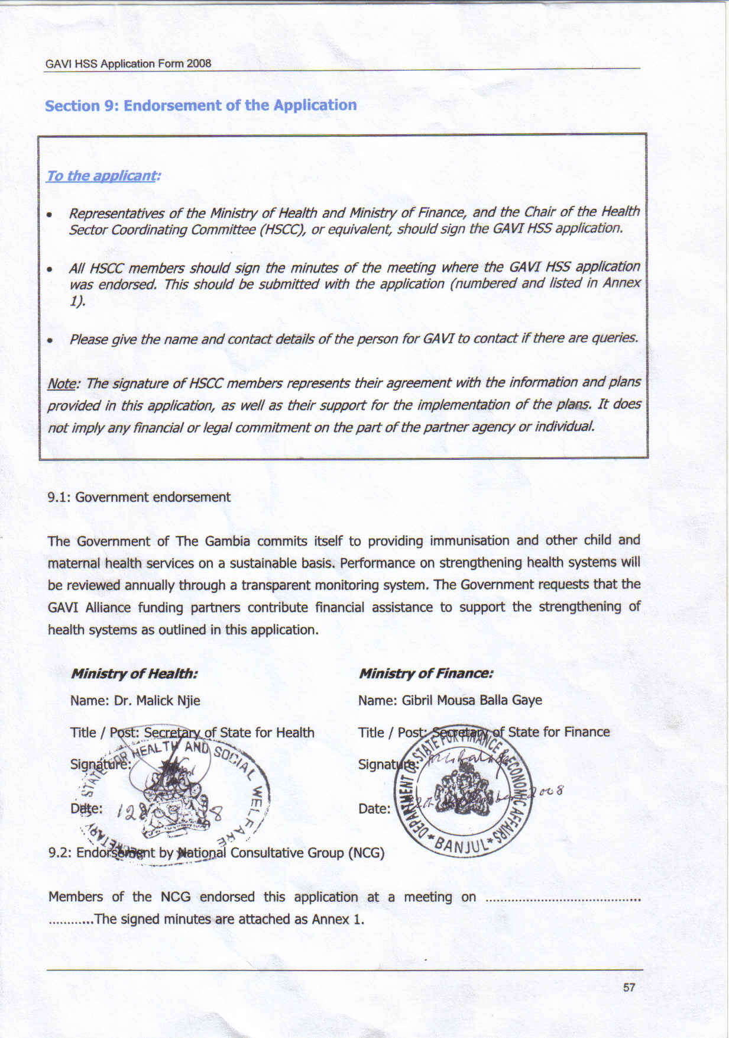
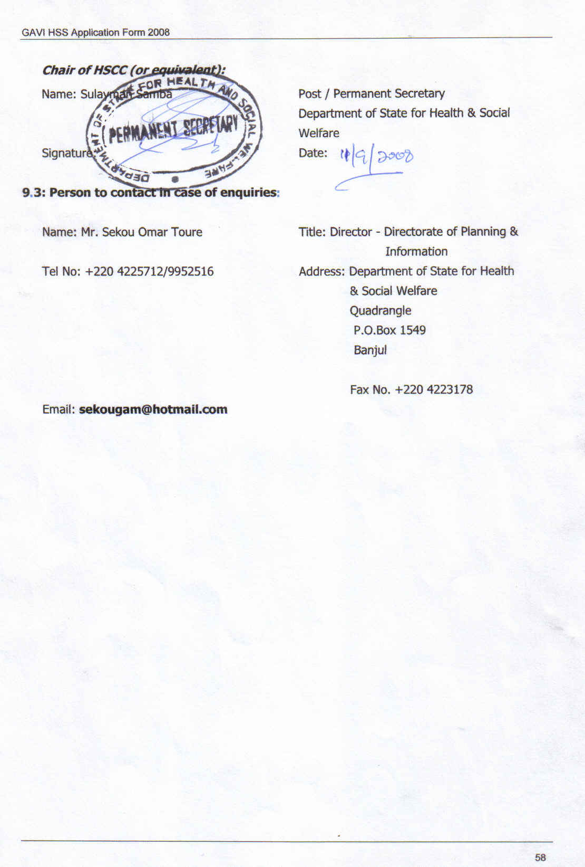

ANNEX 1 Documents submitted in Support of the GAVI HSS Application

Annex 1.1 HEALTH MASTER PLAN

Annex 1.2 cMYP

Annex 1.3 EPI DESK REVIEW

Annex 1.4 SYSTEM WIDE BARRIERS

Annex 1.5 PRSP II ACTION PLAN

Annex 1.6 PRSP II IMPLEMENTATION ACTION PLAN

Annex 1.7 PRSP II

Annex 1.8 HEALTH POLICY FRAMEWORK

Annex 1.9 HEALTH SECTOR SITUATION ANALYSIS

Annex 1.10 HEALTH INFORMATION SYSTEM REVIEW

Annex 1.11 MDG NEEDS ASSESSMENT

Annex 1.12 HUMAN RESOURCE FOR HEALTH SITUATIONAL ANALYSIS

Annex 1.13 NATIONAL HEALTH ACCOUNT

Annex 1.14 Evaluation of the availability, utilisation and quality of emergency obstetric care services in The Gambia

Annex 1.15 Briefing Paper on Health Sector for the Round Table Conference

ANNEX 2 Banking Form
ANNEX 3 Additional Information To Clarify the Issues Raised By IRC

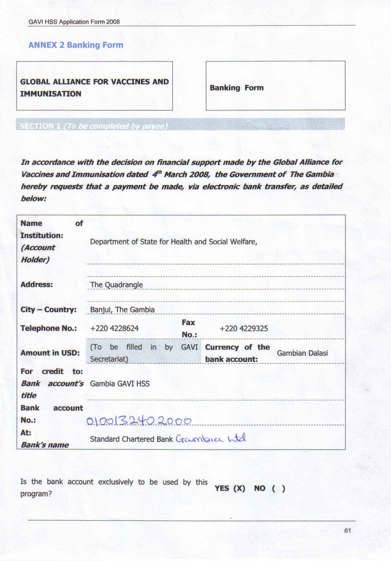
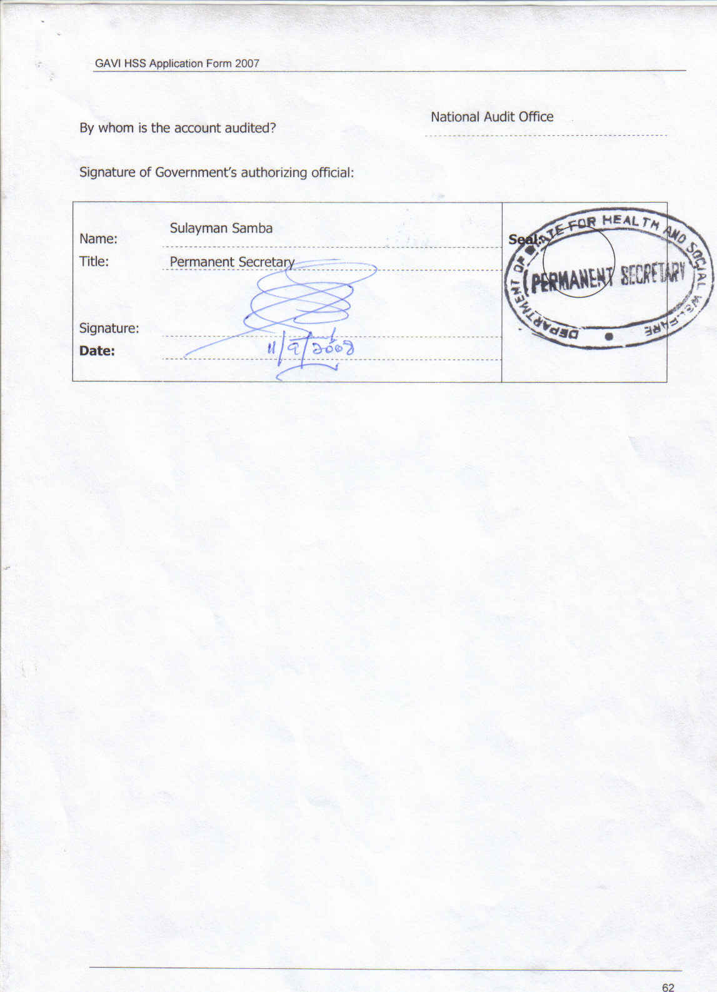
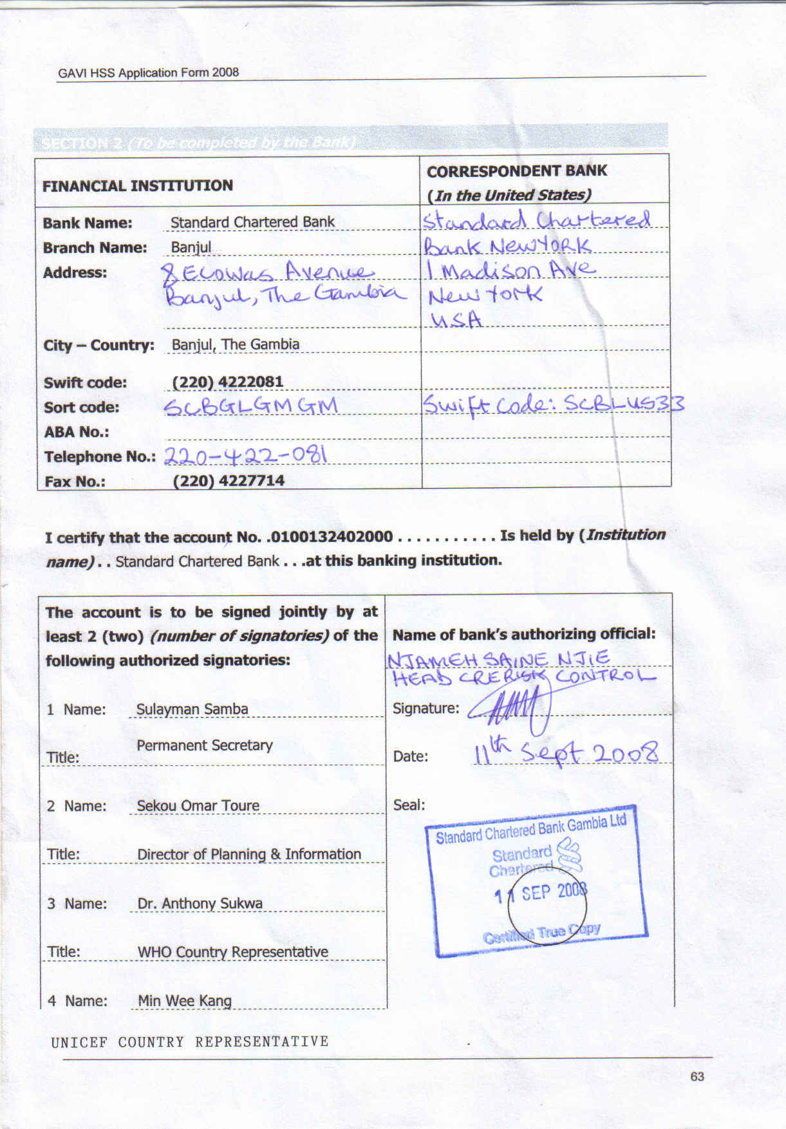
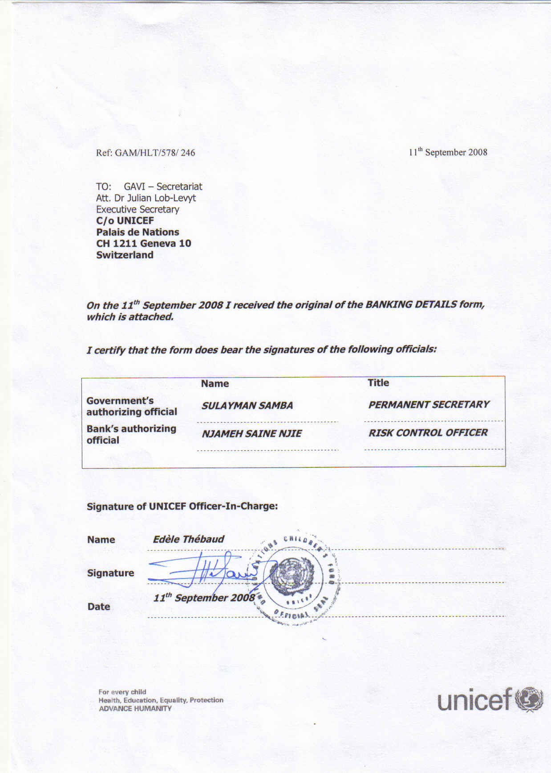
ANNEX III: Additional Information to clarify the Issues Raised by IRC

Weaknesses
Response:
- Significant inconsistencies (explanation for percentage change in government expenditure).

Response:

The 7% is the accurate figure for level of Government expenditure on health. The 92.6% DPT 3 coverage was obtained from EPI routine Data whilst the 86.8% comes from the MICS 2005 /2006. The NCG agreed to use published data in the proposal during the meetings following the first submission, however for the regional data the EPI routine is the only available data on quarterly/annual basis. The different DPT3 coverage(82.4% and 86.8%) are both from the MICS 2005/06, 82.4% represent coverage from 0-11months and 86.8% represent 0-23months. The 86.8% is put in the document as part of the socioeconomic indicators since it is the figure quoted in the published MICS III summary (refer page vii and page 92 of the MICS III 2005/06).

Lack of Clarity

Barriers that are not selected for GAVI HSS funding.

Of the six barriers not addressed, three were left out of the GAVI Proposal as a result of the intervention of other development partners as explained below:

High attrition of health care workers.

Department of State for Health and Social Welfare will introduce an incentive package for all health care workers as a measure to retain staff in the health sector. The Global Fund is providing incentives to health workers at the health facilities including Village Health Workers at community level. The accelerated training of health workers will start soon in all health training institutions to increase production and minimize the effect of attrition. Plans are in progress to expand the capacity of the health training institutions.

Inadequate number of reliable transport for service delivery.

Department of State for Health and Social Welfare has signed a memorandum of understanding with the Riders for Health to provide fleet of vehicles and motor cycles for health service delivery. However these motor cycles are meant for public health officers at health facility level and community health nurses at the village health services and exclude RCH outreach staff.

Inadequate operational funds at central and regional level.

The budget allocated to health is grossly inadequate and what is disbursed is generally less than the budget allocation. However, The Department of State for Health and Social Welfare, civil society organisations and partners are presently engaged in advocacy to increase government funding to the health sector to meet the Abuja Declaration.

Correction made on the Major activities& Implementation Schedule

- Procure spare parts for the vehicle annually instead of quarterly.
- Procure 9000 litres of petrol for 30 motor cycles not 80. The fuel will be bought annually not quarterly.

- Budget
Since there are some unit costs provided in the budget, the IRC was able to ascertain their appropriateness. External hard drives of 500GB size for USD 500 have an average open market price of around USD100, even considering cost increases for transport and customs, the unit cost seems still overestimated. The unit cost of a copy of an HMIS bulletin is USD 32.5(absorbing $97.5k in 3years) when given that the HMIS has a web based focus this figure seems excessive.

In consultation with the local ICT equipment vendors/ suppliers, the average cost for the external hard drive (500GB) is GMD 8, 000 (USD400).

Additional Information

- The criteria for selection of the various regions/facilities targeted.

Response:
The criteria for the selection of regions and facilities include the following:
(a) Regions with the lowest immunization coverage and
(b)Facilities with the most dilapidated outreach RCH Stations.

2. Information on what is meant by adequate facilities and what basic furniture and equipment mean.

Response:

Basic furniture at outreach posts in the rural villages in the Gambia includes tables, benches, couches, and chairs.
Basic equipment at outreach post includes Bp machine, stethoscope, and scales (standing scale, bath room scale and Salter scale) thermometer and vaccine carrier.
By national standards, an outreach post is said to have adequate facilities when it has the following materials in place:

Five (5) tables | One (1) sphygmomanometer | One (1) thermometer
Ten (10) benches | One (1) stethoscope | One (1) vaccine carrier
One (1) couch | One (1) standing scale | One (1) bathroom scale
Ten (10) chairs | One (1) salter scale | One (1) Hb meter and its accessories
One (1) cupboard | One (1) tape measure | Two (2) Pinnard stethoscope

(Source: Health Mapping Final Report, Synergy International)

4. The role of the requested 30 motorbikes for RCH service delivery within the monitoring and supervision objective

Response
The requested 30 motorbikes will be used by RCH team in the facilities for supervision and monitoring, follow up of activities, immunization defaulter tracing and disease surveillance in the communities. The motorbikes can also be used for outreach services when vehicle is not available.

5. How activities proposed in objective 2 will result in ensuring timely accurate and complete quarterly HMIS reports. Specifically: A. Whether the proposed cadre of information systems workers are already working in the health system and whether they are centrally located, B. What strategies are planned for HMIS training to health sector workers and Regional Health Teams (in charge of preparation of HMIS reports)

Response
A. The primary data collector is not a proposed cadre of the information system but rather are the various cadre of health workers (nurses, public health officers, laboratory personnel, pharmacy personnel, Leprosy and TB inspectors, data entry clerks and medical record clerks) who are mainly responsible for the collection of the data at the field or health facility levels. They are currently employed by the Department of state for Health and social welfare. They operate from the village health services (Primary level) to the basic health care (secondary level) and the Hospital (tertiary level). Presently the total number of primary data collectors we have in the health system is about 2500. Training 1000 during the three year period is about one third of the primary data collectors. In the next three years, the department is expecting to recruit about 240 SRN, 120 SEN, 120 CHN, 120 public health officers, 45 lab personnel, 45 pharmacy personnel from the health training institutions as the accelerate training of health workers has started.

B. The strategies planned for HMIS training are:
- Training of trainers (TOT) at the central level
- Step down training of health workers by the trainers at regional levels
- Training of the RHT staff on data processing, analysis, interpretation and report writing.
- Training of the primary data collectors on data management, data quality assurance and data audit processes.

6. Information regarding the strategy for dissemination of the HMIS bulletins given the hire of 15 web designers and a high cost for printing them.

Response

The HMIS bulletin will be produced quarterly on hard copies that would be distributed to all stakeholders and development partners. The unit cost for the production of the quarterly bulletin is provided by the WHO office during the production of their news letter.

The health department has a website called www.dosh.gm which has been operational for about four years. One of the problems the department is facing as far as the website is concern is the inability of the staff to update the website. The website was last updated in 2005 and up to date the technical skills are not there to up date it. It is planned to train 15 staff of the department on website design and updating. This training will build the capacity of the department to be able to up date the website regularly especially with the data generated at the field level. The department has recruited ICT support technicians to all the six health regions and central level. It is expected that these ICT technicians and the staff of the HMIS would be trained to be up dating the web site regularly. Already Department of State for Health has a website and the proposal did not mention hiring of web designers but training of existing ICT Technicians on web designing.

- In addition to management costs of USD 94,520 over the three year period there is also a request for USD 214,520 for support costs with no explanation attached for its existence, please clarify

Response

The revised amount for the support cost is $156,292.5. It is not a simple support cost but the total intended expenditure of the three support costs (management cost at central level- $88, 679.5 technical support $34,359 and conduct operational research study-$33, 254,)

8. Review the cost for the one week and two weeks Technical Assistance during the life of the proposal to reflect its estimated value. The original USD 100,000 value seem an over estimation.

Response:
The technical support is divided into two phase's i.e. mid-term project review and also end of project review.

The cost and the duration for the two consultancies: mid-term review (local consultancy) for three weeks and end of project review (external consultancy) for four weeks has been reviewed and the amount is USD 34, 359. ($27,500)

9. Review unit costs and, where not provided in the proposal, please supply.

Response: unit costs have been revised and where not provided previously, now have been provided. See table 8.1

10. Information on how activities described in the proposal intended to be funded through GAVI HSS are harmonised and in addition to government, civil society and health sector partners.

Response
This was clearly explained in the proposal, however we reiterate once again. The harmonization of the activities has been enshrined in the DOSH five-year strategic plan and a two-year investment plan. The two year investment plan has provided the total cost of activities in the two years. It further identifies funds expected from government and partners as well as the funding gap. Therefore, the funding sought from GAVI HSS will be used to support activities related to HSS that are not funded by DoSH and Partners (funding gap).
It should be noted that Global Fund intervention in terms of motorbikes is only for one region (western region) in the country as stated in the document.
ANNEX IV

Responses to issues identified by IRC recommendation to GAVI Alliance Board for Conditional approval to the Gambia's GAVI HSS proposal 6th July 2009

Condition 1: Clarify budget inconsistencies and provide a comprehensive budget with accurate figures clearly showing unit costs

Below are the explanations of further details on the unit costs that were not provided in the budget of the proposal submitted in May 2009.

Objective 1. To increase the number of outreach posts with adequate facilities from 89 to 179 (35% to 70%) by 2011.
- Activity 1.1, the unit cost should be $1059.34 based on the sum total of furniture unit costs, whilst the unit Cost was given as $1100 in May submission. As the breakdown of items was in the May proposal, the technical committee decided on the slight revision of the unit cost to $1059.34.
- Activity 1.2 (refurbishment) has a unit cost of $1,700 – Based on the break down of estimate, total unit cost comes up to D45,328 ($1,723) which is close to the $1,700 in the proposal submitted in May 2009. The breakdown is provided below.
Structure | in Dalasis (D)
7 Cement bags @ D280 per bag | 1960
Trip of Sand | 3000
Trip of gravel (half) | 3000
5 tins of Oil paint @ D500 + D500 20 litre water paint | 3000
1 Pack of Corrugated Iron Sheet | 1400
Water barrel for reservoir @D450 + Bucket * D200 | 650
 | 13010
6 Pieces of Timber wood: 4"*6"* 3metres @ D1300 | 7800
20 Pieces of Timber wood: 2"*3"* 3metres @ D700 | 14000
4 Kilos of 6" nails @ D35 per kg | 350
6 Kilos of 4" nails @ D18 per kg | 108
4 Kilos of 2" nails @ D15 per kg | 60
 | 22318
Labour
Fixed priced for labour team (Masons, carpenter & painters) | 10000
TOTAL | 45328
As at August 2009 Dalasis per US $: | 26.31
Total Cost of Out reach refurbishment in US $ | 1722.8

The Technical Committee decided to maintain the approximate unit cost of S1700 of April 2009 as there will always be a slight difference whenever the cost breakdown of items is given due to exchange rate variation.

- Activity 1.3 Unit cost for basic equipment for an outreach post.
Equipment | $
sphygmomanometer | 30
thermometer | 2
stethoscope | 20
vaccine carrier | 15
standing scale | 200
bathroom scale | 26
Salter scale | 25
Pinnard stethoscope (2) @ $1 | 2
Tape measure | 1
Hb meter and its accessories | 250
Total | 571

- Activity 1.4 Develop an inventory control system: The unit cost is for 6 people to visit all outreach stations and take inventory for 12 days, spending 2 days in each region. That is 6 x$50x12 days = $3600 + $257 to provide the inventory form for all 257 outreach posts (approximated at $1 per outreach post). $3,600 + $257= $3,857. The activity has also been shifted to 2010.
Objective 2.0 To ensure timely, accurate and complete quarterly HMIS reports from all six Regions by 2011

- Activity 2.1 Procure 12 desktop computers and accessories for the six regions and 4 for the central.. The desktop computer with accessories which include printer, 2 printer cartridges and UPS gives a total unit cost of $1520.33 as detailed below:
Unit cost of Computer and accessories | Dalasi | US$
Desktop computer @ D22000 | 22000 | 836.18
Printer @ D10000 | 10000 | 380.08
Printer cartridges @ D3000*2 | 6000 | 228.05
UPS @ D2000 | 2000 | 76.02
 | 40000 | 1520.33
As at August 2009 Dalasis per US $: | 26.31
Total unit Cost of computers and accessories US $ |  | 1520.33

Objective 3. To strengthen monitoring and supportive supervision through the provision of logistics at central level and in three regions

Activity 3.4 Procure spare parts for the vehicle

A sum of US$2300 has been allocated for the procurement of spare parts in 2011, in addition to the quarterly maintenance cost of US$414.29 for 3 quarters in 2010 and 4 quarters in 2011. Find below the breakdown of maintenance cost.

Vehicle Maintenance | Dalasi | US$
Change of Oil Filter @ D3000 per quarter | 3000 | 114.03
Change of fuel Filter @ D900 per quarter | 900 | 34.21
Change of Oil @ D500 twice per quarter | 1000 | 38.01
Workmanship @ D6000 | 6000 | 228.05
 | 10900 | 414.29
As at August 2009 Dalasis per US $: | 26.31
Total Unit cost of Vehicle maintenance per quarter US $ |  | 414.29

Activity 3.7 Procure spare parts for the 30 motor cycles

The estimated quarterly maintenance cost of a motorcycle is $132.08 based on the costing below:

Motor Cycle maintenance | Dalasi | US$
1 litre engine oil @ D75 per month * 3 months | 225 | 8.55
Oil Filter @ D75 * twice per quarter | 225 | 8.55
Inner tubes @ D100*2 | 200 | 7.60
Chain @ D150 | 150 | 5.70
Prockets @ D450* 2 | 900 | 34.21
Timing Chain | 450 | 17.10
Light bulb | 25 | 0.95
workmanship | 600 | 22.81
Contingency | 700 | 26.61
 | 3475 | 132.08
As at August 2009 Dalasis per US $: | 26.31
Total unit Cost of maintenance per quarter US $ |  | 132.08

The contingency is for tyres, rings, pistons and crane shaft that may not be required every quarter..

Base on these adjustments budget inconsistencies have been clarified and the total amount reduced.
See budget on table number 8.1 in the proposal

Condition 2. Correct the error in the procurement of 16 external hard drives from US$ 64,000 to US$6,400.
The correction has been done in the budget

Condition 3. Justify the changes and adjust the work plan accordingly.

Response:
The likelihood that funds will not be available in 2009 made it necessary for us to shift all the activities to 2010. This is because a Financial Management Assessment (FMA) is currently going on and the GAVI secretariat has indicated that no funds will be disbursed upon approval without the finalization of FMA. The National Consultative Group meeting on the 28th August 2009 agreed to shift the entire activities scheduled for 2009 to 2010.

The following activities scheduled for 2009 have now been shifted to 2010:

Activity 1.4 Develop inventory control system
Activity 2.1 Procure 12 desktop computers and accessories for the six regions and 4 for the central
Activity 2.3 Procure 16 external hard drives for data backup (500 GB)
Activity 2.4 Develop a data reporting guidelines
Activity 2.6 Production of 600 Registers and other HMIS tools
Activity 2.7 Procure 60 filing cabins for storage Of data collection tools
Activity 2.8 Train 900 Primary Data Collectors
Activity 2.9 Train 90 Data Entry and Record clerks
Activity 2.10 Train 15 on web designing and hosting
Activity 2.11 Quarterly publication of HMIS
Activity 3.1 Conduct quarterly monitoring and supervision at regional and health facility levels
Activity 3.2 Procure one vehicle for monitoring and supervision for DPI
Activity 3.3 Procure 2600 liters of diesel annually for the vehicle
Activity 3.4 Procure spare parts for the vehicle
Activity 3.5 Procure 30 Motorcycles for RCH service delivery
Activity 3.6 Procure 9000 litres of petrol for the motorcycles
Activity 3.7 Procure spare parts for the 30 motor cycles annually
Management costs at central level
Technical support
Conduct operational research studies

In light of this decision, some activities scheduled for 2010 were readjusted to accommodate the shifting of the 2009 activities within the budget ceiling for 2010. The compression of activities in 2010 also entail that some of the activities had to be reduced. These are:

Activity 2.8 Training of 900 Primary Data Collectors has been reduced to 400 Primary Data Collectors.
Activity 3.4 Procure spare parts for the vehicle also reduced as spare parts will be bought in 2011.
Activity 3.5 Procure 30 Motorcycles for RCH service delivery has been adjusted to 10 motorbikes in 2010 and 20 motorbikes in 2011.
Activity 3.6 Procure 9000 litres of petrol for the motorcycles has been reduced to 5760 litres (10 motorbikes for 2010 and 30 motorbikes for 2011).
Activity 3.7 Procure spare parts for the 30 motor cycles annually reduced to spare parts for 10 motorbikes in 2010 and 30 motorbikes for 2011.
A management cost at central level was revised downwards as a result of the shift from three years to two years implementation plan.

Total funds for technical support has reduced due to the removal of the mid term review.

Other conditions to be addressed:

1 GLOBAL FUND MALARIA GRANT SUPPORT TO THE HMIS UNIT

The Global Fund Malaria Grant round 6 support for monitoring and supervision was specifically meant for the RHTs staff to the health facilities and communities.

Since the harmonization process started in 2007, the Global Fund extended its support for quarterly monitoring and supervision visits by the HMIS unit (for three people) to the regions and health facilities. However, due to the limited number of personnel and the frequency not all data sources at the field level are supervised. In situation where there are data inconsistencies and gaps it could take the team to detect it only in the next quarterly visit. An increase in the frequency of the visits (two per quarter) will help to address such anomalies on time. The GAVI HSS support will strengthen and increase the number of personnel for central level monitoring and supervision by the HMIS unit to RHTs and health facilities.

GAVI HSS will support the training of health workers in data management. The Africa Network Project is introducing new software called Open MRS and DHIS 2 and staff need to be orientated and trained on them.

Presently there are over two thousand five hundred health workers in the field who need to be trained in data management and out of which only two hundred and seventy nine had been trained. In addition, every year graduates from the health training schools need to be trained in data management.

The GFATM round 6 procured 6 computers for the RHTs for administrative work and three lap tops for the HMIS. Presently none of the 42 health facilities including RCH clinics have computers for data management.

According to the 2 year investment plan 60 computers and accessories are planned to be procured for the HMIS (HMIS component under the strategy strengthen information generation for effective planning, monitoring and evaluation at all levels). Out of this number 42 will be provided to the health facilities. We are requesting 16 computers from GAVI HSS and the gap is expected to be provided by government and other partners.

2 Justification for Barriers selected for GAVI HSS support

These barriers are selected for GAVI HSS support because they are the only barriers out of the eleven identified barriers for which there is no adequate support as explain under each barrier:

Barrier 1: Inadequately delivered outreach services due to poor physical infrastructure and equipment at PHC level.

The outreach posts play a very vital role in the delivery of basic health services at the community level. Since the inception of PHC in 1981, some of the outreach posts were refurbished with support from NGO partners such as Action Aid The Gambia, Save the Children UK and Concern Universal. However, this support does not cover the 257 outreach posts because only 89 posts are fully functional. Since the EPI services are integrated in the RCH services and are usually delivered at the outreach posts, GAVI HSS support is requested to increase the number of functional outreach posts from 89 to 179. This will complement the efforts of the other partners and Government in improving the Reproductive and Child Health Services including immunization coverage.

Barrier 2: Weak HMIS (poor data management at all levels; central, regional and health facility).

As mentioned earlier there are over two thousand five hundred health workers in the field that need to be trained in data management and of these only two hundred and seventy nine have been trained. In addition, every year graduates from the health training schools need to be trained in data management.

The HIS assessment report 2006 (page 19) revealed that HIS institution, human resources and financing had a low score of 39% which is found to be not adequate at all. The results of such a low score could be attributed to the fact that there is no adequate office space, trained HIS staff and lack of adequate financial and material support for the development of HIS.

HMIS as one of the building blocks of HSS is a crossing cutting issue and when strengthened would lead to the production of reliable data in the monitoring of the MDGs. The GAVI HSS support will strengthen the capacities of the health workers to produce credible and quality data for planning and decision making.

(Please refer to clarification on Global fund support to HMIS)

Barrier 3: Weak monitoring and supervision at central and regional levels.

Monitoring of indicators regarding the health status of the population, the provision of services as to the coverage and utility, and status of equipment on a regular basis is the responsibility of the Directorate of Planning and Information and the Regional Health Teams. Accurate, relevant and up-to-date information is essential in order to recognize weakness in the health service provision and take actions that will improve service delivery in the areas of immunization, outreach trekking and follow-ups.

Immunization coverage performance varies between regions. The EPI routine data showed that only two regions out of six have DPT 3 coverage of ≥ 80%. The GAVI HSS will focus on three of the remaining four regions in terms of the provision of the adequate transport and logistic support. As mentioned under the section additional information requested for GAVI IRC queries number 1 and 4, one of the criteria for the selection of regions relates to regions with the lowest immunization coverage. The motorbikes that are going to be provided by the GAVI HSS will be used by the RCH team in the facilities for supervision and monitoring, follow up of activities, immunization defaulter tracing and disease surveillance in the communities. The motorbikes can also be used for outreach services when the trekking vehicle is not available. One of the aims of improving the weak monitoring and supervision is to improve the immunization coverage in the three regions with low immunization coverage.

3. Provision of the Gambia 5-year Strategic Plan and 2-year Investment Plan

The costed strategic plan (Health Strategic Document) and the 2-year investment plan are attached as annex v. The summary table of the document on page 24 shows the funding required, anticipated funding from donors and Government and the funding gap. This is also outlined in the 2-year Investment Plan.

4. Country partners involvement to assist The Gambia Ministry of Health to provide an accurate comprehensive budget with unit costs.

The Coordinator of the proposal development attended a peer review meeting of the IRC responses to GAVI HSS proposal from 17th to 19th August 2009 in Ouagadougou, Burkina Faso. The meeting was organized by WHO Inter-Country Support Team for West Africa in collaboration with WHO Headquarters (HQ). A budget expert from WHO HQ was provided to the Gambia team to assist in adjusting the budget.

