Joint Appraisal (JA) Template

The Joint Appraisal (JA) is an essential element of Gavi’s regular monitoring and performance management (MPM). The JA has evolved to align with Gavi 5.0 strategic shifts.

The JA is an annual, country-led, multi-stakeholder review/discussion that represents an important opportunity for countries to engage Gavi Alliance partners and other key stakeholders on annual progress of routine immunisation programmes against national goals and objectives, and to discuss how Gavi support is contributing to this progress. Key stakeholders involved in the country’s immunisation programme should be represented at the Joint Appraisal, including civil society organisations (CSOs).

As an integrated part of Gavi’s portfolio management process, the JA discussion should review Gavi’s contribution to immunisation programme performance in 2022/early 2023, including current status of your COVID-19 programme and efforts on integration. A key feature of the JA is the joint discussion about the promising practices, challenges met and future needs for improving immunisation performance with a focus on reaching zero-dose children and missed communities.

The modality of the Joint Appraisal exercise is tailored to the country context and may be scheduled taking into consideration other planning exercises such as EPI reviews or National Immunisation Strategy Development. The JA process will involve preparatory work to assemble and analyse data in advance of the discussion, exchange on the trends and their implications for the EPI program, and will conclude with the finalisation of a report and relevant deliberation outcomes and follow-up actions. At least one live discussion (in person or virtual) of the multiple stakeholders engaged in the Joint Appraisal should be organised.

The 2022 Joint Appraisal template is structured as follows
- Section 1: Country situation: overview of performance of Gavi support & discussion on progress and challenges faced
- Section 2: Looking forward: summary of discussion points and follow up actions

The information and indicators contained in section 1 on the country immunisation programme performance and Gavi support are mostly based on standard reporting. They are part of Gavi’s monitoring and performance management framework, which will inform ongoing portfolio discussions, the JA, as well as discussions at Gavi’s High-Level Review Panel (HLRP).

Section 1 is also where Gavi expects reporting against the Grant-linked Key Performance Indicators developed during FPP / EAF applications. For these indicators, results are to be analysed as (1) the absolute change in the indicator as a trend over time and; (2) the percent change in the indicator against the baseline value from the FPP or EAF application. Changes over time will be assessed against the end of grant target set during the application stage. Please ensure that sufficient data is provided to conduct such analyses, including the baseline values, targets, and sufficient annual data to infer trends.

The below set of cross-cutting questions should be considered to structure qualitative information:

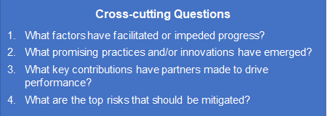

Section 1 forms the analytical foundation to structure the JA discussion with Section 2 summarising the outcome of the JA and follow-up actions.

The outcome of this Joint Appraisal will include a joint assessment of promising practices, perceived challenges and opportunities for Gavi investments, and should elaborate future actions with clear targets and assigned responsibilities which is owned by the full set of in-country stakeholders.

Section 1: Country situation: overview of performance of support & discussion on progress, challenges faced

- Immunisation Programme Performance – Zero-dose, Routine immunisation coverage, Vaccine introductions, campaigns, and outbreak response

1. Learning Question: What progress has been made to reach zero-dose and under-immunised children with vaccinations?
Indicator | 2019 | 2020 | 2021 | % change, 2019-2021 | % change, 2020-2021
Number of zero dose children at national level¹ | 331,181 | 296,837 | 360,765 | +8% (+29,584) | +18% (+63,928)
Drop out from DTP1 to DTP3 at national level¹ | 4% | 10% | 11% | +64% | +9%
Drop out from DTP1 to last routine dose of MCV at national level¹ | 45% | 45% | 41% | -10% | -10%
Percentage of health facilities that reported no stock-outs for the full year for DTP² | NA | NA | 100% | NA | NA
¹Source: WHO/UNICEF Estimates of National Immunisation Coverage (WUENIC), July 2022. https://immunizationdata.who.int/listing.html?topic=coverage
²Country data as reported to WHO/UNICEF through the electronic Joint Reporting Form (eJRF), July 2022. https://www.who.int/teams/immunization-vaccines-and-biologicals/immunization-analysis-and-insights/global-monitoring/who-unicef-joint-reporting-process

Country comments (please consider the set of cross-cutting questions to structure comments):

2. Learning Question: How well are vaccine stocks being managed?
Indicator(s):  - Number of health facilities that reported no stock-outs of DTP containing vaccine  - Number of health facilities that reported no stock-outs of Measles containing vaccine  - Closed vial wastage of DTP-containing vaccine  - Number of CCE received/installed/ leased through third party providers.  - Equipment maintenance and/or onsite readiness.  - Cumulative volume of C19 doses expired to date (and volume specific to COVAX supported doses, if the data is available) | Graphs:  (Examples to be replaced with specific country versions)
Country comments (please consider the set of cross-cutting questions to structure comments):

3. Learning Question: Are vaccines being consumed at rates that are in-line with approved forecasts? What are the key drivers of consumption compared to expectation (e.g., stockouts, increased coverage, wastage)?
Indicator(s):  - Percentage of forecasted Annual Vaccine Requirement (AVR) consumed in prior period (by antigen) | Graphs:  (Examples to be replaced with specific country versions)  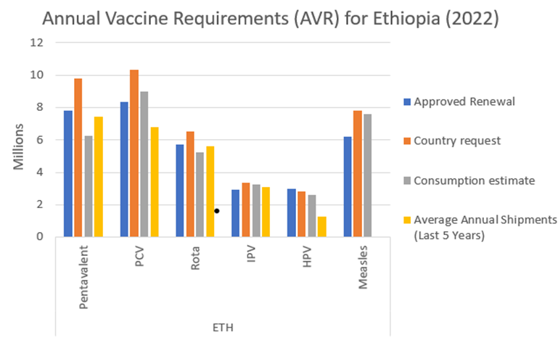
Country comments (please consider the set of cross-cutting questions to structure comments):

4. Learning Question: Is the country complying with co-financing requirements in a timely manner?
Indicator(s):  - Country co-financing obligation met in a timely manner | Graphs:  (Examples to be replaced with specific country versions)  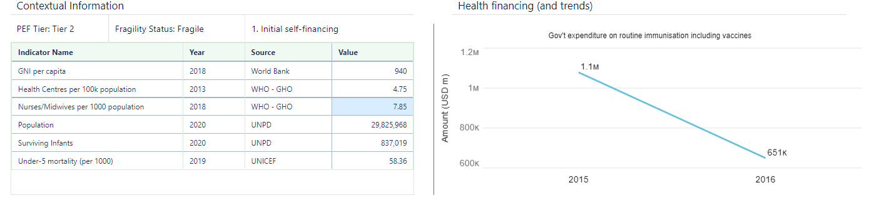
Country comments:

5. Learning Question: If applicable, have new vaccines been introduced as planned and if not, why? Is coverage of recently introduced vaccines being scaled-up as expected?
Indicator(s):  - Number of routine introductions completed over number of targets set for the calendar year  - Coverage of recently introduced vaccines  In addition, forecasted routine introduction & campaign dates should be validated during the JA discussion | Graphs:  (Examples to be replaced with specific country versions)  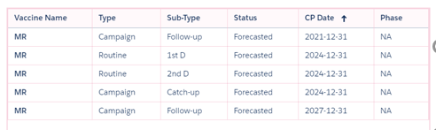
Country comments (please consider the set of cross-cutting questions to structure comments):

6. Learning Question: If relevant, how effective have recent Gavi supported vaccination campaigns been? Please highlight lessons learned which are applicable for routine immunisation and upcoming campaigns (e.g., timeliness of outbreak response, quality, campaign reach and link back to strengthening routine immunisation).
Indicator(s):  - Number of vaccination campaigns conducted (stratified by type of campaigns, including preventive, reactive, catch-up, follow-up, sub-national and national)  - Coverage of recent Gavi-supported campaigns, compared to target (coverage rate disaggregated by sex if collected)  - Number of reported outbreaks of vaccine-preventable diseases (for which GAVI supports with reactive campaigns) | Graphs:
Country comments (please consider the set of cross-cutting questions to structure comments):

7. Learning Question: What is the current status of your COVID-19 vaccination?
Indicator(s):  - Report and reflect on progress in uptake, with particular emphasis on older adults, health workers and other high-priority population group (as defined by WHO SAGE guidance). Analyse both primary series uptake and boosting.  - Describe if and how the country is integrating delivery of COVID-19 vaccine with routine immunisation & other primary health care services, including reflecting on how Gavi CDS has been used to support these integration efforts (if applicable).  - How have CDS funds been used to strengthen broader RI efforts beyond COVID-19? | Graphs:  (Examples to be replaced with specific country versions)
Country comments (please consider the set of cross-cutting questions to structure comments):

8. Learning Question: Trajectory and progress against targets set
- How does the progress over the past year compare with your Theory of Change or programme objectives?
- How has COVID-19 and COVID-19 vaccination impacted your routine immunisation programme, what has been done to maintain and restore immunisation and what has been the impact of it (please include reference to trends in DTP3 and MCV1 coverage)?
- If there are other factors (e.g., government transitions, natural disasters, other disease outbreaks, etc.) which have led to disruptions in your immunisation programme over the last year, please also reflect on those.
Indicator(s):  - Number of children who received DTP3 and number of children who received MCV1 in the past year compared to the number who received those vaccines in 2019.  - Qualitative information | Graphs:  (Examples to be replaced with specific country versions)
Country comments (please consider the set of cross-cutting questions to structure comments):

- Programme Management

Financial implementation of Gavi cash grants

Cash Support Summary*
Grant | Recipient | Period | Status as of <ENTER DATE> |  |  |  |  | Cash Bal | Compliance**
 |  |  | Grant Value | Appr. | Disb. | Expenditure | Utilisation |  | Fin. Rep | Audit
*All amounts are in USD
**Comment below in case of non-compliance

9. Learning Question: How well is the country able to absorb Gavi funding and what are the drivers? (This should cover all funding including funds channelled through partners.)
- Comment on the financial implementation progress of grants including but not limited to the utilisation rates. What are the key issues?
Indicator(s):
- Percentage of grant funds utilised
- Amount of cash balance in-country
Country comments:

10. Learning Question: How well is the country resolving issues arising from assurance activities? What issues are left to solve and what is the path forward?
- What is the progress of Grant Management Requirements implementation?
- How has the country addressed recommendations arising from past audit recommendations (annual external audits + Gavi Programme Audit)?
- Comment on the improvements that have been made to financial management and risk assurance activities with support of assurance providers (e.g., Fiscal Agents, Monitoring Agents, Financial Management Technical Assistance)?
- Specifically, what actions have been taken to enable a larger % of Gavi funds to be channelled back through government systems?
Country comments:

11. Learning Question: Please comment on any other financial management-related bottlenecks for implementation and compliance.
Country comments:

12. Learning Question: Is the country effectively addressing gender related barriers (e.g. faced by caregivers or adolescents in accessing immunisation services and barriers faced by health workers in delivering immunisation services)?
Indicator(s):  - Did (when) the country conduct a gender analysis that identified barriers faced by health workers, caregivers and adolescents (yes/no)  - Has the country implemented initiatives that remove or reduce gender related barriers? | Graphs:  (Examples to be replaced with specific country versions)
Country comments:

Please use the below table when reporting on initiatives that remove or reduce gender related barriers.

Barriers faced by caregivers
Barrier (state the barriers that restricts the caregiver from access the service) | Intervention that addresses barriers (state the interventions planned) | Was the intervention implemented? (no, partially, fully) | What was the impact (provide evidence)?

Barriers faced by healthworker
Barrier (state the barriers that restricts the caregiver from accessing services) | Intervention that addresses barriers (state the interventions planned) | Was the intervention implemented? (no, partially, fully) | What was the impact (provide evidence)?

Barriers faced by adolescents
Barrier (state the barriers that restricts the adolescents from accessing services) | Intervention that addresses barriers (state the interventions planned) | Was the intervention implemented? (no, partially, fully) | What was the impact (provide evidence)?

What new programming or reprogramming is required to improve impact?

13. Learning Question: How well is the country implementing its health information systems and data strengthening, monitoring and learning activities?
- What is the progress of planning and implementing health information system and data strengthening, monitoring and learning activities? Do these collectively constitute at least 10% of your HSIS/EAF grant budget?
- How will the country address remaining data-related gaps or barriers to immunization programme performance?
- Comment on key results or findings for identified learning priorities based on country’s application. Specifically, what actions have been taken to improve immunization programme performance based on these data? e.g. better understand specific barriers to immunisation, successfully guide implementation, inform course correction for grant activities
Please share any documentation of learning results if available (e.g. reports, evaluations, assessments, etc).
Country comments:

- Implementation of Technical Country Assistance (PEF-TCA)

14. Learning Question: Is the country implementing PEF TCA and COVAX TA as expected? Please explain how the TCA has helped to support the achievement of the country objectives.
Indicator(s):  - Country analysis on partner performance as per workplans | Graphs:  (Examples to be replaced with specific country versions)  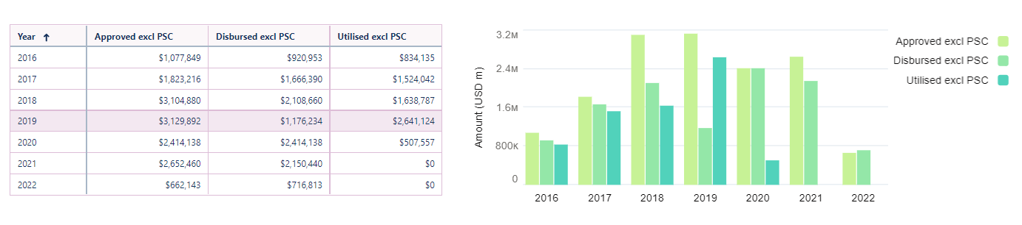
Country comments:

Row Labels | Completed | Major Delays | Minor Delays | On Track | Re-programmed | Unreported | Grand Total | Achievement
COVAX Technical Assistance
Target Country Assistance
Grand Total

Section 2: Looking forward: Summary of key discussion points and follow up actions

Briefly summarise the key discussion points, including identified needs and follow up actions resulting from the Joint Appraisal review and dialogue.
This may include
- Identified (future) needs and priorities
- Follow-up actions to accelerate planned activities
- Expected adjustments to activities and as applicable the Gavi workplan, targets and budget, such as budget reallocations, modifications in TCA planning, revision of dates for anticipated new vaccine applications or introductions, etc.
- Roll-out or expansion of promising practices and innovations
- Other aspects and follow up actions

Follow up action | Timeline | Responsible person/partner

Countries which are finalising in the course of 2022 a Full Portfolio Planning are not expected to conduct a JA.
Please reflect on those campaigns conducted since the last Joint Appraisal/Multi-Stakeholder Dialogue exercise.
All HSIS grants (HSS, VIGs, OPS, Switch), EAF and CDS cash support as applicable.
This refers to all types of Gavi support

