January 2005
Progress Report
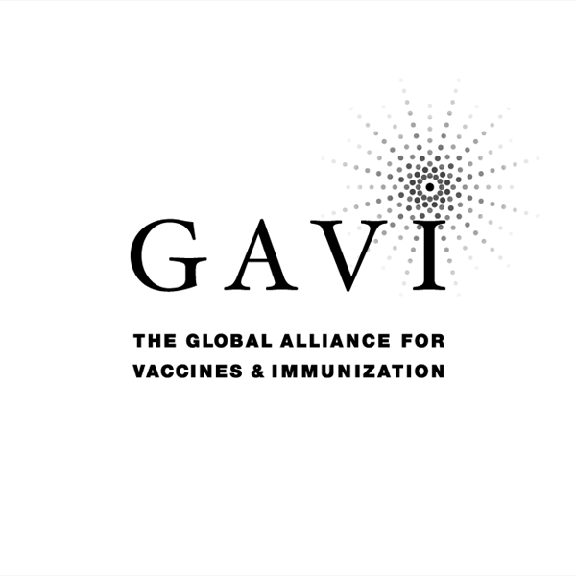
Partnering with The Vaccine Fund

to the
Global Alliance for Vaccines and Immunization (GAVI)
and
The Vaccine Fund

by the Government of
COUNTRY: BURKINA FASO
Date of submission: 2000

Reporting period: 2004 ( Information provided in this report MUST refer to
2004 activities )

( Tick only one ) :
Inception report ◻
First annual progress report ◻
Second annual progress report ◻
Third annual progress report ◻
Fourth annual progress report X
Fifth annual progress report ◻

Text boxes supplied in this report are meant only to be used as guides. Please feel free to add text beyond the space provided.
*Unless otherwise specified, documents may be shared with GAVI partners and collaborators

Progress Report Form: Table of Contents

Report on progress made during 2004
  - Immunization Services Support (ISS)
1.1.1 Management of ISS Funds
Use of Immunization Services Support
1.1.3 Immunization Data Quality Audit
  - GAVI/Vaccine Fund New and Under-used Vaccines
1.2.1 Receipt of new and under-used vaccines
1.2.2 Major activities
    - Use if GAVI/The Vaccine Fund financial support (US$100,000) for introduction of the new vaccine
1.3 Injection Safety
    - Receipt of injection safety support
    - Progress of transition plan for safe injections and safe management of sharps waste
    - Statement on use of GAVI/The Vaccine Fund injection safety support (if received in the form of a cash contribution)

2. Financial Sustainability

3. Request for new and under-used vaccine for 2006
  - Up-dated immunization targets
  - Confirmed/revised request for new vaccine (to be shared with UNICEF Supply Division) for year…
  - Confirmed/revised request for injection safety support for the year…

- Please report on progress since submission of the last Progress Report based on the indicators
selected by your country in the proposal for GAVI/VF support

5. Checklist

6. Comments

7. Signatures

1. Report on progress made during 2004

To be filled in by the country for each type of support received from GAVI/The Vaccine Fund.

Immunization Services Support (ISS)

1.1.1 Management of ISS Funds

Please describe the mechanism for management of ISS funds, including the role of the Inter-Agency Co-ordinating Committee (ICC).
Please report on any problems that have been encountered involving the use of those funds, such as delay in availability for programme use.

In accordance with the directives of GAVI/Global Vaccine Fund, and to ensure transparency in management of these funds, Burkina Faso has had two management bodies in being since the 27 July 2001 (Order no./2001/145/MS relating to the establishment, organisation and operation of the steering committee and management committee for GAVI funds). A steering committee chaired by the Minister of Health and a management committee chaired by the Secretary General, with the various partner members of the CCIA, representatives of the Ministry of Health such as the Director General for Health and the Director for Research and Planning, as members. The management committee, which is the technical body, makes proposals for the use of these funds to the Steering Committee, which approves them. By way of a reminder the CCIA was set up on the 26 September 1989 and modified on the 31 July 2000. The main partners are: WHO, UNICEF, PDSN, the Rotary Club, CATR, the NGO SCPB, the NGO Plan International, and the World Bank).
Problems encountered are essentially the administrative burden in the process of unlocking funds and the acquisition of equipment (State Contract) which has had the result that work in the field has slowed down.
In order to make the CCIA more operational and reduce administrative burdens, it has been proposed that a Technical Committee (TC/EPI) Supporting the Expanded Programme of Immunisation (EPI) should be set up, and this will be responsible for making proposals to the CCIA for the adoption of appropriate strategies which will make it possible to achieve the annual and multi-year targets of the EPI, the utilisation of GAVI funds, the preparation of files for the various meetings of the CCIA, the preparation of annual and multi-year plans, and evaluation and follow-up of implementation of the various programmes and plans.
The Technical Committee (TC/EPI) for Support for the Expanded Programme of Immunisation (EPI) has as its chairman the Director for Prevention by Immunisation. He will be supported by a vice chairman and a spokesman. The members will be the health administrators of the various partners which are full members of the CCIA. The proposal to revise the CCIA is awaiting signature by the Ministry of Health authorities. In the course of the meeting on Thursday the 31 March 2005 the members desired that meetings should be presided over in person by the Minister of Health.

1.1.2 Use of Immunization Services Support

In 2004, the following major areas of activities have been funded with the GAVI/Vaccine Fund Immunization Services Support contribution.

Funds received during 2004 ___437,700 USD_
Remaining funds (carry over) from 2003 ___17 894 USD___

Table 1: Use of funds during 2004

Area of Immunization Services Support | Total amount in US $ | AMOUNT OF FUNDS
Area of Immunization Services Support | Total amount in US $ | PUBLIC SECTORS |  |  | PRIVATE SECTOR & Other
Area of Immunization Services Support | Total amount in US $ | Central | Region/State/Province | District | PRIVATE SECTOR & Other
Vaccines |  | USD | USD | USD
Injection supplies
Personnel
Transportation (fuel) | 52 052 |  |  | 52 052 (100%)
Maintenance and overheads | 50 888 |  |  | 50 888 (100%)
Training
IEC / social mobilization
Outreach
Supervision | 10 599 |  |  | 10 599 (100%)
Monitoring and evaluation
Epidemiological surveillance
Vehicles
Cold chain equipment | 342 055 |  | 37 830 (11,05 %) | 304 225 (88,95%)
Other …………. (specify)
Total: | 455 594
Remaining funds for next year: | 0
Exchange rate: 550 CFAF for 1 USD.

*If no information is available because of block grants, please indicate under ‘other’.

Please attach the minutes of the ICC meeting(s) when the allocation of funds was discussed.

Please report on major activities conducted to strengthen immunization, as well as, problems encountered in relation to your multi-year plan.

The main activities carried out in order to increase vaccination in 2004 in accordance with the 2001-2005 multi-year plan and the 2004 annual action plan have been the following:
- Strengthening of the strategy put forward through equipping peripheral units with mopeds and a supply of fuel
- Provision of cold chain equipment to peripheral units
- Supervision of the 13 Regional Health Departments and 55 Health Districts by the central organisation
- Check on the EPI stores of the 13 Regional Health Departments and 55 Health Districts by the Central Organisation
- Improving communication activities in 11 Health Districts
- Holding the statutory meetings of the CCIA, in the course of which members considered the following points: the plan for utilisation of the funds provided by GAVI, the plan for implementing polio and measles NID, reports on supplementary immunisation activities.
- The holding of two decentralised meetings monitoring EPI activities and epidemiological monitoring, bringing together those responsible for EPI and those responsible for statistics from the regions, districts and hospitals for following up the programme. During these meetings routine EPI, monitoring and social awareness were considered.
- The conduct of additional immunisation activities in the context of the eradication of polio and the elimination of MNT.
- Implementation of active surveillance which has made it possible to detect cases of Wild Polio Virus, Neonatal Tetanus, and measles, for which action was undertaken.
- An exhaustive inventory of the cold chain throughout the territory and preparation of the refurbishment plan.
- The problems which arose in implementing the multi-year plan, and the 2004 action plan related to:
- Failure to achieve the immunisation coverage targets for TTV, yellow fever vaccine, measles.
- Lack of promptness in the transmission of monthly reports.
- The irregularity of feedback information from the central organisation to the regions
- The breakdown of data management facilities
- The lack of IEC materials in the field
- The failure to implement planned training
- Shortfalls in vaccine stock controls at regional and local level.

Immunization Data Quality Audit (DQA) (If it has been implemented in your country)

Has a plan of action to improve the reporting system based on the recommendations from the DQA been prepared?
If yes, please attach the plan.

YES NO
✓

If yes, please report on the degree of its implementation.

In cooperation with GAVI the Ministry of Health proposed that the second DQA be implemented in September 2005.
The following actions were carried out in the context of implementing the 2002 DQA recommendations: the provision of materials to all immunisation units, the supervision of units and the planning of a DQS workshop in June 2005, the preparation of a plan for improving the quality of data.
Administrative slowness meant that materials were not available in good time. However most health units and district and regional depots reproduced the items in notebooks and on other documents so as to follow up the handling of vaccines, consumables and vaccine doses administered.
The existence of graphs of immunisation coverage and the incidence and prevalence of diseases was noted in the course of supervision. Data are often analysed by health units, this should be done systematically and monthly with the Health Management Committees.
Promptness and completeness is however often at a low level. This requires better organisation of the health units and districts and regions, because data which are incomplete and sent in late make it impossible to make decisions at the appropriate time.
Materials were provided to those taking part during decentralised meetings. Practical exercises enabled them to familiarise themselves with the tools.

Please attach the minutes of the ICC meeting where the plan of action for the DQA was discussed and endorsed by the ICC.

Please report on studies conducted regarding EPI issues during 2004 (for example, coverage surveys).

Evaluation (CDC) of the measles campaign in November 2004: evaluation carried out in December 2004.

GAVI/Vaccine Fund New & Under-used Vaccines Support

1.2.1 Receipt of new and under-used vaccines during 2004

Start of vaccinations with the new and under-used vaccine: MONTH……………….. YEAR……………….

Please report on receipt of vaccines provided by GAVI/VF, including problems encountered.

The request for the introduction of DTP-HeB-HIB submitted to GAVI was accepted for a start in January 2006.

1.2.2 Major activities

Please outline major activities that have been or will be undertaken, in relation to, introduction, phasing-in, service strengthening, etc. and report on problems encountered.

Introduction from January 2006 onwards

1.2.3 Use of GAVI/The Vaccine Fund financial support (US$100,000) for the introduction of the new vaccine

Please report on the proportion of 100,000 US$ used, activities undertaken, and problems encountered such as delay in availability of funds for programme use.

During February 2005 a letter requesting the transfer of funds provided by GAVI was sent to the Executive Secretary of GAVI for the provision of funds which will be used for:
- The purchase of separate parts for the cold chain
- The training of agents
- The supervision of preparatory work for the introduction of new vaccines
- Evaluation follow-up
- Monitoring
- Communication

Injection Safety

1.3.1 Receipt of injection safety support

Please report on receipt of injection safety support provided by GAVI/VF, including problems encountered

Self-blocking syringes (SBS) for yellow fever, measles, DTC vaccines: 1,136,200 SBS
Self-blocking syringes for BCG: 1,352,175
Reconstitution syringes for measles and yellow fever vaccine: 64,188 SBS
Safe boxes: 10,100 SBS
Due date for the supply of injection equipment by GAVI end 2005-05-24
Since announcement of the Information about the end of the period for taking responsibility for the safety of injections, the Ministry has taken steps to ensure that the supply of injection materials is taken over by the State through the national budget and HIPC funds for the year 2006. The file will be presented to members of the CCIA in the course of the meeting in the second half of 2005.

Progress of transition plan for safe injections and safe management of sharps waste.

Please report problems encountered during the implementation of the transitional plan for safe injection and sharp waste

In the course of the year all health units providing immunisation were equipped with self-blocking syringes, vaccine reconstitution syringes and boxes for the collection of used syringes.
The major problem is the destruction of the wastes. Most of the incinerators available are non-functioning. Each health unit carries out destruction through burning and burial or using the functioning incinerators available. Some practices in the field do not ensure safety for personnel and the public:
Such as the storage of collection boxes containing wastes in health units and the destruction of wastes under unsuitable conditions.

Please report on the progress based on the indicators chosen by your country in the proposal for GAVI/VF support.

Indicators | Targets | Achievements | Constraints | Updated targets
1 – Percentage of self-blocking syringes used in the course of routine EPI activities. | 1 – Ensuring the regular supply of vaccination units in self-blocking syringes, dilution syringes, and in safe boxes for the destruction of soiled material.  100% of children will be vaccinated using SBS (one dose, one syringe) | 1 – All vaccination units have benefited from the regular supply of self-blocking syringes, dilution syringes and safe boxes in the course of the year 2004. This equipment is delivered at the same time as the vaccines.  100% of children have been vaccinated using SBS (one dose, one syringe) | Low ability of the districts and health units to ensure the destruction of wastes. | 1 – Always ensuring a regular supply of vaccination units in self-locking syringes on the basis of the principle of one dose/one syringe.  2 – Ensuring a regular supply of vaccination units in safe containers  3 – Providing the health districts with incinerators  4 – Ensuring the destruction of wastes in existing incinerators.  5 – Preparing a plan for the collection and destruction of wastes by health districts  6 – Ensuring wide distributions of the directives on adverse post-immunisation reactions  7 – Ensuring that health agents are trained in injection safety

1.3.3 Statement on use of GAVI/The Vaccine Fund injection safety support (if received in the form of a cash contribution)

The following major areas of activities have been funded (specify the amount) with the GAVI/The Vaccine Fund injection safety support in the past year:

Burkina Faso has received no funds for carrying out activities relating to the safety of injections in 2004.

2. Financial sustainability

Inception Report: Outline timetable and process for the development of a financial sustainability plan . Describe assistance that may be needed for developing a financial sustainability plan.

First Annual Progress Report: Submit completed financial sustainability plan by given deadline. Describe major strategies for improving financial sustainability.

Subsequent Progress Reports: According to current GAVI rules, support for new and under-used vaccines is covering the total quantity required to meet country targets (assumed to be equal to DTP3 targets) over a five year period (100% x 5 years = 500%). However, in an attempt to help countries find sources of funding in order to attain financial sustainability by slowly phasing out GAVI/VF support, they are encouraged to begin contributing a portion of the vaccine quantity required. Therefore, GAVI/VF support can be spread out over a maximum of ten years after the initial approval, but will not exceed the 500% limit (see figure 4 in the GAVI Handbook for further clarification). In table 2.1, specify the annual proportion of five year GAVI/VF support for new vaccines that is planned to be spread-out over a maximum of ten years and co-funded with other sources. Please add the three rows (Proportion funded by GAVI/VF (%), Proportion funded by the Government and other sources (%), Total funding for …………. (new vaccine)) for each new vaccine.

Table 2.1: Sources (planned) of financing of new DTC hEPV HIB vaccine
Proportion of vaccines supported by * | Annual proportion of vaccines
Proportion of vaccines supported by * | 20..** | 2006 | 2007 | 2008 | 2009 | 2010 | 2011 .. | 2012 | 20.. | 20..
Proportion funded by GAVI/VF (%) |  | 100 | 100 | 80 | 70 | 60 | 50 | 40
Proportion funded by the Government and other sources (%) |  | 0 | 0 | 20 | 30 | 40 | 50 | 60
Total funding for …………. (new vaccine) *** |  | 100 | 100 | 100 | 100 | 100 | 100 | 100

* Percentage of DTP3 coverage (or measles coverage in case of Yellow Fever) that is target for vaccination with a new and under-used vaccine
** The first year should be the year of GAVI/VF new vaccine introduction
*** Should total 500% at the end of GAVI/VF support

In table 2.2 below, describe progress made against major financial sustainability strategies and corresponding
indicators.

Table 2.2: Progress against major financial sustainability strategies and corresponding indicators

Financial Sustainability Strategy | Specific Actions Taken Towards Achieving Strategy | Progress Achieved | Problems Encountered | Baseline Value of Progress Indicator | Current Value of Progress Indicator | Proposed Changes To Financial Sustainability Strategy
Resource mobilisation strategy | Requesting an increase in the part of the government budget allocated to EPI | Financing of immunisation through the national budget  HIPC support | Administrative slowness  Extension of HIPC to other social sectors | 3.5% | 4.5% | The State must maintain the present level of resources from the HIPC initiative allocated to the health centre, or even increase it.
 | Requesting an increasing contribution from partners | Regular holding of CCIA meetings | Cooperation programmes with multilateral institutions involved in the financing of EPI are subject to cycles (2 to 5 years). This gives rise to a need for mobilising resources from traditional partners at the end of their cycles of cooperation with Burkina Faso | ND | ND | Making the operation of the CCIA more dynamic  Holding quarterly meetings of the CCIA  Widening the composition of the CCIA to other partners and Departments  Seeking financial partners for health districts which do not have them in order to finance EPI  Negotiating long term finance with partners
Strategies with a view to increasing the effectiveness with which resources are used | Increasing the availability of vaccines | Availability of vaccines in health districts in the course of the year 2004 | Lack of transport facilities for supplying the regions and districts with vaccines and consumables | Levels of  DTC : 46.44%  YF : 10%  Measles : 0%  TT : 73.15%  BCG : 50% | No sudden change was noted in the course of the year 2004 | Ensuring satisfactory operation of the follow-up organisation  Maintenance of the cold chain  Training of vaccinating agents in use of the cold chain  Improvement of the quality of planning and management at all levels
 | Reducing antigen losses |  |  | Vaccine wastage levels:  OPV : 45% (2002)  DTC 28% (2002)  - YF : 49% (2002)  - Measles : 54% (2001)  - TT : 44% (2002)  - BCG : 64% (2002)  Sources: investigation into vaccine wastage levels 2002 | Vaccine wastage levels:  OPV : %  DTC %  - YF : %  - Measles : %  - TT : %  - BCG : %  Sources: investigation into vaccine wastage levels 2002  Evaluation in progress 2005 | Training those involved at intermediate and decentralised levels in the management of EPI, epidemiological monitoring and maintenance of the cold chain  Regular supervision of vaccination units
 | Reducing levels of abandonment between DTC1 and 3 | Start of implementation in some districts through daily monitoring of immunisation coverage by village  Initiation of research into those lost to follow-up through the use of notebooks and other media | Inadequate utilisation of notebooks and other media by the districts in searching for those lost to follow-up | Level of loss of follow-up between DTcoq1 and 3 = 16% in 2003 | Level of loss of follow-up between DTcoq1 and 3 = 13.3% in 2004 | Increased searching for those lost to follow-up, through the census of populations, the establishment of a search system (notebook, schedule, register) in all health units carrying out vaccination.  Members of HMC, associated organisations, Village Government Officers and Nursing Aides could carry out these activities.

3. Request for new and under-used vaccines for year 2006

Section 3 is related to the request for new and under used vaccines and injection safety for 2006.

Up-dated immunization targets

Confirm/update basic data approved with country application: figures are expected to be consistent with those reported in the WHO/UNICEF Joint
Reporting Forms. Any changes and/or discrepancies MUST be justified in the space provided (page 14). Targets for future years MUST be provided.

Table 3 : Update of immunization achievements and annual targets
Number of | Achievements and targets
Number of | 2004 | 2005 | 2006 | 2007 | 2008 | 2009 | 2010 | 2011 | 2012
DENOMINATORS
Births | 607 854 | 622 321 | 637 132 | 652 296 | 667 820 | 683 715 | 699 987 | 716 647 | 733 703
Infants’ deaths | 50 452 | 51 653 | 52 882 | 54 141 | 55 429 | 56 748 | 58 099 | 59 482 | 60 897
Surviving infants | 557 402 | 570 668 | 584 250 | 598 155 | 612 391 | 626 966 | 641 888 | 657 165 | 672 806
Infants vaccinated in 2004 (JRF) / to be vaccinated 2005 and beyond with 1st dose of DTP (DTP1)* | 561 720 | 570 668 | 0 | 0 | 0 | 0 | 0
Infants vaccinated 2004 (JRF) / to be vaccinated 2005 and beyond with 3rd dose of DTP (DTP3)* | 486 989 | 513 601 | 0 | 0 | 0 | 0 | 0
NEW VACCINES **
Infants vaccinated 2004 (JRF) / to be vaccinated 2005 and beyond with 1st dose of …......... (new vaccine) | SO | SO | 584 250 | 598 155 | 612 391 | 626 966 | 641 888 | 657 165 | 672 806
Infants vaccinated 2004 (JRF) / to be vaccinated 2005 and beyond with 3rd dose of…….… ( new vaccine) | SO | SO | 525 825 | 550 303 | 563 393 | 589 348 | 603 375 | 624 307 | 639 166
Wastage rate in 2004 and plan for 2005 beyond*** ………….. ( new vaccine) | SO | SO | 25 | 20 | 15 | 15 | 10 | 10 | 10
INJECTION SAFETY****
Pregnant women vaccinated / to be vaccinated 2004 (JRF) / to be vaccinated 2005 and beyond with TT | 415 674 | 497 857 | 522 448 | 554 451 | 587 682 | 608 606 | 636 988 | 666 481 | 697018
Infants vaccinated / to be vaccinated 2004 (JRF) / to be vaccinated 2005 and beyond with BCG | 608 945 | 570 668 | 584 250 | 598 155 | 612 391 | 626 966 | 641 888 | 657 165 | 672 806
Infants vaccinated / to be vaccinated 2004 (JRF) / to be vaccinated 2005 and beyond with Measles | 431 607 | 513 601 | 537 510 | 556 284 | 575 648 | 595 618 | 629 050 | 644 022 | 659 350
* Indicate actual number of children vaccinated in past years and updated targets (with either DTP alone or combined)
** Use 3 rows (as indicated under the heading NEW VACCINES) for every new vaccine introduced
*** Indicate actual wastage rate obtained in past years
**** Insert any row as necessary

Please provide justification on changes to baseline, targets, wastage rate, vaccine presentation, etc. from the previously approved plan, and on reported figures which differ from those reported in the WHO/UNICEF Joint Reporting Form in the space provided below.

In the letter of approval for the plan for the introduction of new vaccines and in the plan for the financial viability of EPI the base data used were those from the RGPH* for 1996 (in 1996 the population was 10,312,609 inhabitants, with a growth rate of 2.38%, it will be 13,357,799 inhabitants in 2007), EDS* for 1998-1999 (the gross birth rate is 46.1 per 1000 and the infant mortality rate is 105 per 1000). Given the problems associated with estimating the denominator and estimated coverage levels in 2004, and in order to have figures which were consistent with the common WHO/UNICEF report form, data for populations provided by all districts (birth rate 46.1 per 1000 and mortality rate of 83 per 1000) were used in order to obtain the number of surviving infants. This will have an impact on quantities of vaccine and consumables for new vaccines.

3.2 Confirmed/Revised request for new vaccine (to be shared with UNICEF Supply Division) for 2006

Please indicate that UNICEF Supply Division has assured the availability of the new quantity of supply according to new changes.

Table 4: Estimated number of doses of …… vaccine (specify for one presentation only): Please repeat this table for any other vaccine presentation requested from
GAVI/The Vaccine Fund
Remarks
- Phasing: Please adjust estimates of target number of children to receive
new vaccines, if a phased introduction is intended. If targets for hep B3 and Hib3
differ from DTP3, explanation of the difference
should be provided
- Wastage of vaccines: Countries are expected to plan for a maximum of:
50% wastage rate for a lyophilized vaccine in 10 or 20-dose vial; 25% for a liquid
vaccine in a10 or 20-dose vial; 10% for any vaccine (either liquid or lyophilized)
in 1 or 2-dose vial.
- Buffer stock: The buffer stock is recalculated every year as 25% the current
vaccine requirement
- Anticipated vaccines in stock at start of year… ….: It is calculated by
counting the current balance of vaccines in stock, including the balance of buffer
stock. Write zero if all vaccines supplied for the current year (including the
buffer stock) are expected to be consumed before the start of next year. Countries
with very low or no vaccines in stock must provide an explanation of the use of
the vaccines.
- AD syringes: A wastage factor of 1.11 is applied to the total number
of vaccine doses requested from the Fund, excluding the wastage of vaccines.
- Reconstitution syringes: it applies only for lyophilized vaccines. Write zero
for other vaccines.
- Safety boxes: A multiplying factor of 1.11 is applied to safety boxes to cater
for areas where one box will be used for less than 100 syringes

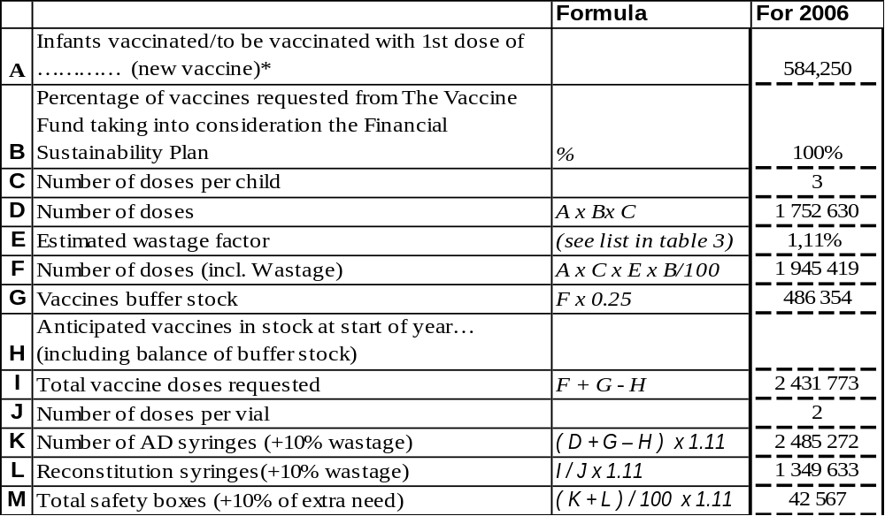
*Please report the same figure as in table 3.

Table 5: Wastage rates and factors
Vaccine wastage rate | 5% | 10% | 15% | 20% | 25% | 30% | 35% | 40% | 45% | 50% | 55% | 60%
Equivalent wastage factor | 1.05 | 1.11 | 1.18 | 1.25 | 1.33 | 1.43 | 1.54 | 1.67 | 1.82 | 2.00 | 2.22 | 2.50

3.3 Confirmed/revised request for injection safety support for the year …… (indicate forthcoming year)

Table 6: Estimated supplies for safety of vaccination for the next two years for BCG

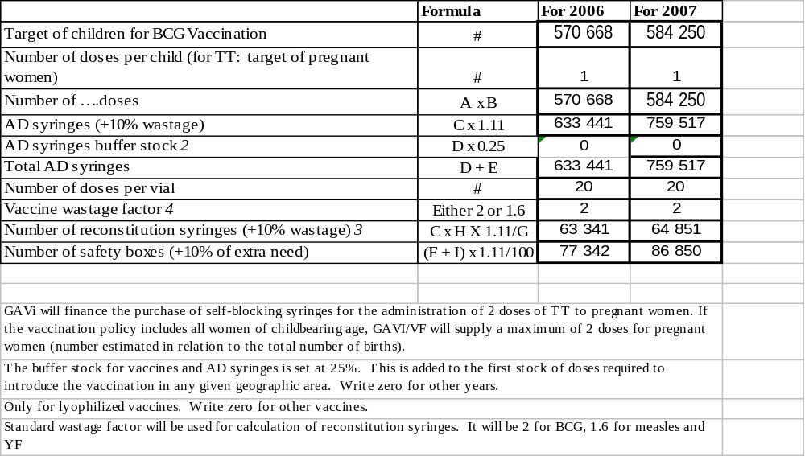

Table 7: Estimated supplies for safety of vaccination for the next two years for DTC-HepB-HIB

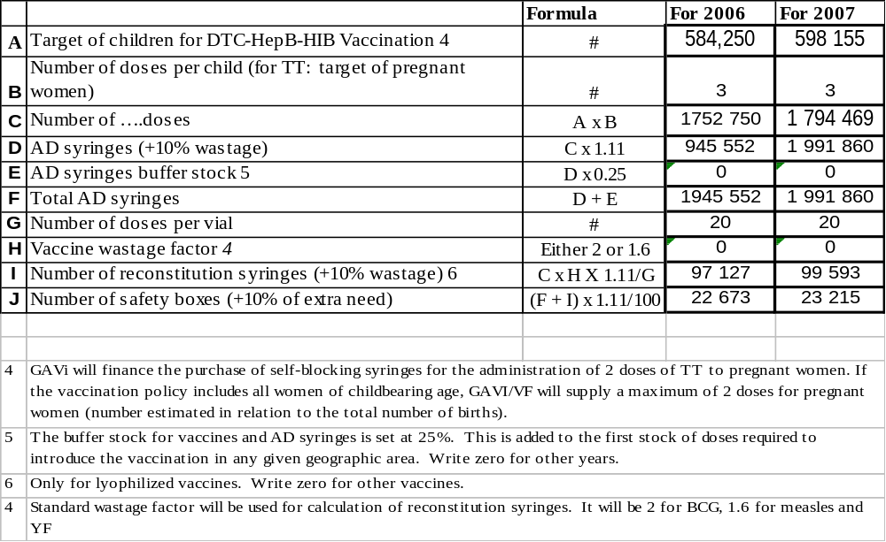

Table 8: Estimated supplies for safety of vaccination for the next two years for Measles

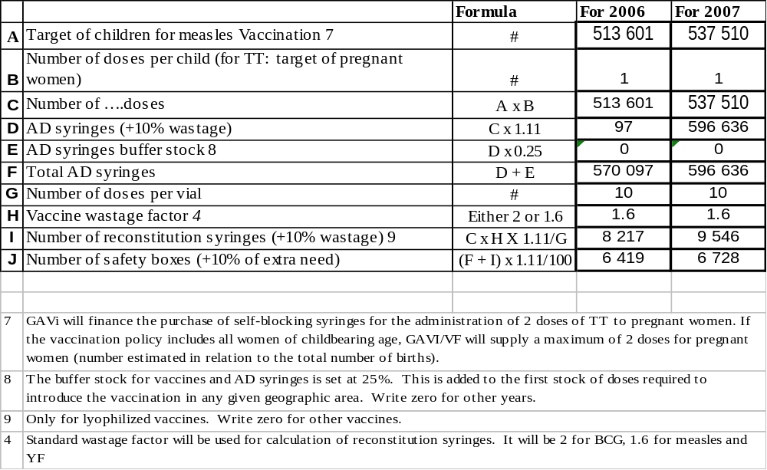
Table 9: Estimated supplies for safety of vaccination for the next two years for TT

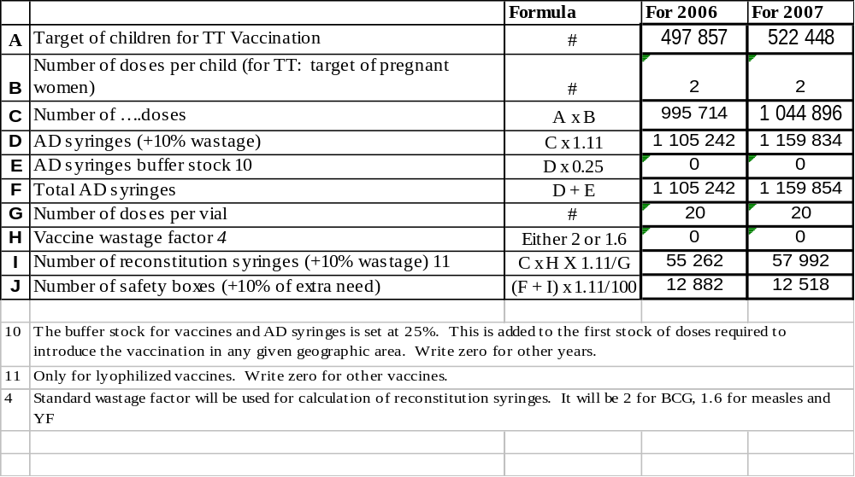

If quantity of current request differs from the GAVI letter of approval, please present the justification for that difference.

In the letter of approval and in the plan for the financial viability the base data used were those from the RGPH* for 1996 (in 1996 the population was 10,312,609 inhabitants, with a rate of growth of 2.38%, it will be 13,357,799 inhabitants in 2007), EDS* for 1998-1999 (the gross birth rate is 46.1 per 1000 and the infant mortality rate is 105 per 1000). Given the problems associated with estimating the denominator and estimated coverage levels in 2004, and in order to have figures which were consistent with the common WHO/UNICEF report form, data for populations provided by all districts (birth rate 46.1 per 1000 and mortality rate of 83 per 1000) were used in order to obtain the number of surviving infants. This will have an impact on quantities of vaccine and consumables for new vaccines.

4. Please report on progress since submission of the last Progress Report based on the indicators selected by your country in the proposal for GAVI/VF support

Indicators | Targets | Achievements | Constraints | Updated targets
Taux de couverture en  BCG  DTC1  DCT3  Polio3  Measles 1  Yellow fever  TT2+  Protection against tetanus at birth | Objectives en 2004  BCG : 91%  DTC1 : 91%  DCT3 : 80%  Polio3 : 80%  Measles 1 : 80%  Yellow fever : 80%  TT2+ : 80%  Protection against tetanus at birth | Results obtained in 2004 :  BCG : 100,17%  DTC1 : 101,19%  DCT3 : 87,73%  Polio3 : 82,75%  Measles 1 : 77, 75%  Yellow fever : 75,46%  TT2+ : 64,99% | - The lack of EPI training for new agents.  - Administrative slowness in unblocking GAVI funds and in acquiring equipment for the cold chain.  Failure to achieve coverage objectives for some antigens: TT, YF, measles.  - Lack of promptness in the transmission of monthly reports.  - Irregularity in feedback information from the central organisation to the regions.  Inadequate maintenance of cold equipment.  - Defective vehicle logistics (motorcycles) | In 2005:  Children from 0 to 11 months  - BCG: 100%  - DTC3: 90%  - Measles: 90%  - YF: 90%  Pregnant women  TT2: 80%

Checklist

Checking of the completed form:

Item: | Completed | Comments
Date of submission | x
Reporting Period (consistent with previous calendar year) | x
Table 1 filled-in | x
DQA reported on | x
Report on use of 100,000 US$ | x
Report on the Safety of Injections | x
FSP Reported on (progress against country FSP indicators) | x
Table 2 filled-in | x
New Vaccine Request completed | x
Revised request for injection safety completed (where applicable) | x
ICC minutes attached to the report | x
Government signatures | x
ICC endorsed | x

6. Comments

ICC/RWG comments:

The CCIA/EPI is an organisation which is operating well in Burkina Faso. It would be desirable for the text to be revised and for the chairmanship to be taken by the Minister of Health, and that the Ministry of Finance should be involved. A technical committee must be set up to provide technical support for CCIA decisions. The appropriate distribution of GAVI funds must also be noted, access essentially at operational level (health districts) and on the actual needs of the districts with regard to immunisation.
The conclusions of the inventory which was held in the course of the year 2004 show that the cold chain is ready. Its capability and functioning are adequate for the receipt of new vaccines.
Members of the CCIA adopted the 2004 Progress Report in the course of their meeting on the 29 April 2005.

7. Signatures

For the Government of ………………..…………………………………

Signature: ……………………………………………...……………...

Title: ………………………………………….………………….

Date: ………………………………………….………………….

We, the undersigned members of the Inter-Agency Co-ordinating Committee endorse this report. Signature of endorsement of this document does not imply any financial (or legal) commitment on the part of the partner agency or individual.

Financial accountability forms an integral part of GAVI/The Vaccine Fund monitoring of reporting of country performance. It is based on the regular government audit requirements as detailed in the Banking form. The ICC Members confirm that the funds received have been audited and accounted for according to standard government or partner requirements.

Agency/Organisation | Name/Title | Date Signature | Agency/Organisation | Name/Title | Date Signature
Minister of Health | Pr Agr G J OUANGO  Secretary General
WHO | Dr Mohamed Hacen  WHO Representative
UNICEF | Mme Joan French  UNICEF representative
FED –ARIVA project | Dr Hamidine Mahamane  Coordinator

~ End ~

