LIBERIA’S CLARIFICATIONS TO GAVI IRC COMMENTS
Rotavirus Vaccine Clarifications:
1) Provide dates when cold chain will be adequate to hold vaccine supply. GAVI disbursement of vaccine or finance is contingent on this matter being clarified.
Clarifications: The two additional regional walk-in cold rooms proposed in the application will be located in Central and South-Eastern regions. The sites for the two cold rooms have been identified in these regions and the sketch plan completed. The contract for the construction is soon to be awarded. The request for the procurement of the cold rooms has already been made to UNICEF by the Ministry of Health & Social Welfare and procurement will be done in the first quarter of 2014. The cold rooms will be assembled and made operational before the proposed date of introduction (October 2014).
All health facilities offering immunization services have been provided with solar refrigerators for vaccine storage. In addition, there are new sets at the central level for the replacement of faulty ones and installation in new facilities to be constructed.
Liberia’s initial choice of the three-dose schedule (Rotateq) was based on the information provided of its availability and that the two-dose schedule (Rotarix) was not going to be available until 2015 or beyond. Post IRC review, UNICEF Supply Division through GAVI Headquarters has indicated that the first shipment of Rotarix could be made available to Liberia in the fourth (4th) quarter of 2014. In this regard, the country wishes to switch to the two-dose schedule for which the current cold chain space and shipment schedule can accommodate. Notwithstanding this, the expansion of the cold chain system will still be pursued vigorously.

Comments from GAVI:

1. Liberia has clarified when cold rooms will be available and has also clarified what CC capacity is available at the HF level.

2. Liberia is switching from Rotateq 3-dose schedule to rotarix 2-dose schedule which has a significant impact on the requirement of cold chain capacity. The country has been asked to provide the projected month and year of rotavirus vaccine introduction and the corresponding target number of children for the duration of support, taking into account the time required to complete the activities outlined in the Vaccine Introduction Plan and other priorities in the country.
2) Please describe the current system for reporting on adverse events following immunisation, the mechanisms in place to respond to adverse events and the plans for strengthening this system.
Clarifications: Standard AEFI case reporting and investigation forms already exist. These were revised during the mass preventive Yellow Fever campaign in 2009 and have continued to be used since then. The reporting channels consist of Community to health facility and from facility to District Surveillance Officer (DSO) and then to County Surveillance Officers (CSO) as illustrated below.
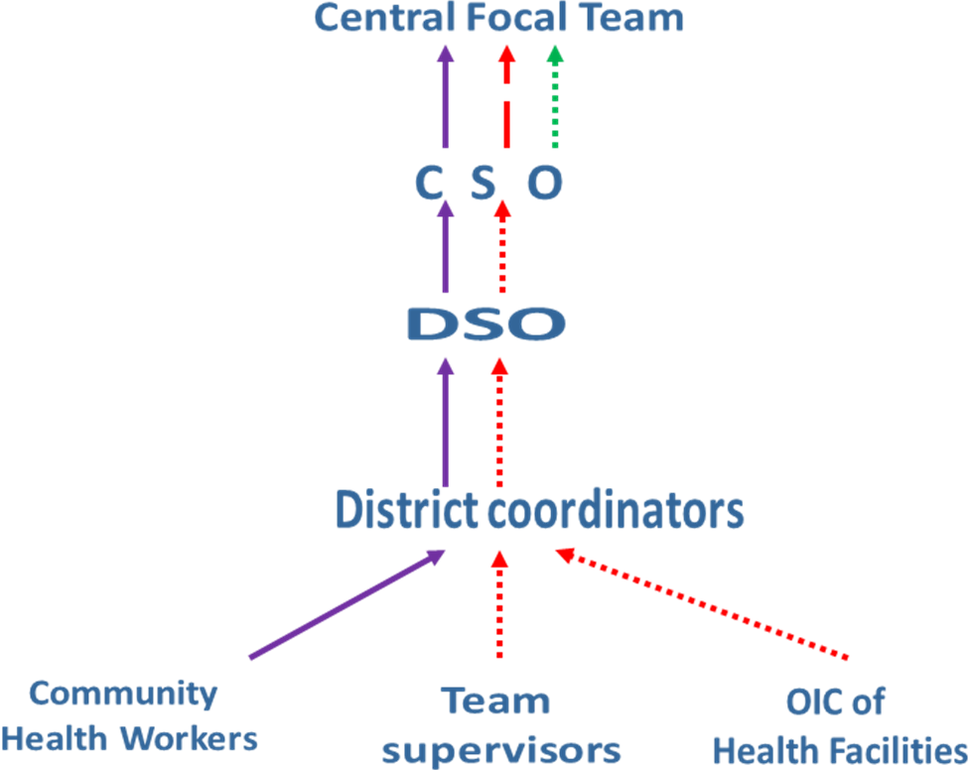
The areas to be strengthened includes training of staff on AEFI reporting and investigation. There will be increased collaboration with pharmagovigillance system been established by the Pharmacy Board. Cases would be managed in County hospitals and linkages have been established with reference laboratories in and outside the country. Part of the communication strategy also includes how to deal with rumours.

Comments from GAVI:
The country has sufficiently clarified the AEFI process.

3) Clarify how Liberia will address budget gap between what is budgeted and what GAVI will fund.
Clarifications: Cost (and finance) to introduce the Rotarix, 2 -dose schedule US$
Cost Category | Total cost for preparation of and  delivery of campaign in US$ | Funded with GAVI introduction grant in  US$
Training | 37,786 | 37,786
Social Mobilization, IEC and  advocacy | 67,000 | 30,214
Cold Chain Equipment &  Maintenance | 400,000 | 0
Vehicles and Transportation | 15,000 | 15,000
Programme Management | 12,000 | 12,000
Surveillance and Monitoring | 5,000 | 5,000
Human Resources | 0 | 0
Waste Management | 7,000 | 0
Technical Assistance | 6,000 | 0
Other (please specify | 0 | 0
Total | 549,786 | 100,000

The budget to be supported by GAVI has been adjusted accordingly to US$100,000.
Additional funds will be mobilized through traditional partners who have already shown commitment. Funding for cold chain equipment, vehicles and Technical Assistance (TA) have been secured through the new Health System Strengthening (HSS) grant, funds for Surveillance activities are secured through WHO and Social Mobilization activities secured through UNICEF.
Comments from GAVI:
The country has sufficiently clarified the funding gap between the needs and what is available.
HPV Demonstration programme clarifications:
1) Budget is over what GAVI will allow. Clarify how Liberia will fund the gap and/or how the budget can be reduced. Clarifications: The budget has been adjusted accordingly as per the below table.
Cost category | Funding source | Estimated costs per annum in US$
Cost category | Funding source | Year 1 | Year 2
TAG meetings | GAVI | 3600 | 600
Programme management and coordination | GAVI | 14400 | 5000
Cold chain equipment | GAVI | 0 | 0
Other capital equipment (describe) | GAVI | 0 | 0
Personnel, including salary supplements and/or per diems | GAVI | 14400 | 11400
Transport | GAVI | 16500 | 6500
Training | GAVI | 32847 | 7000
Community sensitization and mobilization | GAVI | 5000 | 2026
Waste disposal | GAVI | 5000 | 0
AEFI monitoring | GAVI | 2500 | 2315
Monitoring and supportive supervision | GAVI | 6000 | 6000
Evaluation of vaccine delivery | GAVI | 30,000 | 14000
Assessment of feasibility of integrating ADH with HPV vaccines | GAVI | 5000
Drafting national cervical cancer prevention and control strategy | GAVI | 20000 | 0
Technical assistance from local experts | GAVI | 8000 | 5000
Subtotal from other funding sources | Other Partners | 0 | 0
TOTAL |  | 163247 | 59841

Comments from GAVI:
The country has adjusted the budget.

2) The country should be made aware that they can ask for an additional US$25,000 to be disbursed in year 2 exclusively if they decide to integrate vaccination with other ADH services.
The country takes note of this provision and will revert back to GAVI appropriately.

Comments from GAVI:
The country has confirmed that they are aware of the additional funding and has confirmed they will inform GAVI if there are changes which will make them eligible for the additional funding.

3) Please ensure that, if you are conducting activities that might be deemed research, you seek the appropriate ethical approvals based on your national guidelines, and if applicable, submit a copy of the approval letter with year 1 deliverables.
The Country has national Ethical Committee and the secretariat is housed in WHO and any research linked to this proposal will follow due process.

Comments from GAVI:
The country has sufficiently responded to the question.

Geneva 12-12-2013

