ROTECTING CHILDREN AGAINST VACCINE PREVENTABLE DISEASE
National Plan for Strengthening Cold Chain and Logistics Systems in Haiti
November 2011
Objective: | Strengthen the EPI Cold Chain and Logistics System Prior to Introducing New Vaccines (Penta/2012 - PCV13 +Rota/ 2013)
Components: | - Central Vaccine Cold Store;  - Intermediate Vaccine Depots;  - Health Centers.
Total Cost: | 2011-2012 | 2013-2023
 | $9,405,112 | $25,889,282
Secured Funding: | $4,201,200 | $0.00
Funding Gap: | $5,203,912 | $25,889,282
Country: | Republic of Haiti
Partners: | MOH/DNPEV; UNICEF; WHO; CDC; CIDA; JICA; Cooperation Brazil/Cuba/Haiti;
PROJECT SUMMARY

TABLE OF CONTENTS

ISSUE

Country Background 3

Status of the Cold Chain 6

ACTION AND IMPACT

Main Issues and Responses 8

Summary of the Rehabilitation Plan 13

BUDGET

Budget Projections 14

Annex: Gap Analysis 15

1. COUNTRY BACKGROUND
Haiti is a hugely unique country, rich in history, culture and music. It was the first independent nation in Latin America and is the only predominantly francophone independent nation in the Americas. Yet Haiti is also the least developed and most densely populated country in the western hemisphere. Centuries of repression, conflict, recurrent disasters, political instability and economic adversity have brought grinding hardship and undermined Haiti’s potential for economic growth. Even before the January 2010 earthquake Haiti’s development indicators were comparable to some of the most vulnerable African and Asian countries; three quarters of Haiti’s population of 10.03 million people were already surviving on only US$ 2 per day, and half on US$ 1 per day.
Moreover, Haiti is one of the most unequal societies in the world, with a vast wealth gap and social inequalities; 70 per cent of national income goes to the richest 20 per cent of the population, while the bottom 20 per cent receives less that 1.5 per cent, and the chances that a child whose parents are among the richest 20 per cent of the population will go to secondary school are 18 times higher than those of a child whose parents are among the poorest 20 per cent. There are also stark and increasing disparities between rural and urban areas, marked by rapid urbanisation and persistent rural impoverishment.
The confluence of emergencies in 2010 undoubtedly presented a huge threat to MDG 4 (reduce child mortality), eroding progress achieved over previous years in reducing the Infant Mortality Rate (IMR) from 105 per 1,000 live births in 1990 to 64/1,000 in 2009, and the Under Five Mortality Rate (U5MR) from 152 per 1,000 live births in 1990 to 87/1,000 in 2009 (Haiti had been on track to achieve the U5MR component of MDG 4 – to reduce the U5MR by two thirds by 2015). Progress was highly uneven between Haiti’s top and bottom quintiles, with the burden of high child mortality weighing disproportionately on the poorest and most vulnerable segments of society.
Despite the overall (albeit uneven) progress, Haiti’s child mortality rates remained unacceptably high (the highest in the Americas) with one in every thirteen children dying before their fifth birthday. The leading causes of death in children under the age of five are acute respiratory infections (ARI), diarrhoea and neonatal infections. The elevated mortality rates were attributable to the lack of access to timely and quality basic health care. Before the earthquake, public funds spent on health represented only US$ 2 per person, and had shown a decline. Half of Haiti’s population lacked access to medicines, and 47 per cent did not have access to health care, neither through the public sector (comprising only one third of the country’s 663 health institutions), semi-public sector (composed of non-profit institutions that are supported mainly by NGOs.
This was due to the extremely centralised nature of the health system; for example, approximately 73 per cent of all physicians, 67 per cent of all nurses, 35 per cent of all health care facilities, and 52 per cent of all hospital beds were concentrated in the West department containing Port au Prince (PAP), yet served only one third of Haiti’s total population. Vast disparities also existed between urban and rural areas in general, and between departments; for example, in 2008, fewer than 40 per cent of the population had access to basic health services in certain departments such as the West, North, and Northeast.
Accessibility is low due to financial barriers; even public services were not free of charge, with local health facilities heavily dependent on income to pay for part of their staff and services. Furthermore, even when accessible, health services are generally poor in quality due to infrastructural deficiencies and lack of supervision and human resources (there were only 2.5 physicians per 10,000 inhabitants in 1999). This absence of a comprehensive public health system offered some explanation of why 80 per cent of Haitians turn to traditional healers.
In terms of the expanded programme for immunisation (EPI), while polio and measles have been controlled in Haiti an estimated 10 per cent of children had never been vaccinated, according to the last nationwide demographic and health survey, underlining the need to ‘narrow the gaps’ and reach the hardest to reach with sustainable services. According to the same source, only 58 per cent of children under five had been vaccinated against measles, and 53 per cent had received all three doses of the Diphtheria, Tetanus and Pertussis (DTP) vaccine. Figures were even lower in terms of children receiving vaccines before the age of 12 months – the recommended World Health Organisation (WHO) guideline by when the complete course of childhood vaccinations should have been administered – only 33 per cent of children had been fully immunised at this age.
Statistics are proportionally lower in rural areas (40 per cent of 12-23 month olds fully vaccinated, compared to 45 per cent in urban areas) and within the poorest quintile of the population (34 per cent of 12-23 month olds fully vaccinated, compared to 56 per cent of children from the richest quintile) . Most disturbingly, 44 per cent of communes in Haiti had less than 50 cent vaccination coverage, indicating that there are some serious gaps that pose a threat not only for children in these communities – but for the rest of the country as a whole.
Administrative data from MSPP indicates that approximately 119,558 children have been against measles, 182,605 against DTP and prevent tuberculosis primo-infection and tetanus for 179,360 children under 12 months during the year 2010. At the same time, eradication of polio in Haiti continues to be a reality and 164,894 children under 12 months in 2010 received three doses of OPV. Moreover, specific support (including from UNICEF) to 20 communes with low immunization coverage led to a 150% increase in the number of children immunized in these targeted districts, rising from 7,847 children receiving 3 DTC doses to 19,609 children.
National Immunization Schedule – Traditional and New
Target groups for Traditional and New vaccines
Vaccines for Children | Waste % | Dose/Fl | Doses  0-11 months | Doses  12-23 months
BCG | 50 | 20 | 1 | 0
OPV | 30 | 10 | 4 | 1
DTP | 30 | 10 | 3 | 1
RR | 30 | 10 | 1 | 0
Vaccines for Women | Waste % | Dose/Fl | Doses  Pregnant | Doses  15-49 yrs
dT | 30 | 10 | 2 | 2

Vaccines for Children | Waste % | Dose/Fl | Doses  0-11  months
DTP-HepB-Hib | 5 | 1 | 3
PCV 13 | 5 | 1 | 3
Rota | 5 | 1 | 2

Haiti Population Projections 2012 - 2017 (*)
 | 2012 | 2013 | 2014 | 2015 | 2016 | 2017
Total Population | 10,649,600 | 10,943,529 | 11,245,571 | 11,555,948 | 11,874,893 | 12,202,640
Birth cohort | 298,189 | 306,419 | 314,876 | 323,567 | 332,497 | 341,674
Surviving infants | 281,192 | 288,953 | 296,928 | 305,123 | 313,545 | 322,198
Pregnant women | 298,189 | 306,419 | 314,876 | 323,567 | 332,497 | 341,674
Women 15 – 49 years | 2,787,000 | 2,863,922 | 2,942,966 | 3,024,192 | 3,107,659 | 3,193,431
(*) RGPH – 2003 IHSI-UNFPA

2. STATUS OF THE COLD CHAIN LOGISTICS SYSTEM (CCL)
Since 2001, assessments of Haiti’s CCL system have been commissioned by various EPI Partners. Experts’ reports are consistent in describing the structural faults and gaps in the system, and most recommend similar remedial actions to address its deficits, including those after the January 2010 earthquake, which further weakened the already fragile system.
Among the numerous interventions required to rehabilitate Haiti’s CCL system, two issues present particularly serious concerns:
- Poor cold chain and inadequate infrastructure at 30 intermediate vaccine depots;
- Unsecure funding for Liquid Propane (LP) Gas which is essential to maintaining cold chain integrity at health facilities.
In addition to these constraints however, the CCL system will be challenged even more by the introduction of three new antigens in the country’s vaccination schedule. The antigens are:
- Pentavalent in 2012;
- PCV13; and
- Rota in 2013
Therefore the provision of adequate cold chain storage capacity in 2011, and the reorganization/funding of the EPI Logistics system before 2012 must become short term priorities for the Programme and its Partners.

2.1. Description of the CCL System
Immunization services in Haiti are provided through 10 Departments; 140 Communes and 553 Communal Sections. The CCL system for immunization operations Haiti has three operational levels as shown by the graph in next page.
- Central Level – One (01) vaccine store located in Port-au Prince at PROMESS
- Intermediate Level – Thirty (30) vaccine stores and sub-stores at Departments/Communes (*)
- Health Facility Level - Six hundred seventy six (676) HCs at urban and rural localities
The central vaccine store receives vaccines quarterly from abroad. Quarterly deliveries of vaccines are made from the central store directly to a network of thirty intermediate depots and sub-depots. Each intermediate depot and sub-depot is the location where six hundred and seventy six health facilities come to collect vaccines and supplies on a monthly basis.

The challenge of introducing Penta in 2012, followed by PCV 13, Rota in 2013 require an analysis of the present transport and distribution system to determine its cost effectiveness. Efforts are currently underway to:

- Determine alternate delivery schedules and/or routing schemes
- Apply optimal delivery schedules to the new CCL system

(*) One store in the Metroplolitan was totally destroyed by the 2010 earthquake, and will not be reinstated.
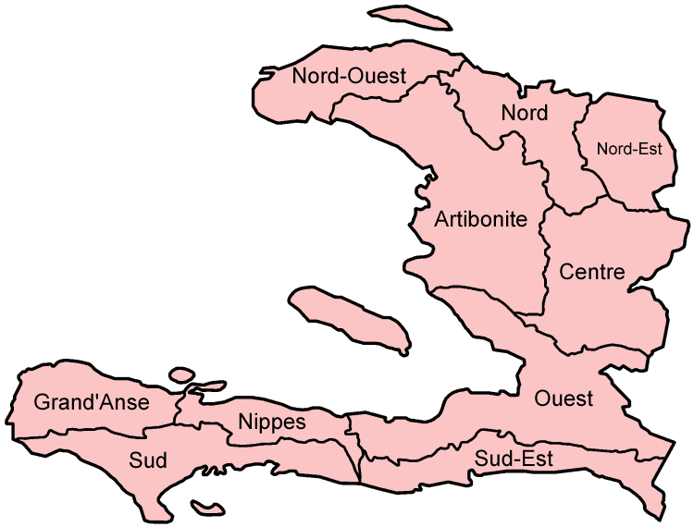
3. MAIN ISSUES AND RESPONSES FOR CCL
A - Central Level Issues and Responses
- Issue # 1 – Insufficient cold storage capacity
- The vaccine storage space required to store traditional and new vaccines in 2012-2015, at the rate of four deliveries a year, is estimated at 60 m3. Presently, only 17 m3 of storage capacity is available. That storage space is sufficient to store traditional vaccines only. Thus a gap of 33 m3 in vaccine storage capacity needs to be bridged before 2012.
- Responses to Issue # 1 – Provision of additional Cold storage capacity
- Three (03) new walk-in cold rooms of respectively 40, 20, and 20 cubic meters of storage capacity are presently available at a UNICEF/PAP warehouse. As per the consensus reached between between MoH, OPS, and UNICEF the three new units will be installed at PROMESS. The combined capacity of 80 m3 between the three new cold rooms will exceed by 50% the volume required to bridge the storage gap identified at the central level.

- Two local companies have responded to UNICEF’s call for bids on the installations. Discussions are presently under way between the MoH, OPS, and UNICEF over the construction of an extension to the building where the three additional cold rooms are to be installed. The completion of building extensions and the installation of cold rooms are scheduled for January 2012. Additional cold rooms will need more electrical energy and for that, UNICEF has planned to purchase additional three (03) electric generators for the Government’s management at the Central level but currently lacks funds for this purpose. At the same time, UNICEF planned to purchase seven (07) electric generators to support EPI at the intermediate level, however, there is currently a funding gap for these procurements as well. Total funding gaps in this area to 2023 are $ 211,400.
- Issue # 2 – Insufficient dry storage capacity
- By year 2017, the dry storage volume required to store injection material will be 253 m3. Presently, vaccines dispatched from PROMESS to the intermediate depots are not systematically bundled with injection materials. This situation occurs mainly because the storage and management of EPI injection material and dry goods in PAP is split between PROMESS and other MoH facilities.
- Responses to Issue # 2 – Provision of additional dry storage capacity
- Discussions are ongoing between MoH, OPS, and UNICEF to consolidate the storage of all EPI injection materials and dry goods at PROMESS. The provision of adequate dry storage space will be integrated in the planned expansion of buildings. Completion of building extension and provision of dry storage space are scheduled for March 2012. UNICEF will provide technical assistance to ensure building standards and is interested in supporting construction costs, if adequate funds are mobilized.

- Issue # 3 – Waste management

- It is estimated that ninety six (96) incinerators are needed by EPI to properly eliminate contaminated sharps produced from vaccination. To dispose of its biomedical waste, the EPI has 46 incinerators available, of which 37 are installed. Nine (090) have been awaiting installation since 2006 by the SOGEBANK Foundation. Seventeen (17) electrical incinerators are malfunctionning and are awaiting to be fitted with the proper spare parts. The equipment is not standardized and is comprised of a mix of biomass and electrical/fuel models. Overall however, the utilization of available incinerators is poor for technical and managerial reasons.
- Responses to Issue # 3 – Strengthening of waste management system
Waste management is one of the greatest concerns of UNICEF and the organisation is seeking funding to support the Government to:
- Pay for the cost of repairing the 17 electrical incinerators that are out of order;
- Purchase Eighty-five (85) new electrical incinerators in 2012;
- Purchase Fourty-five (45) new electrical incinerators in 2013;
- Support the operating costs of the incinerators, and the system of collection/incineration of filled Safety Boxes from health facilities.
- Issue # 4 – Management of vaccines at the central level
- PROMESS is a central medical store directly operated by PAHO. The facility manages the national network for the distribution of essential drugs. Because the EPI Programme does not have its own central cold chain store, vaccines are kept at PROMESS. The vaccine storage equipment consists of walk-in cold rooms procured and installed by UNICEF.

- An annual fee representing ten percent of the value of antigens has been paid by UNICEF to PROMESS to support the safekeeping of EPI vaccines – however these costs are not sustainable and UNICEF continues to advocate with the Government and Development Partners to allocate funds for these costs.

- PAHO and UNICEF continue to work to enhance the capacity of the Government to progressively manage the national medical stores independently. However, the EPI personnel responsible for vaccine management at the central level are absent from PROMESS. The national manager of the central vaccine store works at the MoH, where no vaccines are stored.
- Responses to Issue # 4 – Strengthening management of the central vaccine store
- MoH and UNICEF are reviewing TORs for a vaccine manager at the central level. This staff is responsible for vaccine management at central level – and will work at PROMESS.
- A new National CCL Manager (that works on vaccines; logistics and the cold chain teams throughout the country) with the desired profile has recently been appointed by the MoH, as a result of UNICEF advocacy;
- To better support the Government with technical assistance, UNICEF has also created and will fund a new National Officer post for CCL Logistics. The preferred candidate should begin working before the end of 2011;
- Mid-Level Management training (a training course for national and sub national EPI staff) is planned in 2011/2012, with costs and technical assistance supported by UNICEF.
- Issue # 5 – Transport and distribution of EPI vaccines and commodities
- Cold Chain Technicians stationed at EPI Directorate in PAP routinely make rotations to carry out the actual distribution of vaccines and injection materials to the 30 stores at the intermediate level. UNICEF usually supports the local costs of these scheduled distribution activities. Recently however, ad-hoc shipments of vaccines have become common due the frequent failure of the cold chain at intermediate vaccine warehouses. Shortages due to poor planning and/or crisis situations explain why small quantities of vaccines have to be constantly fed to the depots on an ad-hoc basis.

- For many years, UNICEF has been supporting the Government by purchasing LP gas, but due to poor management of available LP gas, failures of distribution often occur at health facilities. This creates a situation of chronic cold chain disruption. In an environment where temperatures are not satisfactorily monitored, this situation makes the largest portion of the national cold chain very vulnerable to spoilage.
- Responses to Issue # 5 – Managed transport and distribution system for CCL
- Using the fairly accurate data bases available on vaccine quotas by locality, and on the GPS positionning of health facilities, an initiative is underway to select optimal delivery schedules, cargo configurations, and best routing schemes for the new vaccine supply chain of EPI Haiti. UNICEF is providing technical assistance to the Government for this initiative and is seeking funds to continue the effort.

- The Government of Brazil’s mission through the Tripartite Cooperation (Haiti/Brazil/Cuba) has recently committed itself to made available three mid-size 4X4 trucks to the EPI Programme. The acquisition of this fleet will allow the consolidated delivery of vaccines, injection material, LP Gas, and other EPI commodities. Presently, each commodity is transported separately from the same locations to the same destinations. Budgets for the running costs of these trucks are developed from the planning of optimal cargo sizes, deliveries schedules, and route mapping.

- The Brazilian mission has also expressed firm intentions to fund the budget of LP Gas. Negotiations are on-going between the mission and MoH, both in Haiti and in international forums.
- Issue # 6: Capacity building and Technical assistance:
Considering the development of new kinds of cold chain equipment (such as the Solar Chills and Fridge Tags) at all levels’ the introduction of new vaccines and the general need to improve knowledge, skills and capacities to manage vaccines and consumables – systematic training and mentoring is required at all levels. With our global and national experience in cold chain management, UNICEF has an important role to play in terms of supporting the Government at both central and decentralized levels to develop and implement a variety of training programmes.

B - Intermediate Level Issues and Responses
To take a quick pulse of Haiti’s CCL, a comprehensive review of the central and intermediate cold chain was conducted in April 2011. At the intermediate level, the poor status of the cold chain equipment, the inadequate layout of many depots, and the inefficient management of these structures are observations documented in several evaluation reports on Haiti’s CCL. By all accounts, the intermediate level is clearly identified as the weakest link of EPI Haiti’s CCL system. Stores are in great need of short term rehabilitation of their cold chain equipment, and infrastructure in general.

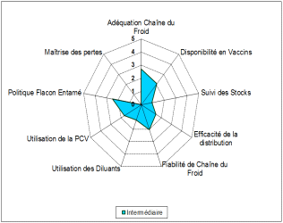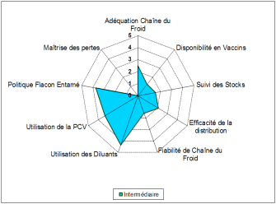Summary of indicators of four Sub Stores 2006 Summary of indicators of same four Sub Stores 2011

These charts provide a summary of the cold chain assessments. On the outer rim of the web we can see the critical elements of cold chain management. A score between 0 (representing poor performance) and 5 (indicating sufficient performance) has been assigned to each element. These charts indicate that progress has been made in the handling of vaccine but the cold chain inadequacy is stagnant, and its reliability has regressed.

- Issue # 1 – Insufficient cold storage capacity
- The vaccine storage space required to store traditional and new vaccines in 2012-2015, at the rate of four deliveries a year, is estimated at 15 m3. Presently, the combined vaccine storage capacity of the 30 intermediate stores is around 5 m3, made of small Sibir fridges which need to be replaced. Thus a gap instead of 10 m3, will be of 15 m3 in vaccine storage capacity needs to be bridged before 2012.
- Responses to Issue # 1 – Provision of additional cold storage capacity
- Individual gaps in storage capacity have been determined for each of the 30 depots. Calculations are based on quarterly deliveries of all vaccines, and on 200 cm3 of storage capacity per fully immunized child. The combined cold chain capacity needs can be satisfied with the provision of approximately 150 refrigerators of 100 liter capacity each.

- Given the chronic shortage of electricity at the sub national level in Haiti, the recommended refrigerator model is the battery-less solar refrigerator called the “Sure Chill”. This model has just been approved for utilization in EPI Programmes by WHO. The unit cost of the sure chill is around $3.500. The Brazilian mission has expressed strong commitment in financing the procurement of 150 units by March 2012, which would satisfy current needs.
- Issue # 2 – Dry storage capacity
- By year 2017, the combined dry storage volume required to store injection materials will be around 63 m3. In the present situation, health facilities do not always find injection materials at the depots where they collect their vaccines. Because of space constraints at many intermediate vaccine depots, injection materials and other commodities such as LP Gas, etc. are stored at various locations in the same city where vaccines are kept. Consolidating vaccines and related dry goods in the same compound will offer obvious managerial benefits.
- Responses to Issue # 2 – Provision of dry storage capacity
- At each intermediate depot, sufficient floor space needs to be provided for the uncluttered layout of refrigerators, and for the storage of bulky commodities such as diluents, syringes, needles, safety boxes, passive cold chain equipment, and gas cylinders.

- The requirements for dry storage capacity have been estimated for the year 2017 on the basis of 1.5 m2 of floor space for 1 refrigerator. The same amount of floor space is allocated for the storage of all dry goods. The table below shows calculations for each individual store. The estimated average cost of refurbishing each store is $30,000. The Brazilian mission has expressed strong commitment in financing the $900,000 budget, which represents 100 percent of the overall estimated costs.

Cost Projections by Individual Store at the Intermediate Level
# | Vaccine store | Pop 2017 | Nb CS | Cold storage capacity required in liters | Fridges of 100 liter cap. | M3/ Inj Mat | Nb Gas cyl | Total dry Storage Space/M2
1 | Carrefour | 603,456 | 26 | 754 | 8 | 3.335 | 78 | 24
2 | Delmas | 927,807 | 29 | 1,160 | 12 | 5.127 | 87 | 36
3 | Kenscoff | 70,223 | 7 | 88 | 1 | 0.388 | 21 | 3
4 | Pétion-Ville | 430,287 | 20 | 538 | 5 | 2.378 | 60 | 15
5 | Port. Leogane - PAP | 1,131,127 | 22 | 1,414 | 14 | 6.250 | 66 | 42
6 | Croix des Bouquets | 257,618 | 19 | 322 | 3 | 1.424 | 57 | 9
7 | Cabaret | 70,429 | 5 | 88 | 1 | 0.389 | 15 | 3
8 | Petit Goave | 178,502 | 12 | 223 | 2 | 0.986 | 36 | 6
9 | Ganthier | 64,536 | 9 | 81 | 1 | 0.357 | 27 | 3
10 | Arcahaie | 134,477 | 7 | 168 | 2 | 0.743 | 21 | 6
11 | Anse a Galets | 64,561 | 10 | 81 | 1 | 0.357 | 30 | 3
12 | Fonds Verretes | 51,625 | 3 | 65 | 1 | 0.285 | 9 | 3
13 | Cornillon | 61,570 | 2 | 77 | 1 | 0.340 | 6 | 3
14 | Thomazeau | 54,656 | 1 | 68 | 1 | 0.302 | 3 | 3
15 | Anacaona | 206,208 | 11 | 258 | 3 | 1.139 | 33 | 9
16 | Gonaïves | 1,131,238 | 58 | 1,414 | 14 | 6.251 | 174 | 42
17 | Saint Marc | 723,486 | 41 | 904 | 9 | 3.998 | 123 | 27
18 | Hinche | 415,067 | 23 | 519 | 5 | 2.294 | 69 | 15
19 | Mirebalais | 427,247 | 16 | 534 | 5 | 2.361 | 48 | 15
20 | Jérémie | 496,170 | 45 | 620 | 6 | 2.742 | 135 | 18
21 | Miragoane | 316,907 | 29 | 396 | 4 | 1.751 | 87 | 12
22 | Cap-Haïtien | 973,338 | 60 | 1,217 | 12 | 5.379 | 180 | 36
23 | Pignon | 184,259 | 8 | 230 | 2 | 1.018 | 24 | 6
24 | Fort-Liberté | 95,670 | 26 | 120 | 1 | 0.529 | 78 | 3
25 | Port-de-Paix | 506,370 | 38 | 633 | 6 | 2.798 | 114 | 18
26 | Jean Rabel | 259,317 | 26 | 324 | 3 | 1.433 | 78 | 3
27 | Les Cayes | 902,956 | 65 | 1,129 | 11 | 4.990 | 195 | 33
28 | Jacmel | 496,543 | 36 | 621 | 6 | 2.744 | 108 | 18
29 | Thiotte | 165,253 | 12 | 207 | 2 | 0.913 | 36 | 6
 | Total | 11,400,903 | 666 | 14,251 | 143 | 63 | 1,998 | 426

- Issue # 3 – Maintenance of cold chain and EPI Logistics equipment

- The routine maintenance/repair of the cold chain equipment of the intermediate level is the responsibility of a group of twenty (20) “Departmental” cold chain technicians. These technicians are employees of the MoH, and are mostly present at their respective duty stations. But their effective participation in cold chain maintenance is limited by a lack of tools; of spare parts; of means of transport; of irregular salaries and/or, of unclear work contract situations and overall poor support and supervision.

- In practice, maintenance/repair services to the intermediate (and often to Health Facility) levels are provided directly from PAP by a group of nine (09) DNPEV staff dedicated to the support of all “Logistics” interventions in the field, including vaccine and supplies deliveries. Very often, the “Departmental” cold chain technicians do not participate in those interventions, even while they are occurring in their perimeter of responsibility.

- To strengthen cold chain supervision, EPI Directorate has multi-year plan for the purchase of vehicles for the Central level as well as motorcycles for the intermediate and operational levels.

- Response to Issue # 3 – Maintenance of cold chain and EPI Logistics equipment

- The new CCL management system re-assigns the routine maintenance and repair of the cold chain equipment to the “Departmental” cold chain technicians.
- UNICEF has recently procured individual tool kits which will be distributed to each technician. Regular in-service training is also scheduled to build their capacity and upgrade their skills. UNICEF will be supporting this training financially and with technical assistance.
- UNICEF is willing to support the procurement of vehicles and motorcycles in support of the EPI Directorate, if sufficient funds are mobilized (current funding gap for 2012 $ 153,000).
- The EPI Programme has recently recruited a national manager for the CCL system. Care was taken by the MoH to select an officer with the desired profile and competencies. A budget is also inserted in the 2012 plan of operation to finance systematic supervision of the CCL in the field by six technical staff of the central level.

C - Health Facility Level
- Issue # 1 – Cold chain management
- At the peripheral level, more than two thirds of the 676 health facilities that offer immunization services are equipped with an LP gas operated vaccine refrigerator. Surveys have shown a propensity by this refrigerator to reach freezing temperatures. This raises concerns about the protection of new and expensive vaccines that are freeze-sensitive.

- The last inventory of the equipment was done in 2001. Efforts have been made by UNICEF and WHO to update the data base in 2006 and 2009. However, an accurate update of the inventory is key to the correct estimates of costs for replacement and/or expansion of the equipment.

- The systematic recording and monitoring of temperatures is less than adequate from the intermediate level down. Few health facilities maintain records on temperature variations of their cold chain equipment. Except for the central level, existing temperature records are not analyzed.

- Because of poor management as well as delay in funding, health facilities faced frequent disruptions of gas supply. This causes serious concerns about the integrity of the cold chain, and the quality of vaccines that are stored at the service level.

- Each gas operated refrigerator consumes more than 2 cylinders of 25 lb per 30 days of operation. To provide gas operated refrigerator with full autonomy of energy, each one is allocated three (03) LP gas cylinders of 25 lb. Thus a total of 2,090 gas cylinders are circulating in the distribution system. At $ 16 per refill, the monthly budget is around $ 540,000 per year, counting transport.
- Responses to Issue # 1 – Cold chain management
- The gas operated refrigerators have a net storage capacity of fifty five (55) liters. This is enough space to store traditional and new vaccines for one month, for a total population of 10,000 people. Therefore available cold chain capacity is adequate at the facility level.

- In addition to the 676 installed refrigerators, 110 gas operated refrigerators of 55 liter capacity, and 170 solar refrigerators of 19 liter net capacity are being installed at selected health facilities. The idea is to replace all the gas powered refrigerators by the solar powered refrigerators by purchasing and installing approximately 124 new solar refrigerators each year from 2012 until 2015. An EVM is scheduled to take place by end 2012 and will help to determine the number and functionality of existing refrigerators. UNICEF is willing to support the Government to procure these refrigerators, if sufficient funds are mobilized (approximately $2.7 million is required for procurement between now and 2023.This does not include the cost of installation).

- In 2010, three hundred Fridge Tags (FT) to monitor temperatures were installed in EPI refrigerators of four of ten departments of the country. Temperature records are analyzed regularly. Four hundred more FTs are being installed in EPI refrigerators. By end 2012, all EPI refrigerators will be systematically monitored. UNICEF procured these fridge tags for the Government, and continues to be willing to expand efforts.

- To reduce the burden of high recurrent costs for gas, while eliminating the heavy logistics of distributing gas cylinders, the cMyP (complete Multiyear Plan) 2011-2015 of EPI has decided to gradually phase out all gas operated refrigerators by 2015. UNICEF continues to support the planning and realization of this effort.
4. SUMMARY OF REHABILITATION PLAN FOR CCL FOR EPI

Objectives

- To expand the storage capacity of the Central Cold Store;
- To strengthen cold chain capability at thirty Departmental and sub departmental vaccine depots;
- To reorganize cold chain maintenance at the Intermediate and peripheral levels;
- To rehabilitate existing incinerators, and to expand network;
- To strengthen the capacity of cold chain technicians;
- To strengthen the logistics capacity.

Strategies

- Upgrade the central cold store at PROMESS;
- Install new, large capacity electrical refrigerators at thirty intermediate vaccine depots ;
- Establish operational capability for cold chain maintenance and repair;
- Establish and manage a network of incinerators;
- Trained cold chain technicians;
- Purchase vehicles and motorcycles for the improvement of cold chain system.

5. Budget Projections

The total investment required to strengthen Haiti’s EPI cold chain up till end 2012 is US $9,349,512. The funded amount is US $4,201,200. Thus a funding gap of US $5,433,912 remains to be filled.

With the projection of the budget from 2013 to 2023, the total investment needed is of US $ 19,907,382. No funding amount is available now. Thus the funding gap is US $ 19,907,382.

UNICEF stands ready to support the Government with procurement of critical cold chain inputs (such as incinerators; generators; solar chills; fridge tags, etc.) as well as provision of technical and financial assistance to build the capacity of the EPI Directorate and MSPP with training, support and mentoring for planning and implementation processes.

6. ANNEXES
- Budget Projections:
- For 2011-2012

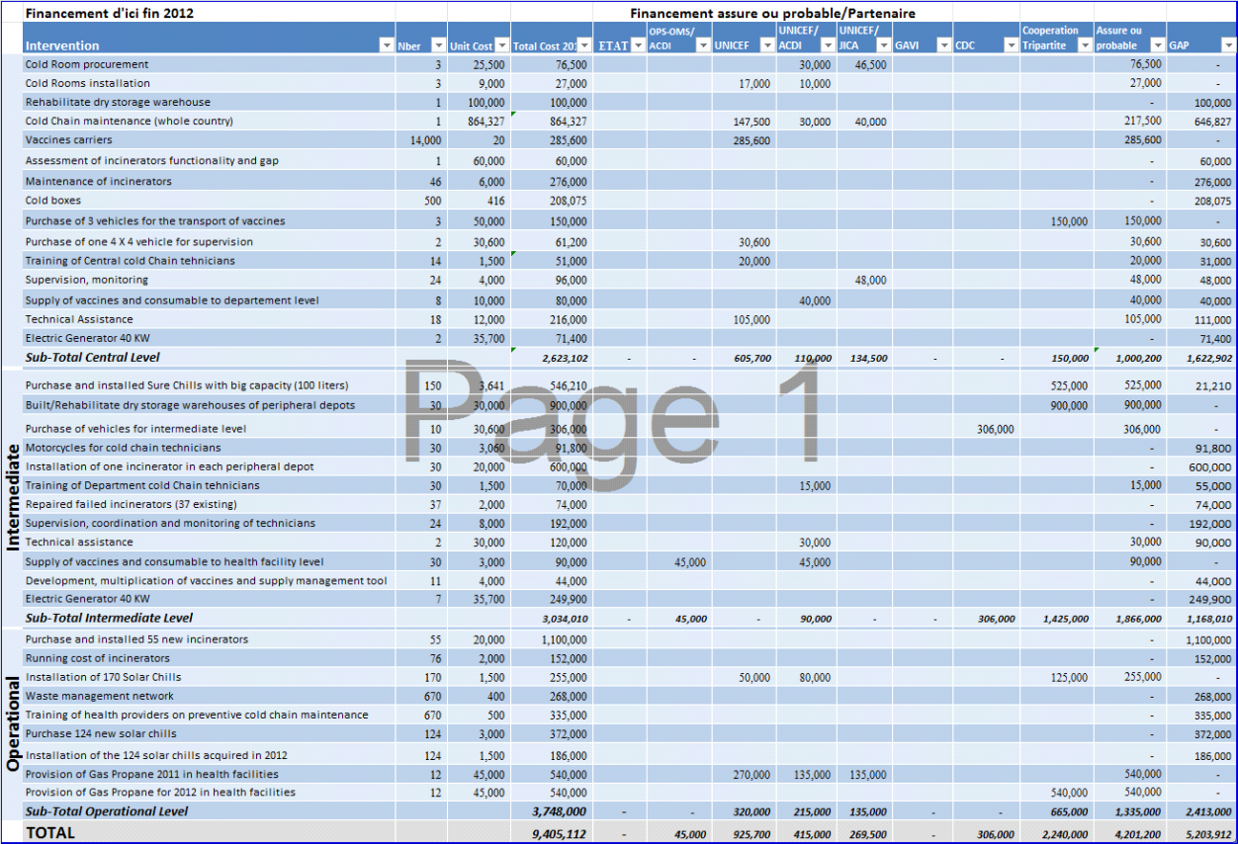

- Indicative Short-Term Timeline
Activities | 2011 |  |  |  |  |  |  |  |  |  |  |  | 2012
 | 1 | 2 | 3 | 4 | 5 | 6 | 7 | 8 | 9 | 10 | 11 | 12 | 1 | 2 | 3 | 4 | 5 | 6 | 7 | 8 | 9 | 10 | 11 | 12
Cold room procurement |  |  |  |  |  |  | X
Cold room installation |  |  |  |  |  |  |  |  |  |  | X | X
Rehabilitate dry storage warehouse |  |  |  |  |  |  |  |  |  |  |  |  |  |  | X
Procurement of Cold boxes |  |  |  |  |  |  |  |  |  |  | X
Purchase of trucks (CCL transport) |  |  |  |  |  |  |  |  |  |  | X
Purchase of vehicles |  |  |  |  |  |  |  |  |  |  |  | X
Purchase of diesel generators |  |  |  |  |  |  |  |  |  |  | X
Procurement of solar refrigerators |  |  |  |  |  |  |  |  |  |  |  |  | X
Dry storage rehabilitation |  |  |  |  |  |  |  |  |  |  |  |  |  |  | X
Procurement of motorcycles |  |  |  |  |  |  |  |  |  |  |  | X
Procurement of incinerators |  |  |  |  |  |  |  |  |  |  |  | X |  |  | X
Repair of out of order incinerators |  |  |  |  |  |  |  |  |  |  |  | X | X | X
Installation of incinerators |  |  |  |  |  |  |  |  |  |  |  |  |  | X | X
Production of management tools |  |  |  |  |  |  |  |  |  |  |  | X

