MINISTRY OF HEALTH/GHANA HEALTH SERVICE
Re – Ghana’s Proposal to the GAVI Alliance: Response to GAVI Decision Letter on Conditional Approval for New Vaccines
Preamble: Ghana submitted application for New Vaccine Support (NVS) submitted in September 2009 which received conditional approval from GAVI as per GAVI Decision letters of 31 March 2010 and December 2010. The country applied for Pneumococcal vaccine, Rotavirus vaccine and second dose measles vaccination in the routine EPI.
Summary of conditions which need clarifications are as follows:
- Resolve the differences in the budget so that correct dosage costs as well as the number of doses are used: for Rota a 2-dose presentation is preferred but 3-doses appear to have been use in the budgetary calculations. The budgetary adjustments are also likely to have implications on the financial gap analyses and these may need to be corrected.
- Clarify the situation with regards to possible needs for cold chain capacity
- Provide further details about possible plans for improving injection safety practices
Ghana is currently applying for introduction of Meningitis A conjugate vaccine and had to revise the CMYP and some of our tables in the new documents address some of the concerns raised in the conditional approval. The country hopes that the Independent Review Committee (IRC) will take into consideration both the old and the revised documents in their consideration of Ghana’s response to the conditionalities. The responses to the conditionalities are in 3 sections - section one providing responses to conditionalities relating to budgeting and financing, section 2 on cold chain whilst section 3 deals with injection safety. The conditionality is indicated in italics whilst the response is in regular fonts (in blue):
- RESPONSES TO CONDITIOALITIES RELATING TO BUDGETING AND FINANCING

  - Resolve the differences in the budget so that correct dosage costs as well as the number of doses are used: for Rota a 2-dose presentation is preferred but 3-doses appear to have been use in the budgetary calculations. The budgetary adjustments are also likely to have implications on the financial gap analyses and these may need to be corrected.
Correct dosage costs as well as the number of doses : we confirm that the two-dose schedule is preferred by Ghana. The Logistics forecasting tool and cMYP Costing tool have therefore been revised to reflect the 2-dose schedule for rotavirus vaccine chosen by Ghana as stated in Section 2.2.3 in the “Introduction Plan for Pneumococcal and Rotavirus vaccines”. The budgetary calculations in the logistics forecasting and the cMYP costing tools for the cost of the rotavirus vaccine have been revised to reflect the 2-dose schedule. The financial gap analyses will therefore reflect the actual financial gap

  - Table 3.5 of the application gives a total programme cost of USD 166.2mil vs USD 211.8mil in the cMYP.

The total programme cost for immunization in the cMYP Costing tool (Costing Worksheet B6:K15) and the cMYP Document under section 4.1.2 includes Shared Health Systems cost of $ 45.6m as shown in the table below.
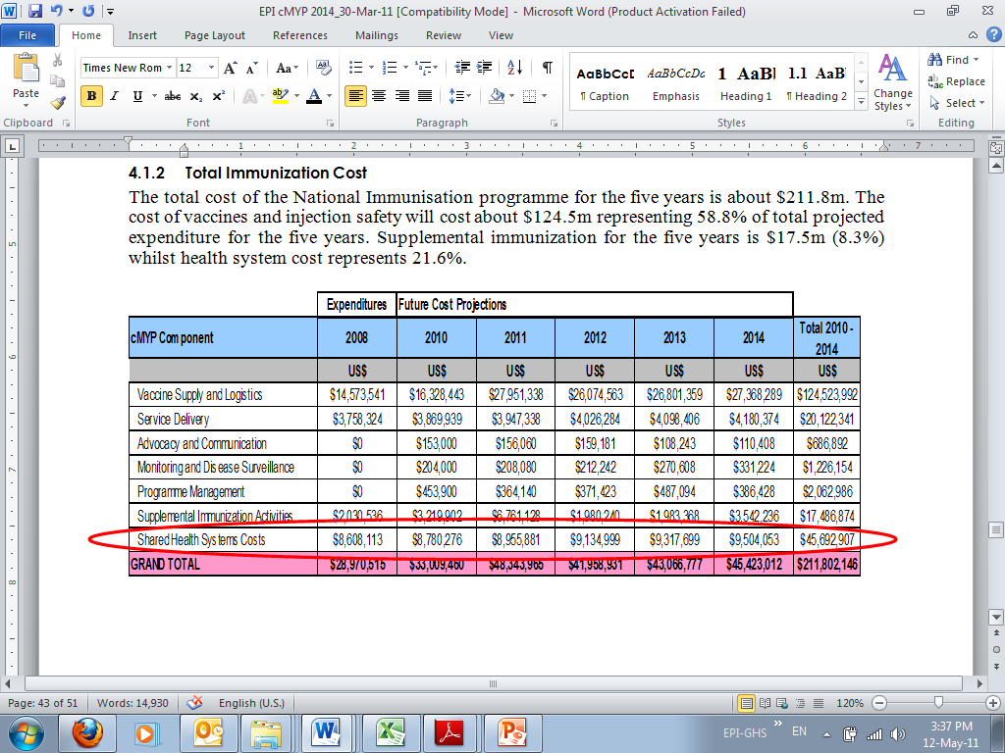

However, the total cost for immunization shown in table 3.5 in the NVS Application does not have a row for Shared Health Systems Cost.

When the Shared Health Systems cost of $ 45.6 is added to the total programme cost of $ 116.2 stated in the NVS Application, it amounts to the same total (that is, $ 166.2m + $ 45.6m= $ 211.8). This accounted for the difference in the two documents.

  - Also table 3.5 is not consistent with table 3.6 (USD 166.2m vs USD 161.9m) – totals for 2011 and 2014 differ

In the financial analysis stated in the decision letter dated 8th December 2010 (table inserted below), the two figures quoted (7,696,000 and 9,883,000) for 2011 in table 3.6 of the proposal for the cost of new and under-utilized vaccines referred only to GAVI contributions.
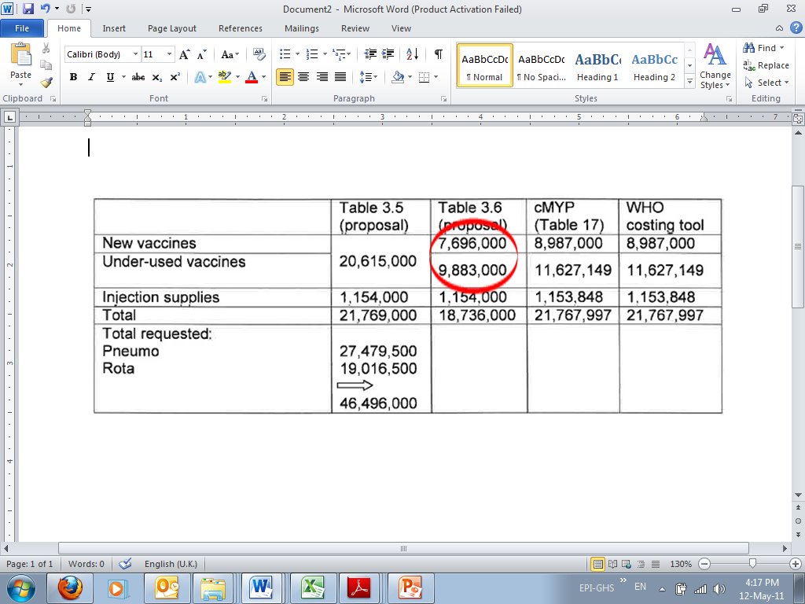
The gap between the sum of the two figures (that is $17,579,000) and the figure quoted in table 3.5 (that is, $20,615,000) of the application is Government contribution (3,036,000) to the new and under-utilized vaccines. This does not affect the totals for 2011 and 2014.
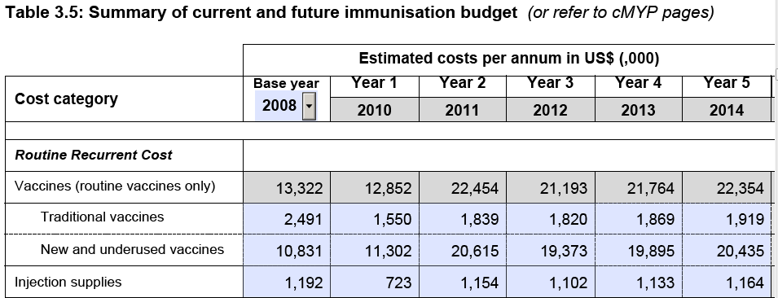

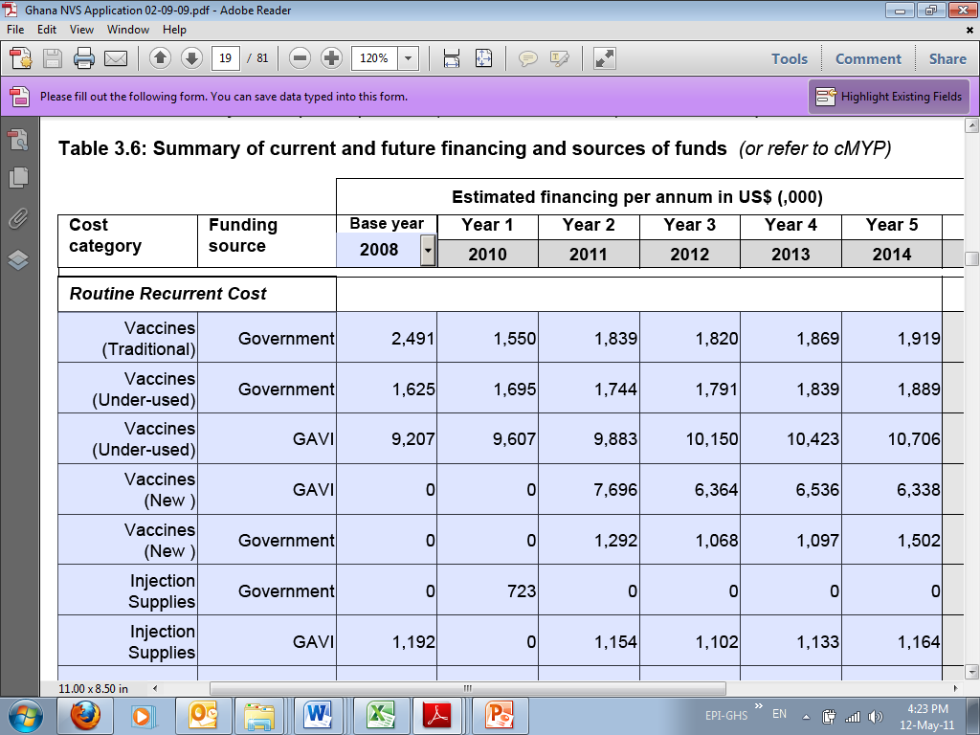
We have realised that the actual cause of the inconsistency in table 3.5 and table 3.6 of the application is, the total cost for Yellow Fever campaign. The cost of the Yellow Fever campaign has been correctly stated in table 3.5 as USD 4,828,000 for 2011. In table 3.6, WHO contribution of USD 3,328,000 to the total cost of the campaign was wrongly stated as USD 500,000. Also, the total cost for measles campaign in 2014 has been correctly stated in table 3.5 of the proposal. In table 3.6, Government contribution of USD 1,465,000 to the total cost of measles campaign for 2014 was omitted. The two errors therefore accounted for the differences in the total cost for 2011 and 2014.

  - There are also differing figures for the cost of the new vaccines within the cMYP costing tool and between this tool and the proposal

The cost of the new vaccines in all sections of the cMYP 2010 – 2014 have been rectified and are now the same (Please refer to “Revised CMYP document”).

  - The co-financing amounts for year 2011 on page 23 mentions USD 15 – 20 for all vaccines not USD 0.15 – 0.20. Coverage in the application form for the rotavirus vaccine is calculated at 94%. However, the new vaccine introduction plan aims to reach >85% coverage by 2015

The issue on the correct co-financing for Ghana has been noted and addressed in the revised version of the cMYP. The correct co-financing level is USD 0.15 - 0.20.

The correct target coverage for rotavirus vaccine as indicated in the proposal is 94%. The target coverage of >85% in the vaccine introduction plan has therefore been corrected.

- Clarify the situation with regards to possible needs for cold chain capacity
Issue:
The WHO logistics planning tool was used to assess the existing cold chain capacity and additional requirements for both national and regional stores. However, the need for expansion of the cold chain capacity is unclear. The proposal states that there is need for cold chain expansion at the regional level. This requires 22 TCW300 fridges, 11 TF800 freezers and 3 Walk-in-cold rooms together with 693 cold boxes for the regions and districts at an estimated cost of $60,000. The various documents also state that the Government had earlier planned an extensive expansion of the cold chain capacity in anticipation of introducing new vaccines.
Condition:
- Clarify the situation with regard to possible needs for cold chain capacity

Clarifications on cold chain needs is provided as follows:
The estimations for the cold chain have been reviewed based on the updated vaccines volumes.

National level:
There is no need for the cold chain capacity expansion at the national store (see table below).
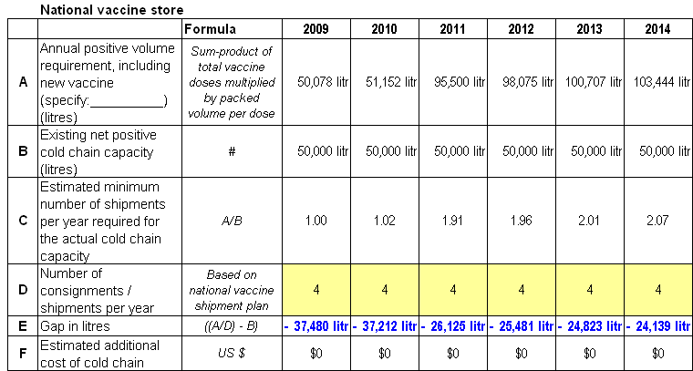

Sub-national level:
The cold chain capacity analysis has been done at the regional stores. The table below presents the situation by 2014.

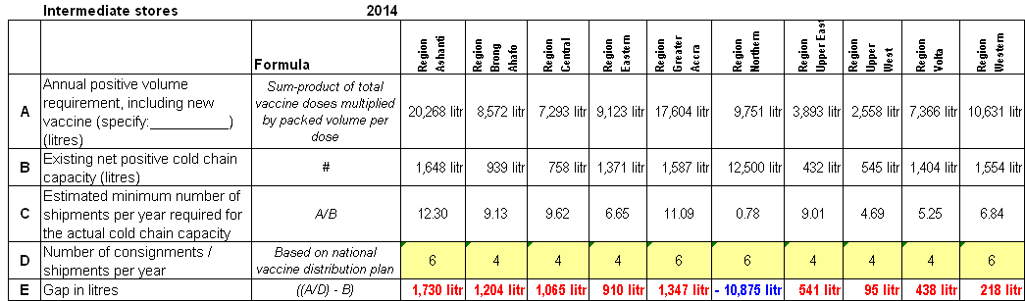

The implementation of the cold chain capacity expansion plan for regions and districts is ongoing. Government had secured support of some partners to procure cold chain equipment ready for installation in regions and distribution to districts and sub-districts. Nine walk-in-cold rooms (30 m3 gross capacity each) have being procured for installation at the regional stores. Once installed, these new cold rooms will cover the need for storing all the vaccines without changing the frequency of deliveries. To date (May 2011), seven (7) out of the nine regional stores with gap have been equipped with new walk-in-cold rooms. This brings to 8 regions with walk-in-cold rooms out of the total of 10 in the country The two regions (Greater Accra and Western) will be equipped by the end of the year.

In addition, 140 refrigerators and 18 freezers have been procured with the support from UNICEF, USAID and JICA. These equipments have been installed in districts and sub-districts, where a gap of cold chain capacity has been identified. Since vaccines are supplied from districts to sub-districts on monthly basis now the few districts which will have capacity problems will have to increase frequency of deliveries whilst steps are taken to get the requisite cold chain equipment for them. A total of 6,079 vaccine carriers and 401 cold boxes have also been distributed to districts and facilities with the support of UNICEF.

An “Effective Vaccine Assessment (EVM)” was conducted in Ghana in September 2010 and the report is submitted along with this document. In response to the findings of the EVM we have developed a “Plan To Improve Vaccine And Cold Chain Management In Ghana” attached as Annex 1

- Provide further details about possible plans for improving injection safety practices

Issue
There is a national plan on health care waste management. Not much is, however, said about injection safety practices although it was mentioned in the cMYP as a problem area.

Condition:
- Provide further detail about possible plans for improving injection safety practices.

Ghana has been using AD syringes for all vaccinations since 2000. A number of trainings on injection safety have been organized to refresh staff on injection safety practices. Staff have been orientated on bad practices such as recapping and this practice non-existent. Hub cutters have now been introduced for use at immunization sessions throughout the country. These cutters were piloted during the November 2010 measles SIAs in the country. This device cuts the hub of syringes together with the needle at the point of use into a ‘hard’ container. The advantage of the cutter is that once the needle of the syringe is de-fanged the remaining plastic becomes harmless and can be easily burnt even in a pit. There will be regular supply of hub-cutters just as safety boxes and the AD syringes for immunizations in the country.

Incinerators have also been constructed in over 120 out of the 170 districts in the country and plans are on-going to construct incinerators for every district at the district capital and also for major health centres and poly-clinics

A “Plan To Improve Injection Safety And Waste Management In Ghana” has been developed and it is attached as Annex 2.

Conclusion
Ghana is poised for action to introduce the three new vaccines as a means of achieving the Millennium Development Goal (MDG-4). In line with this objective we submit the attached social mobilization plan (Annex 3) and a supporting document – “Revised Introduction Plan” for the three new vaccines. Recording documents for routine immunization like “Child Health Records” and “Monthly Reporting forms” have already been revised to accommodate the new vaccines and the social mobilization activities will be rolled out as soon as approval is given so we can make an impact towards achieving the MDG-4.

Annex 1:
PLAN TO IMPROVE VACCINE AND COLD CHAIN MANAGEMENT IN GHANA

Background

The Government of Ghana, in collaboration with WHO and UNICEF, conducted the Effective Vaccine Management (EVM) assessment in September 2010 to determine vaccine and cold chain management capacity needs of the country. This is to strengthen the logistics management system for successful introduction and management of new vaccines planned as from 2012.

The EVM assessment in the country became very necessary because of the following:
- The last assessment was conducted in May 2001 (nine years back)
- Ghana has planned to introduce new vaccines – pneumococcal, rotavirus and second dose measles and there was the need to ensure effective storage and management of these expensive vaccines
- Staff situation in the immunization programme has changed over the years and needs upgrading in terms of training and orientation
- Equipment situation has also changed over the years and needs over hauling and replacement.

The main objective was to generate information that will facilitate effective planning and management of vaccines and cold chain logistics in the immunization system at all levels in the country. Information is required in terms of staff training needs and equipment needs at all levels in the country.

Findings from the assessment revealed that most major indicators –eg storage facility, temperature monitoring, vaccine management etc are below the standard score of 80% at the sub-national levels and needed immediate attention for improvement. Recommendations from the assessment include staff training, storage facility expansion, equipment replacement, regular monitoring and supervision.

Improvement plan

- Goal – to improve on the vaccine and cold chain capacity in the country as recommended by the assessment report.

- Main objective – to achieve the standard EVM scores of 80% and above for all indicators at all levels
- Strategies
- Cascaded training for staff at all levels in the regions
- Cold chain storage expansion in all regions and some districts
- Replacement of cold chain equipment at all levels in the regions
- Regular monitoring and supportive supervision

Key Activity | Beneficiary | Cost (US$) | Responsible | Source of funds
Debriefing of ICC on EVM report | ICC members |  | EPI manager, WHO and UNICEF
Dissemination workshop with regions | National and 10 Regions | 25,000 | Technical Team | GOG
Finalize EVM report and submit | Technical Team | 2000 | EPI Manager, WHO | GOG
Develop training plan with regions | National and 10 Regions |  | EPI Manager
Training material develop workshop and printing | Technical Team | 15,000 | Technical Team | GOG
National level TOT | Regional teams | 30,000 | Technical Team | GoG and Partners
Regional level training of district teams | 10 regions | 70,000 | Regions | GoG and Partners
District level training and selected sub-metros | 187 districts/sub-metros | 280,500 | Districts | GoG and Partners
Construction of cold room buildings | 9 regional cold rooms | 585,000 | EPI manager  Regions | GoG , GAVI and other Partners
Walk-in-refrigerators | 9 regions | 225,000 | EPI manager  Partners | JICA(8);  UNICEF (1)
Installation of walk-in-fridges | 9 regions | 72,000 | EPI manager  Estate Department | GoG and Partners
Procure TCW 3000 for distribution to districts | 50 pieces | 125,000 | EPI manager  Partners | USAID and GAVI
Procure TCW 2000 for distribution to sub-districts and health facilities | 200 | 440,000 | EPI manager  Partners | JICA, USIAD and GoG
Procure and distribute freeze tags to all facilities | 2000 | 20,000 | EPI manager  Partners | UNICEF
Procure and distribute cold boxes, | 400 | 144,000 | EPI manager  Partners | UNICEF
Procure and distribute vaccine carriers | 6000 | 720,000 | EPI manager  Partners | UNICEF
Procure new cold vans in 2012 | 3 vans | 345,000 | EPI manager  Partners | JICA
Half year cold chain inventory | Regions and districts | 50,000 | Regions and districts
Quarterly tripartite committee review meeting (4 meetings) | EPI, WHO and UNICEF | 2000 | EPI, WHO and UNICEF
 | TOTAL | US$3,150,500.0

Implementation framework
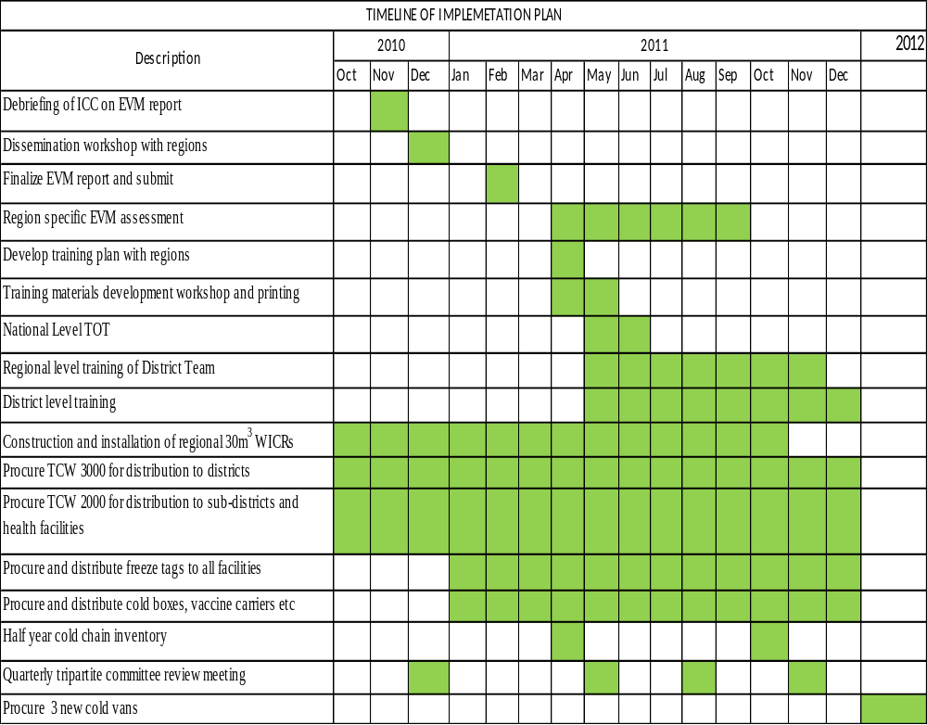
Annex 2
PLAN TO IMPROVE INJECTION SAFETY AND WASTE MANAGEMENT IN GHANA

Background
Ghana has used Auto-Disable (AD) Syringes as far back as 1993 for the EPI. Since then safety boxes of different types have been provided to all immunization centres for use. Health Staff engaged in the immunization activities in the districts have regularly been encouraged to use the AD syringes and the safety boxes in all immunization activities. .
In addition to the use of safe injection equipment, the Government of Ghana was also concerned about the management of injection waste and monitoring of adverse events following immunizations (AEFI) in the country. The concern was as a result of the realisation of the health hazards that inappropriate injection waste disposal and management pose to the service provider, the client and the community as whole. Waste disposal practices at most of the health facilities prior to the introduction the pentavalent vaccine and the measles SIA all in 2002 were crude dumping with irregular burning. Recapping was also practiced by most health staff whilst Sharps were scattered around health centres and disposal sites– posing high risk to children and other health hazards to community

As part of efforts to address some of the concerns, the National EPI policy developed in 1996 and revised in 2011, stressed use of only AD syringes for injections under the immunization system. A 5-year EPI injection safety policy and strategic plan for 2002-2006 developed by the National EPI prior to introduction of the pentavalent also emphasized the use of AD syringes only for all immunizations with safety boxes.

Although much efforts has been made over the years to ensure the safety of injections and effective management of waste generated from immunization in Ghana, much still remains to be done due to change in technology, increase in volume of waste, staff turnover and introduction of new vaccines.

This document summarizes plans to sustain the gains already made and also improve on the situation as the country advances with plans to introduce new vaccines such as pneumococcal, rotavirus, second dose measles and meningitis A vaccine as from 2012. It is presented in three sections:
- plans to improve Injection safety
- plans to improve waste management
- monitoring of Adverse Events Following Immunization (AEFI)

- Plan to improve Injection Safety

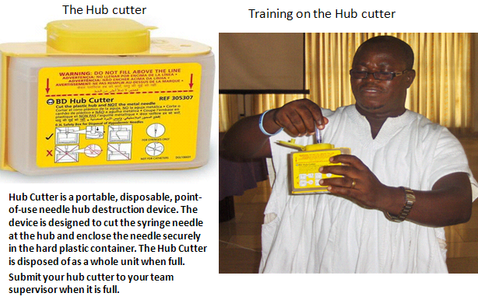
With the introduction of the bundling system (vaccine are accompanied by required ancillary materials) for procurement of vaccines since 2000 there has been regular supply of injection safety materials and staff orientation to ensure that:
- AD syringes and safety boxes are used in immunization services at all immunization centres
- There has been supply of safety boxes for clinical services – injection rooms in the major health facilities
- No recapping practiced at immunization centres - to avoid/reduce needle stick injuries

In addition to the ongoing practices, hub cutters have now been introduced for use during immunization sessions throughout the country. The needle cutters were introduced during the November 2010 measles SIAs in the country. There will be regular supply just as the safety boxes and the AD syringes for the immunization programme in the country. The advantage is that once the syringe is de-fanged and the metal part captured by the hub cutter the remaining plastic part can be easily burnt even in a pit.

Staff training on injection safety will continue at the service delivery points during all SIAs and also at the introduction of the pneumococcal and meningitis vaccines. Use of the hub-cutter will be encouraged especially in areas without incinerators.

- Plan to improve Waste Management

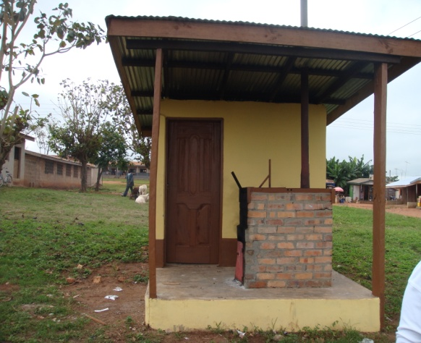
in 2002 one hundred and ten incinerators were constructed throughout the 110 districts then in Ghana. As the number of districts has increased up to 170 it has become important to construct more incinerators for the new districts and rehabilitate old incinerators.

In 2010, the Expanded Programme on Immunization (EPI) in collaboration with the Estate Management Division (EMD) of the Ghana Health Service (GHS) agreed on construction of thirteen additional Incinerators in selected facilities in four regions (Ashanti, Brong Ahafo, Central and Volta) at the cost of approximately US$70,000. The project is aimed at improving injection safety and waste management in the health facilities and generally in the districts. Over the years, effort has been made by the programme to provide incinerators in all districts. As stated earlier t he priority now is on the newly created districts and large health centres and polyclinics where such facility does not exist.
Three different sizes of incinerators (small, medium and large)are to be put up at different facilities depending upon the volume of waste generated from both the clinical and immunization services as shown in the table below.
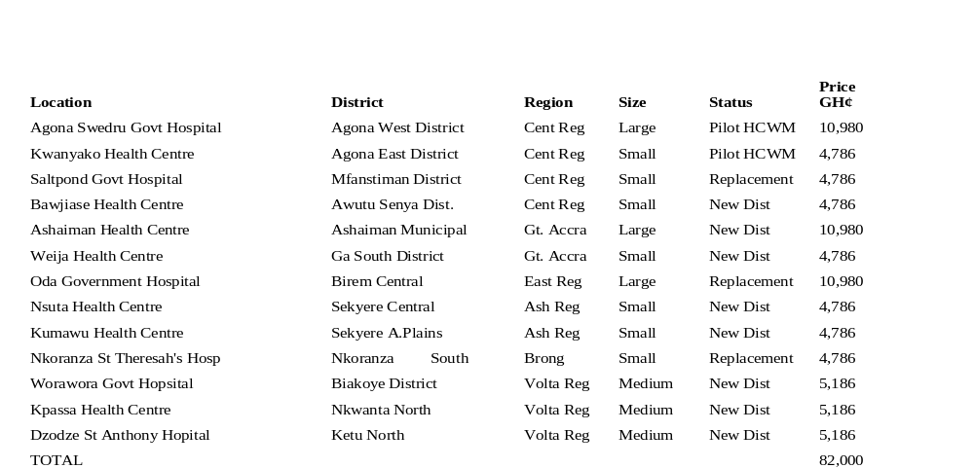
Construction started in February 2011. Eight sites have been supplied with materials with the exception of Saltpond, Kpassa, Worowora, Dzodze and Ashaiman. Four incinerators have almost been completed at the following sites; Nkoranza, Weija, Nsuta and Kumawu.

Plan for 2011 - The following new districts are yet to be taken care of in 2011 at an estimated cost of approximately US$68,000.0
- Bosome Freho District – Ashanti Region
- Nkoranza North District (Busunya)
- Ledzokuku-Krowo Municipal- Gt. Accra Region-
- Adenta Municipal –Gt. Accra- Medium

Immunization centres which do not have incinerators will be encouraged to continue to usehub-cutters and improved pits for burning of the waste generated through routine immunization services until an incinerator is provided. During campaigns, such facilities will be required to assemble the safety boxes for collection and incineration at the nearest districts where there are incinerators. Regular inspection of disposal sites will continue in all districts to ensure effective management of the waste. Protective materials for the Attendants will regularly be supplied and they will be oriented to use the materials at all times to avoid other health hazards.
Every month availability and use of safety boxes are reported on through the EPI monthly reporting form.

- Plan to improve-adverse events following immunization – AEFI
AEFI monitoring is part of the monthly district EPI activity reporting system. Through the monthly reporting form zero-reporting is ensured. Case investigation forms have been designed for all health facilities to investigate each case. During the H1N1 vaccination campaign a lot (about 769 cases) of AEFIs were reported, however reporting in the routine is quite low but expected to pick up with time. There is regular orientation of health workers on the importance of AEFI reporting and monitoring for routine services and during SIAs. There is a Pharmaco-vigilance centre set up at the Food and Drugs Board that monitors the AEFI in collaboration with the national EPI. This collaboration will continue and even be strengthened through regular meetings, training and monitoring visits to regions and districts.
Annex 3
SOCIAL MOBILIZATION AND COMMUNICATION PLAN FOR INTRODUCING NEW VACCINES (PNEUMOCOCCAL VACCINE, ROTAVIRUS VACCINE, MEASLES SECOND DOSE AND MENINGOCOCCAL A CONJUGATE VACCINE) IN GHANA.

- Introduction
The Government of Ghana has plans to introduce the pneumococcal and rotavirus vaccines into the routine immunization system as from 2012 as a means of reducing child mortality and achieving the MDG4. In addition the Government is also keen on introducing second dose measles to provide second opportunity to sustain the gains made in the measles control programme. The Government will also introduce Meningitis conjugate vaccines (Meng A) in the three Northern regions lying in the meningitis belt through a campaign for people aged 1-29 years.

The introduction of these expensive vaccines (especially pneumococcal and rotavirus vaccines) can only be successful if the people of Ghana are adequately informed and educated on the socio-economic importance of these vaccines and their need for the children in the country.

It is against this background that a social mobilization and communication plan is required as part of the preparatory activities towards the introduction of the new vaccines.

- Objectives
The objective of the social mobilization and communication plan is to provide key messages that will create public awareness on the importance of the vaccines and encourage acceptance and demand for the vaccines when introduced.

- Strategies
Key strategies will include: inter personal communication among individuals, use of mass communication channels, print media, community durbars, school programmes, use of the religious institutions and gatherings etc

- Key activities
- Set up inter-sectoral technical committee (Health, education, etc) to plan and coordinate social mobilization component of the new vaccines introduction plan
- Search for consultants to provide technical support for development of materials and messages
- Organize materials development and key messages workshop
- Organize public education programmes (TV and radio discussions, fun games, school talks, church programmes, community durbars of chiefs and people, etc)
- Hold press briefing and national launch, etc

