Inventory of Cold Chain Equipment and Space for Existing and New Vaccine (PCV, IPV, MRSD and HPV)

National Immunization Program of Nepal has a wide cold chain networks throughout the country. Central vaccine stores at Teku and Pathlaiya, six regional vaccine stores at regional head quarters, seventy five district vaccine stores and vaccine sub stores as well as vaccine distribution points are identified and in most of these stores appropriate cold chain equipments are in place.
There is a big shift in vaccine and cold chain management in Nepal due to the introduction of under used (HepB) and new vaccine (Hib and JE) in national immunization schedule initiated in 2003 and expansion and replacement of cold chain equipments at central, regional and district vaccine stores to store these vaccines. Additionally, the new vaccine and cold chain management guideline has allowed to keep vaccine at vaccine sub stores (located in health facility) and thus has also given provision to recruit cold chain personnel.
National immunization program has expressed the commitment in its multi year plan of action to introduce PCV in 2014, Rota in 2016. As a part of global polio eradication and mitigation of cVDP program has decided to introduce one dose IPV in 2014. MR second dose, and HPV demonstration project in Kaski and Chitawan (2 districts) are also scheduled in this year. Such changes underscore the need to update the whole cold chain system in Nepal. This document has included cold chain inventory of vaccine stores and the cold chain capacity.

Existing cold chain equipment status, storage capacity for RI and new vaccines at central vaccine store
The primary (national) level vaccine store receives vaccine directly from the manufacturer or from an international supplier such as UNICEF. There are two central stores Teku and Pathlaiya. Vaccines are stored as per WHO recommendation temperature for each antigen in cold rooms (WIC) and freezer rooms (WIF).

- Central Vaccine store Teku: There are 5 walking cold rooms (WICRs) with net vaccine storage capacity of 45,780 liters and 2 walk in freezer (WIFRs) with net vaccine storage capacity of 24,000 liters

- Central vaccine store Pathlaiya: Pathlaiya vaccine store has 2 WICs with net vaccine storage capacity of 9,660 and 1 WIF with net vaccine storage capacity of capacity of 5,040 liters

Below is the inventory of cold chain equipments at central vaccine stores by make, model, gross and net volume

1.1 List WIC/WIF at Central Vaccine Stores Teku and Pathlaiya.
Vaccine stores | Model | Make | Equipments (type) | Refrigerant(Types) | Gross volume (cm3) | Net volume ( cm3) | Installed | Temperature recording system | Generator  /voltage stabilizer
CVS Teku | HRC100 | Huurre | WIC | R404a | 22.77 | 7.59 | 1984 | Multi log | Yes
CVS Teku | HRC100 | Huurre | WIC | R404a | 22.77 | 7.59 | 1987 | Multi log | Yes
CVS Teku | HRF300 | Huurre | WIF | R404a | 41.40 | 13.80 | 1987 | Multi log | Yes
CVS Teku | CBC070C | Cold Bank China | WIC | R404a | 30.60 | 10.20 | 2010 | Multi log | Yes
CVS Teku | CBC070C | Cold Bank China | WIC | R404a | 30.60 | 10.20 | 2010 | Multi log | Yes
CVS Teku | CBC070F | Cold Bank China | WIF | R404a | 30.60 | 10.20 | 2010 | Multi log | Yes
CVS Teku | Everest | Nepal | WIC | R134A | 30.60 | 10.20 | 2006 | Multi log | Yes
CVS Pathlaiya | Everest | Neapl | WIC | R134A | 13.86 | 4.62 | 2006 | Multi log | Yes
CVS Pathlaiya | CBC040C | Cold Bank China | WIC | R404a | 15.12 | 5.04 | 2010 | Multi log | Yes
CVS Pathlaiya | CBC040F | Cold Bank China | WIF | R404a | 15.12 | 5.04 | 2010 | Multi log | Yes

1.12: Graph below shows the total existing net cold chain capacity of Central vaccine stores and cold chain capacity need for new vaccines.
The total net capacity need for the storage of all antigens (BCG, DPTHepBHib, MR (1st and MR2nd), OPV, Td, IPV, and PCV) is 40,645 and existing capacity is 55,440 liters

(The maximum allowable period to stock vaccine at central level is 11 months and the net vaccine storage volume need is 40,645 and thus is sufficient to stock vaccine safely)

Existing cold chain equipment status, storage capacity for RI and new vaccine at regional vaccine stores
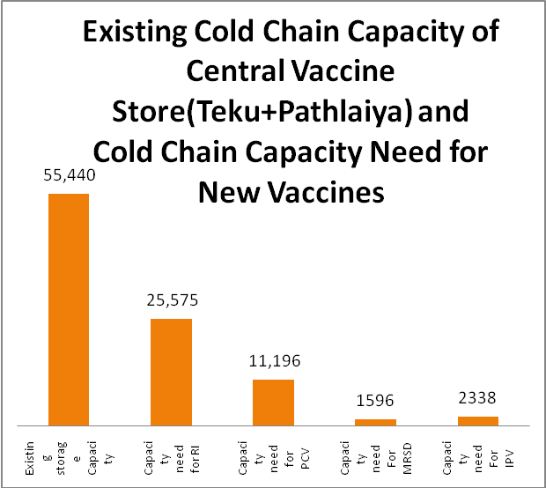
There are six regional vaccine stores (Biratnagar (EDR), Hetauda (CDR), Butwal (WDR), Pokhara (WDR), Nepalgunj (MWDR) and Dhangadhi (FWDR). These vaccine stores are secondary level of stores and receive vaccine and supplies from central vaccine stores. These vaccine stores distribute vaccine and supplies to the districts vaccine stores under them. The maximum allowable vaccine storage periods for these stores are 4.5 months. The net vaccine storage capacity of each of the regional vaccine stores and the total net capacity need for the storage of all antigens (BCG, DPTHepBHib, MR (1st and MR2nd), OPV, Td, IPV, and PCV) is as follows:
Need 40, 645 LTRS

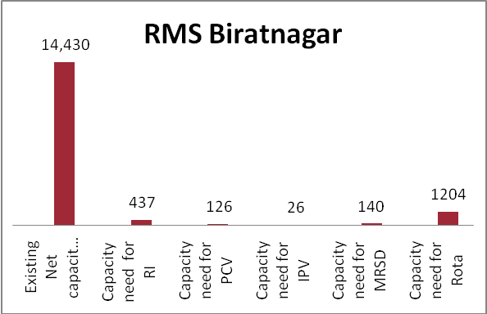
- Biratnagar regional vaccine store:
The existing net storage capacity of Biranagar regional vaccine store is 14,430 Liters and to store the vaccines of 16 districts of EDR for maximum allowable period of 4.5 months for RI (BCG, DPTHepBHib, OPV, MR1, Td and JE), IPV, PCV, MR2 vaccines is 898 liters, thus existing capacity is sufficient to store the vaccines mentioned above.

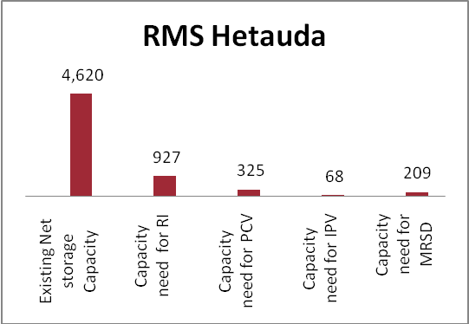
- Hetauda regional vaccine store
The existing net storage capacity of Hetauda regional vaccine store is 4,620 Liters and to store the vaccines of 9 districts of CDR (note that rest 10 districts vaccines are supplied directly from Teku vaccine store) for maximum allowable period of 4.5 months for RI (BCG, DPTHepBHib, OPV, MR1, Td and JE), IPV, PCV, MR2 vaccines is 1750 liters, thus existing capacity is sufficient to store the vaccine mentioned above.
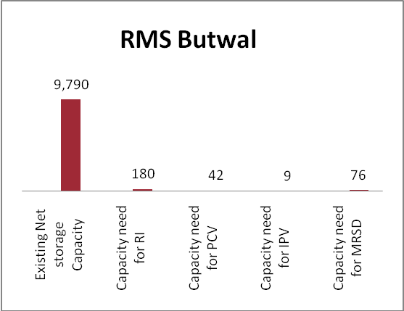
- Butawal regional vaccine store
The existing net storage capacity of Butwal regional vaccine store is 9,790 Liters and to store the vaccines of 6 districts of WDR (note that rest 10 districts vaccines are supplied by Pokhara regional vaccine store) for maximum allowable period of 4.5 months for RI (BCG, DPTHepBHib, OPV, MR1, Td and JE), IPV, PCV, MR2 vaccines is 404 liters, thus existing capacity is sufficient to store the vaccine mentioned above.

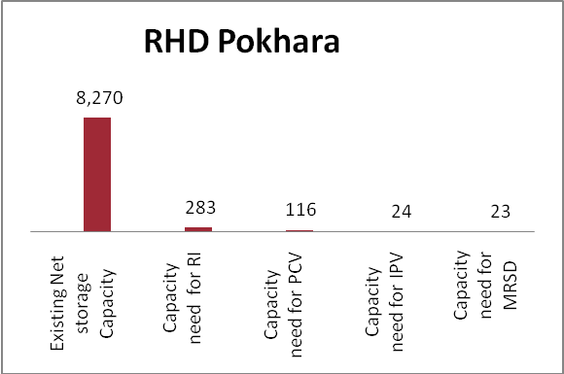
- Pokhara regional vaccine store
The existing net storage capacity of Pokhara regional vaccine store is 8,270 Liters and to store the vaccines of 10 districts of WDR (note that rest 6 districts vaccines are supplied by Butwal regional vaccine store) for maximum allowable period of 4.5 months for RI (BCG, DPTHepBHib, OPV, MR1, Td and JE), IPV, PCV, MR2 vaccines is 453 liters, thus existing capacity is sufficient to store the vaccine mentioned above.

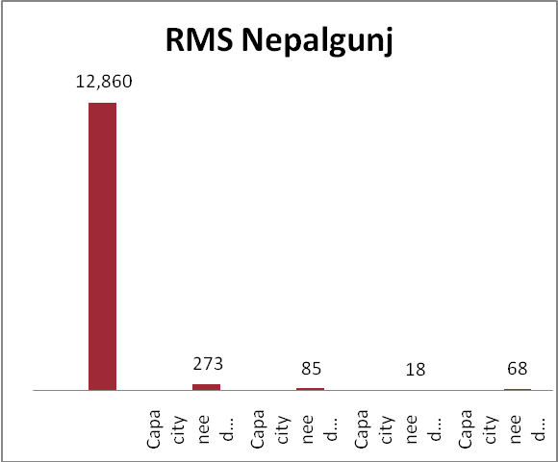
- Nepalganj vaccine store
The existing net storage capacity of Nepalganj regional vaccine store is 12,860 Liters and to store the vaccines of 15 districts of MWDR for maximum allowable period of 4.5 months for RI (BCG, DPTHepBHib, OPV, MR1, Td and JE), IPV, PCV, MR2 vaccines is 521 liters, thus existing capacity is sufficient to store the vaccine mentioned above.
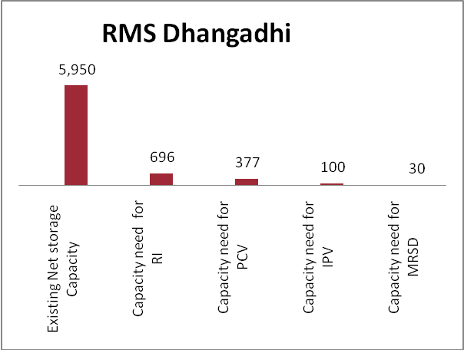
- Dhangadhi vaccine store
The existing net storage capacity of Dhangadhi regional vaccine store is 5,950 Liters and to store the vaccines of 9 districts of FWDR for maximum allowable period of 4.5 months for RI (BCG, DPTHepBHib, OPV, MR1, Td and JE), IPV, PCV, MR2 vaccines is 1,192 liters, thus existing capacity is sufficient to store the vaccine mentioned above

Below is the inventory of cold chain equipments by regional vaccine stores by make, model, gross and net volume

1.2 List of WIC/WIFs at six Regional Medical Stores.
Vaccine stores | Model | Make | Equipments (type) | Refrigerant(Types) | Gross volume (cm3) | Net volume ( cm3) | Installed | Temperature recording system | Generator  /voltage stabilizer
RMS Biratnagar | HRC100 | Huurre | WIC | R404a | 14.26 | 4.75 | 1987 | Multi log | Yes
RMS Biratnagar | Everest | Nepal | WIC | R134A | 13.92 | 4.64 | 2006 | Multi log | Yes
RMS Biratnagar | CBC040C | Cold Bank China | WIC | R404a | 15.12 | 5.04 | 2010 | Multi log | Yes
RMS Hetauda | HRC100 | Huurre | WIC | R404a | 13.86 | 4.62 | 1987 | Multi log | Yes
RMS Dhangadhi | Everest | Nepal | WIC | R134A | 9.70 | 3.23 | 2006 | Multi log | Yes
RMS Dhangadhi | HRC100 | Huurre | WIC | R404a | 8.15 | 2.72 | 1987 | Multi log | Yes
RMS Nepalgunj | Everest | Nepal | WIC | R134A | 13.92 | 4.64 | 2006 | Multi log | Yes
RMS Nepalgunj | CBC040C | Cold Bank China | WIC | R404a | 15.12 | 5.04 | 2010 | Multi log | Yes
RMS Nepalgunj | HRC100 | Huurre | WIC | R404a | 9.84 | 3.28 | 1987 | Multi log | Yes
RMS Butawal | CBC040C | Cold Bank China | WIC | R404a | 15.12 | 5.04 | 2010 | Multi log | Yes
RMS Butawal | Everest | Nepal | WIC | R134A | 14.26 | 4.75 | 2006 | Multi log | Yes
RMS Pokhara | CBC040C | Cold Bank China | WIC | R404a | 15.12 | 5.04 | 2010 | Multi log | Yes
RMS Pokhara | HRC100 | Huurre | WIC | R404a | 9.70 | 3.23 | 1987 | Multi log | Yes

Existing cold chain equipment status, storage capacity for RI and new vaccine at Districts vaccine stores

There are 75 districts with vaccine stores located at their headquarters. These vaccine stores are equipped with different type of cold chain equipments - refrigerators, freezer and solar refrigerators (see the type of cold chain inventory of the districts).

The districts have maximum allowable vaccine storage period of 2.25 months. Hence the calculation of the cold chain capacity for the vaccine of routine immunization (BCG, DPT Hep Hib, MR1, OPV, Td and JE) and new vaccines (IPV, PCV and MR2) has been done by districts. The cold chain volumes of the districts have been calculated against the net volume of the equipments available at district vaccine stores. The cold chain equipments of sub vaccine stores (is a part of district vaccine stores) have also been included in the calculation of net volume of districts vaccine stores.
The calculation of the vaccine volume and existing cold chain capacity shows that 69 districts vaccine stores have sufficient cold chain capacity to store the vaccines for 2.25 months while 6 districts - Kathmandu, Lalitpur, Darchula, Pyuthan, sarlahi and Jhapa have gap in cold chain storage capacity.

some of the districts need immediate visit to fix small problems prior to the introduction of new vaccines while the districts vaccine stores where the cold chain capacity is critically low need immediate replacement of cold chain equipments immediately and to note that there is availability of cold chain equipments at central store and distribution list is under preparation.

Below is the inventory of cold chain equipments of the district vaccine stores by make and model
Districts Cold Chain Equipments Inventory
Eastern Development Region
Types of Cold Chain Equipments (Refrigerator/freezers) by District Vaccine Stores.
SN | Districts |  | MK304 |  | Sanyo |  | TCW3000AC |  |  | TCW1152 | MF304 | SB302 | TFW791 | TFW800 | Sibir170 | Sibir240 | PF230 | Sunfrost | TCW2000DC | RCW65 | RAK100 |  | Medical refriAK66
1 | Morang |  | 1 |  | 2 |  | 1 |  |  | 1 | 0 |  |  | 1
2 | Dhankuta |  | 2 |  | 1 |  |  |  |  | 1 |  |  | 1 | 1
3 | Panchthar |  | 2 |  |  |  |  |  |  |  | 2 | 1 |  | 1 |  |  |  | 1
4 | Okhaldhunga |  | 1 |  |  |  |  |  |  |  |  |  |  |  |  | 2 | 2 |  | 1 | 0
5 | Khotang |  |  |  |  |  |  |  |  |  | 1 |  |  |  |  | 1 |  |  |  | 1
6 | Illam |  | 2 |  |  |  | 1 |  |  |  |  | 1 |  | 1 |  | 1 | 3 |  |  | 1
7 | Saptari |  | 2 |  |  |  | 1 |  |  |  | 2 | 1 |  | 2 |  |  | 1 |  |  |  |  |  | 1
8 | Sankhuwasabha |  | 1 |  |  |  |  |  |  |  | 1 | 1 |  | 1 |  | 1 |  |  |  | 1
9 | Siraha |  | 2 |  |  |  |  |  |  |  | 1 | 1 |  | 1
10 | Sunsari |  | 2 |  |  |  |  |  |  |  | 1 | 1 | 1 | 1 | 1
11 | Taplejung |  | 1 |  |  |  |  |  |  | 1 |  | 1 |  | 1 | 1 | 0 |  |  |  | 1 | 1
12 | Terhathum |  |  |  |  |  |  |  |  |  | 1 |  |  | 1 |  | 1 |  |  |  | 2 | 1
13 | Udayapur |  | 2 |  |  |  |  |  |  |  | 1 |  |  | 1 |  |  |  |  |  |  | 1
14 | Bhojpur |  | 2 |  | 1 |  |  |  |  |  | 1 | 1 |  | 1 | 1 |  |  |  | 1
16 | Solukhambu |  |  |  | 1 |  | 1 |  |  | 1 |  | 1 |  | 1
Central Development Region
SN | Model |  | MK304 |  | Sanyo |  | TCW1151 |  |  | TCW3000AC | TCW1152 | MF304 | SB302 | Norder | PR265 KE | TFW791 | TFW800 | Sibir170 | Sibir110 | PF230 | Domestic |  | RCW42EK
17 | Bara |  | 2 |  |  |  |  |  |  |  | 2 | 1 | 1 | 0 |  | 0 | 2 |  |  |  | 3
18 | Bhaktpur |  | 2 |  | 2 |  | 0 |  |  |  |  |  |  |  | 0 | 0 | 1
19 | Parsa |  | 2 |  |  |  |  |  |  | 1 | 1 | 1 | 1 |  | 2 |  | 1
20 | Chitawan |  | 2 |  | 1 |  |  |  |  |  |  | 1 | 1 |  |  |  | 1
21 | Dhanusa |  | 4 |  |  |  |  |  |  | 1 | 1 | 2 |  |  |  |  | 2 | 1
22 | Dolakha |  | 1 |  | 1 |  |  |  |  |  | 1 |  | 1 |  |  |  | 1 |  |  | 1
23 | Kathmandu |  | 2 |  | 1 |  |  |  |  |  |  | 1 |  |  |  |  | 1 |  |  | 1
24 | Kavre |  | 2 |  | 3 |  | 1 |  |  |  |  | 1 |  | 1 |  |  | 1
25 | Mahottari |  | 2 |  |  |  |  |  |  | 1 |  | 2 |  |  | 2 |  | 1
26 | Makawanpur |  | 2 |  | 1 |  |  |  |  | 1 |  | 1 |  |  |  |  |  |  |  |  | 1
27 | Ramechap |  | 1 |  |  |  |  |  |  |  |  | 1 |  | 1 |  |  | 1 |  |  |  | 1
28 | Dhading |  | 2 |  |  |  |  |  |  |  |  |  | 1 | 1 |  | 0 | 1
29 | Rautahat |  | 2 |  | 1 |  |  |  |  | 1 |  | 1 | 1 |  | 1 |  | 1
30 | Sarlahi |  | 2 |  | 1 |  |  |  |  | 1 |  | 1 | 1 | 0 |  |  | 1 |  |  | 1 | 1
31 | Sindhuli |  | 2 |  |  |  |  |  |  |  | 1 |  |  | 1 | 1 |  | 1 |  |  |  |  |  | 2
32 | Lalitpaur |  | 1 |  | 1 |  |  |  |  |  |  |  |  | 1 |  | 1 | 1
33 | Nuwakot |  | 1 |  | 2 |  |  |  |  |  | 1 | 1 |  |  |  |  | 1
34 | Rasuwa |  |  |  | 1 |  |  |  |  |  |  |  |  |  |  |  |  | 1
35 | Sindhupalckowk |  | 1 |  |  |  |  |  |  |  |  | 1 |  |  | 3 |  | 1 |  |  |  | 1
Western Development Region
SN | Model |  | MK304 |  | Sanyo |  | TCW1151 |  |  | TCW3000AC | TCW1152 | MF304 | SB302 | Norder | PR265 KE | TFW791 | TFW800 | Sibir170 | Sibir240 | PF230 | TCW2000DC |  | RCW65 |  | RAK 100
SN | Disttrict |  | Working |  | Working |  | Working |  |  | Working | Working | Working | Working | Working | Working | Working | Working | Working | Working | Working | Working |  | Working |  | Working
36 | Kapilbastu |  | 2 |  | 0 |  |  |  |  |  |  | 1 |  |  | 1 | 0 | 1 |  |  | 2 |  |  | 0
37 | Lamjung |  |  |  |  |  | 1 |  |  |  | 1 | 1 |  | 1 |  |  | 1 |  |  | 1
38 | Gorkha |  | 1 |  | 1 |  | 1 |  |  | 1 | 1 | 0 |  |  | 1 |  | 1
39 | Myagdi |  | 2 |  |  |  |  |  |  |  |  | 1 | 1 |  | 1 | 1 | 1 |  |  | 1
40 | Nawalparasi |  | 3 |  | 1 |  |  |  |  |  |  |  | 2 |  | 1 |  | 1
41 | Mustang |  |  |  |  |  |  |  |  |  |  |  |  |  | 2 |  |  | 0 | 1 |  | 1 |  | 1
42 | Tanahu |  | 3 |  | 1 |  |  |  |  |  |  | 1 |  |  |  |  | 1
43 | Kaski |  | 2 |  | 0 |  |  |  |  |  |  | 1 |  |  | 1 |  | 1 |  |  | 1
45 | Parbat |  | 2 |  | 1 |  |  |  |  |  |  |  |  |  | 1 |  | 1 |  |  | 1
46 | Rupandehi |  | 3 |  |  |  |  |  |  | 1 |  | 1 |  |  |  |  | 1
47 | Syangja |  | 3 |  | 1 |  |  |  |  |  |  |  |  |  |  |  | 1 |  |  | 1
48 | Palpa |  | 2 |  |  |  |  |  |  |  |  | 2 |  |  | 1 |  | 1 |  |  |  |  |  |  |  | 1
49 | Baglung |  | 3 |  | 2 |  | 1 |  |  |  | 1 | 2 |  |  | 1 |  | 1
50 | Gulmi |  |  |  |  |  | 2 |  |  |  |  | 1 | 2 |  |  |  | 2 | 1 | 1 |  |  |  |  |  | 1
51 | Arghakhachi |  | 2 |  |  |  |  |  |  |  |  | 1 |  | 1 | 2 | 1 | 1 |  |  |  |  |  | 1 |  | 1
Mid Western Development Region
SN | Model | MK304 |  | Sanyo |  | TCW1151 |  | TCW3000AC | TCW1152 |  |  | MF304 | SB302 | Norder | PR265 KE | TFW791 | TFW800 | Sibir170 | Sibir240 | PF230 |  | TCW2000DC
52 | Kapilbastu | 2 |  | 0 |  |  |  |  |  |  |  | 1 |  |  | 1 | 0 | 1 |  |  | 2
53 | Lamjung |  |  |  |  | 1 |  |  | 1 |  |  | 1 |  | 1 |  |  | 1 |  |  | 1
54 | Gorkha | 1 |  | 1 |  | 1 |  | 1 | 1 |  |  | 0 |  |  | 1 |  | 1
55 | Myagdi | 2 |  |  |  |  |  |  |  |  |  | 1 | 1 |  | 1 | 1 | 1 |  |  | 1
56 | Nawalparasi | 3 |  | 1 |  |  |  |  |  |  |  |  | 2 |  | 1 |  | 1
57 | Mustang |  |  |  |  |  |  |  |  |  |  |  |  |  | 2 |  |  | 0 | 1 |  |  | 1
58 | Tanahu | 3 |  | 1 |  |  |  |  |  |  |  | 1 |  |  |  |  | 1
59 | Kaski | 2 |  | 0 |  |  |  |  |  |  |  | 1 |  |  | 1 |  | 1 |  |  | 1
60 | Parbat | 2 |  | 1 |  |  |  |  |  |  |  |  |  |  | 1 |  | 1 |  |  | 1
61 | Rupandehi | 3 |  |  |  |  |  | 1 |  |  |  | 1 |  |  |  |  | 1
62 | Syangja | 3 |  | 1 |  |  |  |  |  |  |  |  |  |  |  |  | 1 |  |  | 1
63 | Palpa | 2 |  |  |  |  |  |  |  |  |  | 2 |  |  | 1 |  | 1
64 | Baglung | 3 |  | 2 |  | 1 |  |  | 1 |  |  | 2 |  |  | 1 |  | 1
65 | Gulmi |  |  |  |  | 2 |  |  |  |  |  | 1 | 2 |  |  |  | 2 | 1 | 1
66 | Arghakhachi | 2 |  |  |  |  |  |  |  |  |  | 1 |  | 1 | 2 | 1 | 1
Far Western Development Region
SN | Model |  | MK304 |  | Sanyo |  | TCW3000AC |  |  | TCW1152 | MF304 | SB302 | PR265 KE | TFW800 | Sibir170 | Sibir240 | PF230 | Domestic | RCW65
67 | Kailali |  | 2 |  |  |  | 1 |  |  |  | 1 | 1 | 0 | 1 | 0 |  |  | 1
68 | Kanchanpur |  | 2 |  |  |  |  |  |  |  | 1 |  | 2 | 1 |  |  |  | 1
69 | Doti |  | 2 |  | 1 |  |  |  |  |  | 1 |  |  | 1 |  |  | 2
70 | Dadeldhura |  | 2 |  |  |  |  |  |  |  |  | 1 |  |  |  | 1
71 | Baitadi |  | 2 |  | 1 |  |  |  |  |  |  | 2 |  | 1
72 | Bajhang |  | 1 |  |  |  |  |  |  | 1 |  |  |  |  | 1 | 1 |  |  | 1
73 | Acham |  |  |  |  |  | 1 |  |  |  | 2 |  | 2 |  |  | 1 | 1
74 | Darchula |  |  |  |  |  |  |  |  |  | 1 |  |  |  |  | 1
75 | Bajura |  |  |  |  |  |  |  |  |  |  |  | 2 |  |  | 0 |  |  | 1

Below is the cold chain storage capacity of the district vaccine stores
Sn | District | Total Capacity Need For Ri | Existing Capacity |  | Cold Chain Space Required For New Vaccine |  |  | Total Space (Ri+Pcv+Ipv+Mr2) | Cold chain surplus volume
Sn | District | Total Capacity Need For Ri | Plus | Minus | PCV10 | MRSD | IPV | Total Space (Ri+Pcv+Ipv+Mr2) | Cold chain surplus volume
1 | Taplejung | 20 | 279 | 624 | 10 | 4 | 2 | 36 | 243
2 | Panchthar | 30 | 255 | 765 | 15 | 6 | 3 | 54 | 201
3 | Ilam | 46 | 309 | 826 | 23 | 7 | 5 | 80 | 228
4 | Jhapa | 145 | 254 | 1006 | 66 | 26 | 14 | 251 | 3
5 | Morang | 173 | 404 | 756 | 79 | 32 | 16 | 300 | 104
6 | Sunsari | 139 | 271 | 972 | 63 | 26 | 13 | 241 | 30
7 | Dhankuta | 26 | 385 | 552 | 12 | 5 | 3 | 46 | 339
8 | Terhathum | 16 | 148 | 838 | 8 | 3 | 2 | 28 | 120
9 | Sankhuwasabha | 25 | 130 | 403 | 12 | 5 | 3 | 45 | 85
10 | Bhojpur | 28 | 259 | 925 | 14 | 6 | 3 | 51 | 208
11 | Solukhumbu | 17 | 333 | 478 | 8 | 3 | 2 | 30 | 303
12 | Okhaldhunga | 23 | 294 | 390 | 11 | 5 | 2 | 42 | 252
13 | Khotang | 32 | 168 | 473 | 15 | 7 | 3 | 57 | 110
14 | Udayapur | 57 | 254 | 478 | 25 | 11 | 5 | 99 | 155
15 | Saptari | 115 | 443 | 1344 | 52 | 22 | 11 | 200 | 243
16 | Siraha | 116 | 216 | 732 | 52 | 25 | 11 | 203 | 13
17 | Dhanusha | 139 | 783 | 972 | 63 | 27 | 13 | 243 | 540
18 | Mahottari | 117 | 418 | 751 | 52 | 26 | 11 | 206 | 211
19 | Sarlahi | 146 | 343 | 1020 | 66 | 32 | 14 | 258 | 85
20 | Sindhuli | 55 | 459 | 360 | 24 | 11 | 5 | 95 | 364
21 | Ramechap | 36 | 108 | 612 | 16 | 5 | 3 | 60 | 48
22 | Dolakha | 33 | 277 | 612 | 14 | 5 | 3 | 56 | 221
23 | Sindhupalchok | 49 | 221 | 497 | 22 | 8 | 5 | 84 | 136
24 | Kavre | 65 | 385 | 756 | 30 | 10 | 6 | 111 | 274
25 | Lalitpur | 90 | 108 | 696 | 41 | 12 | 9 | 152 | -44
26 | Bhaktapur | 59 | 216 | 492 | 27 | 8 | 6 | 100 | 116
27 | Kathmandu | 348 | 216 | 900 | 163 | 48 | 34 | 593 | -377
28 | Nuwakot | 48 | 277 | 960 | 22 | 8 | 5 | 81 | 196
29 | Rasuwa | 8 | 55 | 180 | 3 | 1 | 1 | 13 | 42
30 | Dhading | 54 | 216 | 1020 | 27 | 11 | 6 | 97 | 119
31 | Makawanpur | 75 | 343 | 408 | 34 | 14 | 7 | 130 | 212
32 | Rautahat | 121 | 254 | 886 | 60 | 30 | 12 | 223 | 30
33 | Bara | 131 | 554 | 936 | 59 | 29 | 12 | 231 | 323
34 | Parsa | 103 | 587 | 751 | 51 | 25 | 11 | 189 | 397
35 | Chitwan | 99 | 216 | 876 | 49 | 16 | 10 | 174 | 42
36 | Gorkha | 42 | 648 | 367 | 21 | 8 | 4 | 75 | 572
37 | Lamjung | 27 | 338 | 756 | 13 | 5 | 3 | 47 | 291
38 | Tanahu | 52 | 324 | 900 | 25 | 10 | 5 | 93 | 231
39 | Syangja | 45 | 324 | 492 | 22 | 8 | 5 | 79 | 245
40 | Kaski | 85 | 254 | 910 | 41 | 15 | 9 | 150 | 104
41 | Manang | 3 | 93 | 46 | 0 | 0 | 0 | 3 | 89
42 | Mustang | 3 | 151 | 49 | 1 | 0 | 0 | 5 | 146
43 | Myagdi | 20 | 254 | 1090 | 9 | 5 | 2 | 35 | 218
44 | Parbat | 25 | 218 | 564 | 11 | 5 | 2 | 44 | 174
45 | Baglung | 47 | 315 | 886 | 21 | 10 | 4 | 82 | 233
46 | Gulmi | 44 | 393 | 708 | 21 | 10 | 4 | 79 | 314
47 | Palapa | 41 | 309 | 778 | 20 | 8 | 4 | 74 | 234
48 | Nawalparasi | 115 | 216 | 1080 | 52 | 20 | 11 | 198 | 18
49 | Rupandehi | 150 | 451 | 468 | 74 | 30 | 15 | 269 | 181
50 | Kapilvastu | 90 | 254 | 970 | 47 | 24 | 10 | 170 | 83
51 | Arghakhanchi | 31 | 308 | 994 | 15 | 7 | 3 | 57 | 251
52 | Pyuthan | 47 | 93 | 454 | 23 | 11 | 5 | 86 | 6
53 | Rolpa | 46 | 208 | 525 | 22 | 11 | 5 | 83 | 124
54 | Rukum | 44 | 285 | 544 | 21 | 9 | 4 | 79 | 206
55 | Salyan | 51 | 108 | 636 | 25 | 10 | 5 | 92 | 16
56 | Dang | 117 | 432 | 960 | 58 | 20 | 12 | 208 | 224
57 | Banke | 114 | 343 | 1200 | 52 | 18 | 11 | 196 | 146
58 | Bardiya | 95 | 324 | 816 | 44 | 15 | 9 | 162 | 162
59 | Surkhet | 81 | 324 | 552 | 37 | 15 | 8 | 140 | 184
60 | Dailekh | 61 | 163 | 1020 | 27 | 14 | 6 | 108 | 55
61 | Jajarkot | 38 | 110 | 349 | 18 | 10 | 4 | 70 | 40
62 | Dolpa | 9 | 299 | 259 | 4 | 2 | 1 | 15 | 284
63 | Jumla | 24 | 259 | 793 | 11 | 6 | 2 | 43 | 216
64 | Kalikot | 31 | 185 | 235 | 15 | 9 | 3 | 58 | 127
65 | Mugu | 13 | 55 | 180 | 6 | 4 | 1 | 23 | 32
66 | Humla | 12 | 173 | 102 | 5 | 3 | 1 | 21 | 152
67 | Bajura | 27 | 75 | 163 | 13 | 7 | 3 | 50 | 25
68 | Bajhang | 38 | 387 | 218 | 18 | 10 | 4 | 71 | 316
69 | Achham | 49 | 182 | 566 | 24 | 14 | 5 | 91 | 90
70 | Doti | 38 | 216 | 900 | 19 | 11 | 4 | 72 | 144
71 | Kailali | 163 | 343 | 732 | 74 | 28 | 16 | 282 | 61
72 | Kanchanpur | 94 | 460 | 487 | 43 | 17 | 9 | 90 | 298
73 | Dadeldhura | 27 | 271 | 302 | 13 | 7 | 3 | 50 | 221
74 | Baitadi | 47 | 324 | 732 | 23 | 12 | 5 | 87 | 237
75 | Darchula | 25 | 55 | 302 | 12 | 6 | 3 | 46 | 9
 | National Total | 4895 | 20948 | 49327 | 2290 | 952 | 478 | 8616 | 12332

Type of Cold chain equipments and their functional status
(Note the cold chain volume of not working/functional (NW) is not included in the calculation of cold chain volume)

Refrigerator/Freezer Model | Mid Western Region |  | Eastern Region |  | Central Region |  | Central Region |  | Far Western Region |  | Regional Medical Stores | Total
 | W | NW | W | NW | W | NW | W | NW | W | NW | W | W | NW
MK304 | 20 | 1 | 24 | 3 | 38 | 0 | 29 | 0 | 15 | 0 | 4 | 130 | 4
Sanyo | 3 | 2 | 5 | 3 | 19 | 7 | 9 | 10 | 3 | 1 | 11 | 50 | 23
TCW1151 | 0 | 1 | 0 | 2 | 3 | 5 | 5 | 13 | 0 | 2 | 0 | 8 | 23
TCW3000 | 1 | 0 | 4 | 0 | 6 | 0 | 2 | 1 | 2 | 0 | 5 | 20 | 1
TCW1152 | 3 | 1 | 7 | 1 | 9 | 3 | 4 | 0 | 3 | 0 | 6 | 32 | 5
MF304 | 9 | 1 | 13 | 4 | 15 | 3 | 12 | 2 | 6 | 0 | 9 | 64 | 10
SB302 | 3 | 1 | 11 | 0 | 7 | 0 | 5 | 0 | 4 | 0 | 0 | 30 | 1
Norder | 5 | 2 | 0 | 1 | 5 | 8 | 3 | 8 | 1 | 2 | 0 | 14 | 21
PR265 | 25 | 13 | 66 | 7 | 75 | 20 | 67 | 9 | 39 | 3 | 0 | 272 | 52
TFW791 | 3 | 3 | 2 | 6 | 1 | 10 | 3 | 12 | 0 | 2 | 3 | 12 | 33
TFW800 | 12 | 5 | 17 | 2 | 19 | 5 | 15 | 1 | 5 | 0 | 7 | 75 | 13
Norcoast | 2 | 6 | 0 | 0 | 0 | 0 | 0 | 0 | 0 | 0 | 0 | 2 | 6
Sibir V170KE | 24 | 7 | 36 | 9 | 48 | 23 | 20 | 10 | 14 | 4 | 0 | 142 | 53
Sibir V240KE | 6 | 4 | 11 | 3 | 2 | 3 | 11 | 9 | 8 | 4 | 0 | 38 | 23
Sibir V110KE | 1 | 0 | 6 | 0 | 1 | 0 | 1 | 0 | 1 | 0 | 0 | 10 | 0
PF230 | 9 | 3 | 23 | 4 | 20 | 7 | 18 | 7 | 8 | 2 | 1 | 79 | 23
Domestic | 9 | 0 | 20 | 2 | 38 | 3 | 4 | 1 | 10 | 0 | 0 | 81 | 6
Sunforst | 9 | 1 | 9 | 1 | 4 | 1 | 3 | 0 | 10 | 0 | 0 | 35 | 3
RCW65 | 16 | 9 | 15 | 10 | 6 | 1 | 8 | 9 | 4 | 6 | 0 | 49 | 35
TCW2000AC | 0 | 0 | 1 | 0 | 1 | 0 | 2 | 0 | 1 | 0 | 0 | 5 | 0
TCW2000DC | 2 | 0 | 3 | 0 | 1 | 0 | 3 | 0 | 2 | 0 | 0 | 11 | 0
RAK100 | 6 | 3 | 3 | 4 | 3 | 1 | 4 | 3 | 0 | 0 | 0 | 16 | 11
RAKL66 | 1 | 3 | 1 | 2 | 0 | 2 | 0 | 2 | 0 | 0 | 0 | 2 | 9
MK204 | 1 | 1 | 0 | 0 | 0 | 0 | 0 | 0 | 0 | 0 | 0 | 1 | 1
Medical Refri | 1 | 0 | 0 | 0 | 0 | 0 | 0 | 0 | 0 | 0 | 0 | 1 | 0
RCW42EK | 0 | 0 | 0 | 0 | 8 | 0 | 1 | 1 | 0 | 0 | 0 | 9 | 1
Sundanzer | 0 | 0 | 0 | 0 | 0 | 0 | 0 | 0 | 1 | 0 | 0 | 1 | 0

Cold chain capacity calculation of "Human Papilloma Vaccine"
Government Nepal is piloting HPV vaccination in two districts, hence the cold chain capacities of these districts have been calculated below with the remarks.

Estimation of cold chain space for HPV
Chitawan: Total net storage space is required for all antigens (RI+PCV+IPV+MRSD) is 174 litres whereas existing capacity available is 216 litres in this district.
HPV will need around 58 litres of cold chain storage capacity thus there will be short fall of 16 litres hence there is need of additional one ILR MK304.

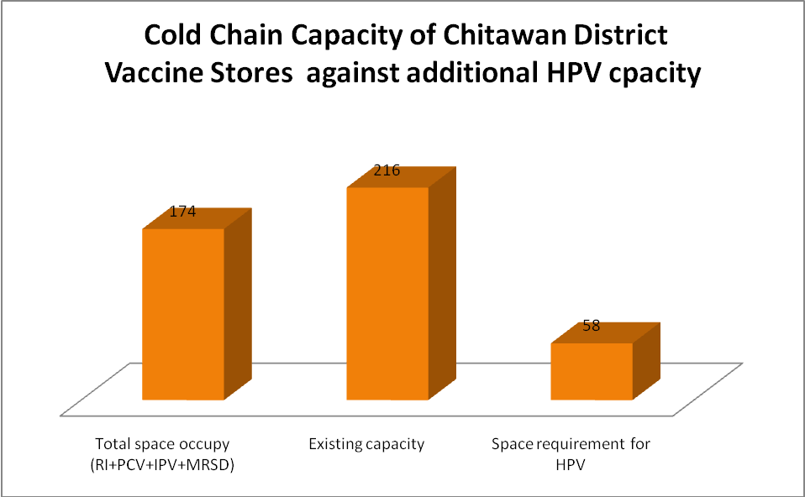

Kaski: Total net storage space is required for all antigens (RI+PCV+IPV+MRSD), is 150litres.
HPV will need 75 litres of cold chain capacity and existing cold chain space is 254 litres. Therefore, there is enough space for HPV vaccine as well.
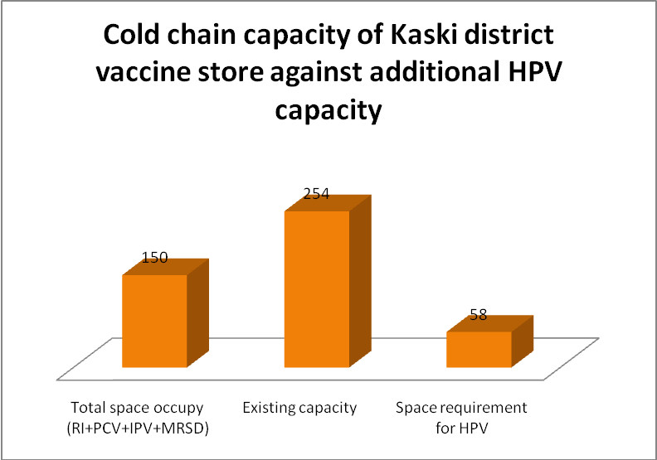

Summary: The cold chain capacity of the vaccine stores (primary, regional and most of the district vaccine stores) is sufficient to store vaccine to the maximum allowable period of storage except six districts where cold chain equipments need to be replaced

