OCTOBER 2005

The Government of
ZIMBABWE

Proposal for support submitted to the

Global Alliance for Vaccines and Immunization (GAVI)

and The Vaccine Fund

Executive Summary
The Government of Zimbabwe through the Ministry of Health and Child welfare is committed to the programme as a pillar for child survival and improvement of child health in line with the fourth Millennium Development Goal.
The Zimbabwe Expanded Programme on Immunisation (ZEPI) was launched in 1981 under the auspices of the Primary Health Care (PHC) programme. The PHC programme sought to improve the accessibility of health services and quality of life and health of the general population. Over the years, the immunisation programme has benefited from government and political commitment at all levels. Working with its partners, government embarked on the Universal Child Immunization (UCI) programme and achieved coverage exceeding 80% for all six antigens in 1990.

As from 1996 to 2002 the Government met all the costs for vaccine procurement for all the seven antigens in use. The antigens offered in ZEPI include DPT, HepB monovalent, BCG, OPV, and Measles. Hepatitis B monovalent was introduced throughout the country in 2003 to replace the tetravalent DPT-HepB combination that had been in use from 1999.This resulted from inadequate funding due to shortage of foreign currency. Due to foreign currency and other economic constraints the Government has not been able to continue purchasing EPI vaccines and other inputs. All current vaccines and inputs are being funded and procured by EPI partners. However the Government continues to allocate funds for vaccine procurement to EPI and this money is being used for programme enhancement in the country.

This proposal has been developed in consultation with the Inter-agency Coordinating Committee (ICC). The ICC discussed and endorsed the intention of the country to apply for support for New Vaccines and Injection Safety from GAVI. Furthermore the ICC has reviewed and endorsed this proposal.

Immunisation coverage that was on a downward trend in the last three years started picking up from 2003. DTP3 coverage for 2002 was 58% while in 2004 it was 86% according to routine Health Information System data. Projected coverage for DTP3 are as follows; 2005 – 90%; 2006 – 90%; 2007 – 95%; 2008 – 95%; 2009 – 97%; 2010 – 97%; and 2011 – 97%. The denominators were derived from projections of the population based on the 2002 Census. A number of EPI Assessments have been done and the findings including the recommendations are included herein. Some of the recommendations have already been implemented whilst implementation of other recommendations is in progress.

The country qualified for GAVI Injection Safety support in 2003 and started receiving AD syringes second quarter of 2004. Countrywide use of AD syringes in EPI commenced July 2004. A rapid assessment on injection safety is due in November 2005.

The country hereby applies for the pentavalent vaccine (DPT-Heb+Hib). The number of doses required for 2007 is 1,601,431 to cover 361,905 children. The number of AD syringes is 2,449,457 including reconstitution syringes while the number of safety boxes is 27,189. It should be noted that pentavalent will be introduced in the first quarter of 2007. In 2008 the requirements will be 1,295,236 doses for 365,886 children, with 1,937,256 AD and reconstitution syringes and 21,504 safety boxes.
Government of Zimbabwe is committed to continued funding of the immunisation programme as evidenced by continued annual allocation of funds to EPI (Z$2.2 billion in 2005 and 7 billion for 2006)
Government of Zimbabwe and its partners are committed to continue funding all aspects of the immunisation programme. UNICEF is committed to supporting the immunization services as long as funds are available and will therefore continue its fundraising efforts to meet this commitment

Country profile
Zimbabwe is a landlocked country, bordered by Mozambique in the east, South Africa in the south, Botswana in the west and Zambia in the north and northwest. It is part of the great plateau of the Southern African region. About five percent of Zimbabwe’s land area is more than 1500 metres above sea level, whilst the rest of the country is more than 300 metres above sea level, with nearly 80 percent lying more than 900 metres above sea level.

The total 2005 population of Zimbabwe was estimated at (population density of 29) 12022845 projected from 2002 census. The current rate of natural increase is 2.25, with an average annual inter-censual growth rate of 1.1%. Population for the <1 year is 3.1%. The 1994 Demographic and Health Survey (DHS) found a population growth rate of 2.2% to 2.4% for that year, suggesting a relative stagnation of fertility rate in Zimbabwe. The country population is subdivided administratively into 11 provinces(3 of which are major cities), 58 districts as its administrative structures.

The Zimbabwean population is largely rural with only 32 percent of the population living in urban areas as per the 2002 census. There is substantial provincial variation in the degree of urbanization, with the proportion of the population living in urban areas ranging from as high as 59 percent in Mashonaland East to 6 percent in Masvingo and less than 3
percent in Matebeleland South.

Health status and demographic indicators
The health status of the Zimbabwean people is low as compared to other higher income countries, but compares well with sub Saharan African countries of similar status.

Key health indicators
Indicator | Value
Infant mortality rate | 65/1000
Maternal mortality rate | 695/100,000
Access to health care | 80%
Life expectancy at birth for females | 57
Source : Zimbabwe Demography and Health Survey (ZDHS) 1999

As with many of the similar countries, basic population indicators are on the decline. Life expectancy at birth for Zimbabwean males had dropped from 58 to 52.6 years, and for Zimbabwean females from 62 years to 57.2 years, between 1997 and 2002 at the time of the Census.

Disaggregated data by gender and age indicates that about one in two Zimbabweans are under 18 years and about one in five is under 5 years. The sex ratio is about 92 males to 100 females. From the 1997 Inter-Censal Demographic Survey, 43.9% of Zimbabweans were under 15 years old and 6% were over 65% old, giving a dependency ratio of 98.4, an increase of 4.25% from the 1992 dependency ratio of 94.4.

The health system and health sector reforms
Beginning in 1991, the country has been going through Economic Structural Adjustment Programmes, which encompasses both fiscal and monetary, as well as legal and institutional reforms that are meant to promote productive investment and employment creation.

The Health Sector has been undergoing reforms in line with recommendations of the 1998 Health Review Commission. The on going reforms in the health delivery system have seen the establishment of a Health Services Board in July 2005 that is responsible for the conditions of services for all health personnel in the ministry. It is anticipated that with the establishment of the Health Services Board the loss of skilled personnel currently being experienced in the Health Sector will be reduced.

2. Signatures of the Government and the Inter-Agency Co-ordinating Committee

The Government of ………………………………………………………………….. commits itself to developing national immunization services on a sustainable basis in accordance with the multi-year plan presented with this document. Districts’ performance on immunization will be reviewed annually through a transparent monitoring system. The Government requests that the Alliance and its partners contribute financial and technical assistance to support immunization of children as outlined in this application.

Signature: …………………………………………...

Title: …………………………………………...

Date: …………………………………………...

The GAVI Secretariat is unable to return submitted documents and attachments to individual countries. Unless otherwise specified, documents may be shared with the GAVI partners and collaborators.

We, the undersigned members of the Inter-Agency Co-ordinating Committee endorse this proposal on the basis of the supporting documentation, which is attached. Signatures for endorsement of this proposal do not imply any financial (or legal) commitment on the part of the partner agency or individual:

Agency / Organization | Name/Title | Date | Signature
Secretary For Health and Child Welfare | Dr E T Mabhiza
Director of Technical Services, MoHCW | Dr Davis Dhlakama
Rotary Zimbabwe | Mr A.D. MacDonald
Health Sector Support, Programme EU | Mrs P. Darikwa
Riders for Health (Private) | Mr Mashonga
UNICEF | Dr F Kavishe
WHO | Dr E.K. Njelesani
Ministry of Finance | Mr Ngorora
UNFPA | Dr B Campbell

In case the GAVI Secretariat have queries on this submission, please contact:

Name: Dr Davis Dhlakama Title/Address: Director, Technical Services, MoH&CW

Tel.No.: (263-4) 793412 Ministry of Health and Child Welfare

P.O. Box CY 1122, Causeway, Harare, Zimbabwe

Fax No.: (263-4) 790554

E-mail:

Alternative address:

Name: Mrs M Kamupota Title/Address: National EPI Manager

Tel.No.: (263-4) 790896 Ministry of Health and Child Welfare

Fax No.: (263-4) 794734 P.O. Box CY 1122

E-mail: kamupotam@yahoo.co.uk Causeway, Harare, Zimbabwe

3. Immunization-related fact sheet

Table 1: Basic facts for the year 1999 to 2005
Population | (Year 2005)  12 022 845 | GNP per capita | $US 20.09  as of 2003
Estimated surviving Infants* | 372 708 | Infant mortality rate | 65/ 1000  (DHS 1999)
Percentage of GDP allocated to Health | (in 2001) – 17.6% | Percentage of Government expenditure for Health Care | 12% (2005)

* Surviving infants = Infants surviving the first 12 months of life

Table 2: Trends of immunization coverage and disease burden by 12 months of age (as per last two annual WHO/UNICEF Joint Reporting Form on Vaccine Preventable Diseases)
Trends of immunization coverage (in percentage) |  |  |  |  |  |  |  |  | Vaccine preventable disease burden
Vaccine |  |  | Reported |  | Survey |  |  |  | Disease | Number of reported cases (lab confirmed)
 |  |  | 2003 | 2004 | 200… | Age group | 200… | Age group |  | 20003 | 20004
BCG |  |  | 89 | 97.63 |  |  |  |  | Tuberculosis | 43892 | 105745
DTP | DTP1 |  | 78 | 102.5 |  |  |  |  | Diphtheria | 0 | 0
DTP | DTP3 |  | 63 | 86.18 |  |  |  |  | Pertussis | 0 | 0
OPV3 |  |  | 74 | 84.47 |  |  |  |  | Polio | 0 | 0
Measles |  |  | 82 | 80.75 |  |  |  |  | Measles | 2 | 31
TT2+ (Pregnant women) |  |  | 57 | 72.95 |  |  |  |  | NN Tetanus | 9 | 6
Hib3 |  |  | N/A | N/A |  |  |  |  | Hib | *37 | *8
Yellow Fever |  |  | N/A | N/A |  |  |  |  | Yellow fever | N/A | N/A
HepB3 |  |  | 74 | 79.88 |  |  |  |  | hepB seroprevalence (if available) | - | -
** Vit A supplementation |  | Mothers ( < 6 weeks after delivery )
 |  | Infants ( > 6 months)

* In Zimbabwe there is one Hib sentinel site(Isolating Hib ) at one of the main admitting paediatric hospitals, that is Harare Central Hospital within Harare city.

**Calculation of Vitamin A coverage had not been fully integrated into the routine EPI programme and therefore vitamin A coverage will be calculated as from 2005.

The best official estimate: Indicate the best official estimate of coverage among infants as reported in WHO/UNICEF Joint reporting form. Provide explanatory comments on why these are the best estimates:

- Immunisation coverage increased in the last 12 months, the problem of resource shortage experienced in 2003 was resolved and adequate resources were available in 2004. We based estimates on routine reporting (National Health Information System) which was confirmed to be reliable by the DQA conducted in December 2004 (Score was 0.79)

- The ongoing 2005 DHS will confirm the increase in coverage.

Summary of health system development status relevant to immunization:

OVERALL GOVERNMENT HEALTH POLICIES AND STRATEGIES

- The Government of Zimbabwe through the Ministry of Health and Child Welfare is committed to improving the health status and quality of life of the general population.

- Public health interventions like the immunization program are being monitored closely and supported within the Government’s economic ability.

As from 1996 to 2002 the Government met all the costs for vaccine procurement for all the seven antigens in use (BCG, DTP-HB, Polio, Measles and Tetanus Toxoid for women in the childbearing age. However due to foreign currency and other economic constraints the Government has not been able to continue purchasing EPI vaccines and other inputs. All current vaccines and inputs are being funded and procured by partners. The Government continues to allocate funds for vaccine procurement to EPI and this money is being used for programme enhancement in the country.

All recipients receive vaccine free of charge.

- Primary health care is the cornerstone of health services delivery with a thrust on improving access to health services and community participation recognising the centrality of communities in promoting their own health.
- According to the 1997 to 2007 National Health Strategy, 85% of the population lived within 8km of a health facility. However population movements as a result of ongoing agrarian reforms have reduced geographical accessibility in some parts of the country and changed the situation. This calls for construction of new health facilities in newly resettled areas. An attempt is being made to reach disadvantaged populations without access to health facilities through conducting monthly outreach services for immunization and basic curative care.
- In an effort to expand health services to the poor, all unemployed patients are exempted from paying hospital fees as long as they can prove that they are unemployed. All pregnant women and under fives are treated free of charge in Government institutions. Also no fees are charged at rural health centers (clinics) for all patients.
- Wider participation of other sectors in Government and non-governmental organizations in health matters is encouraged at all levels under the leaderships of the public health sector, which is the largest provider of health services.
- Considerable attention is given to rational resource allocation targeting the most vulnerable populations and those programs such as immunization, which make a difference in the quality of life of children and the general population.

- To guide the development of health services, a ten-year national health strategy is in place covering the period 1997 to 2007.

A total of 1536 health institutions (run by Government, local authority missions and private sector) serve the Zimbabwean population.

*The population/doctor ratio is 16885:1 whilst the population/nurse ratio is 1671:1.

- Attached are the relevant section(s) of strategies for health system development | Document numbers
- Overall government health policies and strategies: | Document number 1…
- Structure of the government health services and how it relates to immunization services (with an organisational chart): | Document number…2
- Ongoing or planned health reforms (e.g. decentralisation, integration of functions, changes in financing) and their impact on immunization services | Document number…3
- Government policies and practices on private sector participation, as it relates to immunization services | Document number…4

4. The Inter Agency Co-ordinating Committee (ICC)
Various agencies and partners (including NGOs and Research Institutions) that are supporting immunization services are co-ordinated and organised through an inter-agency co-ordinating mechanism which is referred to in this document as ICC.

4.1 Profile of the ICC

- Name of the ICC: ZIMBABWE EXPANDED PROGRAMME ON IMMUNISATION (ZEPI) ICC

- Date of constitution of the current ICC: 1996

- Organisational structure (e.g., sub-committee, stand-alone): Stand alone

- Frequency of meetings: Quarterly

- Composition:

Function | Title/Organisation | Name
Chair | Rotary International | Mr A.D. MacDonald
 | Secretary for Health and Child Welfare | Dr E. T. Mabhiza
 | Director of Technical Services, MoHCW | Dr Davis Dhlakama
Secretary  Members | EPI Manager, Ministry of Health | Mrs M. Kamupota
Secretary  Members | Rotary Zimbabwe | Mr A.D. MacDonald
Secretary  Members | Health Sector Support, Programme EU | Mrs P. Darikwa
Secretary  Members | Riders for Health (Private) | Mr Mashonga
Secretary  Members | Ministry of Information
Secretary  Members | UNICEF | Dr F Kavishe
Secretary  Members | WHO | Dr E.K. Njelesani
Secretary  Members | NORAD | Mr Kadowaki
Secretary  Members | DANIDA
Secretary  Members | DFID | Ms M. Temin
Secretary  Members | SIDA | Mr A. Foum
Secretary  Members | USAID | Dr E. Jakachira
Secretary  Members | CIDA | Mr J. Copland
Secretary  Members | Member of Parliament
Secretary  Members | Ministry of Finance | Mr Ngorora
Secretary  Members | UNFPA | Dr B Campbell

- Major functions and responsibilities of the ICC:

- Coordination with all partners and resource mobilisation for EPI
- Review and endorse EPI plans in line with programme targets
- Advocacy and social mobilisation to ensure wide publicity of the programme

Attached is the supporting document:

- Terms of reference of the ICC | Document number 5…….

- Three major strategies to enhance the ICC’s role and functions in the next 12 months:

- The Permanent Secretary and the Director of Technical Services Ministry of Health and Child Welfare and heads of partner agencies to continue as members of ICC.
- Additional agencies to be solicited to appoint representatives to the ICC.
- The ICC to continue reviewing and giving direction to the planning and implementation of EPI activities.
- The ICC to continue mobilising resources and support for strengthening of the EPI.

4.2 Functioning of the ICC

- Three main indicators (in addition to DTP3 coverage) that are chosen by the ICC to monitor implementation of this proposal :

- Completeness and timeliness of disease surveillance reports.
- Proportion of districts with adequate stools.
- Proportion of districts with vaccine stock outs.

Attached are the supporting documents :

- Terms of reference of the ICC | Document number …5
- ICC’s work plan for the next 12 months | Document number …6.
- Minutes of the three most recent ICC meetings or of any other meetings in which partners participated that concerned improving and expanding the national immunization programme | Document number …7.

5. Immunization services assessment(s)

Reference is made to the most recent assessments of the immunization system that have been completed within the three years prior to the submission of this proposal.

- Assessments, reviews and studies of immunisation services for current reference:

Title of the assessment | Main participating agencies | Dates
EPI Review | WHO/UNICEF/MOH | May 2003
Cold Chain Assessment | WHO/UNICEF/MOH | March 2004
Vaccine Management Assessment | WHO/WHO/ICP/MOH | Dec 2004
Data Quality Audit | WHO/EUROHEALTH/MOH | Dec 2004
External Surveillance Review | WHO/UNICEF/MOH | May 2005
RED Evaluation | CDC/WHO/UNICEF/MOH | June 2005

Major strengths ,problems identified and recommendations given in the assessments conducted in Zimbabwe.

EPI Review

- Strengths
  - EPI disease surveillance system is fully integrated into the Health Information System
  - Multi Dose Vial Policy (MDVP) observed throughout the country

- Problems
  - Lack of well trained manpower
  - Inadequate funding for EPI programme
- Recommendations
  - Avail guidelines for calculating drop out and wastage rates
  - Avail case definitions to all facilities

Vaccine Management Assessment

- Strengths
  - Adequate storage capacity at all levels
  - No vaccine stock outs at central level and minimal stock outs at sub-national level

- Problems
  - No standard stock recording tool.
  - Freezing of vaccines in vaccine carriers
- Recommendations
  - Train staff on Vaccine Management with emphasis calculation of requirements and on preventing vaccines from freezing
  - Standardised stock recording systems

Cold Chain Assessment

- Strengths
  - All health facilities have functional refrigerators
  - MDVP is being applied throughout the country

- Recommendations
  - ZEPI National Policy to be revised in order to reflect current recommended vaccine storage temperatures at all levels.
  - Cold Chain equipment to be replaced in the next five years from 2004.

External Surveillance Review

- Strengths
  - AFP surveillance structure supporting case-based measles and neonatal tetanus surveillance including outbreak investigation and response.
  - Zimbabwe selected to present report on its polio-free status to the African Regional Certification Commission in October 2005.
- Problems
  - Surveillance focal person in most districts visited had not received refresher training on surveillance in 6 – 12 months prior to review
  - Inadequate supply of fuel to run surveillance vehicles in most provinces visited
- Recommendations
  - Strengthen the technical capacities of surveillance officers and all those responsible for surveillance at all levels
  - The MOHCW should develop a plan with timeframe for the implementation of key recommendations

RED Evaluation

- Strengths
  - EPI registers for defaulter tracing were introduced in the districts implementing RED
  - Catchments area and hard to reach area defined at the health facility and at district levels
- Problems
  - Data discrepancy between district and central level.
  - No additional resources availed to support RED activities other than money for RED training.
- Recommendations
  - Provide districts/health facilities with adequate transport and fuel for EPI
  - Plan, fund and facilitate initial refresher training.
- Attached are complete copies (with an executive summary) of:

- The most recent assessment reports on the status of immunization services | Document number 8…..
- A list of the recommendations of the assessment reports with remarks on the status of their implementation i.e. included in work-plan, implemented, not implemented, in progress…. | Document number 9..

- Components or areas of immunization services that are yet to be reviewed (or studied).

Component or area | Month/Year
Injection Safety and Waste Disposal Assessment | 2005
Data Quality Self Assessment | 2005
Data Quality Audit | 2006
Effective Vaccine Store Management | 2006
Post NIDs Evaluation | 2006

6. Multi-Year Immunization Plan

Based upon the recommendations of the assessment of immunization services, the Government has developed (or updated) the multi-year immunization plan or adjusted the health sector plan.

- Attached is a complete copy (with an executive summary) of the comprehensive Multi-Year Immunization Plan or of the relevant pages of the health sector plan. | Document number 10…….

Technical support required for implementation of the immunization plan (expert consultants, training curricula, managerial tools…)
Type of technical support | Period for the support | Desired from which agency
Technical support and training during implementation of the assessments/surveys | 2005 and 2006 | WHO/UNICEF

Table 3: Schedule of vaccinations with traditional and new vaccines, and with Vit A supplementation
Vaccine (do not use trade name) | Ages of administration (by routine immunization services) | Indicate by an “x” if given in: |  | Comments
Vaccine (do not use trade name) | Ages of administration (by routine immunization services) | Entire country | Only part of the country | Comments
BCG | At birth | X
DTP1, HepB1, OPV1 | 3 months | X
DTP2, HepB2, OPV2 | 4 months | X
DTP3, HepB3, OPV3 | 5 months | X
Measles | 9 months | X
DTP Booster  OPV Booster | 18 months | X
DTP Booster  OPV Booster | 5 years | X
Vitamin A  50 000 IU | 0 – 6 months | X
Vitamin A  100 000 IU | 6 – 11 months | X
Vitamin A  200 000 IU | 12 – 59 months | X
*DTP-HepB+Hib | 3, 4, 5 months | X |  | After introduction of pentavalent vaccine into the EPI programme, the country will no longer require mono valent Hep B and separate DPT for under ones.

*When introduced into the programme

- Summary of major action points and timeframe for improving immunization coverage:

- Strengthen capacity of health workers on EPI management and EPI disease surveillance annually
-Conduct multi-antigen supplementary vaccination campaigns to reach zero dose children who have been difficult to reach through routine immunization by using the RED approach, through re-establishment of outreach points.
-Strengthen social mobilization so as to increase immunisation service utilization annually.

Table 4: Baseline and annual targets
Number of |  | Baseline and targets
 |  | Base-year | Year of GAVI/VF application | Year 1 of Programme implementation | Year 2 of Programme implementation |  | Year 3 of Programme implementation | Year 4 of Programme implementation | Year 5 of Programme implementation | Year 6 of Programme implementation
 |  | 2004 | 2005 | 2006 | 2007 |  | 2008 | 2009 | 2010 | 2011
Births |  | 394281 | 398618 | 403003 | 407436 |  | 411918 | 416449 | 420727 | 425661
Infants’ deaths |  | 25628 | 25910 | 26195 | 26483 |  | 26775 | 27069 | 27347 | 27668
Surviving infants |  | 368653 | 367808 | 372708 | 380953 |  | 385143 | 389380 | 393663 | 397993
Pregnant women |  | 475681 | 480914 | 486204 | 491552 |  | 496959 | 502426 | 507952 | 513540
Infants vaccinated with BCG |  | 359924 | 366729 | 374793 | 382990 |  | 391322 | 399791 | 408105 | 417148
BCG coverage* |  | 91% | 92% | 93% | 94% |  | 95% | 96% | 97% | 98%
Infants vaccinated with OPV3 |  | 311413 | 324256 | 335359 | 346667 |  | 354332 | 362123 | 369777 | 378093
OPV3 coverage** |  | 84% | 87% | 89% | 91% |  | 92% | 93% | 94% | 95%
Infants vaccinated with DTP3*** |  | 317701 | 327983 | 339127 | 346667 |  | 354332 | 362123 | 369777 | 378093
DTP3 coverage** |  | 86% | 88% | 90% | 91% |  | 92% | 93% | 94% | 95%
Infants vaccinated with DTP1*** |  | 377877 | 372708 | 376808 | 380953 |  | 385143 | 389380 | 393663 | 397993
Wastage rate in base-year and planned thereafter |  | 10% | 10% | 10% | 10% |  | 10% | 10% | 10% | 10%
Infants vaccinated with 3rd dose of HepB (use these four rows for any new vaccine) |  | 294476 | 316802 | 339127 | 346667 |  | 354332 | 362123 | 369777 | 378093
…………. Coverage** |  | 80% | 85% | 90% | 91% |  | 92% | 93% | 94% | 95%
Infants vaccinated with 1st dose of DTP-HepB+Hib
Wastage¹ rate in base-year and planned thereafter |  | 15% | 15% | 15% | 15% |  | 15% | 15% | 15% | 15%
Infants vaccinated with Measles |  | 297677 | 316802 | 327823 | 339048 |  | 350480 | 362123 | 369777 | 378093
Measles coverage** |  | 81% | 85% | 87% | 89% |  | 91% | 93% | 94% | 95%
Pregnant women vaccinated with TT+ |  | 347015 | 365495 | 388963 | 403073 |  | 417446 | 281359 | 446999 | 462186
TT+ coverage |  | 73% | 76% | 80% | 82% |  | 84% | 86% | 88% | 90%
Vit A supplementation | Mothers (< 6 weeks from delivery) | 368653 | 372708 | 376808 | 380953 |  | 385143 | 389380 | 393663 | 397993
Vit A supplementation | Infants (> 6 months) | 2855087 | 2886493 | 3071836 | 3299728 |  | 3532262 | 3769512 | 4011554 | 4055681
* Number of infants vaccinated out of total births |  |  |  |  |  | ** Number of infants vaccinated out of surviving infants
*** Indicate total number of children vaccinated with either DTP alone or combined

Table 5: Estimate of annual DTP drop out rates
 | Actual rates and targets
 | 2004 | 2005 | 2006 | 2007 | 2008 | 2009 | 2010 | 2011
Drop out rate [ ( DTP1 - DTP3 ) / DTP1 ] x 100 | 10% | 10% | 10% | 10% | 10% | 10% | 10% | 10%

- Countries requesting YF vaccine have to present the same table for measles vaccine wastage rates.

- Planning and constraints for the Polio Eradication Initiative:

- Although Zimbabwe has been selected to present documentation on Polio free status in 2005 it continues to face several challenges related to Polio eradication initiative
- Inadequate transport and fuel affects supportive supervision, active search for AFP cases as well as follow up of AFP cases.
- High staff turnover continues thereby requiring continuous training and sensitisation of clinicians on EPI management including EPI disease surveillance.
- Zimbabwe managed to meet the Polio free certification criteria in 2002 and 2003 but the indicators declined in 2004 and action plan was put in place to reverse the decline.

7.Injection safety

7.1 Summary of the injection safety strategy for immunization (for all proposals):

The country has qualified for injection safety support from GAVI.AD syringes were introduced in EPI countrywide from 2004.

7.2 For countries submitting a proposal for Injection Safety Support. Summarise the most important findings of a recent assessment of Injection Safety and Waste Disposal. The relevant documents are attached

- Situation Analysis of Injection Safety and Waste Disposal or Report of the most recent Injection Safety and Waste Disposal Assessment | Document number…
- Update of the implementation status of recommendations from recent injection safety assessment or injection safety components from a broader review. | Document number…
- Policy on Injection Safety and Waste Disposal or a Draft Policy awaiting endorsement | Document number…
- A copy of the Plan to achieve Safe Injections (including plans for transition to auto-destruct syringes) and Safe Management of Sharps Waste or of the relevant pages of the health plan. | Document number…

7.3 Injection safety equipment (For countries submitting a request for injection safety support). GAVI’s support is only for three years of routine immunization.

The following tables calculate the amount of supplies requested for injection safety:

Table 6.1: Estimated supply for safety of vaccination with ………... vaccine
( Use one table for each vaccine BCG(1 dose), DTP(3 doses), TT(2 doses) ¹, Measles(1 dose) and Yellow Fever(1 dose), and number them from 6.1 to 6.5)
 |  | Formula | 20… | 20… | 20… | 20… | 20…
A | Number of children to be vaccinated ² | #
B | Percentage of vaccines requested from The Vaccine Fund ³ | %
C | Number of doses per child | #
D | Number of doses | A x B/100 x C
E | Standard vaccine wastage factor ⁴ | Either 2.0 or 1.6
F | Number of doses ( incl. wastage) | A x B/100 x C x E
G | Vaccines buffer stock ⁵ | F x 0.25
H | Number of doses per vial | #
I | Total vaccine doses | F + G
J | Number of AD syringes (+ 10% wastage) requested | (D + G) x 1.11
K | Reconstitution syringes (+ 10% wastage) requested ⁶ | I / H x 1.11
L | Total of safety boxes (+ 10% of extra need) requested | (J + K) / 100 x 1.11
¹ GAVI/The Vaccine Fund supports the procurement of AD syringes to deliver two doses of TT to pregnant women. If the immunization policy of the country includes all Women in Child Bearing Age (WCBA), GAVI/The Vaccine Fund will contribute to a maximum of two doses for Pregnant Women (estimated as total births)
² To insert the number of infants that will complete vaccinations with all scheduled doses of a specific vaccine.
³ Estimates of 100% of target number of children is adjusted if a phased-out of GAVI/VF support is intended.
⁴ A standard wastage factor of 2.0 for BCG and of 1.6 for DTP, Measles, TT, and YF vaccines is used for calculation of INS support
⁵ The buffer stock for vaccines and AD syringes is set at 25%. This is added to the first stock of doses required to introduce the vaccination in any given geographic area. Write zero under other years. In case of a phased introduction with the buffer stock spread over several years, the formula should read: [ F – number of doses (incl. wastage) received in previous year ] * 0.25.
⁶ It applies only for lyophilized vaccines; write zero for other vaccines.

7.4 For countries requesting GAVI/The Vaccine Fund to provide funds in lieu of the supply calculated above.

List of activities of the injection safety plan funded by The Vaccine Fund and by other sources:

Source of fund | Injection Safety activity | Month of start of fund utilization
(Use as many rows as necessary

8.New and under-used vaccines

Summary of those aspects of the comprehensive multi-year immunization plan that refer to the introduction of new and under-used vaccines.

- Various Hep B sero-prevalence studies conducted in Zimbabwe and surveillance data from the current HiB sentinel site at one of the major referral paediatric hospitals in Harare city give enough justification for introducing the pentavalent vaccine(In particular HepB and Hib). A sero-epidemiological cross sectional study of hepatitis B virus was conducted in Zimbabwe by professor S. Tswana et al from 1989 to 1991. Main results showed an overall prevalence of HBsAg of 15.4%.
- Data from the Harare hospital Hib sentinel site has revealed that more than 17% of CSF isolates are positive for haemophilus influenzae type B hence the need for introducing Hib vaccine.
- The target group will be children under one year and the schedule will be the same as for DPT, and OPV (3, 4 and 5 months).
- Combined DPT/Hep B and Hib vaccine rather than the monovalent reduces the number of injections per child resulting in reduced costs and vaccine wastage.
- Injection safety plan is being adhered to and AD syringes are in use throughout the country.

- Assessment of burden of relevant diseases (if available) :

Disease | Title of the assessment | Date | Results
Hep B | Sero-epidemiological cross-sectional study of hepatitis B virus in Zimbabwe. | 1998 to 1991 | 15.4% HBsAg prevalence rate.

In 2002, Hib sentinel site(Isolating Hib) was established at Harare central hospital which is one of the major training and referral paediatric hospital within Harare City..
- (For Europe and Asia countries requesting support for Hib Vaccines). WHO advise on Hib introduction is attached:

- WHO advise on introduction of Hib in this country | Document number…N/A

- (if new or under-used vaccines have been already introduced)
Lessons learnt about storage capacity, protection from accidental freezing, staff training, cold chain, logistics, drop out rate, wastage rate etc. as per current experience with new and under-used vaccines:

Most of the central, provincial, district and health facilities do have enough storage facility. Vaccines were being frozen in vaccine carriers at the health facility level. Some districts and provinces did not have the minimum and maximum levels for stocks. Staff was not trained in vaccine management and there was information gap. The drop out rate is sometimes high in other districts due to the tallying which will not be consistent. Wastage rate, monitoring and calculation is not done at all levels.

- Summary of the action points that address possible implications for storage capacity, staff training, cold chain, measures to avoid freezing of vaccines,logistics, drop out rate, wastage rate etc… in the Plan for Introduction of New and Under-used Vaccines :

The Central Vaccine Stores has enough storage capacity to accommodate new vaccine in the schedule. Staff have been sensitised on the reconditioning of ice packs to avoid freezing of vaccines during vaccine management training. The country is in the stage of replacing its cold chain equipment which is now more than 10 years old. Wastage is reduced due to the MDVP in the country. Wastage is recorded but it is not used to monitor the trends

- First preference: required number of doses and presentations of requested new and under-used vaccines. (For each one of the requested first preference of new and under-used vaccine, please use provided formulae)

 | Table 7.1: Estimated number of doses of ………... vaccine (Specify one table for each presentation of any vaccine and number it 7.2, 7.3, …)
 |  | Formula | 2007 | 2008 | 2009 | 2010 | 2011
A | Number of children to be vaccinated with the first dose ¹ | # | 346667 | 354332 | 362123 | 369777 | 378093
B | Percentage of vaccines requested from The Vaccine Fund ² | % | 100 | 100 | 100 | 100 | 100
C | Number of doses per child | # | 3 | 3 | 3 | 3 | 3
D | Number of doses | A x B/100 x C | 1040001 | 1062996 | 1086369 | 1109331 | 1134279
E | Estimated vaccine wastage factor | see list in table α | 1.18 | 1.18 | 1.18 | 1.18 | 1.18
F | Number of doses ( incl. wastage) | D x E | 1227201 | 1254335 | 1281915 | 1309011 | 1338449
G | Vaccines buffer stock ³ | F (-F of previous year) x 0.25 | 306800
H | Number of doses per vial | # | 2 | 2 | 2 | 2 | 2
I | Total vaccine doses requested | F + G | 1534001 | 1254335 | 1281915 | 1309011 | 1338449
J | Number of AD syringes (+ 10% wastage) | (D + G) x 1.11 | 1494949 | 1179926 | 1205870 | 1231357 | 1259050
K | Reconstitution syringes (+ 10% wastage) ⁴ | I / H x 1.11 | 851371 | 696156 | 711463 | 726501 | 742839
L | Total of safety boxes (+ 10% of extra need) | (J + K) / 100 x 1.11 | 26044 | 20825 | 21282 | 21732 | 22221

- Table α : Wastage rates and factors Countries are expected to plan for a maximum of 50% wastage rate for a lyophilized vaccine in 10 or 20-dose vial, 25% for a liquid vaccine in a10 or 20-dose vial, 10% for any vaccine (either liquid or lyophilized) in 1 or 2-dose vial, and to reduce it in the following years.
Vaccine wastage rate | 5% | 10% | 15% | 20% | 25% | 30% | 35% | 40% | 45% | 50% | 55% | 60%
Equivalent wastage factor | 1.05 | 1.11 | 1.18 | 1.25 | 1.33 | 1.43 | 1.54 | 1.67 | 1.82 | 2.00 | 2.22 | 2.50

- Second preference: Required number of doses and presentations of requested new and under-used vaccines, if first preference is not available. (Please use provided formulae as per table 7.1)

- Attached is the plan of action for introduction of vaccinations with new or under-used vaccines (if already contained within the national multi-year plan, indicate pages) | Document number 11

9. Financial analysis and planning

Assured long term financing is crucial for maintaining program improvements and sustaining the introduction of new vaccines. Meeting the financial requirements of improved and expanded immunization programs has proven to be the biggest challenge that countries and their partners face. The financial analysis of the estimated cost of immunization (including the introduction of a new vaccine) is summarised in three major areas for the next years (see the document attached hereby):

- Rigorous analyses of the current and projected future costs for the program for the next years;
- Projected financing from all sources for the same time period;
- Description of the highest priority actions that the government/ will take to fill any resource gaps.

-Government of Zimbabwe (GOZ)is committed to continued funding of the immunisation programme as evidenced by continued annual allocation of funds to EPI( Z$2.2 billion in 2005 and 7 billion for 2006) Although GOZ has not been using the EPI funds for vaccine procurement, the funds have been used for supporting EPI activities such as training of health workers and supportive supervision and this will continue until the economic situation stabilises.
-The decentralized health services fund generated from the clinic fees is ploughed back into the health system.
-The National Health Insurance Plan, which is at an advance stage, will also contribute towards health financing.

-Government of Zimbabwe and its partners are committed to continue funding all aspects of the immunisation programme. Currently UNICEF is, procuring all vaccines as well as supporting other inputs like LP gas for EPI refrigerators and cold chain spare parts. The organization is also providing technical support to the EPI programme in such areas as Routine EPI surveillance and social mobilization.
-UNICEF is committed to supporting the immunization services as long as funds are available and will therefore continue its fundraising efforts to meet this commitment

-Currently WHO is providing technical and financial support to the EPI programme in such areas as Routine EPI, surveillance, EPI logistics ,operational research and social mobilization.
WHO is committed to continue offering the same type of support pending availability of funds.

-Through ICC, MOH & CW is planning to broaden the support base for EPI by involving other stake holders such as Red Cross, Save the Children UK, Norway, World Vision and Plan International.

  - For countries that have already completed a Financial Sustainability Plan (FSP):

- The attached document is an update of the program costs, financing projections and the plan of action for addressing the financial gap (if already contained within the national, comprehensive multi-year plan, indicate pages) | Document number 12…

  - For countries that have not completed a FSP:

- The attached document summarises the results of most recent efforts to conduct the needed financial analyses and prepare a FSP. (if already contained within the national, comprehensive multi-year plan, indicate pages) | Document number -12

Please follow the latest version of the financial analysis tool which is available @ http://www.who.int/immunization_financing/tools/annexes/en/

With reference to all points presented above, the Government of ZIMBABWE,

10. Summary of Requests to GAVI and the Vaccine Fund

Considering that its DTP3 coverage for 2004 was 86% corresponding to 317701 children receiving 3 doses of DTP, requests the Alliance and its partners to contribute financial and technical assistance required to increase immunization of children.

Specifically, the Government hereby applies for the following types of support from GAVI and the Vaccine Fund. (Circle “YES” or “NO” according to the requests submitted with this proposal):

- Support for Immunization Services YES NO

- Support for New and Under-used vaccines YES NO

- Support for Injection Safety YES NO

10.1 SUPPORT FOR IMMUNIZATION SERVICES

GAVI and the Vaccine Fund are requested to fund the strategies for strengthening immunization services in year 20…according to the number of additional children (as compared to the baseline) that are targeted to be immunized with DTP3 as presented in table 4, namely ………… (number of children). Funds will also be requested for following years as estimated in table 4.

- The Government takes full responsibility to manage the in-country transfer of funds.
(In case an alternative mechanism is necessary please describe it and the reasons for it:)

- Operational mechanism that is followed for safeguarding transparency, standards of accounting, long-term sustainability and empowerment of the government in using the funds:

- Countries requesting immunization services support should submit the “Banking Details” form (Annex 2) with their proposal.

10.2 SUPPORT FOR NEW AND UNDER-USED VACCINES

GAVI and the Vaccine Fund are requested to fund the introduction of New and Under-used Vaccines by providing the following vaccines: (fill in only what is being requested from the Vaccine Fund in line with tables 7.1, 7.2…)

Table 8: New and under-used vaccines requested from GAVI and the Vaccine Fund (fill in the annual amount of row “I” of table 7.1. Specify one additional row for each presentation of any vaccine as per tables 7.2, 7.3, …)
Vaccine presentation | Number of doses per vial | Starting month and year | Number of doses requested for first calendar year | Number of doses requested for second calendar year *
DPT-HepB + Hib | 2 | Jan 2007 | 1506431 | 1218400
* Vaccines will also be requested for following years as described in tables 7.1, 7.2…

- Vaccines will be procured (tick only one) :

By UNICEF By GOVERNMENT

- (If vaccines are proposed to be procured by the Government) Process and procedures of the National Regulatory Authority to control the purchase and delivery of vaccines into the country, including weaknesses, constraints and planned measures to improve the control system:

- (In case you are approved, you will be entitled to receive a lump-sum of US$ 100,000 to facilitate the introduction of new vaccines) Please submit the attached “Banking Form”( Annex 2) with the proposal, in case you have not yet already done so for other types of support from GAVI/The Vaccine Fund..

Banking form was submitted before together with ISS and Injection safety applications.

  - SUPPORT FOR INJECTION SAFETY

GAVI and the Vaccine Fund are requested to support the injection safety plan by providing:

(Tick one choice only): The amount of supplies listed in table 9

The equivalent amount of funds

Table 9: Summary of total supplies for safety of vaccinations with BCG, DTP, TT, MEASLES and YF, requested from GAVI and the Vaccine Fund for three years (fill in the total sums of rows “J, K and L” of tables 6.1, 6.2, 6.3, 6.4 and 6.5).
 | ITEM |  | 20.. | 20.. | 20.. | 20..
J | Total AD syringes | for BCG
J | Total AD syringes | for other vaccines
K | Total of reconstitution syringes
L | Total of safety boxes

- (In case you request funds equivalent to the above supplies at the prices obtained by UNICEF) Please submit the attached “Banking Form”(Annex 2) with the proposal, in case you have not yet already done so for other types of support from GAVI/The Vaccine Fund.

Additional comments and recommendations from the ICC
This application follows the original April 2003 application. At the time of submission, pentavalent vaccine was not available, and Zimbabwe was requested to reapply nearer the time that the vaccine would be required.
Some of the key issues that the ICC would like to highlight are as follows:

- The economic situation in Zimbabwe continues to be difficult. Owing to its general unavailability, foreign exchange for the purchase of routine vaccines is generally being provided through ICC members and particularly UNICEF. The funds committed by the Government of Zimbabwe in local currency are being used to meet local costs.
- The ICC receives an update of the vaccine supply situation at each of its quarterly meetings, and is thus able to evaluate needs and assess funding requirements.
- The ICC continues to monitor and support all aspects of the EPI programme. As noted elsewhere, particular concerns are the shortage of transport and the skills losses resulting from continued migration. Additional emphasis is therefore placed upon the procurement of extra support vehicles and the volume, level and quality of training being carried out to replace lost skills.
- The need for the maintenance of effective surveillance and reporting of occurrences of possible symptoms of the key diseases, particularly AFP in the case of polio, is also a concern of the ICC. This has been the subject of specific focus in recent meetings. A recent WHO supported review of surveillance efficiency helped to establish an action plan for improvement.
- The ICC fully supports this application because of the improved efficiency in vaccine delivery which will be achieved. In the case of Zimbabwe, where the use of outreach programmes means that as much as possible needs to be achieved during every visit, the availability of pentavalent will reduce the number of visits required to each location and reduce the volume of storage space required in cold chain facilities.

ANNEX 1
Index of documents attached

Section of proposal | Document Subject | Document number
3 | A copy of the relevant section(s) of strategies for health system development | 1-4
4 | a) The terms of reference of the ICC | 5
4 | b) The ICC’s workplan for the next 12 months | 6
4 | c) The minutes of the three most recent ICC meetings or any meetings concerning the introduction of new or under-used vaccines or safety of injections | 7
5 | a) Most recent, national assessment report(s) on the status of immunization services | 8
5 | b) Summary of the recommendations of the assessment report(s) with remarks on the status of implementation of each recommendation. | 9
6 | A complete copy (with executive summary) of the comprehensive Multi-Year Immunization Plan or of the relevant pages of the health sector plan | 10
7 | a) The Situation Analysis of Injection Safety and Waste Disposal or Report of the most recent Injection Safety and Waste Disposal Assessment
7 | b) An update of the implementation status of recommendations from recent injection safety assessment or injection safety components from a broader review. | N/A
7 | c) The Policy on Injection Safety and Waste Disposal or a Draft Policy awaiting endorsement | N/A
7 | d) The plan to achieve Safe Injections (including plans for transition to auto-destruct syringes) and Safe Management of Sharps Waste or relevant pages of the health plan. | N/A
8 | a) WHO’s advise on introduction of Hib in this country (for European and Asian countries) | N/A
8 | b) Plan of Action for the introduction of new or under-used vaccines into immunization services (if already contained within the national, multi-year plan, please indicate page and paragraphs) | 11
9 | Updated Financial Sustainability Plan (or a summary of the relevant financial analysis for preparation of the FSP) | 12

ANNEX 2

GLOBAL ALLIANCE FOR VACCINES AND IMMUNIZATION |  |  |  |  |  | Banking Form
SECTION 1 (To be completed by payee)
In accordance with the decision on financial support made by the Global Alliance for Vaccines and Immunization and the Vaccine Fund dated . . . . . . . . . . . . . . . . . . . . . . . . . . . . . . . . . . . . ,
the Government of . . . . . . . . . . . . . . . . . . . . . . . . . . . . . . . . . . . . . . . . . . . . . . . . . . . . . . . . . . . . . . . . . . . . . . . . . . . . ,
hereby requests that a payment be made, via electronic bank transfer, as detailed below:

Name of Institution:
(Account Holder)

Address:

City – Country:
Telephone No.: |  |  |  | Fax No.:
Amount in USD: |  | (To be filled in by GAVI Secretariat) |  |  | Currency of the bank account:
For credit to: Bank account’s title
Bank account No.:
At: Bank’s name
Is the bank account exclusively to be used by this programme? |  |  |  |  |  |  | YES ( ) NO ( )

By whom is the account audited?

Signature of Government’s authorizing official:

Name: |  |  |  |  |  |  |  |  | Seal:

Title:

Signature:
Date:

SECTION 2 (To be completed by the Bank)
FINANCIAL INSTITUTION |  |  |  | CORRESPONDENT BANK  (In the United States)
Bank Name:
Branch Name:
Address:

City – Country:
Swift code:
Sort code:
ABA No.:
Telephone No.:
Fax No.:
I certify that the account No. . . . . . . . . . . . . . . . . . . . . . . . . . . . . . . . . . . . . is held by (Institution name) . . . . . . . . . . . . . . . . . . . . . . . . . . . . . . . . . . . . . . . .at this banking institution.
The account is to be signed jointly by at least …… (number of signatories) of the following authorized signatories: |  |  | Name of bank’s authorizing official:
1 Name:  Title: |  |  | Signature:
1 Name:  Title: |  |  | Date:
2 Name:  Title: |  |  | Seal:
3 Name:

Title:
4 Name:

Title:

COVERING LETTER

(To be completed by UNICEF representative on letter-headed paper)

TO: GAVI – Secretariat

Att. Dr Tore Godal

Executive Secretary
C/o UNICEF
Palais des Nations
CH 1211 Geneva 10
Switzerland

On the ……………………………… I received the original of the BANKING DETAILS form, which is attached.

I certify that the form does bear the signatures of the following officials:

 |  | Name |  |  | Title
Government’s authorizing official
Bank’s authorizing official
Signature of UNICEF Representative:

Name
Signature
Date

THE FOLLOWING CLARIFICATIONS HAVE BEEN RECEIVED ON THE ABOVE PROPOSAL

      - in PR 2006.01
      - in PR 2006.02

Zimbabwe Financing Clarifications:
Short Analysis of the cMYP costing for Zimbabwe - 2007-2011

Between 31 October and 8 November 2005 the GAVI Independent Revue Committee (IRC) met in Geneva. The report of the IRC noted that the request for support for the introduction of pentavalent (DTP-HepB-Hib) into routine immunization was given conditional approval. In order to qualify for final approval, Zimbabwe needed to provide a satisfactory financial analysis that includes: (a) a rigorous analysis of the current and projected future costs for the program for the next years; (b) projected financing from all sources for the same time period; and a (c) a description of the highest priority actions that the government will take to fill any resource gaps.

Given that Zimbabwe is currently developing a cMYP, the costing and financing clarifications are based on the recent analysis and projection made using the cMYP costing tool.

- A rigorous analysis of the current and projected future costs for the program for the next years

In 2005, the total expenditures on immunization totalled $8.9 million. In the baseline year, 100% of spending on immunization was for routine delivery systems - there we no reported campaigns that year. Translated into indicators, the cost of routine immunization represents $0.7 per capita or almost $38 per DPT fully vaccinated child.

Baseline Indicators | 2005
Total Immunization Expenditures | $8,913,479
Campaigns | $0
Routine Immunization only | $8,913,479
Per capita | $0.7
Per DTP3 child | $27.6
% vaccines and supplies | 16.8%
% national funding | 72.4%
% total health expenditures | 2.2%
% government health expenditures | 6.1%
% GDP | 0.15%
Total Shared Costs | $11,543,758
% Shared health systems cost | 56%
TOTAL | $20,457,237

Total expenditures on routine immunization represent some 2% of total expenditures on health and where national funding is short of 75% (72%) of overall funding for immunization. Government funding mainly covers for the needs for basic vaccines, staff salaries and overhead costs of the programme.

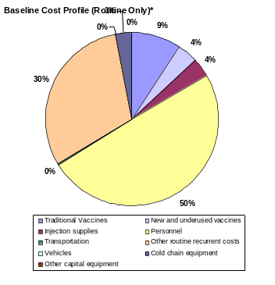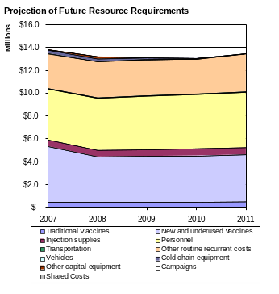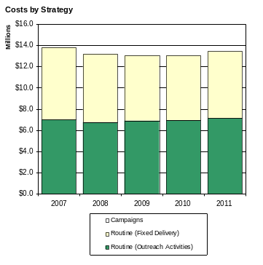

The cost profile for Zimbabwe shows that the major cost driver of routine immunization lies with personnel costs (50%) and other recurrent expenses (30%) such as training, social mobilization, surveillance activities and IEC. To note that the cost of Hepatitis B monovalent vaccine as an under-utilized vaccine represents 4% of the overall cost of the programme in the baseline year.

Future resource requirements are based on current objectives of the immunization programme as being detailed in the development of a new comprehensive multi-year plan for the period 2007-2011. While the information is still work in progress, the resource requirements are expected to rise primarily due to the introduction of DTP-HepB-Hib vaccine. An increase in cost by a factor of 1.5 is notes when comparing the baseline expenditure (2005) on routine immunization with future resource requirements. The cost of introducing the pentavalent vaccine will add at least $4 million a year to the national immunization programme. The details of the costing of the new vaccine is presented in the tables below.

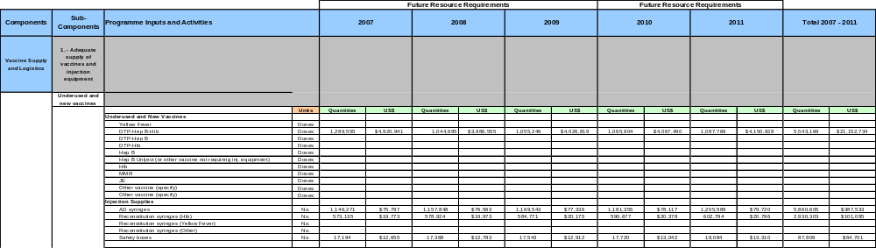

Over the entire 2007-2011 period, approximately $66 million will be required to cover for the entire needs of the programme. Several points are worth noting:
  - This is approximately $13 million a year or $1.1 per capita and $38 per DTP fully vaccinated child.
  - The cost per capita increases by $0.4 from the baseline and more than $10 per DTP fully vaccinated child.
  - Of these amounts, almost 40% are to cover for the need for vaccines.
  - Outreach is an important delivery strategy (about 50% of the costs)

- Projected financing from all sources for the same time period

In 2005 in Zimbabwe, the main funding sources for routine immunization are the national government (72%), GAVI (4%), UNICEF (4%), WHO (7%) and the European Union (13%).

Future funding was projected over the period and by including both monies that are secured and those that could be available (probable). On the funds that are considered secure, national financing is expected to stay fairly constant at about $6.5 to $7 million annually. Some extended funding from WHO and UNICEF is secured up to 2007.

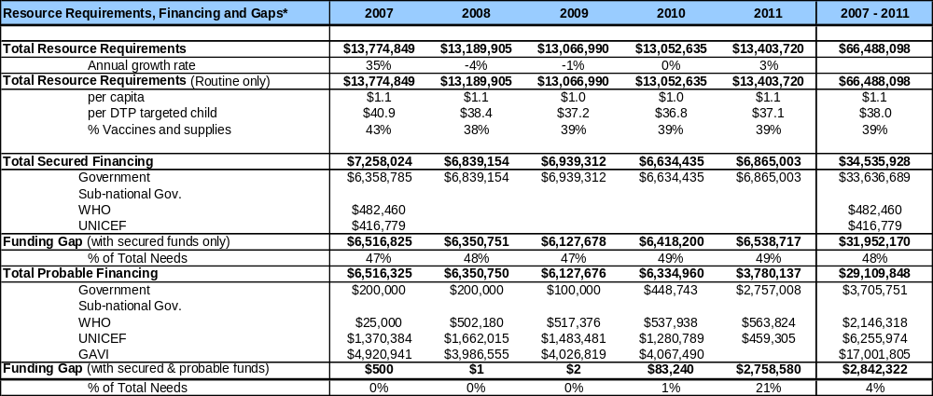

On the probable funding, national financing has been included that will cover an increasing proportion of new vaccine costs. The funding from GAVI for the pentavalent vaccines was considered as probable funding given the conditional approval for DTP-HepB-Hib vaccines. GAVI awards will end by 2011 and by then, the majority of the cost of the vaccines will be financed by the government. Probable funding from WHO and UNICEF has been projected assuming that the same levels of funding provided today, will continue in the future (about $500,000 annually for WHO) For UNICEF, there are planned increases in funding to reach $1 to $1.5 million annually.

If only secure funding is considered, some 48% of resources requirement over the entire period are unmet (about $32 million for 2007-2011). At least $6 million shortfall exists every year of the period. If probable funds are included, most of the needs are meet over the 5 year period.

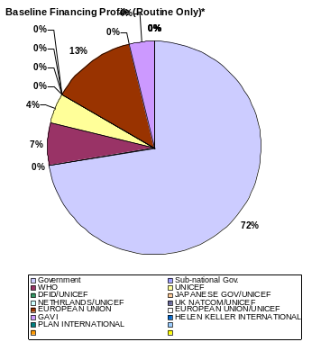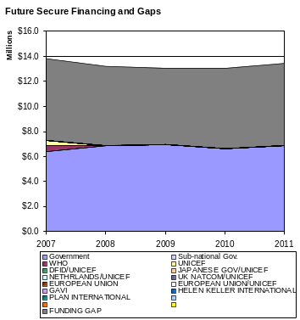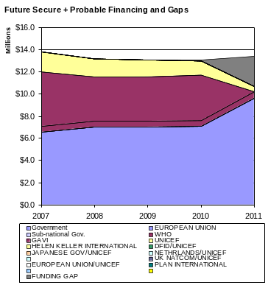

- A description of the highest priority actions that the government will take to fill any resource gaps

Please refer to FSP strategies section of the FSP document.

Zimbabwe Financing Clarifications:
Short Analysis of the cMYP costing for Zimbabwe - 2007-2011

Between 31 October and 8 November 2005 the GAVI Independent Revue Committee (IRC) met in Geneva. The report of the IRC noted that the request for support for the introduction of pentavalent (DTP-HepB-Hib) into routine immunization was given conditional approval. In order to qualify for final approval, Zimbabwe needed to provide a satisfactory financial analysis that includes: (a) a rigorous analysis of the current and projected future costs for the program for the next years; (b) projected financing from all sources for the same time period; and a (c) a description of the highest priority actions that the government will take to fill any resource gaps.

Given that Zimbabwe is currently developing a cMYP, the costing and financing clarifications are based on the recent analysis and projection made using the cMYP costing tool.

- A rigorous analysis of the current and projected future costs for the program for the next years

In 2005, the total expenditures on immunization totalled $8.9 million. In the baseline year, 100% of spending on immunization was for routine delivery systems - there we no reported campaigns that year. Translated into indicators, the cost of routine immunization represents $0.7 per capita or almost $38 per DPT fully vaccinated child.

Baseline Indicators | 2005
Total Immunization Expenditures | $8,913,479
Campaigns | $0
Routine Immunization only | $8,913,479
Per capita | $0.7
Per DTP3 child | $27.6
% vaccines and supplies | 16.8%
% national funding | 72.4%
% total health expenditures | 2.2%
% government health expenditures | 6.1%
% GDP | 0.15%
Total Shared Costs | $11,543,758
% Shared health systems cost | 56%
TOTAL | $20,457,237

Total expenditures on routine immunization represent some 2% of total expenditures on health and where national funding is short of 75% (72%) of overall funding for immunization. Government funding mainly covers for the needs for basic vaccines, staff salaries and overhead costs of the programme.

The cost profile for Zimbabwe shows that the major cost driver of routine immunization lies with personnel costs (50%) and other recurrent expenses (30%) such as training, social mobilization, surveillance activities and IEC. To note that the cost of Hepatitis B monovalent vaccine as an under-utilized vaccine represents 4% of the overall cost of the programme in the baseline year.

Future resource requirements are based on current objectives of the immunization programme as being detailed in the development of a new comprehensive multi-year plan for the period 2007-2011. While the information is still work in progress, the resource requirements are expected to rise primarily due to the introduction of DTP-HepB-Hib vaccine. An increase in cost by a factor of 1.5 is notes when comparing the baseline expenditure (2005) on routine immunization with future resource requirements. The cost of introducing the pentavalent vaccine will add at least $4 million a year to the national immunization programme. The details of the costing of the new vaccine is presented in the tables below.

Over the entire 2007-2011 period, approximately $66 million will be required to cover for the entire needs of the programme. Several points are worth noting:
  - This is approximately $13 million a year or $1.1 per capita and $38 per DTP fully vaccinated child.
  - The cost per capita increases by $0.4 from the baseline and more than $10 per DTP fully vaccinated child.
  - Of these amounts, almost 40% are to cover for the need for vaccines.
  - Outreach is an important delivery strategy (about 50% of the costs)

- Projected financing from all sources for the same time period

In 2005 in Zimbabwe, the main funding sources for routine immunization are the national government (72%), GAVI (4%), UNICEF (4%), WHO (7%) and the European Union (13%).

Future funding was projected over the period and by including both monies that are secured and those that could be available (probable). On the funds that are considered secure, national financing is expected to stay fairly constant at about $6.5 to $7 million annually. Some extended funding from WHO and UNICEF is secured up to 2007.

On the probable funding, national financing has been included that will cover an increasing proportion of new vaccine costs. The funding from GAVI for the pentavalent vaccines was considered as probable funding given the conditional approval for DTP-HepB-Hib vaccines. GAVI awards will end by 2011 and by then, the majority of the cost of the vaccines will be financed by the government. Probable funding from WHO and UNICEF has been projected assuming that the same levels of funding provided today, will continue in the future (about $500,000 annually for WHO) For UNICEF, there are planned increases in funding to reach $1 to $1.5 million annually.

If only secure funding is considered, some 48% of resources requirement over the entire period are unmet (about $32 million for 2007-2011). At least $6 million shortfall exists every year of the period. If probable funds are included, most of the needs are meet over the 5 year period.

- A description of the highest priority actions that the government will take to fill any resource gaps

Please refer to FSP strategies section of the FSP document.

CLARIFICATIONS FOR PR 2006.02

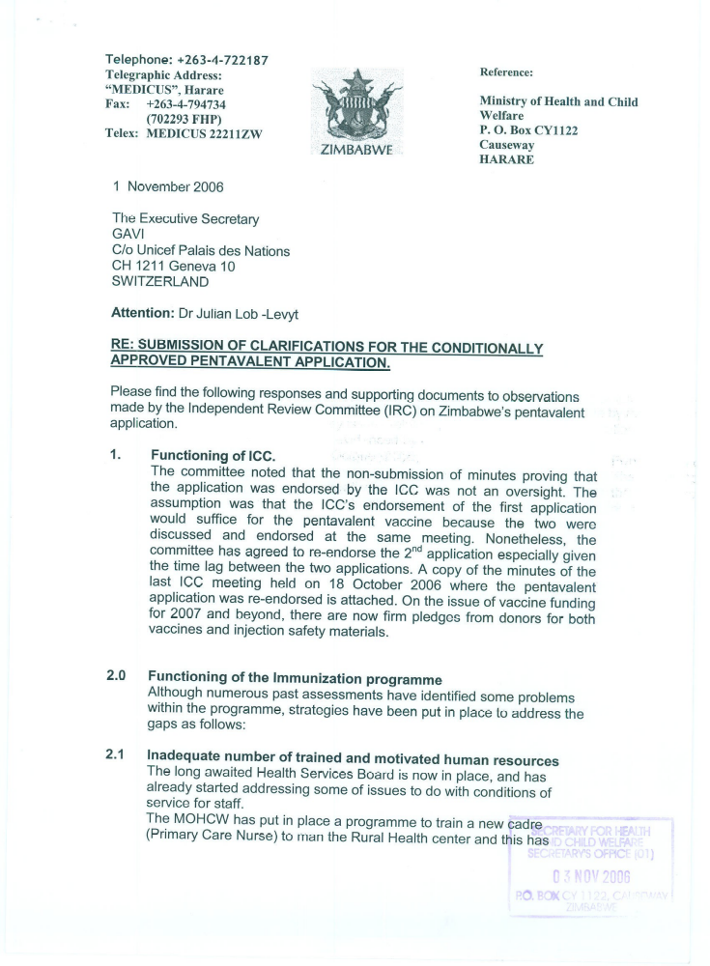

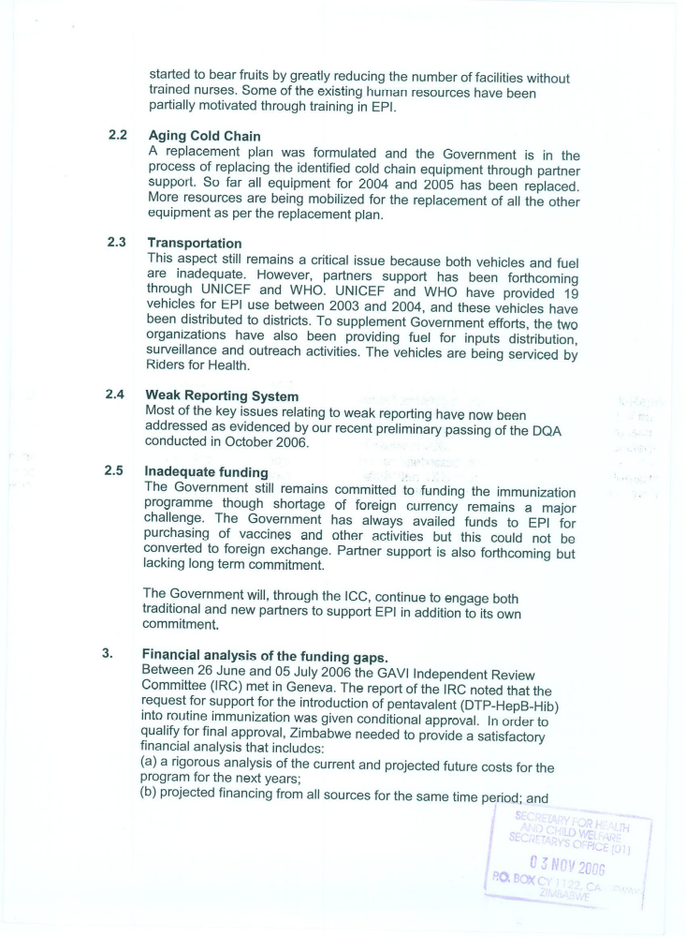

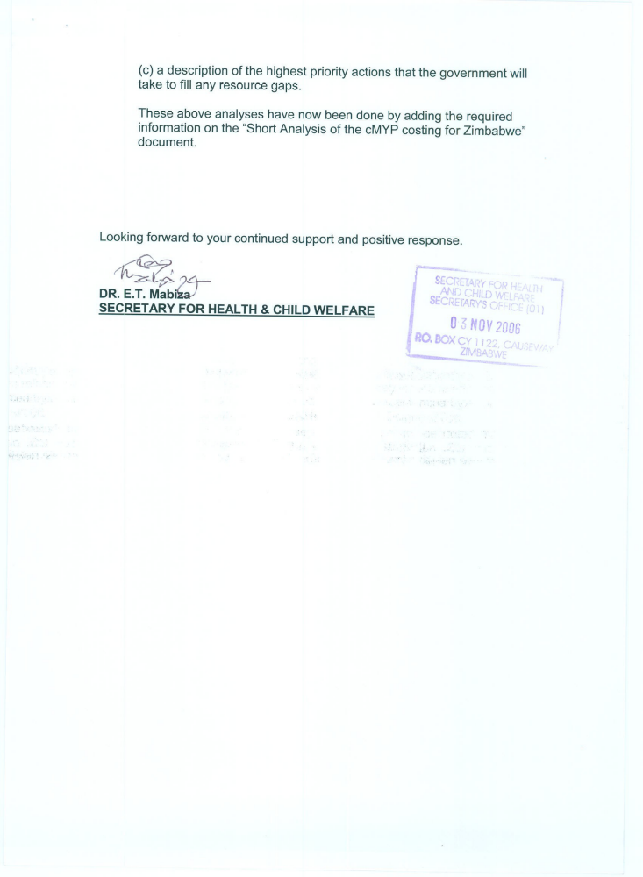

The formula to calculate a vaccine wastage rate (in percentage): [ ( A – B ) / A ] x 100. Whereby : A = The number of doses distributed for use according to the supply records with correction for stock balance at the end of the supply period; B = the number of vaccinations with the same vaccine in the same period. For new vaccines check table α after Table 7.1. *2004 BCG coverage different from GAVI annual report because its now based on births rather than surviving infants. Coverage targets have also been revised.

