Application Form for the Cold Chain Equipment (CCE) Optimisation Platform – supplementary material to Health System Strengthening (HSS) requests for January and May 2016 submissions only

Deadlines for submission of application:
15 January 2016
1 May 2016

Document dated: December 2015

NOTE: 2016 will be a development and learning period for the CCE optimisation platform. This supplementary material will be adapted and evolve as Gavi gains experience from the implementation of the platform (including for September 2016 submissions).

Application documents for 2016:
Countries applying for all types of Gavi support in 2016 are advised to refer to the following documents in the order presented below:
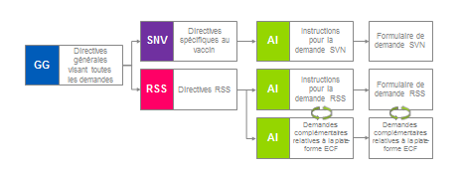
Additional applications relating to the CCE platform  Form | Purpose of this document:  This form must be filled in in order to submit an application for Gavi support for the CCE optimization platform. Applicants are required to read the Supplementary CCE optimisation platform application instructions prior to completing this application form. Applicants should first read the General Guidelines for all types of support as well as the HSS Guidelines before this document. The application form and attachments must be submitted in English, French, Portuguese, Spanish, or Russian.
Weblinks and contact information:
All application documents are available on the Gavi Apply for Support webpage: www.gavi.org/support/nvs For any questions regarding the application guidelines please contact proposals@gavi.org or your Gavi Senior Country Manager (SCM).
TABLE OF CONTENTS
Part A: Summary of support requested and applicant information 1
Part B: Application objectives 7
PART E: Implementation related details 12
PART G: List of Mandatory and Optional Attachments 18

Part A: Summary of support requested and applicant information
1. Applicant information
Country Name | Democratic Republic of the Congo (DRC)
Date | 29 April 2016
Name & job title | Dr Guylain KAYA MUTENDA SHERIA, EPI Director ai.
Email address | guylainkaya@gmail.com
Telephone | +243, 815678166
Total funding requested from CCE platform (US$) | This should correspond exactly to the budget requested in Question 9 (detailed budget).  $USD16,696,660
Does your country have an approved HSS grant on-going? | Yes X | No
Indicate the end year of the HSS support:
HSS2 Grant 2019
Proposed CCE platform grant start date: | Indicate the month and year of the planned start date of the grant based on the strategic deployment plan:  December 2016
Proposed CCE platform grant end date: | Indicate the month and year of the planned end date of the grant based on the strategic deployment plan:  31 December 2020

2. Executive summary (Maximum 2 pages)
The EPI supply chain is organized into 3 levels: (i) The central level includes 4 modern hubs (one at the central level in Kinshasa and 3 in the provinces), which are under construction; (ii) The intermediate level made up of 9 coordination warehouses and 49 branch and relay warehouses; (iii) and the peripheral level which includes 516 health zone warehouses and 8830 health centres. The national EPI program must overcome several challenges in order to achieve its goals for coverage and equity, among them supply chain strengthening
Currently there are 10 antigens in the RDC EIP routine program. In addition to the traditional vaccines (BCG, OPV, DTP, TT, measles) administered since its creation, the program has progressively introduced the yellow fever vaccine in 2013, DTP-HepB in 2007, DTP-HepB-Hib in 2009, PCV-13 in 2011 and IPV in 2015. The country is considering the progressive introduction of rotavirus, HPV and measles-rubella vaccines in the coming years with a resulting increase in the storage capacity needs at all levels.
The data from the Cold Chain Equipment inventory done in 2014 and updated in April 2016 show that at the central level the storage capacities which are currently insufficient will be sufficient starting in 2017 with the construction of 4 hubs which are under construction. At the branch and coordination depot level, the capacities are sufficient until 2020 to meet the progressive introduction of new vaccines.
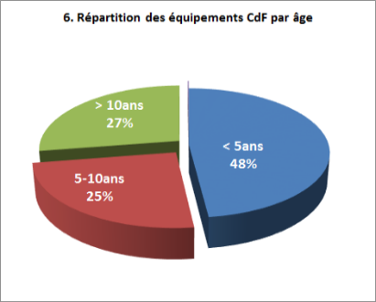
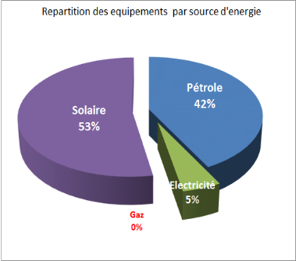
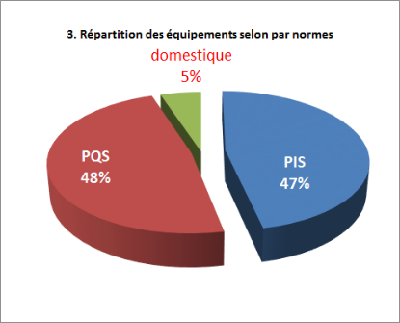
At the operational level (Health Areas), only 51.7% of the health areas are covered with cold chain equipment; the situation is shown in the following charts.
The results of the Effective Vaccine Management (EVM) evaluation done in 2014 show insufficiencies in these criteria: E2 (temperature: 66% in the HZ and 58% in the HA), E3 (Storage capacity: 68% in the HZ and 48% in the HA), E5 (Maintenance: 49% in the HZ and 21% in the HA), and E9 (MIS, support function: 62% for the HZ and 54% for the HA).
Referring to the data from the structures targeted for the CCEOP, 1.2% of the health centres are connected to the national electrical grid.
It can be seen from the preceding that there is insufficient cold chain equipment coverage at the operational level (i.e. health areas). Additionally, the EVM evaluation and supervisor reports from the field have shown the worn out condition of the cold chain equipment, the lack of training of the personnel on preventive maintenance, prolonged and repeated shortages of petrol and replacement parts and prolonged failures because of the lack of qualified technicians. It also needs to be indicated that the absence of standardized operating procedures and shortcomings in monitoring of the temperature of cold chain equipment constituted significant weaknesses which led to the preparation of the Improvement Plan.
In addition to others, the bottlenecks which hinder vaccination are among others: (i) the DRC has a vaccine supply chain which does not always guarantee the availability of quality vaccines at the points of final use (transportation, storage and logistics management); (ii) the low availability at the decentralized level of the health system of quality health services which incorporate vaccination; (iii) the weakness of the institutional capacities and of steering by the health bodies and structures at all levels of the health system; (iv) the low quality of the data which do not make it possible to have a better assessment of the efforts provided by the teams at all levels and which do not allow pertinent decision-making in vaccination matters; (v) the low demand for vaccination services by the community including in the Health Zones where the services are available.
in that way, in order to address the main bottlenecks and in connection with end-to-end supply chain strengthening in order to assure availability of quality vaccines and other specific supplies at all levels, the country received Gavi/HSS2 support whose main activities are (among others): (i) strengthening the capacity for storage and preservation of vaccines and dry vaccination supplies by construction of a modern Hub in Kinshasa and 3 decentralized Hubs (in Lubumbashi, Kisangani and Ilebo); (ii) the reduction of the cost of transporting vaccines from Kinshasa to the provinces by the acquisition of a refrigerated boat in order to supply the decentralized Hubs; (iii) the conversion to solar power of 23 cold rooms which were using electric generators as the main energy source; (iv) the acquisition and installation of 2312 SDD solar refrigerators in the health centres and (210) in the Health Zones Central Offices; (v) strengthening of cold chain maintenance by establishing maintenance pools and training of 35 engineers/technicians at the central level and in the PHD; (vi) the acquisition of replacement parts; (vii) establishing a continuous temperature monitoring system at various levels. Similarly, the MPH planned training and deployment of 120 logistics experts to the health areas in order to assure the supply and management of stocks among other things. All these investments will contribute to improving coverage and equity. Similarly, a structured equipment maintenance plan was developed in order to overcome the deficiencies observed during the EVM with financing provided by the MPH and its partners.
At this time, after progressively receiving and installing 2313 refrigerators, the coverage with functional refrigeration equipment will move from 16% to 51.7% (; all energy sources combined) at the service delivery structure level with 4562 health centres covered out of 8830 in total. Efforts are still needed to cover the 4268 health centres and replace the 42% of absorption refrigerators. Administrative data shows that in 2015 14% of the HZ achieved Penta 3 coverage <80%. According to the supervisory reports these poor performances would be related in part to the poor cold chain equipment coverage in the health centres and also the weakness of the maintenance.
The country decided to submit the Gavi CCEOP application in order to support the purchase, transport and installation of 2087 solar refrigerators (36 L TCW40SDD) for the health centres, 209 replacement part kits, 28 long storage life ice chests for vaccine storage and 4583 Fridge-tags. This project is going to involve 23 out of 26 PHD in the country whose cold chain equipment coverage rate is below 74% will be affected by this project. In all, 418 health zones out of 516 (81%) will benefit from this support.
The following considerations were included in selecting the equipment type:
- “Cold Chain Equipment Optimization Platform” technology guide from Gavi;
- Lessons learned in the areas of acquisition, installation and operation of solar refrigerators in the country;
- Technical guidelines covering the choice of eligible equipment by platform;
- Guidelines from the Ministry of Public Health for the standardization of the cold chain equipment embedded base
- The possibilities that these refrigerators provide for recycling cold packs.
The country will be able to improve several vaccination service indicators with this project.
- Availability of quality vaccines at all levels: 1687 health centres not yet equipped and 400 health centres whose refrigerators have broken down will be provided with new solar refrigerators or long storage life ice chests. In this way, the Health Centre cold chain equipment coverage can be increased. In this way, the structures will be able to have good quantity and quality vaccines.
- Access to vaccination for all the Country’s population: because of the availability of cold chain equipment in hard to reach health areas, the country will be able to reach unvaccinated people and organize outreach strategies.
- Increase the vaccination coverage: Increasing the cold chain coverage and improving the maintenance system are going to contribute to minimizing missed opportunities by increasing the number of vaccination sessions in fixed and outreach strategy. Recent data from the country already show that a trend of increasing the number of vaccination sessions is observed in the provinces where GAVI/RSS2 refrigerators have already been installed.
- Supply chain strengthening: With this project, the MPH will be able to strengthen the supply chain, in particular near vaccination services delivery points. In fact the Country receives Gavi support for end to end supply chain strengthening by the construction of modern hubs in Kinshasa and in 3 provinces (Kisangani, Ilebo and Lubumbashi) and the construction of a boat for transportation of vaccines and other supplies. The sharing of the logistics means of various specialized programs and Directions will be progressively effective once the structures go into operation in order to make vaccines and other health products available at all levels.
- Equity between all health zones and centres: The current data show that the coverage rate in cold chain equipment and in particular solar equipment in the health areas varies from one province to another. The lowest cold chain coverage is 30% (Mongala PHD) and the highest is 90% (Maniema PHD). The lowest solar cold chain coverage rate is 37% (Kasai PHD) and the highest is 75% (Tshuapa PHD). This submission will make it possibly to equitably extend the cold chain equipment in the HA over the entire country. All PHD eligible for the project will have their cold chain coverage increased to at least 72%. In the implementation of this project, priority is given to provinces with low cold chain equipment coverage rates (HA cold chain coverage <74%), those having low solar cold chain coverage and those having more non-PQS refrigerators. Because of this project, the peripheral level cold chain coverage differences will be considerably reduced In that way, the vaccination activities will be organized equitably at all levels with the same quality.
- Vaccine Safety and Quality: Direct control solar refrigerators (without batteries) and long storage time ice chests, having technology with which to maintain the required storage temperatures of the vaccines, will be selected. With the availability of cold chain equipment and good maintenance, health centres will be able to store and administer quality vaccines. Specific emphasis will be placed on management and monitoring of vaccines and temperature.
- Strengthening of cold chain maintenance: By applying the maintenance plan, it will be possible to make the maintenance pools installed in the PHD operational. The availability of trained and qualified technicians will make it possible to provide quality maintenance and optimize the operation of equipment in order to guarantee vaccine availability and quality at all levels. Through the project, the EPI will be able to rehabilitate and extend the cold chain equipment and to standardize equipment in order to assure acquisition of replacement parts and proper maintenance.
- Updating the equipment inventory: A mechanism for periodic updating of the cold chain equipment inventory will make it possible to collect and analyze data on the operation at the turn-up of the ILAMT tool.

3. Acronyms
Provide a full list of all acronyms used in this application.
Acronym | Acronym meaning
ASAP |  | Health Area
CTA |  | Country Tailored Approach
IC |  | Calmette-Guerin Bacillus Vaccine
CCE |  | Cold Chain Equipment
ICC |  | Interagency Coordination Committee
CC |  | Cold chain
CS |  | Health Centre
PHD |  | Provincial Health Division
DTP-HepB-Hib |  | Diphtheria, tetanus, pertussis, hepatitis B and Haemophilus influenza type b vaccine
Gavi |  | Global Alliance for Vaccines and Immunisation
EVM |  | Effective Vaccine Management
Anti HPV |  | Human papillomavirus (HPV) vaccine
MPH |  | Ministry of Public Health
WHO |  | World Health Organisation
Pentavalent |  | Pentavalent vaccine
EPI |  | Expanded Programme on Immunization
NHSP |  | National Health Development Plan
PON |  | Standardized Operating Procedures (SOP)
cMYP |  | Comprehensive Multi-Year Plan
PQS |  | Performance, Quality and Security (prequalified products)
DRC |  | Democratic Republic of the Congo
MR |  | Measles/rubella
HSS |  | Health System Strengthening
SNEL |  | Société Nationale d’Electricité
UNICEF |  | United Nations Children's Fund
UNOPS |  | United Nations Office for Project Services
YFV |  | Yellow fever vaccine
MCV |  | Measles vaccine
ATV |  | Tetanus Vaccine (Tetanus Toxoid)
IPV |  | Inactivated Polio Vaccine
OPV |  | Oral Polio Vaccine
ZS |  | Health Zone

4. Signatures
4a. Government endorsement
Include Minister of Health and Minister of Finance endorsement of the HSS proposal – Mandatory Attachment #1.
We, the undersigned, affirm that the goals and activities of the Gavi proposal are fully aligned with the national health strategic plan (or equivalent), and that the funds for implementing all activities, including domestic funds and any needed vaccine joint investment, will be included in the annual budget of the Ministry of Health.
Minister of Health (or delegated authority) Minister of Finance (or delegated authority)
Name: We, the undersigned, affirm that the goals and activities of the Gavi proposal are fully aligned with the national health strategic plan (or equivalent), and that the funds for implementing all activities, including domestic funds and any needed vaccine joint investment, will be included in the annual budget of the Ministry of Health.
Minister of Health (or delegated authority) Minister of Finance (or delegated authority)
Name: Dr. Felix KABANGE NUMBI MUKWAMPA Name: Henri Yan MULANG

Signature: Signature:

Date: Date:
4b. Strategic ICC endorsement of the EIP
Include official endorsement of the proposal – Mandatory Attachment #2
Include a signature of each committee member in attendance and date.
Mandatory Attachment #2: Approval of the proposal by the HSCC/ICC
We, members of the Interagency Coordinating Committee “ICC/EIP”, met April 22, 2016 to review this supplemental proposal. At that meeting we endorsed this proposal on the basis of the supporting documentation which is attached. The minutes of the meeting endorsing this proposal are attached to this application.
Please list all committee members | Title/Organisation | Name | Sign below to confirm:
 |  |  | Attendance at the meeting where the proposal was endorsed | Endorsement of the minutes of the meeting during which the proposal was discussed
Chair | DRC Minister of Health | Dr. Felix KABANGE NUMBI MUKWAMPA
Secretary | Expanded Programme on Immunization | Dr. Guylain KAYA MUTENDA SHERIA
MOH members | General Secretary for Health | Dr. MUKENGESHAYI KUPA
Development partners
CSO members
WHO
UNICEF

Part B: Application objectives
5. Impact of the supply chain, and in particular CCE, on coverage and equity goals (Approximately 1 page)
What is the coverage gap? What supply chain challenges were created or exacerbated by [non-functional or poorly performing] cold chain equipment? What is the impact of the supply chain on coverage and equity in your country? What is the impact of the CCE on coverage and equity in your country? Provide: Mandatory Attachment #4: Most recent EVM Improvement Plan and Mandatory Attachment #5: Most recent progress report on the EVM Improvement Plan implementation

According to the 2015 EPI annual report, 71 health zones (14%) have reported Penta 3 vaccination coverage below 80%. Among the reasons given for this poor performance, the following, among others, are notable: difficulties reaching remote populations by outreach for lack of cold chain equipment, repeated petrol and replacement part outages, and frequent breakdown of the equipment due to wear and insufficient maintenance of the cold chain often resulting in vaccine stock outages. To remedy this situation, in connection with Gavi/HSS2, the country is strengthening the cold chain by purchasing 2312 TCW40SDD refrigerators and 210 TCW2000SDD refrigerators. This raised the cold chain coverage to 51.7% (4562 of 8830 HA) but there still remain challenges to overcome for better coverage and equity.
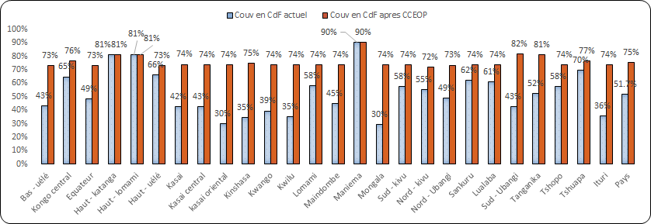
The cold chain coverage of the Health Centres varies from one PHD to another. The lowest is 30% (Mongala) and the highest is 90% (Maniema). 23 out of 26 PHD have a coverage below 74%.

From national data (2015) it can be seen that the persistence of a large number of unvaccinated or insufficiently vaccinated children (211,363 children from 0 to 11 months old) because among other things of the irregularity of holding outreach vaccination sessions due among other things to an insufficient cold chain.
In this project, priority will be given to PHD in which the Health Centre cold chain coverage is below 74%. Therefore, 23 out of 26 PHD will be involved. The cold chain equipment coverage will be extended by the project to at least 72% in all provinces. Nationally, the level will go from 51.7% to 75%. The project will give priority to the extension of the cold chain to the HC which are still not equipped (81% of the equipment from the proposal), the replacement of unrepairable broken-down equipment, storage capacity strengthening and improvement of cold chain quality and reliability. The HC which previously depended on other centres equipped with refrigerators will now be autonomous and will no longer need to go tens of kilometres to get vaccines from the resupply site.
The goals in matters of equity are covered because the country is going to extend the reach of its vaccination supply chain to the HC which did not previously have cold chain equipment. The country’s populations will equitably benefit from the vaccines. Because of this project, very isolated rural zones and marginalized urban zones will have, which will make it possible to provide the health centres with refrigerators capable of recycling cold packs for the regular organization of vaccination sessions in strategies. Vaccines and vaccination services will be brought closer to parents, especially mothers of children, who previously had to walk more than 5 km to reach the closest vaccination sites.
It will allow the country to proceed with a progressive replacement of worn-out equipment and equipment not meeting the PQS standards and to standardize the deployed base.

PART C: Status of the CCE
6. Rational for the specific need for rehabilitation and expansion of the country’s CCE (approximately 1 page)
Describe the existing CCE situation in the country, detail your rehabilitation and expansion request and explain on what basis it is needed. Please provide: Mandatory Attachment #6: the CCE inventory and facility segmentation, the Mandatory Attachment #7: CEE rehabilitation and expansion plan.
The cold chain equipment inventory done in 2014 and updated in April 2016 brought out the situation at the operational level which is presented in the following charts:
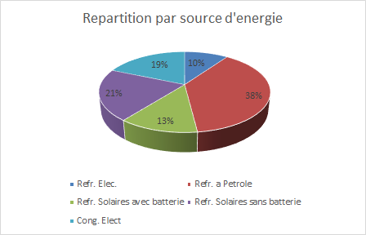
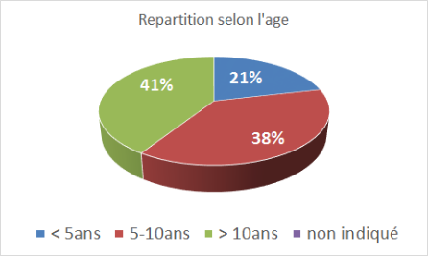
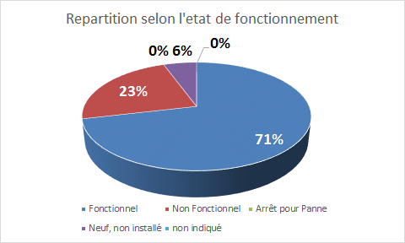
At the health zone level:

At the health area level:
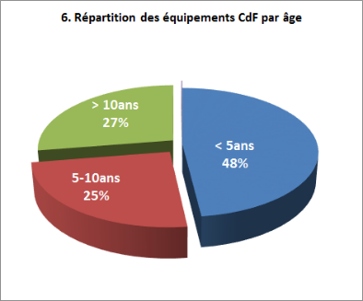
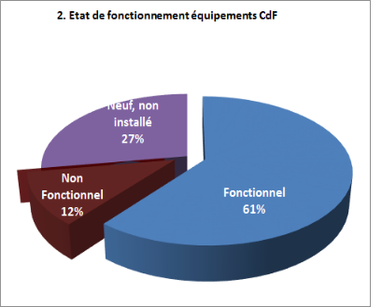
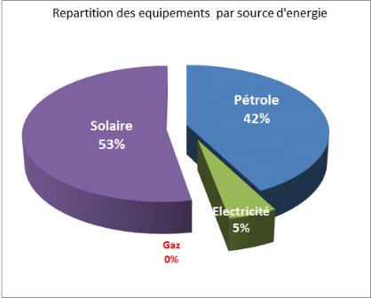

The main causes of frequent breakdowns of equipment affecting the vaccination service offering are: the worn-out condition of cold chain equipment (25% of the health centre refrigerators are more than 10 years old); the continuous unavailability of quality kerosene; shortages of spare parts and lack of qualified technicians for maintenance.
With this project, the country will be able to acquire effective equipment for assuring vaccination service continuity, standardizing the equipment types which will make maintenance easier and progressively eliminating inventories of unapproved equipment. The hard-to-reach HA will be provided with cold chain equipment in order to reduce the long distances for supplying them with vaccines and the cost of transportation of the supplies and also to make outreach vaccination easier.
The supply with quality vaccines and strengthening of the cold chain are crucial questions confronting the EIP in the Democratic Republic of the Congo. Because of this, the EPI with the support of its main partners is implementing measures to strengthen the supply chain management structures and more specifically the management of vaccines and the cold chain at all levels (e.g. central, intermediate and peripheral). The present project will serve to address the main bottlenecks, specifically: (i) the availability of cold chain equipment in the health centres; (ii) strengthening operational level storage capacity; (iii) cold chain reliability; (iv) compliance of the devices with PQS standards at all levels; (v) improvement of the organization of the supply chain, particularly the availability of the logistics for vaccine and supply distribution; (vi) strengthening of the temperature control and monitoring system.
The 2015 vaccination coverage data show that about 14% of the health zones have a Penta3 vaccination coverage below 80%. This poor performance is mostly related to difficulties supplying vaccines and petrol and to the availability of the functional cold chain especially in hard-to-reach areas.
The cold chain equipment coverage in health centres can be raised from 51.7% to 75% with the acquisition and installation of new equipment through this project. In order to meet the 2015-2019 cMYP goals, efforts are underway to replace absorption refrigerators with solar refrigerators. The platform project calls for the replacement of 400 refrigerators that are broken down and not repairable and equipping health centres that are not currently equipped with 1687 refrigerators
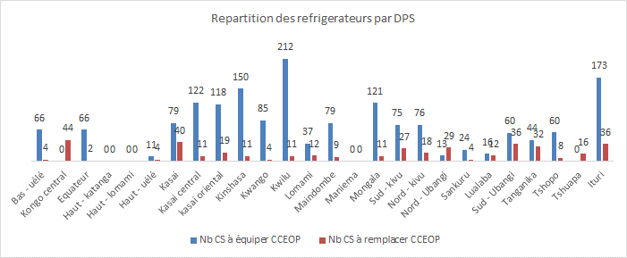

Referring to the country’s rehabilitation plan, the following table summarizes the needs until 2020 for refrigerators in the health area.

Types of equipment | Number of equipment |  |  |  |  | Total
 | 2016 | 2017 | 2018 | 2019 | 2020
Small-capacity solar refrigerators (TCW40SDD) |  | 2.087 | 2.000 | 2.000 | 690 | 6.777
Compared to the not yet covered needs, the country is going to continue to mobilize both internal and external resources in order to improve arriving to full satisfaction in matters of cold chain coverage in the health areas.

7. Anticipated impact of the rehabilitation and expansion plan on enhancing the design of the supply chain to improve its efficiency/effectiveness (approximately 1 page)
Describe how the proposed CCE rehabilitation and expansion plan will impact the system design and contribute to the effectiveness of the supply chain (accounting for the commissioning and decommissioning of CCE). Supply: Mandatory Attachment #3: EVM assessment report and Optional Attachment #13: Health system bottleneck analysis.

The central warehouse currently has 20 functional cold rooms: 15 positive cold rooms with a gross total capacity of 480 m³ and 5 negative cold rooms with a total gross capacity of 120 m³. The current positive capacity of the central warehouse is insufficient for receiving all the vaccines with a shortage of 105 m³. In 2020 the required net positive capacity will be about 230 m³. The Kinshasa Hub which is being built with 2200 m³ positive cold rooms and 1400 m³ negative cold rooms will make it possible to fully cover the gap until beyond 2025. At the intermediate level, according to the inventory data, all the Coordinations and Branches have sufficient storage capacity to meet the progressive introduction of new vaccines such as planned in the 2015-2019 cMYP. However, routine supply problems related to transport are ongoing (e.g. scarcity of flights, etc.). The expenditures related to the cost of transporting vaccines to the PHD can be limited by the construction of 3 modern provincial Hubs having positive cold rooms with gross storage capacity of 480 m3 in Kisangani, 160 m3 in Ilebo and 320 m3 in Lubumbashi and also the acquisition of a boat.
It can be seen from the inventory data that 80% of the health centre refrigerators are functional. The coverage of 51.7% of the Health Centres with cold chain equipment is insufficient because of the country’s immensity. The inventory also showed that the equipment embedded base includes several brands of equipment. This situation makes supply chain management difficult (e.g. ordering replacement parts, maintaining equipment, monitoring the cold chain, etc.). The introduction of new vaccines (e.g. rotavirus, HPV, MenA, etc.) called for in the 2015-2019 cMYP and the organization of supplemental immunization activities are considered in the cold chain rehabilitation plan as are the needs of not yet equipped health centres.
Maintenance is being strengthened by establishing maintenance pools (35 engineers/technicians will be trained) in order to strengthen the end-to-end supply chain.
These capacities will be strengthened by the acquisition of 2087 TCW 40SDD refrigerators, 209 replacement part kits, 28 long storage life ice chests for the storage of vaccines (experimental phase) and 4583 fridge-tags with the option of standardizing the equipment in the supply chain. In that way, in 23 of 26 PHD targeted by this project, 2087 health centres distributed in 418 health zones (81%) will get refrigerators.
For the unit cost estimate of the refrigerator (estimated at $7850 by UNICEF), the country referred to the actual execution costs during recent refrigerator acquisitions with Gavi/HSS2 funds via UNICEF.
The installation of new refrigerators and the replacement of the existing ones will be done based on 4 priorities: (i) Priority 1: health centres not yet equipped with refrigerators; (ii) Priority 2: health centres with broken refrigerators (PQS and non-PQS); (iii) Priority 3: Health centres with refrigerators that are more than 10 years old; (iv) Priority 4: Health centres would non-PQS refrigerators which are less than 10 years old.
PART D: Requested Support
8. Total quantity and budget of CCE requested (including the platform and country joint investment)
Please use the CCE optimization platform budget form to list the yearly amount of support requested both in terms of number of units and cost (including both purchase and service bundle cost). Indicate and justify any additional requirement that you may have (e.g., manufacturer, features).
www.gavi.org/XXXXXXXXXXXX <LINK TO BE UPDATED>

9. Justification of the scale and technology requested (approximately 1/2 page)
Given the country’s current or anticipated system design and CCE situation, justify that your request is at the right scale and for the right technology (number, capacity, type) to address the identified bottlenecks.
Supply: Mandatory Attachment #8: Equipment Selection and Optional Attachment #14: Total cost of ownership analysis (if needed)
In the DRC, the choice of SDD solar refrigerators is motivated by the unreliability of the national electric grid, program needs, acquired experience, standardization of the installed equipment base in order to make maintenance easier, and total cost of ownership.

About 42% of the CCE used in the health centres operate on petrol which would cost the country about US$427,883 per month or $5,134,056 per year (45 L of petrol per refrigerator per month equivalent at US$90) which is about the purchase cost of 650 TCW40SDD solar refrigerators. The absence of secured funds for the purchase and supply of petrol and replacement parts and the poor quality of the maintenance often leads to cold chain outages and vaccine wastage.
Up to the end of 2015, the country also reported warehouse fires for the branches, health zone central offices and health centres (fires in Mbandaka branch in 2007, Boende in 2013, etc.), causing very significant losses of resources essentially due to the failure of petrol refrigerators and the Sibir in particular. Similarly, the DRC is not immune to the phenomenon of global warming with greenhouse gases released by petrol refrigerators. Referring to the data from the structures targeted for the CCEOP, 1.2% of the health centres are connected to the national electrical grid.
In fact, the country is engaged in a progressive process of conversion of the cold chain equipment to solar energy at the intermediate level (solar energy for cold rooms) and operational level (supplying health centres and replacing non-PQS refrigerators with SDD solar refrigerators).

Additionally, some solar equipment is operationally stopped because of un-replaced batteries.
Considering the difficulties indicated above, the DRC opted for the use of solar refrigerators without batteries because of advantages offered by this new technology.
Meeting the chilled water production capacity needs at the level of health centres organizing outreach strategies is an absolute necessity for the country.
The segmentation of the health centres revealed that 91% have storage capacity needs by 2020 included between 5 and 36 L. Thus, among the cold chain equipment for the health areas prequalified in the PQS, the one selected by the DRC EPI (TCW40SDD) best meets the needs of the country and the Gavi platform eligibility criteria. For the moment, this equipment is the only one having a capacity for recycling ice packs with a vaccine storage volume included between 15 and 50 L which is eligible under the platform Similarly, the country anticipates the acquisition of 28 long storage time ice chests (one ice chest per province) as a pilot for the health centres whose storage volume is less than 5 L. If the experience is persuasive, the country anticipates extending it to other health centres whose number is estimated at about 450 according to the segmentation.

PART E: Implementation related details
10. Description of equipment purchase and deployment (approximately 1 page)
Explain how you intend to manage the purchase and deployment of equipment and ensure that it is done as per your plans in a timely manner.
Provide: Mandatory Attachment #9: Strategic deployment plan and Optional Attachment #15: National Procurement Policy

The logistics commission, composed of MPH technicians and those from the main EPI partners (e.g. UNICEF, WHO, BMG, USAID, etc.) provided the preparation of submission documents and the selection of the equipment. This logistics commission, under the leadership of the ICC, will provide the coordination role in the implementation of this project.
A detailed purchasing plan was prepared for the ordering and purchasing of equipment. During execution, this plan will be examined quarterly on the basis of a forecast plan established by the logistics commission. In the DRC, the EIP has always benefited from the support of UNICEF for purchasing the large majority of the cold chain equipment. Therefore, on the basis of prior experience, the MPH decided to entrust UNICEF with the acquisition process from equipment ordering (in order to benefit from both a better purchase price and also duty-free) to installation by the supplier (after sale warranty). Considering the immense size of the country and in order to reduce the delivery intervals and the internal transport costs, the equipment will be received through the 5 usual entry ports (Matadi/Kinshasa, Lubumbashi, Goma, Bukavu and Bunia) and then will be routed in the provinces according to the preestablished deployment plan.
A detailed plan and timeline for the planning of the purchase, maritime shipping, receiving, distribution inside the country and installation of the equipment in the field was prepared for the project implementation. Upon receiving approval of the file by Gavi, discussions will be held between the MPH, UNICEF and the manufacturer for launching the orders. The installation of the equipment in the health centres and the training of the users will be provided by the manufacturer.
Referring to the attached deployment plan, 37 teams of engineers will be deployed in the field. On average 2 to 3 units will be installed each week by each team.
The logistics commission will support the MPH in tracking the orders, reception and supervision of the installation of the equipment in the field.
Each partner will fully play their part in this project. Thus: (i) The MPH/EPI will provide the coordination of project activities through the logistics commission and the maintenance pools. At the central level and in the 26 provinces, the EIP has more than about 30 trained and qualified engineers/technicians who will be in charge of providing the tracking and maintenance of this equipment. Similarly, in connection with Gavi/HSS2, the EPI received 40 pickup trucks and motorcycles intended for the PHD and which will be mobilized for the movement of technicians for the maintenance operations; (ii) UNICEF: will prepare the order, facilitate the transport, customs clearance and temporary storage at the 5 entry ports and also handle the negotiation and contract signing with the manufacturer. Additionally, UNICEF will provide its technical support for the tracking and coordination of activities; (iii) WHO: will contribute its technical support in the areas of advice, tracking and coordination of the activities; (iii) Manufacturer: will be responsible for the installation of all the equipment, so we can benefit from an after sale warranty, and training of MPH users and technicians; (v) SODETAP: contractor for the manufacturer, is a private company specialized in the cold chain, has significant experience in the DRC and other African countries. It could be selected by the manufacturer to perform the installation and training in the field. 80 technicians were trained among whom about 20 at the B-Medical factory.
Transportation of the equipment from the 5 entry ports to the installation sites will be done by the manufacturer who will be responsible for all installation activities. Installation will be done on the basis of the deployment plan prepared by the MPH. The deployment and installation of the equipment will also be done according to the calendar by port of entry.
In addition to the installation technicians, central supervisors from the MPH, UNICEF, WHO and other partners will be deployed in the field in order to supervise the installation work whose handling will be done by the MPH and its partners.
The order for refrigerators must be issued during February 2017 and receiving them could take place in May 2017.
Under good conditions, installation of the equipment could start beginning in May 2017.

11. Maintenance of the purchased CCE (approximately ½ page)
Summarize your maintenance and repair plans (that should guarantee the lifetime of the CCE funded by the platform). Please explain how activities related to staffing, training and routine maintenance effectively contribute to equipment management and maintenance. Supply: Mandatory Attachment #10: Maintenance plan

During the EVM evaluation done in 2014, the scores for the E5 criterion (Maintenance: 49% at the HZ level and 21% at the HA level) were low, out of an expected minimum of 80%. This is a sign of the absence or poor organization of the maintenance system. Because of this, the EIP prepared a maintenance plan for the cold chain equipment in order to guarantee the quality of the vaccines and increase the lifetime of the cold chain equipment. The preparation and implementation of a cold chain equipment maintenance plan figures among the priority activities of the EIP Improvement Plan and additionally falls under the guidelines of Gavi/HSS2 goal one “Strengthen the end-to-end supply chain in order to assure the availability of quality vaccines at all levels.”

To put the maintenance plan into operation, the following strategies are planned:
- Contracting with cold chain equipment suppliers and other local suppliers;
- Strengthening capacities of maintenance staff and structures for maintenance of cold equipment and transport at all levels of the health system;
- Developing management tools for equipment inventory and maintenance;
In connection with Gavi/HSS2, the establishment of maintenance pools (35 engineers trained) in each PHD is planned. This will make it possible to closely monitor the installed equipment. The users will be trained in preventive maintenance during the installation of each refrigerator.
The ministry of health and its partners will provide the financing for the maintenance plan. The ICC will establish a mechanism with which to mobilize the funds previously dedicated to purchasing kerosene and direct it to maintenance of the equipment.

Similarly Standardized Operating Procedures (SOP) prepared and displayed at each warehouse will guide the user on what to do in case of an abnormal status of the cold chain, and a schedule for updating is prepared.
Maintenance management tools will be implemented for proper tracking of the equipment.
Close supervisions from the central level to the provinces and from the provinces to the health zones will be done for proper tracking of the equipment. By decentralizing the management of replacement parts, technicians from the PHD Pools will be able to act quickly in order to limit the unavailability time of the equipment.
Major work exceeding the provincial level will be done either by the central level technician or in partnership with the private sector.

12. Source and certainty of joint investment funding from the Country (approximately ½ page)
List all the funding sources used to fund the country joint investment and describe their timing and level of certainty
The funding for acquisition and installation of cold chain equipment in the country which will serve to raise the cold chain equipment coverage rate from 51.7% to 75% will be provided by the MPH and its partners.
In connection with this project, the Minister of Health, during the ICC meeting held 22 April 2016 which approved the proposal invited all the partners to align with the platform in order to form the country’s contribution.
In that way, the total amount mobilized for the country’s contribution is: US$3,411,322, coming from various contributions broken down as follows:

# | Funding Source | Amounts in US$
1 | DRC Government | 560,000
2 | UNICEF/Country | 675,000
3 | Remainder from MenAfriVac Campaign in DRC | 1,000 000
4 | Remainder from Gavi/HSS1 | 544,332
5 | Save the Children | 40,000
6 | Remainder from Measles Campaign in DRC | 520,000
Total |  | 3,339, 332
- For the government, with its Health Structures Equipment Project (HSEP) in progress, the acquisition of 70 refrigerators was planned and the MPH decided to transfer these funds into the platform.
- For UNICEF, these amounts are available, USAID and KOICA funding intended for the purchase of refrigerators for the country.
- The Save the Children Partner has already given its upstream for transfer of its funds for the acquisition of 5 refrigerators
- The remainders from the 2013-2014 measles campaign remained in the country ($520,000) and the MenAfriVac campaign ($1 million).
- All the funds are therefore certain.
Relative to the unit cost estimate of the refrigerator (estimated at $7850 by UNICEF), the country referred to the actual execution costs during the purchasing, transport, installation and user training during recent refrigerator acquisitions with Gavi funds via UNICEF.

13. Technical assistance related to CCE
Is the country currently receiving technical assistance related to CCE? | Yes X  X | No
 | Indicate the type, duration and provider of technical assistance
Future technical assistance planned | Describe your likely technical assistance requests in future years for CCE and system design (if foreseeable)  The country will submit a technical assistance need (e.g. WHO, UNICEF, etc.) during implementation of the Hubs and acquisition of the boat.

14. Import tariff exemptions for CCE (approximately ½ pages)
Describe the measures taken to secure the import tariff exemptions for the CCE and explain the current status of the request for exemption from duties (e.g. accepted, rejected, on hold).
Supply: Mandatory Attachment # 11: Evidence of the status of the CCE tariff exemption waiver

All the material and equipment acquired by the government or its partners with external funding are exempt from duties and taxes. In the context of this project, the equipment will be acquired through UNICEF which is a United Nations agency receiving customs waivers for importing equipment and products into the DRC.

PART F: M&E details
15. Description of the monitoring system currently in use in the country
(approximately 1 page)
List the relevant CCE indicators currently tracked by the country and detail the mechanisms used to collect the data and validate its accuracy.
Provide: Mandatory Attachment # 12: National M&E Plan

For the tracking of the activities related to implementation of this supply chain strengthening project and more specifically the tracking of cold chain equipment installed in health centres and health zone central offices, the program prepared a national monitoring plan which serves to periodically update the progress of the project and the state of the functional and nonfunctional devices. In fact, establishing a monitoring system for this project, which will serve to resolve the main bottlenecks, is an absolute necessity.
According to the HSS2 Monitoring and Evaluation Plan, the major indicators which are monitored and analyzed by the EIP are:
- Number of vaccine warehouses having functional vaccine storage equipment conforming to the vaccination schedule and which are without vaccine stock outages during each last 3 months
- % of Health Zones having functional cold chain equipment (including the temperature monitoring system) with required capacity corresponding to the intended use and without any vaccine stock outage during each last 3 months.
- % of Health Zones having functional cold chain equipment (including the temperature monitoring system) with required capacity corresponding to the intended use and not having experienced any vaccine stock outage during each last 3 months.
- % of Health Centres newly equipped with cold chain with required capacity corresponding to intended use.

Therefore, other tools will be developed for monthly collection and analysis of data on the project implementation; the main indicators are:
- The number of meetings of the logistics commission held/planned by level.
- The number of health centres equipped with refrigerators;
- The proportion of refrigerators meeting the PQS standards in the embedded base relative to the beginning
- Number of vaccine warehouses having recorded high or low temperature alarms;
- Number of preventative and corrective maintenance actions done per month and per level.

16. Description of the country plan to report on the contribution of funded CCE to the vaccination program and the supply chain system strengthening
(approximately 1 page)
Describe how the country plans to report on the CCE platform indicators detailed in the Supplementary CCE Optimisation Platform Application Instructions. Annex 3 Table 7.
The MSP and its partners will implement this project through the logistics commission under the leadership of the ICC. In order for the players to have the same level of information, a reporting system will be instituted which will make it possible to monitor the progression of activities in the field. The EPI through the logistics commission will take care of preparing various status reports.
The monitoring reports on the technical aspects of the project will be prepared and shared with all parties involved on a monthly basis. These reports will be first presented and discussed in logistics commission meetings before their approval by the ICC.
CCE platform indicator | Description of plan to report on indicator (incl., baseline, data source, data collection/validation, reporting frequency)
Number of equipped facilities replacing CCE with platform-eligible equipment (ILR, SDD or long-term passive devices) | File: ILAMT/Analyse Gap (CCE inventory)  Regular inventory update.  Inventory report  Supervision Reports
Number of facilities previously without equipment, newly equipped with platform-eligible equipment (ILR, SDD or long-term passive device) | File: ILAMT/Analyse Gap (CCE inventory)  Regular inventory update.  Inventory report  Supervision Reports
Well-defined indicator proposed by country to reflect appropriate maintenance of equipment; for example percentage of equipped facilities with functioning cold chain | File: ILAMT/Analyse Gap (CCE inventory)  Regular inventory update.  Inventory report  Supervision Reports  Maintenance report
Number of intermediate level vaccine warehouses having functional vaccine storage equipment conforming to the vaccination schedule and which are without vaccine stock outages during each last 3 months  Number of intermediate level vaccine warehouses (PHD) having functional vaccine storage equipment conforming to the vaccination schedule and which are without vaccine stock outages during each last 3 months | File: ILAMT/Analyse Gap (CCE inventory)  Regular inventory update.  Inventory report  Supervision Reports  Maintenance report  DVD-MT and SMT  File: ILAMT/Analyse Gap (CCE inventory)  Regular inventory update.  Inventory report  Supervision Reports  Maintenance report  DVD-MT and SMT
% of Health Zones (Health District) having functional cold chain equipment (including the temperature monitoring system) with required capacity corresponding to the intended use and without any vaccine stock outage during each last 3 months. | File: ILAMT/Analyse Gap (CCE inventory)  Regular inventory update.  Inventory report  Supervision Reports  Maintenance report  DVD-MT and SMT,EPI-Log
% of Health Zones having functional cold chain equipment (including the temperature monitoring system) with required capacity corresponding to the intended use and not having experienced any vaccine stock outage during each last 3 months. | File: ILAMT/Analyse Gap (CCE inventory)  Regular inventory update.  Inventory report  Supervision Reports  Maintenance report  DVD-MT and SMT

PART G: List of Mandatory and Optional Attachments
Mandatory Attachments:
No. | Attachment | File link
1 | Signature Sheet for the Minister of Health and Minister of Finance, or their delegates
2 | Signature Sheet for HSCC (or equivalent) endorsement
3 | Effective Vaccine Management (EVM) Assessment report (conducted within the preceding 5 years)
4 | Status of most recent EVM Improvement Plan (or provide justification and identify a plan for developing an improvement plan)
5 | Most recent Progress Report on the EVM Improvement Plan Implementation (should not be older than 6 months prior to application submission or provide justification as to why this is not available)
6 | CCE inventory and facility segmentation (detailed in Application Instructions)
7 | CCE rehabilitation and expansion plan (detailed in Application Instructions)
8 | Equipment selection (detailed in Application Instructions)
9 | Strategic deployment plan (detailed in Application Instructions)
10 | Maintenance plan with financing (detailed in Application Instructions)
11 | Evidence of the status of the CCE tariff exemptions waiver
12 | National M&E Plan

Optional Attachments
No. | Attachment | File link
13 | Health system bottleneck analysis
14 | Total cost of ownership analysis (see TA package on Tech Net)
15 | National Procurement Policy

CCE optimisation platform application materials may be updated for subsequent deadlines based on learnings from the first applications.
This includes the new HSS acquisitions (refrigerators installed and in the pipeline).

