May 2002
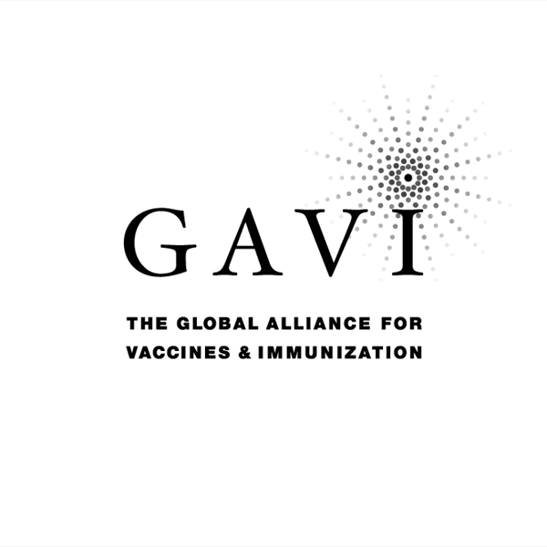
Partnering with The Vaccine Fund
Annual Progress Report

to the
Global Alliance for Vaccines and Immunization (GAVI)
and
The Vaccine Fund

by the Government of
The Socialist Republic of Viet Nam
Date of submission: 9/2002
Reporting period: The first half of 2002 ( previous calendar year )

( Tick only one ) :
Inception report 
First annual progress report  Financial sustainability plan attached 
Second annual progress report 
Third annual progress report 
Fourth annual progress report 
Fifth annual progress report 

Progress Report
Number of under 1 year old children vaccinated with 3 HBV doses from GAVI: 154,009 (From 1/2002 to 6/2002)
(Number of children immunized with current and new vaccines is collected from the WHO/UNICEF Joint Reporting Form (JRF))

To be filled in by the country for each type of support received from GAVI/The Vaccine Fund.

Immunization Services

N/R

New & Under-used Vaccines

1.2.1 Receipt of new and under-used vaccines Date(s) of receipt of vaccines : From 27/11/2001

Starting date of vaccination: 1/1/2002

- Arrived date of the first auto-disable 0.5 ml syringes and safety boxes consignment: 13/12/2001
- Total AD syringes received: 2,675,100
- Total safety boxes received: 29,723

Please report on the progress, including starting date of vaccinations and any problems that have been encountered with regard to vaccines and supplies provided by GAVI/The Vaccine Fund.

Vaccines and auto-disable syringes (ADs) were received on time and in good order, to enable implementation as planned starting form 1 January 2002. The GAVI supplied vaccine is being used in 44 of the 61 provinces (17 provinces using locally-produced vaccine). In 2002 only about half the districts using GAVI vaccine – the remainder to start form 1 January 2003.

Of the 44 provinces, 30 started using hepatitis B in January, 5 provinces in February, 2 in March, 6 in April, and the last one in June. The delays in some of the provinces related to funding for training that preceded new vaccine introduction.

The plan was to use Uniject for the birth dose – however, as this is still not available single dose vials are being used. The supply of vials with VVMs in the second shipment allows use outside the cold chain.

A problem with the receipt of two presentations of hepatitis B vaccine, was that both the one-dose and two-dose vials were shipped in the same box with no labels on the outside of the box to indicate which presentation of vaccine was in that box. This led to some problems in shipping vaccines, and it would be appreciated if the contents of boxes would be indicated on the box in future shipments.

Major activities:

- 61 training courses for district level at each of the 61 provinces (30 provinces with support from UNICEF) ; Time: From 1/2002 to 6/2002
- 392 training courses for commune health workers in districts, of which 35 were funded using GAVI funds; Time: From 1/2002 to 6/2002
- Translation and adaptation of “Introduction of Hepatitis B vaccine into EPI” This booklet provides management guidelines, including information for health workers and parents, and includes information on the use of ADs); Printing of 16,000 copies of the booklet for distribution down to commune level Time: April, 2002

- Introduce and train health workers to use AD syringes and safety boxes
- Distribute AD syringes and safety boxes to all provinces using HB vaccine from GAVI
- Main achievement: AD syringes and safety boxes are available in health facilities
Health workers use AD syringes and safety boxes correctly in HBV immunization as well as in routine immunization
- Targets for next year: National EPI submitted Safety Injection Plan to GAVI to have enough safety injection supplies for routine EPI vaccination

1.2.3 Statement on use of GAVI/The Vaccine Fund financial support (US$100,000) for the introduction of the new vaccine

The $100,000 from GAVI was used to partially support the training courses and booklets prepared (see above).
New vaccine introduction booklet 18,500 $
Training courses: 81,500 $

Injection safety

N/R

2. Financial sustainability

Inception Report : Outline steps towards the development of a financial sustainability plan
First Annual Report : Submit completed financial sustainability plan
Subsequent Reports : Summarize progress on financial sustainability

Government is developing local manufacturing capacity for recombinant vaccine This is expected to become available around the time that GAVI support ends.

3. Request for new and under-used vaccines for year 2003 - 2006 ( indicate forthcoming year )

  - Up-dated immunization targets

Confirm/update basic data (= surviving infants, DTP3 targets, New vaccination targets) of the multi-year immunization plan approved with country application: revised Table 4 of approved application form and give reasons for any changes.

 | Table 1 : Baseline and annual targets
Number of infants: |  | 2000* | 2001* | 2002 | 2003 | 2004 | 2005 | 2006 | 2007
Total |  | 1,577,046 | 1,486,472 | 1,671,535 | 1,696,608 | 1,722,057 | 1,747,888 | 1,774,106 | 1,800,718
Given DTP3 |  | 1,461,895 | 1,437,450 | 1,587,958 | 1,611,778 | 1,635,954 | 1,660,494 | 1,685,401 | 1,710,682
Given HepB3 (local) |  | 254,071 | 362,073 | 250,149 | 253,901 | 273,816 | 294,272 | 315,280 | 320,009
Given HepB3 (GAVI) |  | - | - | 739,402 | 1,103,385 | 1,189,932 | 1,278,827 | 1,370,120 | 1,390,673
Wastage: DTP |  | 1.6 | 1.6 | 1.6 | 1.5 | 1.5 | 1.5 | 1.5 | 1.5
Wastage: HepB (local) |  | 1.2 | 1.2 | 1.2 | 1.18 | 1.16 | 1.15 | 1.13 | 1.13
Wastage: HepB (GAVI) |  | - | - | 1.072 | 1.06 | 1.053 | 1.053 | 1.053 | 1.053
Note: * The data in 2000 and 2001 from JRF (up date data from provincial reports)

Request for supply for the coming years is as in previously approved plan, but with use of single dose vial until Uniject becomes available.

3.2 Confirmed/revised request for new vaccine (to be shared with UNICEF Supply Division) for the year 2003 - 2006;(indicate forthcoming year)

Table 2: Estimated number of doses of HB vaccine (NOTE: DOES NOT INCLUDE LOCALLY PRODUCED HEPATITIS B VACCINE NEED)

Table 7.6: Estimated supplies for GAVI HepB Vaccine
 | 2003 | 2004 | 2005 | 2006
Target no. of children | 1,103,385 | 1,189,932 | 1,278,827 | 1,370,121
Doses per child | 3 | 3 | 3 | 3
Total no. of doses | 3,310,156 | 3,569,796 | 3,836,481 | 4,110,363
Vaccine doses (+5%) | 3,475,664 | 3,748,286 | 4,028,305 | 4,315,882
AD syringes (+10%) | 3,674,273 | 3,962,474 | 4,258,494 | 4,562,503
AD syringes buffer (25%) | 459,284 | 72,050 | 74,005 | 76,002
Total AD syringes | 4,133,557 | 4,034,524 | 4,332,499 | 4,638,506
Safety boxes (+10%) | 45,882 | 44,783 | 48,091 | 51,487

The requirement for vaccine is 1/3 in 1-dose vial (or Uniject) – for birth dose and 2/3 in 2-dose vials.

Shipment of vaccine, AD syringers and Safety boxes for 2003:

Vaccine/Devices | Indicative Delivery Date | Quantity in doses/pcs.
Hep B (1dose vial) | Nov.2002 | 600,000
Hep B (1dose vial) | Apr.2003 | 660,645
Hep B (2 dose vial) | Nov.2002 | 1,000,000
Hep B (2 dose vial) | Apr.2003 | 1,000,000
Hep B (2 dose vial) | Oct.2002 | 1,193,636
AD Syringes (for North part) | Dec.2002 | 1,000,000
AD Syringes (for South part) | Dec.2002 | 1,500,000
AD Syringes (for North part) | May.2003 | 435,800
AD Syringes (for South part) | May.2003 | 1,654,700
Safety Boxes (for North part) | Dec.2002 | 10,000
Safety Boxes (for South part) | Dec.2002 | 15,000
Safety Boxes (for North part) | May.2003 | 5,625
Safety Boxes (for South part) | May.2003 | 13,900

Estimated stock at year end is:
1-dese vial: 161,279 doses
2-does vial: 408,329doses
TOTAL = 569,608 doses
As 2003 is first year of national supply buffer stock requirement for new population 2003 is 25% = 868,916 doses (split between 1-dose and 2-dose as above)).
Therefore in addition to supply calculated in Table, a request is made for (25% BUFFER—Est stock at year-end)

3.3 Confirmed/revised request for injection safety support
N/R

Signatures

For the Government of The Socialist Republic of Viet Nam

Signature: ……………………………………………...……………...

Title: ………………………………………….………………….

Date:

We, the undersigned members of the Inter-Agency Co-ordinating Committee endorse this report. Signature of endorsement of this document does not imply any financial (or legal) commitment on the part of the partner agency or individual.

Financial accountability forms an integral part of GAVI/The Vaccine Fund monitoring of reporting of country performance. It is based on the regular government audit requirements as detailed in the Banking form. The ICC Members confirm that the funds received have been audited and accounted for according to standard government or partner requirements.

Agency/Organisation | Name/Title | Date Signature | Agency/Organisation | Name/Title | Date Signature
UNICEF
WHO
PATH
JICA

