January 2005
Progress Report

Partnering with The Vaccine Fund

to the
Global Alliance for Vaccines and Immunization (GAVI)
and
The Vaccine Fund

by the Government of
COUNTRY: MADAGASCAR
Date of submission: May 2006

Reporting period: January – December 2005

( Tick only one ) :
Inception report
First annual progress report
Second annual progress report
Third annual progress report
Fourth annual progress report X
Fifth annual progress report

Text boxes supplied in this report are meant only to be used as guides. Please feel free to add text beyond the space provided.
*Unless otherwise specified, documents may be shared with GAVI partners and collaborators

Progress Report Form: Table of Contents

Report on progress made during 2005
  - Immunization Services Support (ISS)
1.1.1 Management of ISS Funds
Use of Immunization Services Support
1.1.3 Immunization Data Quality Audit
  - GAVI/Vaccine Fund New and Under-used Vaccines
1.2.1 Receipt of new and under-used vaccines
1.2.2 Major activities
    - Use if GAVI/The Vaccine Fund financial support (US$100,000) for introduction of the new vaccine
1.3 Injection Safety
    - Receipt of injection safety support
    - Progress of transition plan for safe injections and safe management of sharps waste
    - Statement on use of GAVI/The Vaccine Fund injection safety support (if received in the form of a cash contribution)

2. Financial Sustainability

3. Request for new and under-used vaccine for 2007
  - Up-dated immunization targets
  - Confirmed/revised request for new vaccine (to be shared with UNICEF Supply Division) for year…
  - Confirmed/revised request for injection safety support for the year…

- Please report on progress since submission of the last Progress Report based on the indicators
selected by your country in the proposal for GAVI/VF support

5. Checklist

6. Comments

7. Signatures

1. Report on progress made during 2005

To be filled in by the country for each type of support received from GAVI/The Vaccine Fund.

Immunization Services Support (ISS)

1.1.1 Management of ISS Funds

Please describe the mechanism for management of ISS funds, including the role of the Inter-Agency Co-ordinating Committee (ICC).
Please report on any problems that have been encountered involving the use of those funds, such as delay in availability for programme use.

In 2005, the country did not receive any allocation from GAVI because the results of the data quality audit conducted in 2003 were deemed to be unsatisfactory. However, there was a balance left over from the funds paid in 2004, which was managed jointly by the Director General for Family Health (see new Ministry organization chart) and the head of the Immunization Service. The Director for Family Health, and the head of the Immunization Service are co-signatories. General EPI coordination is provided by the Inter-Agency Coordinating Committee (ICC), which is chaired by the Minister of Health and Family Planning. The Senior ICC comprises senior ministry officials (Finance and Budget, Population, Education, Communication, National Defence, etc.) and agency heads. It meets every three months to approve the EPI Annual Work Plan and the use of the funds. A report on the use of funds is submitted to the members of the ICC. For this year, the funds were used mainly for the central and regional levels (Regional Health and Family Planning Department - RHFPD). The procedure for managing funds requires two signatures for project management. The funds are paid directly into the bank accounts for the peripheral level. The RHFPD is advised of the payment by letter. As the national territory is now divided into regions, 22 regional Health and Family Planning Departments were established in June 2005 to replace the previous 6 Provincial Departments.
The consolidated budgets are audited at least once a year by officials from the Ministry of Health and Family Planning.
Once an activity has been completed, the original supporting documentation is sent to the Immunization Service, the users keeping copies for four years. The Immunization Service or Family Health Directorate sends out a reminder in writing or by SSB if the documentation has not been received six months after the end of the activity. No further funds are released until the documentation has been received.

1.1.2 Use of Immunization Services Support

In 2005, the following major areas of activities have been funded with the GAVI/Vaccine Fund Immunization Services Support contribution.

Table 1: Use of funds during 2005

Area of Immunization Services Support | Total amount in US $ | AMOUNT OF FUNDS
Area of Immunization Services Support | Total amount in US $ | PUBLIC SECTOR |  |  | PRIVATE SECTOR & Other
Area of Immunization Services Support | Total amount in US $ | Central | Region/State/Province | District | PRIVATE SECTOR & Other
Vaccines
Injection supplies
Personnel (advanced strategy)
Transportation | 15 730 | 14 924 | 806
Maintenance and overheads | 2 593 | 2 593
Training (including RED strategy)
IEC / social mobilization | 800 | 800
Outreach
Supervision | 1 829 | 1 829
Monitoring and assessment
Epidemiological surveillance
Vehicles | 1 800 | 1 800
Cold chain equipment
Preventive maintenance - cold chain | 342 |  | 342
Mobile strategies
Fuel
Storage material (barrels)
Total: | 23 094 | 21 946 | 1 148
Remaining funds for next year:  (with interest and balance carried forward) | 1 626

*If no information is available because of block grants, please indicate under ‘other’.

Please attach the minutes of the ICC meeting(s) when the allocation of funds was discussed: 27.01.05 and 26.05.05

Please report on major activities conducted to strengthen immunization, as well as, problems encountered in relation to your multi-year plan.

Madagascar’s infant-child mortality rate remains high, despite a substantial improvement between the last two Population and Health Surveys, down from 159 per 1 000 in 1997 to 58 per 1 000 in 2003-2004. Although considerable efforts have been made in the past few years, low immunization coverage continues to pose a risk of epidemics among children belonging to insufficiently covered cohorts, particularly during the first half of the year.

To increase immunization coverage, the EPI was given renewed impetus with the drawing up of 100-day regional EPI reactivation plans during the last quarter of 2005. The implementation of these plans required the application of the “peer approach” strategy, whereby the services of the health workers of an efficient district are used to support less well-performing districts. The Reach Every District (RED) approach was also introduced or implemented within the framework of the plans, as well as the advanced and mobile strategies, which were conducted with the support of the mobile regional health teams. Searches were also conducted to reduce the drop out rate. In total, 82 districts in 20 regions benefited from the 100-day EPI reactivation plans, with technical and financial support being provided by the EPI partners (UNICEF, USAID/SANTENET, WHO). The RED approach was launched in 2003 and is based on identifying priority districts before drawing up micro plans, starting from the peripheral level (commune, basic health centre (BHC), district). In 2005, the RED approach was introduced in 27 districts and implemented in 42 districts. In total, 82 districts have been implementing the RED approach since 2003.

Four (4) cases of AFP were reported in the province of Toliara in the south of the country. As these were shown to be vaccine-associated polio virus (VDPV) cases, it was decided to conduct a mop-up campaign against poliomyelitis in 21 districts of the province concerned and in 6 neighbouring districts where no AFP cases were reported but where immunisation coverage is low. The campaign targeted children aged between 0 and 59 months and was conducted in two rounds during the months of September and October.

Madagascar also drew up a strategic plan for the elimination of maternal and neo-natal tetanus, with the districts being classified according to risk. In this connection, the Government of Madagascar, under the leadership of the Ministry of Health and Family Planning, organised a national campaign against tetanus at the level of 19 districts identified as being at high risk. Two rounds of the campaign were conducted in October and November and the third round is scheduled for the month of June 2006. The target population consists of women of child-bearing age (15 to 49 years old).

To achieve the targets set for 2005, various strategies were implemented:

- Strengthening the routine EPI
- EPI reactivation strategies to improve immunization coverage through the drawing up of the 100-day EPI reactivation plan, the advanced and mobile strategies, active search for drop outs, the participation of the community, the peer approach and the implementation of the RED approach
- Rehabilitation of the cold chain with the provision of cold rooms at the central and regional levels (2 RHFPDs) and the provision of fuel for the refrigerators in the immunisation health centres and districts.
- Improving health worker skills, with training in computerized EPI and vaccine management for the EPI managers and the personnel responsible for the health statistics data in 9 regions, as well as the heads of the related districts; DQS training for the personnel responsible at central and regional level; training in cold chain maintenance for regional and district managers; and training of the service-providers in the management of waste.
- Drawing up and approval of the injection safety and waste management policy, together with the launch of the construction of incinerators.
- Strengthening of coordination with the establishment of steering committees at all levels and of the technical and senior ICCs at the central level

- Strengthening epidemiological surveillance activities
- Strengthening the capacity of health workers with refresher courses for regional focal points (RFP), district focal points (DFP) and health workers
- Strengthening of the functionality of the various committees
- Training supervision
- Monitoring and assessment, with the organisation of reviews at central and peripheral level (provincial and district)

- Eradication of polio
- Organising a mop-up immunisation campaign against polio at the level of 27 target districts
- Improving the functionality of the various committees
- Strengthening the routine EPI

- Measles control
- Strengthening of case-by-case measles surveillance activities, with laboratory serological confirmation at the level of all the districts
- Training of laboratory technicians in the regional and district hospital centres (CHR and CHD)
- Strengthening of the routine EPI

- Elimination of maternal and neo-natal tetanus
- Conducting an immunisation campaign against tetanus in 3 rounds at the level of 19 high risk districts (2 rounds in 2005 and 1 round in 2006)
- Strengthening of the routine EPI

- Monitoring and assessment
- Monitoring and assessment with quarterly and monthly reviews and supervision training at all levels
- Participation in regional workshops
- Assessment of EPI activities, namely the RED approach, vaccine management, Data Quality Audit and the 2004 Hiaka campaign against measles

The problems encountered in implementing the multi-year plan:
- Logistics: vehicles old and insufficient and operation of the cold chain inadqeuate: problem of fuel and payment of the JIRAMA invoices (cash power), problems in the procurement of spare parts for the refrigerators. These problems were resolved partly thanks to an allocation of fuel by UNICEF, the purchase of fuel and spare parts from the State operating budget and UNICEF financing.
- Isolation of certain districts, with 40% of the population living more than 10 km from a health facility. Hence the establishment of the advanced and mobile strategies, mobile health teams and the 100-day EPI reactivation plan over the last quarter.
- Inadequacy of supervision due to a shortage of human resources and the overlapping of activities (the mop-up campaign against polio was not provided for in the annual work plan -AWP). This latter problem was resolved by integrated supervision at peripheral level (CRESAN II budget).
- The absence of GAVI financing created a problem with regard to the procurement of vaccines and immunisation supplies, which was compounded by the division of the national territory into 22 regions. The problem was resolved thanks to the contribution of UNICEF and funding from the State budget and the CRESAN II budget.
- Problem of data arriving late and incomplete. This was overcome through the establishment of monthly EPI reports, in parallel with the district monthly health reports and the development of the regional 100-day EPI reactivation plans;
- Problem of data quality. This was resolved through the multiplication and distribution of management tools such as pre-report cards, tally cards and EPI monthly report sheets at the level of the regions, districts and health centres and the establishment of a computerised tool for the management of EPI data at the level of the regions and the districts, together with the provision of supervision training for its installation.

Immunization Data Quality Audit (DQA) (If it has been implemented in your country)

The 2nd DQA was conducted during the period from 10 to 26 October 2005. The results showed a verification factor of 1.002 at national level. Recommendations were issued. The action plan intended to improve the reporting system in accordance with the recommendations is included in the 2006 annual work plan.
Has a plan of action to improve the reporting system based on the recommendations from the DQA been prepared?
If yes, please attach the plan.

YES NO
X

If yes, please report on the degree of its implementation.

The 1st DQA was conducted in Madagascar in July 2003. The results showed a verification factor of 62% and a system quality index of 49%. The quality index is average in the districts (53.5%) and the BHCs (45.2%).

An action plan for July-December 2003 was submitted and modified by the ICC in September 2003. This plan comprises 6 strategies, namely:
    - improved programme management
    - strengthening of the logistics and cold chain system
    - strengthening of the strategic communication plan
    - preparation of the measles immunization campaign
    - greater epidemiological surveillance
    - monitoring - assessment
Strategies 1, 5 and 6 are intended to improve the reporting system.
Implementation of the action plan
Measures taken for 2005:
- System design: review of the monthly activity report by the Health Statistics Department and the personnel responsible for programmes including the EPI, Validation by the Ministry of Health and Family Planning in November 2005
- Records: introduction of a computerised EPI data management tool at the level of 9 regions and 45 districts, training of personnel responsible for the Health Information and Management System (HIMS) and for the EPI managers in the regions and districts concerned, supply of management tools such as pre-report and tally cards to the DHSs and BHCs.
- Dissemination of the results of the 2003-2004 Population and Health Survey to the administrative managers in 22 regions and 111 districts
- Reporting and data storage: memorandum sent to all managers at the peripheral level on the need to back-up data and file regularly and to send reports on time. Training of EPI personnel in 27 districts where the RED approach has been introduced on the use and completion of management tools such as the pre-report and tally cards
- Monitoring and assessment: regular monitoring of vaccine stocks at the central and peripheral levels using graphs. MLM training for 30 managers at the central and peripheral levels

Please attach the minutes of the ICC meeting where the plan of action for the DQA was discussed and endorsed by the ICC. 25 September 2003 [Already sent with previous reports]

Please report on studies conducted regarding EPI issues during 2005 (for example, coverage surveys).

- Assessment of the measles immunisation campaign and the routine immunisation activities in May-June 2005.
- External assessment of the RED approach in June 2005.
- Data Quality Audit in October 2005.
- Assessment of vaccine management in November 2005.

GAVI/Vaccine Fund New & Under-used Vaccines Support

1.2.1 Receipt of new and under-used vaccines during 2005

Start of vaccinations with the new and under-used vaccine: December 2001

Please report on receipt of vaccines provided by GAVI/VF, including problems encountered.

The DTP HepB vaccines were received in five consignments:
- 342 500 doses on 24 March 2005
- 342 000 doses on 09 June 2005
- 342 000 doses on 11 August 2005
- 342 000 doses on 14 October 2005
making a total of 1 368 500 doses.

Their reception depended on the vaccine stock situation at the central level.
In 2005, there was some delay in the supply of certain regional storage centres. The reasons for this were as follows:

1. The division of the national territory into 22 regions. In the past, there were only 6 provincial storage centres with distribution centres at the level of a few districts which have since become regional administrative centres. At the present time, certain regions do not yet have storage facilities.
2. The cold rooms of the 6 storage centres located in the former provincial directorates could not be operated on a continuous basis due to changes in the way electricity costs were paid: single counter and card prepayment (cash power), as well as a delay in the release of funds from the State operating budget.
3. The lack or run-down state of the means of transport in certain RDHFPs, making it necessary for the vaccines to be supplied by the central level.

For vaccines sent by air to isolated districts, air traffic should return to normal. However, flight cancellations occur at times, resulting in a delay in the supply of vaccines.

1.2.2 Major activities

Please outline major activities that have been or will be undertaken, in relation to, introduction, phasing-in, service strengthening, etc. and report on problems encountered.

The main activities undertaken to introduce the hepatitis B vaccine and to strengthen services are laid down in the EPI reactivation plan.

Advanced and mobile strategies have been strengthened through the establishment of mobile health teams. The systematic monthly reviews of the districts were replaced by training supervision and quarterly reviews for the heads of the neighbouring BHCs. The quarterly reviews served to conduct refresher sessions on EPI.

The monitoring and assessment of activities are carried out during the half-yearly reviews at the level of the regions, bringing together all district managers.

The operation of the cold chain has been improved through the training of EPI personnel and the staff responsible for maintenance at the regional and district levels, with emphasis on preventive maintenance.

The community-based approach has been strengthened in the districts where the RED approach is implemented. The active search for drop outs was undertaken with the participation of community support staff and the community at large. Regular meetings were held with members of the community to discuss progress.

The national policy on injection safety and waste management has been drawn up and approved.

Problems encountered
- The operation of the cold chain was disrupted because of lack of fuel. This problem was resolved through a fuel allocation for all the districts during the first quarter. A second allocation was granted to the districts involved in the mop-up campaign against polio and the immunisation campaign for the elimination of maternal and neo-natal tetanus (EMNT, UNICEF). Part of the fuel supply was also financed out of the district operating budget and certain BHCs received a contribution from their commune.
- The overlapping of activities, in particular the polio mop-up campaign and the campaign for the elimination of maternal and neo-natal tetanus. As a result, the implementation of the RED approach was delayed in certain districts.
- The risk of injection supplies running out in remote and isolated districts because of transportation difficulties: air transport problem because the volume of the consignment can block air freight to the zones concerned (the North, North-West, East and South-East of the island). Overland transport is possible only during the dry season, and storage capacity at the peripheral level is limited.

1.2.3 Use of GAVI/The Vaccine Fund financial support (US$100,000) for the introduction of the new vaccine

Please report on the proportion of 100,000 US$ used, activities undertaken, and problems encountered such as delay in availability of funds for programme use.

The funds were used in their entirety in 2002. Because of the social crisis in 2002 and the resulting shortages of fuel and paraffin, the funds were used to supply vaccines not only to regional storage centres and district distribution centres but also to certain remote districts. Similarly, part of the paraffin intended for the operation of the cold chain in the BHCs was financed out of these funds. The paraffin was then transported overland and taken by helicopter to remote and isolated districts.
GAVI financial support was also used during the polio NIDs for the transport of vaccines, EPI equipment and management tools by private aircraft, helicopter and overland, as well as to carry senior State officials and the press for high-level social mobilization.

Injection Safety

1.3.1 Receipt of injection safety support

Please report on receipt of injection safety support provided by GAVI/VF, including problems encountered

Madagascar did not receive any injection safety support in 2005. An application was made to GAVI in April 2005 and was approved. The support will concern all the injection supplies for the routine EPI over a period of 3 years, namely from 2006 to 2008.
Nevertheless, Madagascar received the following support in 2005: 3 073 200 0.5-ml AD syringes, 808 000 0.05 ml AD syringes, 51 000 2 ml dilution syringes, 34 500 5 ml dilution syringes and 2 850 safety boxes. The support was received from GAVI for the DTP-hepB vaccine and from UNICEF for the BCG, TT and measles vaccine, as well as the necessary dilution syringes. The EPI has been using AD syringes for all the antigens since 2003.
The problems encountered were as listed above: transportation difficulties in isolated areas and limited storage capacity at the peripheral level.

Progress of transition plan for safe injections and safe management of sharps waste.

Please report problems encountered during the implementation of the transitional plan for safe injection and sharps waste

The problems encountered:
- problems in providing air transport for AD syringes to remote and isolated regions in the North, North-West, East and South-East
- delay in the construction of incinerators in the districts

Please report on the progress based on the indicators chosen by your country in the proposal for GAVI/VF support.

Indicators | Targets | Achievements | Constraints | Updated targets
- Rate of AD syringe utilisation for fixed and advanced strategies by health centres offering immunisation services  - rate of AD syringe utilisation during Supplementary immunisation activities (SIAs)  - Number of basic health centres disposing of waste properly | - Ensure 100% safe injections in fixed and advanced strategy immunisation health centres  - Ensure 100% safe injections and proper waste disposal in immunisation health centres during SIAs  - Draw up and implement the national policy on injection safety and waste management | - Use of AD syringes in fixed and advanced strategies for the DTP-hepB, TT, measles and BCG at the level of the immunisation health centres. AD syringes for BCG, TT and measles are supplied by UNICEF  - Exclusive use of AD syringes for the TT vaccine during the national immunization campaign at the level of the target districts (SIAs).  - Ensuring that waste generated by SIAs is burned in safe pits by all immunizing centres, using safety boxes  - Approval and dissemination of the national policy on injection safety and waste management in health facilities in September 2005. | - Problems of transporting AD syringes to isolated and remote regions, especially in the North, North-West, East and South-East  - Delay in the construction of incinerators in the districts (lack of refractory bricks) | - Ensure 100% safe injections in fixed and advanced strategy immunisation health centres and during SIAs  - Ensure proper waste disposal in 95% of immunisation centres

1.3.3 Statement on use of GAVI/The Vaccine Fund injection safety support (if received in the form of a cash contribution)

The following major areas of activities have been funded (specify the amount) with the GAVI/The Vaccine Fund injection safety support in the past year:

Not applicable.
The revised request was sent to GAVI in April 2005. The support granted will be in kind (AD syringes, dilution syringes and safety boxes)

2. Financial sustainability

Inception Report: Outline timetable and process for the development of a financial sustainability plan. Describe assistance that may be needed for developing a financial sustainability plan.

First Annual Progress Report: Submit completed financial sustainability plan by given deadline. Describe major strategies for improving financial sustainability.

Subsequent Progress Reports: According to current GAVI rules, support for new and under-used vaccines is covering the total quantity required to meet country targets (assumed to be equal to DTP3 targets) over a five year period (100% x 5 years = 500%). However, in an attempt to help countries find sources of funding in order to attain financial sustainability by slowly phasing out GAVI/VF support, they are encouraged to begin contributing a portion of the vaccine quantity required. Therefore, GAVI/VF support can be spread out over a maximum of ten years after the initial approval, but will not exceed the 500% limit (see figure 4 in the GAVI Handbook for further clarification). In table 2.1, specify the annual proportion of five year GAVI/VF support for new vaccines that is planned to be spread-out over a maximum of ten years and co-funded with other sources. Please add the three rows (Proportion funded by GAVI/VF (%), Proportion funded by the Government and other sources (%), Total funding for …………. (new vaccine)) for each new vaccine.

Table 2.1: Sources (planned) of financing of new vaccine DTP HepB (with effect from 2006, proposal for bridge financing) (specify)
Proportion of vaccines supported by * | Annual proportion of vaccines
Proportion of vaccines supported by * | 2002 | 2003 | 2004 | 2005 | 2006 | 2007 | 2008 | 2009 | 2010 | 2011
Proportion funded by GAVI/VF (%) *** | 100 | 100 | 10 | 100 | 85 | 85 | 71 | 57 | 43 | 28
Proportion funded by the Government and other sources (%) | 0 | 0 | 0 | 0 | 15 | 15 | 29 | 43 | 57 | 72
Total funding for …………. (new vaccine) ***

* Percentage of DTP3 coverage (or measles coverage in case of Yellow Fever) that is target for vaccination with a new and under-used vaccine
** The first year should be the year of GAVI/VF new vaccine introduction
*** Should total 500% at the end of GAVI/VF support
In table 2.2 below, describe progress made against major financial sustainability strategies and corresponding
indicators.

Table 2.2: Progress against major financial sustainability strategies and corresponding indicators

Financial Sustainability Strategy | Specific Actions Taken Towards Achieving Strategy | Progress Achieved | Problems Encountered | Baseline Value of Progress Indicator | Current Value of Progress Indicator | Proposed Changes To Financial Sustainability Strategy
1. Self-sufficiency | Advocacy for increased State funding for immunization-related activities  Report / Information for managers concerned | State provided funding for routine vaccines, paraffin and fuel to transport vaccines and paraffin from the districts to the health centres | Credit frozen, insufficient funds for purchase of paraffin | EPI cost per inhabitant in 2002 = 0.36 USD | EPI cost per inhabitant in 2005 = 0.48 USD  State contribution for the purchase of vaccines in 2005: 91% excluding the DTP-hepB vaccine (State contribution for 2004 and 2005); 28% if DTP-hepB is included | For 2006, State contribution for vaccine purchase to be maintained  State contribution for the purchase of the new DTP-hepB vaccine if bridge financing available  N.B According to the medium-term expenditure framework (MTEF), the national planning cycle is 3 years. The state budget is adopted annually. The organic law on the State budgets (Loi Organique sur les Lois de Finances) emphasises the need to move away from the concept of a “resource-based budget” to a “programme- based budget”
2. Reliability of resources | Meeting of Senior ICC members to mobilize resources and coordinate activities | - Regular meetings of the members of the Senior ICC  - Extension to other partners: World Bank, EU, French Cooperation | Positioning of partners in line with annual plan of action | Available  Government: USD 3 016 049, including salaries of EPI personnel UNICEF: USD 1 627 602;  WHO: USD 434 451; USAID/SANTENET: USD 175 000 GAVI: USD 2 057 230, making a total of USD 7 310 332 out of the USD 8 474 819 budgeted in the immunisation service annual work plan for 2005 with the following as technical and financial partners: WHO, UNICEF, JICA, SANTENET/USAID, USAID, IPM | Funds used (USD):  Government:  3 012 246  UNICEF: 2 668 654  WHO: 350 013  GAVI: 1 969 500  USAID/SANTENET:  80 107, making a total of 8 080 520 (routine EPI funds and supplementary immunisation activities: USD 590 607 for polio and USD 484 172 for the elimination of maternal and neo-natal tetanus)
3. Adequate use of resources | Introduction of the RED approach in the target districts  Regional 100-day EPI reactivation plans  Refresher courses in computerized vaccine management for regional and district personnel responsible for the EPI and HIMS data | Introduction of RED approach in 27 districts and implementation in 42 districts, making a total of 82 districts since 2003  100-day EPI reactivation plan in 82 DHSs in 20 regions  Training of 54 EPI personnel in 9 regions and 45 districts | Overlapping of activities (national immunization campaign), leading to delay in implementation of certain activities.  Incomplete and late reports. | DTP3 coverage rate in 2002 = 61.8% | DTP3 = 92.2%  (completion rate: 87%)

3. Request for new and under-used vaccines for year 2006

Section 3 is related to the request for new and under used vaccines and injection safety for 2006.

Up-dated immunization targets

Confirm/update basic data approved with country application: figures are expected to be consistent with those reported in the WHO/UNICEF Joint
Reporting Forms. Any changes and/or discrepancies MUST be justified in the space provided (page 12). Targets for future years MUST be provided.

Table 3 : Update of immunization achievements and annual targets (TARGETS UPDATED AS OF 2005 TO TAKE ACCOUNT OF THE NEW INFANT MORTALITY RATE of 58 per 1,000 (2003-2004 Population and Health survey)
Number of | Achievements and targets
Number of | 2004 | 2005 | 2006 | 2007 | 2008 | 2009 | 2010 | 2011 | 2012
DENOMINATORS
Births | 614 791 | 632 005 | 649 701 | 667 893 | 686 594 | 705 819 | 725 582 | 745 898 | 766 783
Infants’ deaths | 35 658 | 36 656 | 37 683 | 38 738 | 39 822 | 40 937 | 42 084 | 43,262 | 44 473
Surviving infants | 579 133 | 595 349 | 612 019 | 629 155 | 646 772 | 664 881 | 683 498 | 702 636 | 722 310
Infants vaccinated in 2004 (JRF) / to be vaccinated 2005 and beyond with 1st dose of DTP (DTP1)*
Infants vaccinated 2004 (JRF) / to be vaccinated 2005 and beyond with 3rd dose of DTP (DTP3)*
NEW VACCINES **
Infants vaccinated 2004 (JRF) / to be vaccinated 2005 and beyond with 1st dose of DTP/HepB1 | 519 321 | 544 510 | 515 153 | 556 306 | 599 115 | 597 036 | 627 702 | 645 278 | 663 346
Infants vaccinated 2004 (JRF) / to be vaccinated 2005 and beyond with 3rd dose of DTP/HepB1 | 450 171 | 548 916 | 514 096 | 528 490 | 569 159 | 585 095 | 615 148 | 632 372 | 650 079
Wastage rate in 2004 and plan for 2005 and beyond*** DTP/HepB | 10% | 10.5% | 10% | 10% | 10% | 10% | 10% | 5% | 5%
Infants vaccinated 2004 (JRF) / to be vaccinated 2005 and beyond with 1st dose of DTP/Hib1 | - | - | - | - | - | - | - | - | -
Infants vaccinated 2004 (JRF) / to be vaccinated 2005 and beyond with 3rd dose of DTP/Hib3 | - | - | - | - | - | - | - | - | -
Wastage rate in 2004 and plan for 2005 and beyond*** … (new vaccine) | - | - | - | - | - | - | - | - | -
Infants vaccinated 2004 (JRF) / to be vaccinated 2005 and beyond with 1st dose of HepB1 | - | - | - | - | - | - | - | - | -
Infants vaccinated 2004 (JRF) / to be vaccinated 2005 and beyond with 3rd dose of HepB1 | - | - | - | - | - | - | - | - | -
Wastage rate in 2004 and plan for 2005 and beyond*** … (new vaccine) | - | - | - | - | - | - | - | - | -
INJECTION SAFETY****
Pregnant women vaccinated in 2004 (JRF) / to be vaccinated in 2005 with TT2 | 326 369 | 334 748 | 584 731 | 601 104 | 631 667 | 649 353 | 682 047 | 701 144 | 736 112
Infants vaccinated in 2004 (JRF) / to be vaccinated in 2005 with BCG | 532 369 | 601 483 | 545 749 | 587 746 | 617 935 | 635 237 | 653 023 | 671 308 | 705 440
Infants vaccinated in 2004 (JRF) / to be vaccinated in 2005 with Measles | 590 167 | 601 483 | 514 096 | 553 657 | 582 094 | 598 393 | 615 148 | 632 372 | 664 525
* Indicate actual number of children vaccinated in past years and updated targets (with either DTP alone or combined)
** Use 3 rows (as indicated under the heading NEW VACCINES) for every new vaccine introduced
*** Indicate actual wastage rate obtained in past years
**** Insert any row as necessary

Please provide justification on changes to baseline, targets, wastage rate, vaccine presentation, etc. from the previously approved plan, and on reported figures which differ from those reported in the WHO/UNICEF Joint Reporting Form in the space provided below.

The denominators on the joint WHO/UNICEF form are those of the Health Statistics Service, which compiles health data for the Ministry of Health and Family Planning using the monthly district reports. The updated targets are those of the reviewed and updated Financial Sustainability Plan, with a birth rate of 3.53 per 100 and an infant mortality rate of 58 per 1000 in accordance with the 2003-2004 Population and Health Survey.

3.2 Confirmed/Revised request for new vaccine (to be shared with UNICEF Supply Division) for 2007

Please indicate that UNICEF Supply Division has assured the availability of the new quantity of supply according to new changes.

Keep the DTP HepB vaccine in 2006 and 2007; postpone the introduction of the DTP Hib combination vaccine until 2008; the HepB will be in monovalent form. The decision to introduce the Hib vaccine will be taken after the epidemiological survey to be conducted in 2006.

Table 4: Estimated number of doses of …… vaccine (specify for one presentation only): Please repeat this table for any other vaccine presentation requested from
GAVI/The Vaccine Fund
Remarks
- Phasing: Please adjust estimates of target number of children to receive
new vaccines, if a phased introduction is intended. If targets for hep B3 and Hib3
differ from DTP3, explanation of the difference
should be provided
- Wastage of vaccines: Countries are expected to plan for a maximum of:
50% wastage rate for a lyophilized vaccine in 10 or 20-dose vial; 25% for a liquid
vaccine in a10 or 20-dose vial; 10% for any vaccine (either liquid or lyophilized)
in 1 or 2-dose vial.
- Buffer stock: The buffer stock is recalculated every year as 25% the current
vaccine requirement
- Anticipated vaccines in stock at start of year… ….: It is calculated by
counting the current balance of vaccines in stock, including the balance of buffer
stock. Write zero if all vaccines supplied for the current year (including the
buffer stock) are expected to be consumed before the start of next year. Countries
with very low or no vaccines in stock must provide an explanation of the use of
the vaccines.
- AD syringes: A wastage factor of 1.11 is applied to the total number
of vaccine doses requested from the Fund, excluding the wastage of vaccines.
- Reconstitution syringes: it applies only for lyophilized vaccines. Write zero
for other vaccines.
- Safety boxes: A multiplying factor of 1.11 is applied to safety boxes to cater
for areas where one box will be used for less than 100 syringes

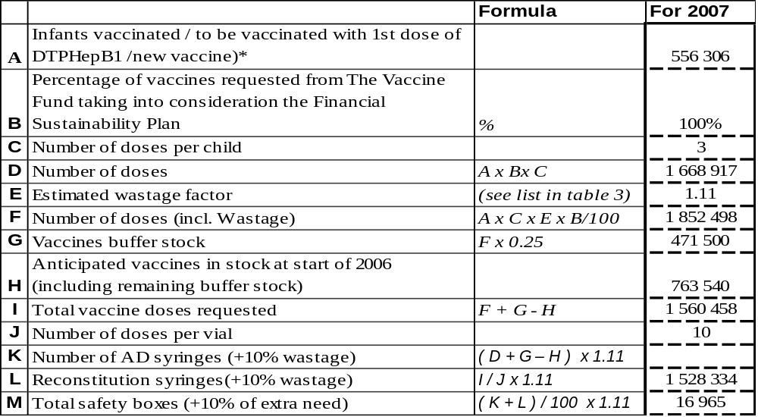
*Please report the same figure as in table 3.

Table 5: Wastage rates and factors
Vaccine wastage rate | 5% | 10% | 15% | 20% | 25% | 30% | 35% | 40% | 45% | 50% | 55% | 60%
Equivalent wastage factor | 1.05 | 1.11 | 1.18 | 1.25 | 1.33 | 1.43 | 1.54 | 1.67 | 1.82 | 2.00 | 2.22 | 2.50

3.3 Confirmed/revised request for injection safety support for the years 2006-2007 (request sent in April 2005)

Table 6: Estimated supplies for safety of vaccination for the next two years with …… (Use one table for each vaccine BCG, DTP, measles and TT, and number them from 4 to 8)

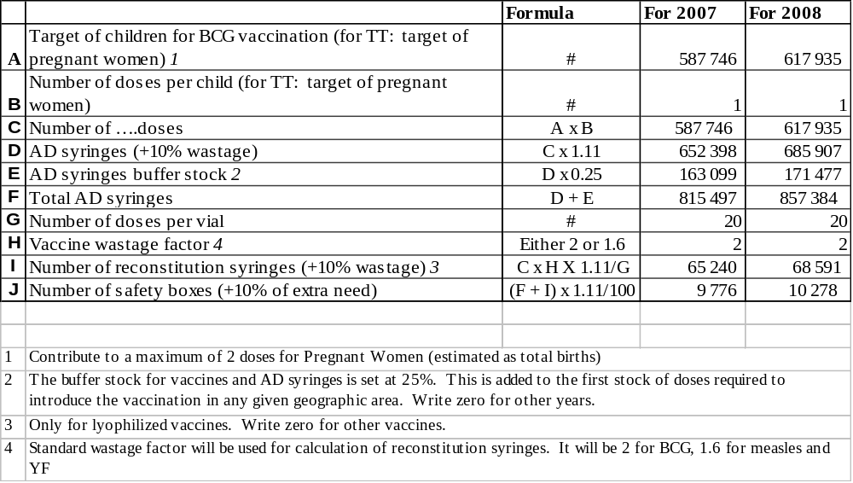

If quantity of current request differs from the GAVI letter of approval, please present the justification for that difference.

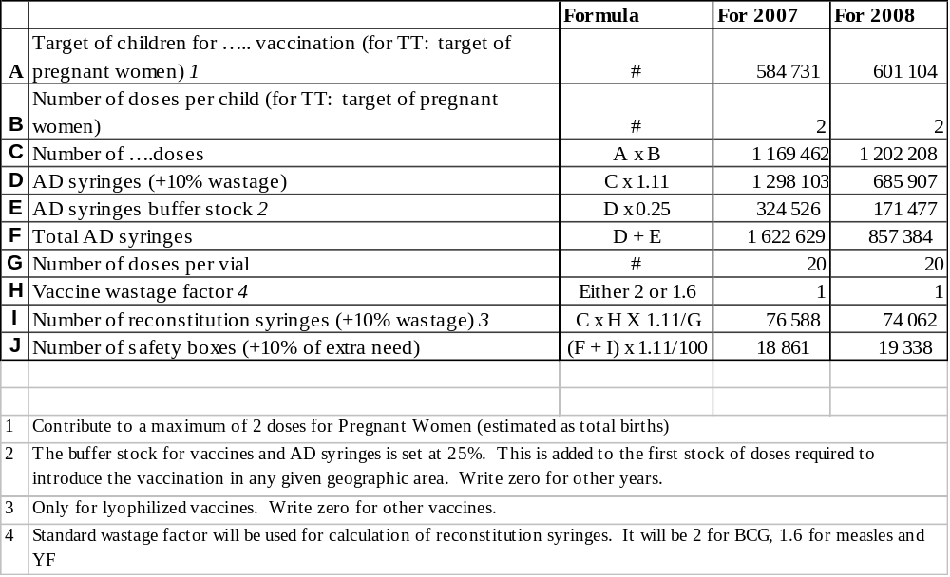

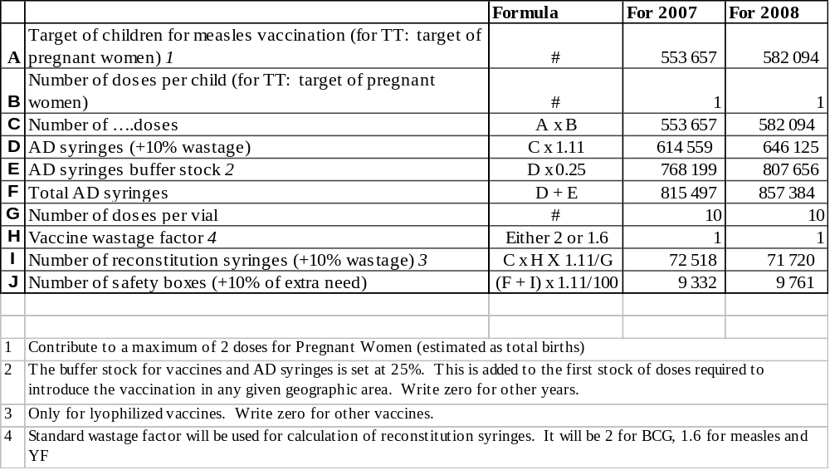

If quantity of current request differs from the GAVI letter of approval, please present the justification for that difference.

4. Please report on progress since submission of the last Progress Report based on the indicators selected by your country in the proposal for GAVI/VF support

Indicators | Targets | Achievements | Constraints | Updated targets
DTP3/HepB coverage rate | 2005: DTP3 coverage rate = 80% | DTP3 coverage rate: 92.2%, data from January to December 2005  Report completion rate = 87% | Incomplete and late reports | Coverage rate for 2006: DTP3>84% at national level

Checklist

Checklist of completed form:

Form Requirement: | Completed | Comments
Date of submission | X
Reporting Period (consistent with previous calendar year) | X
Table 1 filled-in | X
DQA reported on | X
Reported on use of 100,000 US$ | X | Used in 2002
Injection Safety Reported on | X
FSP Reported on (progress against country FSP indicators) | X
Table 2 filled-in | X
New Vaccine Request completed | X
Revised request for injection safety completed (where applicable) |  | Request sent in October 2005 and granted for 3 years (2006-2008)
ICC minutes attached to the report | X
Government signatures | X
ICC endorsed | X

6. Comments

ICC/RWG comments:

7. Signatures

For the Government of ………………..…………………………………

Signature: ……………………………………………...……………...

Title: ………………………………………….………………….

Date: ………………………………………….………………….

We, the undersigned members of the Inter-Agency Co-ordinating Committee endorse this report. Signature of endorsement of this document does not imply any financial (or legal) commitment on the part of the partner agency or individual.

Financial accountability forms an integral part of GAVI/The Vaccine Fund monitoring of reporting of country performance. It is based on the regular government audit requirements as detailed in the Banking form. The ICC Members confirm that the funds received have been audited and accounted for according to standard government or partner requirements.

Agency/Organisation | Name/Title | Date Signature | Agency/Organisation | Name/Title | Date Signature

~ End ~
Funds received in 2005 : nil
2004 balance carried forward: 49 035 275.20 Ariary or USD 24 518 (USD 1 = 2000 ariary)
Total funds available : 49 035 275.20 Ariary or USD 24 518

SUMMARY STATEMENT ON THE APPLICATION OF GAVI FUNDS
Application of funds in 2005
Balance as at 31/12/2004 = 245 176 376 Fmg |  |  |  | 49 035 275.20 Ariary
Sums received = nil
Sum in the account = 49 035 275.20 Ariary
Item heading |  |  | Amount (Ar) | level | comments
Transport of vaccines and supplies |  |  | 31 460 432 | central | 29847990
 |  |  |  | provincial | 1 612 442
Maintenance and overheads |  |  | 5 186 298 | central | 5 186 298
Repair of cold room / Mahajanga RHD |  |  | 684 400 | provincial | 684 400
EPI supervision |  |  | 3658000 | central | 3 658 000
Vehicle |  |  | 3 600 000 | central | 3 600 000
Social mobilisation |  |  | 1 600 000 | central | 1 600 000
 |  | TOTAL | 46 189 130
 |  | balance | 2 846 145.20
 |  |  | 0
Debit agios as at 06/09/05: 925.66 Ariary
Credit agios 30/11/04 to 31/12/05 : 74622.14 Ariary
Cheque discount , balance as at 06/0705 : 332 000 Ariary
Debit agios as at 31/10/05:393,47, making a total debit of 1319.13Ariary
i.e. a credit of 405303.01 Ariary
Balance as at 31/12/05 : 3 251 448.2 Ariary or USD 1625 USD

