0January 2005
Progress Report
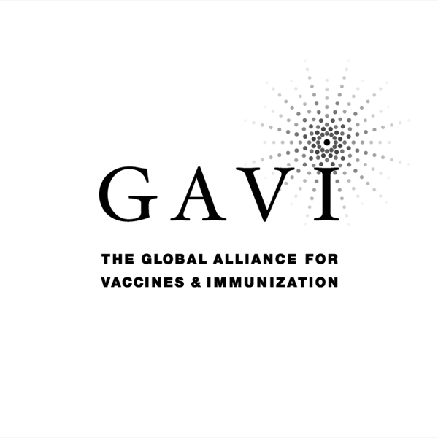
Partnering with The Vaccine Fund

to the
Global Alliance for Vaccines and Immunization (GAVI)
and
The Vaccine Fund

by the Government of
COUNTRY: ERITREA
Date of submission: 15, May 2006

Reporting period: 2005 ( Information provided in this report MUST refer to
2005 activities )

( Tick only one ) :
Inception report 
First annual progress report 
Second annual progress report 
Third annual progress report 
Fourth annual progress report X
Fifth annual progress report 

Text boxes supplied in this report are meant only to be used as guides. Please feel free to add text beyond the space provided.
*Unless otherwise specified, documents may be shared with GAVI partners and collaborators

Progress Report Form: Table of Contents

Report on progress made during 2005
  - Immunization Services Support (ISS)
1.1.1 Management of ISS Funds
Use of Immunization Services Support
1.1.3 Immunization Data Quality Audit
  - GAVI/Vaccine Fund New and Under-used Vaccines
1.2.1 Receipt of new and under-used vaccines
1.2.2 Major activities
    - Use if GAVI/The Vaccine Fund financial support (US$100,000) for introduction of the new vaccine
1.3 Injection Safety
    - Receipt of injection safety support
    - Progress of transition plan for safe injections and safe management of sharps waste
    - Statement on use of GAVI/The Vaccine Fund injection safety support (if received in the form of a cash contribution)

2. Financial Sustainability

3. Request for new and under-used vaccine for 2006
  - Up-dated immunization targets
  - Confirmed/revised request for new vaccine (to be shared with UNICEF Supply Division) for year…
  - Confirmed/revised request for injection safety support for the year…

- Please report on progress since submission of the last Progress Report based on the indicators
selected by your country in the proposal for GAVI/VF support

5. Checklist

6. Comments

7. Signatures

1. Report on progress made during 2005

To be filled in by the country for each type of support received from GAVI/The Vaccine Fund.

Immunization Services Support (ISS)

1.1.1 Management of ISS Funds

Please describe the mechanism for management of ISS funds, including the role of the Inter-Agency Co-ordinating Committee (ICC).
Please report on any problems that have been encountered involving the use of those funds, such as delay in availability for programme use.

ISS fund for the year 2005 has not been received.

1.1.2 Use of Immunization Services Support

In 2005, the following major areas of activities have been funded with the GAVI/Vaccine Fund Immunization Services Support contribution.

Funds received during 2005: Nil
Remaining funds (carried over) from 2004: USD 80,000

Table 1: Use of funds during 2005

Area of Immunization Services Support | Total amount in US $ | AMOUNT OF FUNDS
Area of Immunization Services Support | Total amount in US $ | PUBLIC SECTOR |  |  | PRIVATE SECTOR & Other
Area of Immunization Services Support | Total amount in US $ | Central | Region/State/Province | District | PRIVATE SECTOR & Other
Vaccines | 115,039
Injection supplies | 51,500
Personnel
Transportation |  |  | 9,860.00
Maintenance and overheads
Training |  |  | 10,000.00
IEC / social mobilization
Outreach |  |  | 27,000.00
Supervision |  |  | 1,766.67
Monitoring and evaluation
Epidemiological surveillance
Vehicles
Cold chain equipment/maintenance |  |  | 8,000.00
Other (stationary ) |  |  | 1,933.33
Total: |  |  | 58,560
Remaining funds for next year: | _ |  | 21,440

*If no information is available because of block grants, please indicate under ‘other’.

Please attach the minutes of the ICC meeting(s) when the allocation of funds was discussed.
Please report on major activities conducted to strengthen immunization, as well as, problems encountered in relation to your multi-year plan.

Major activities conducted to strengthen immunization
- Implementation of RED strategy in three zones of the county. Expansion to the remaining four zones is on progress.
- Training of health workers on EPI service and the RED strategy
- New central cold chain store fully equipped and furnished.
- Expansion of outreach sites.

Problem encountered in relation to multi year plan
- Shortage of skilled manpower at central and zonal levels.
- Absence of reliable EPI target population estimates.

Immunization Data Quality Audit (DQA) (If it has been implemented in your country)

Has a plan of action to improve the reporting system based on the recommendations from the DQA been prepared?
If yes, please attach the plan.

X

YES NO DQA Recommendations no follow up made by the Ministry!

If yes, please report on the degree of its implementation.

Please attach the minutes of the ICC meeting where the plan of action for the DQA was discussed and endorsed by the ICC.

Please report on studies conducted regarding EPI issues during 2005 (for example, coverage surveys).

GAVI/Vaccine Fund New & Under-used Vaccines Support

1.2.1 Receipt of new and under-used vaccines during 2005: none

Start of vaccinations with the new and under-used vaccine: MONTH……………….. YEAR……………….

Please report on receipt of vaccines provided by GAVI/VF, including problems encountered.

1.2.2 Major activities

Please outline major activities that have been or will be undertaken, in relation to, introduction, phasing-in, service strengthening, etc. and report on problems encountered.

1.2.3 Use of GAVI/The Vaccine Fund financial support (US$100,000) for the introduction of the new vaccine

Please report on the proportion of 100,000 US$ used, activities undertaken, and problems encountered such as delay in availability of funds for programme use.

Injection Safety

1.3.1 Receipt of injection safety support

Please report on receipt of injection safety support provided by GAVI/VF, including problems encountered

In 2005 injection safety support received from GAVI for all EPI vaccines and no problem has been encountered.

Progress of transition plan for safe injections and safe management of sharps waste.

Please report problems encountered during the implementation of the transitional plan for safe injection and sharp waste

Please report on the progress based on the indicators chosen by your country in the proposal for GAVI/VF support.

Indicators | Targets | Achievements | Constraints | Updated targets
Number of zones without AD syringes stock-out  Number of zones without safety boxes stock-out  Number of zones with functioning incinerators  Number of health workers trained annually  Number of serious adverse events reported annually | 100 %  100 %  50%  300  None | 100 %  100%  25%  150  ND | None  None  -Lack of funds  -Lack of appropriate technology  -Competing activities  -Shortage of qualified staff  Lack of efficient monitoring system | 50%

1.3.3 Statement on use of GAVI/The Vaccine Fund injection safety support (if received in the form of a cash contribution)

The following major areas of activities have been funded (specify the amount) with the GAVI/The Vaccine Fund injection safety support in the past year:

2. Financial sustainability

Inception Report: Outline timetable and process for the development of a financial sustainability plan. Describe assistance that may be needed for developing a financial sustainability plan.

First Annual Progress Report: Submit completed financial sustainability plan by given deadline. Describe major strategies for improving financial sustainability.

Subsequent Progress Reports: According to current GAVI rules, support for new and under-used vaccines is covering the total quantity required to meet country targets (assumed to be equal to DTP3 targets) over a five year period (100% x 5 years = 500%). If the requested amount of new vaccines does not target the full country in a given year (for example, a phasing in of 25%), the country is allowed to request the remaining (in that same example: 75%) in a later year. In an attempt to help countries find sources of funding in order to attain financial sustainability by slowly phasing out GAVI/VF support, they are encouraged to begin contributing a portion of the vaccine quantity required. Therefore, GAVI/VF support can be spread out over a maximum of ten years after the initial approval, but will not exceed the 500% limit (see figure 4 in the GAVI Handbook for further clarification). In table 2.1, specify the annual proportion of five year GAVI/VF support for new vaccines that is planned to be spread-out over a maximum of ten years and co-funded with other sources. Please add the three rows (Proportion funded by GAVI/VF (%), Proportion funded by the Government and other sources (%), Total funding for …………. (new vaccine)) for each new vaccine.

Table 2.1: Sources (planned) of financing of new vaccine DPT HepB (specify)
Proportion of vaccines supported by * | Annual proportion of vaccines
Proportion of vaccines supported by * | 2002. | 2003 | 2004. | 2005. | 2006 | 2007 | 2008 | 2009 | 2010 | 2011
A: Proportion funded by GAVI/VF (%)*** | 100% | 100% | 100% | 100% | 90 % | 10%
B: Proportion funded by the Government and other sources (%) | 0 | 0 | 0 | 0 | 10% | 20% | 30% | 40% | 50% | 60%
C: Total funding for DPTHepB | 100% | 100% | 100% | 100% | 100% | 70% | 70%

* Percentage of DTP3 coverage (or measles coverage in case of Yellow Fever) that is target for vaccination with a new and under-used vaccine.

** The first year should be the year of GAVI/VF new vaccine introduction
*** Row A should total 500% at the end of GAVI/VF support

In table 2.2 below, describe progress made against major financial sustainability strategies and corresponding indicators.

Table 2.2: Progress against major financial sustainability strategies and corresponding indicators

Financial Sustainability Strategy | Specific Actions Taken Towards Achieving Strategy | Progress Achieved | Problems Encountered | Baseline Value of Progress Indicator | Current Value of Progress Indicator | Proposed Changes To Financial Sustainability Strategy
1. Increased resources from Government | Committed in FSP | Committed
2. Increased resources from donors | Planned
3. Resources from private sector | Planned
4. Increased support from Non Governmental Organizations | Planned
5. Increased use of community support | Planned
The FSP for Eritrea has been developed and submitted to GAVI in 2004 and based on the comments from GAVI, the plan for re-submission is with the CMYP

3. Request for new and under-used vaccines for year 2007
Section 3 is related to the request for new and under used vaccines and injection safety for 2007.
Up-dated immunization targets

Confirm/update basic data approved with country application: figures are expected to be consistent with those reported in the WHO/UNICEF Joint
Reporting Forms. Any changes and/or discrepancies MUST be justified in the space provided (page 12). Targets for future years MUST be provided.
Number of
Number of | 2005 | 2006 | 2007 | 2008 | 2009 | 2010 | 2011 | 2012
DENOMINATORS
Births | 121,555 | 125,202 | 128,958 | 132,827 | 136,812 | 140,916 | 145,143 | 149,497
Infants’ deaths | 8,022 | 8,263 | 8,511 | 8,766 | 9,028 | 9,298 | 9,576 | 9,862
Surviving infants | 113,532 | 116,937 | 120,445 | 124,061 | 127,784 | 131,618 | 135,567 | 139,635
NEW VACCINES **
Infants vaccinated 2005 (JRF) / to be vaccinated in 2006 and beyond with 1st dose of DPT (DTP1)* …......... (new vaccine) | 87,923 | 101,327 | 110,506 | 113,821 | 117,122 | 120,519 | 124,014 | 127,610
Infants vaccinated 2005 (JRF) / to be vaccinated in 2005 and beyond with 3rd dose of DPT (DTP 3) ( new vaccine) | 81,130 | 99,396 | 105,244 | 108,401 | 111,6549 | 118,456 | 122,010 | 125,672
Wastage rate in 2005 and plan for 2006 beyond*** ………….. ( new vaccine) | 12.2% | 8% | 5% | 5% | 5% | 5% | 5% | 5%
INJECTION SAFETY****
Pregnant women vaccinated in 2005 (JRF) / to be vaccinated in 2006 and beyond with TT2 | 44,470 | 54,033 | 59,436 | 65,380 | 71,918 | 79,110 | 87,021 | 95,723
Infants vaccinated in 2005 (JRF) / to be vaccinated in 2006 and beyond with BCG * | 88,355 | 106,422 | 116,062 | 119,544 | 123,131 | 126,824 | 130,629 | 134,547
Infants vaccinated in 2005 (JRF) / to be vaccinated in 2006 and beyond with Measles * | 76,702 | 99,396 | 105,244 | 108,401 | 111,6549 | 118,456 | 122,010 | 125,672
* Indicate actual number of children vaccinated in 2004 and updated targets (with either DTP alone or combined)
** Use 3 rows (as indicated under the heading NEW VACCINES) for every new vaccine introduced
*** Indicate actual wastage rate obtained in past years
**** Insert any row as necessary

Please provide justification on changes to baseline, targets, wastage rate, vaccine presentation, etc. from the previously approved plan, and on reported figures which differ from those reported in the WHO/UNICEF Joint Reporting Form in the space provided below.

3.2 Availability of revised request for new vaccine (to be shared with UNICEF Supply Division) for 2007

In case you are changing the presentation of the vaccine, or increasing your request; please indicate below if UNICEF Supply Division has assured the availability of the new quantity/presentation of supply.

Table 4: Estimated number of doses of DPTHepB vaccine (specify for one presentation only): Please repeat this table for any other vaccine presentation requested from GAVI/The Vaccine Fund
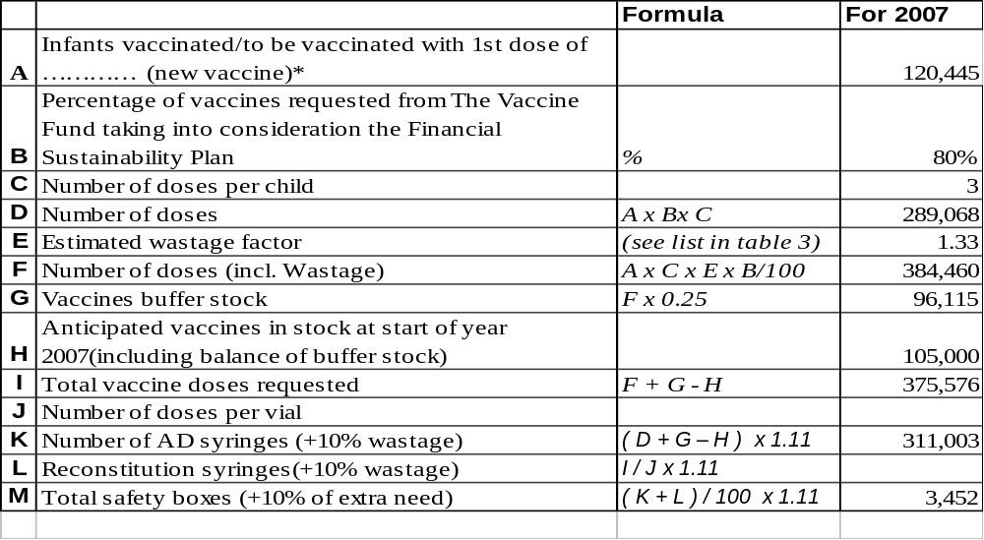

*Please report the same figure as in table 3.

Table 5: Wastage rates and factors
Vaccine wastage rate | 5% | 10% | 15% | 20% | 25% | 30% | 35% | 40% | 45% | 50% | 55% | 60%
Equivalent wastage factor | 1.05 | 1.11 | 1.18 | 1.25 | 1.33 | 1.43 | 1.54 | 1.67 | 1.82 | 2.00 | 2.22 | 2.50

Remarks
- Phasing: Please adjust estimates of target number of children to receive
new vaccines, if a phased introduction is intended. If targets for hep B3 and Hib3
differ from DTP3, explanation of the difference
should be provided
- Wastage of vaccines: Countries are expected to plan for a maximum of:
50% wastage rate for a lyophilized vaccine in 10 or 20-dose vial; 25% for a liquid
vaccine in a10 or 20-dose vial; 10% for any vaccine (either liquid or lyophilized)
in 1 or 2-dose vial.
- Buffer stock: The buffer stock is recalculated every year as 25% the current
vaccine requirement
- Anticipated vaccines in stock at start of year 2006: It is calculated by
counting the current balance of vaccines in stock, including the balance of buffer
stock. Write zero if all vaccines supplied for the current year (including the
buffer stock) are expected to be consumed before the start of next year. Countries
with very low or no vaccines in stock must provide an explanation of the use of
the vaccines.
- AD syringes: A wastage factor of 1.11 is applied to the total number
of vaccine doses requested from the Fund, excluding the wastage of vaccines.
- Reconstitution syringes: it applies only for lyophilized vaccines. Write zero
for other vaccines.
- Safety boxes: A multiplying factor of 1.11 is applied to safety boxes to cater
for areas where one box will be used for less than 100 syringes

3.3 Confirmed/revised request for injection safety support for the years 2007 -2008

Table 6: Estimated supplies for safety of vaccination for the next two years with BCG

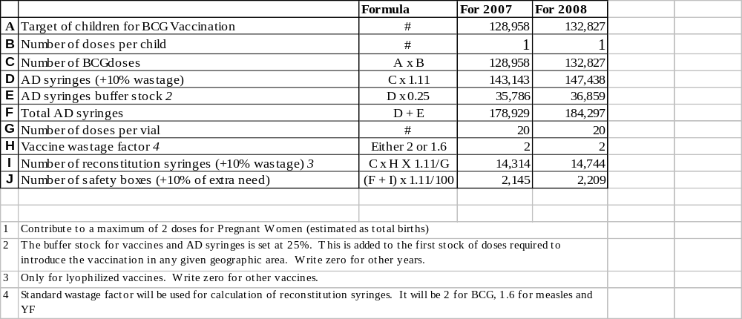

If quantity of current request differs from the GAVI letter of approval, please present the justification for that difference.

Table 7: Estimated supplies for safety of vaccination for the next two years with DPTHepB 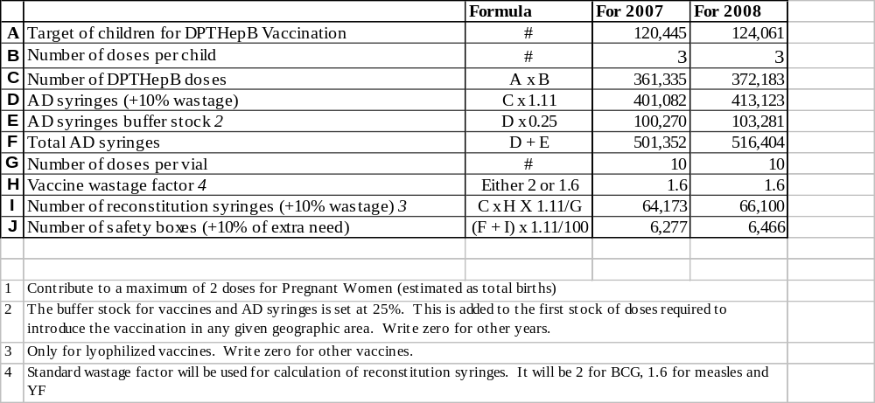

If quantity of current request differs from the GAVI letter of approval, please present the justification for that difference.

Table 8: Estimated supplies for safety of vaccination for the next two years with Measles
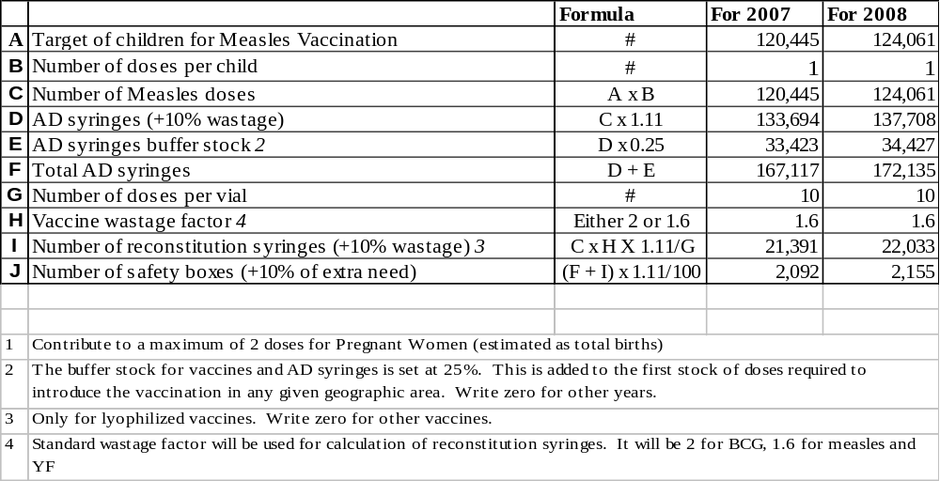

If quantity of current request differs from the GAVI letter of approval, please present the justification for that difference.

Table 9: Estimated supplies for safety of vaccination for the next two years with TT
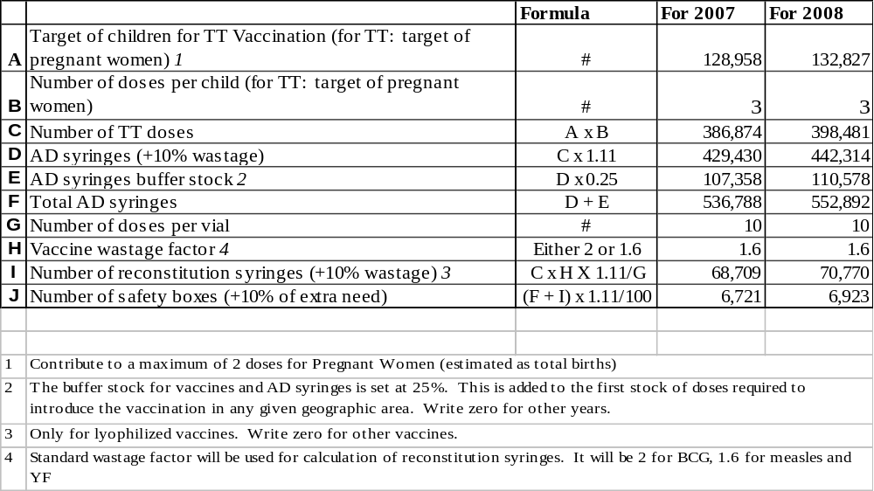

If quantity of current request differs from the GAVI letter of approval, please present the justification for that difference.

4. Please report on progress since submission of the last Progress Report based on the indicators selected by your country in the proposal for GAVI/VF support

Indicators | Targets | Achievements | Constraints | Updated targets
- Reduction of DPT/HepB wastage rate  - Dropout rate reduction (DPT/HepB1-DPT/HepB3)  - Reduction of serious AEFIs | 10 %  5%  < 1/100,000 | 12.2 %  2 %  - | There is no Wastage monitoring system in place  -  There is no AEFI monitoring system in place | 10 %  5 %  <1/100,000  - AEFI monitoring system will be introduced

Checklist
Checklist of completed form:

Form Requirement: | Completed | Comments
Date of submission |  | In progress
Reporting Period (consistent with previous calendar year) | √
Table 1 filled-in | √
DQA reported on | √
Reported on use of 100,000 US$ | √
Injection Safety Reported on | √
FSP Reported on (progress against country FSP indicators) | √
Table 2 filled-in | √
New Vaccine Request completed |  | NA
Revised request for injection safety completed (where applicable) |  | NA
ICC minutes attached to the report
Government signatures | √ | Will be included in the final report
ICC endorsed | √ | Will be included in the final report

6. Comments

ICC/RWG comments:

We appreciate the technical as well as financial assistance of GAVI to the Ministry of Health of the State of Eritrea. Capacity development being one of our priority agenda has been potentially improved by our participation in the FSP proposal development and DQA survey made. Routine coverage is periodically is improving, it is our pleasure to acknowledge you that MoH will participate in other initiatives of its kind for the improvement of health of our children.

ICC Chair person

7. Signatures

For the Government of the State of Eritrea

Signature: ……………………………………………...……………...

Title: Minister of Health

Date: 15 April 2006

We, the undersigned members of the Inter-Agency Co-ordinating Committee endorse this report. Signature of endorsement of this document does not imply any financial (or legal) commitment on the part of the partner agency or individual.

Financial accountability forms an integral part of GAVI/The Vaccine Fund monitoring of reporting of country performance. It is based on the regular government audit requirements as detailed in the Banking form. The ICC Members confirm that the funds received have been audited and accounted for according to standard government or partner requirements.

Agency/Organisation | Name/Title | Date Signature | Agency/Organisation | Name/Title | Date Signature
Ministry of Health | Dr. Zemuei Alemu: Director FCH |  | Vision Eritrea | Mr. Toumzghi Sengal: Health Coor.
Ministry of Health | Mr. Filli Said Fill: EPI Manager |  | Ministry of Education | Ms. Abeba Habtom: Pre-School Coor.
Ministry of Health | Dr. Goitom Mebrahtu: Director CDC |  | Eritrean Red Cross | S/r Brikty Tecletsion: Health Coor.
WHO | Dr. Eyob Araya EPI Focal & Surv.Officer |  | Eritrean Catholic Secretariat | Ms Letemichael T/Giorgis
UNICEF | Dr. Magdy Bayoumi Health and Nutrition

~ End ~

