January 2006
Progress Report
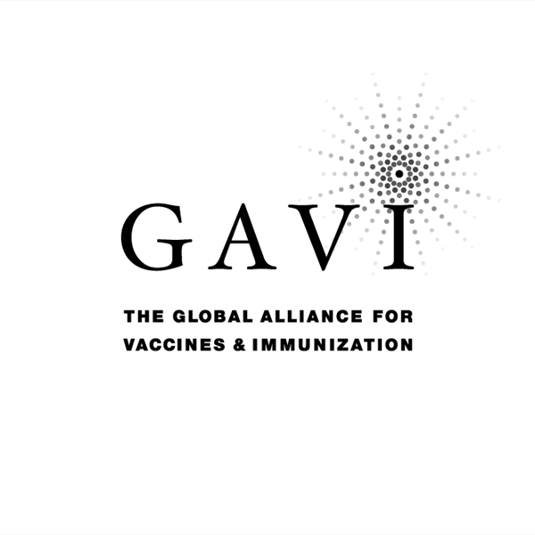
Partnering with The Vaccine Fund

to the
Global Alliance for Vaccines and Immunization (GAVI)
and
The Vaccine Fund

by the Government of
COUNTRY: Islamic Republic of Afghanistan
Date of submission: March, 2006……………

Reporting period: 2005 ( Information provided in this report MUST refer to
2005 activities )

( Tick only one ) :
Inception report 
First annual progress report 
Second annual progress report 
Third annual progress report Y
Fourth annual progress report 
Fifth annual progress report 

Text boxes supplied in this report are meant only to be used as guides. Please feel free to add text beyond the space provided.
*Unless otherwise specified, documents may be shared with GAVI partners and collaborators

Progress Report Form: Table of Contents

Report on progress made during 2004
  - Immunization Services Support (ISS)
1.1.1 Management of ISS Funds
Use of Immunization Services Support
1.1.3 Immunization Data Quality Audit
  - GAVI/Vaccine Fund New and Under-used Vaccines
1.2.1 Receipt of new and under-used vaccines
1.2.2 Major activities
    - Use if GAVI/The Vaccine Fund financial support (US$100,000) for introduction of the new vaccine
1.3 Injection Safety
    - Receipt of injection safety support
    - Progress of transition plan for safe injections and safe management of sharps waste
    - Statement on use of GAVI/The Vaccine Fund injection safety support (if received in the form of a cash contribution)

2. Financial Sustainability

3. Request for new and under-used vaccine for 2006
  - Up-dated immunization targets
  - Confirmed/revised request for new vaccine (to be shared with UNICEF Supply Division) for year…
  - Confirmed/revised request for injection safety support for the year…

- Please report on progress since submission of the last Progress Report based on the indicators
selected by your country in the proposal for GAVI/VF support

5. Checklist

6. Comments

7. Signatures

1. Report on progress made during 2004

To be filled in by the country for each type of support received from GAVI/The Vaccine Fund.

Immunization Services Support (ISS)

1.1.1 Management of ISS Funds
Please describe the mechanism for management of ISS funds, including the role of the Inter-Agency Co-ordinating Committee (ICC).
Please report on any problems that have been encountered involving the use of those funds, such as delay in availability for programme use.

- Mechanism
- GAVI fund is managing according to a mechanism that developed by National EPI office based on standard management tool for management of external grants and endorsed by ICC members in 2004. Different procedures (The ones that not existed in MoPH official documents) also developed to facilitate the management of the fund.
- Based on ICC decision GAVI Fund Management Team established in MoPH and is functional.
- Process of fund release is going through MoPH External Grant Management Unit according to the action plan, request of national EPI office and approval of His Excellency Minister of Public Health.
- Financial Officer for GAVI fund management has been assigned in national EPI office and coordinates the related activities with concerns including Grand and contract Management Unite (GCMU) of MoPH and treasure department of Ministry of Finance (MoF).
- All action plans related to GAVI support or any change in the already endorsed action plans are presented to ICC for the endorsement.
- ICC member kept inform on GAVI expenditures.
- GAVI/Vaccine Fund support is under control of MoPH and considered as part of core budget of the government. A separate banking account has been opened for GAVI to facilitate the monitoring and ensure the support is not used for other purposes rather than EPI.
- Problems
- Changing the account number of GAVI in Da Afghanistan Bank (as result of changes in the management structure of MoF) and miss communication regarding the new account resulted in delay in cash transfer to the new account as the GAVI disbursed the cash (March 2005) to the old account number and it took time for the national EPI office-MoPH to get information on cash disbursement (August 2005) and transfer the cash to the new account (October 2005). This delay is one of the reason for low utilization of 2005 ISS fund.
- Poor banking system in the country still existed that together with poor financial management capacity provincial EPI management teams (PEMT) pushing the national EPI office for centralized management. Although the planning process for GAVI fund support is starting from periphery (province and district). It is plan to delegate some of the financial management responsibilities to PEMTs in year 2006.
- Payment of EPI staff salaries are responsibility of BPHS (Basic Package of Health Services) Implementers NGOs but unfortunately some of the NGOs did not included enough amount for the salary of vaccinators as per MoPH- National Salary Policy in their proposals. There for the GAVI fund use for payment of additional incentive to cover the gap and keep running the EPI canters To avoid it in future GCMU was assigned to ensure enough budgeting for EPI in future contracts with NGOs. As a temporary measures all NGOs which has problem of budgeting for EPI are requested to officially approach MoPH for additional funding to cover the funding gap..
- NGOs receiving fund per capita for service deliver at the district level. One of the chalanges that we face was to avoid duplication. In response to it National Team define role and responsibility of each partners including functional responsibilities. Some of the BPHS implementers NGOs not planning enough for EPI. As per MoPH decision Reflection of EPI in both technical and financial proposals of NGOs is mandatory.

1.1.2 Use of Immunization Services Support

In 2004, the following major areas of activities have been funded with the GAVI/Vaccine Fund Immunization Services Support contribution.

Funds received during 2005 ____1039000_____
Remaining funds (carry over) from 2004 _186043_____.
Table 1: Use of funds during 2005

Area of Immunization Services Support | Total amount in US $ | AMOUNT OF FUNDS
Area of Immunization Services Support | Total amount in US $ | PUBLIC SECTOR |  |  | PRIVATE SECTOR & Other
Area of Immunization Services Support | Total amount in US $ | Central | Region/State/Province | District | PRIVATE SECTOR & Other
Vaccines
Injection supplies
Personnel | 175688 | 38730 | 6847 | 130111
Transportation | 17460 | 448 | 17012 | 0
Maintenance and overheads | 7318 | 3920 | 3398 | 0
Training | 26683 | 0 | 6105 | 20578
IEC / social mobilization | 15567 | 9845 | 5722 | 0
Outreach | 98258 | 0 | 0 | 98258
Supervision | 4451 | 1742 | 2709 | 0
Monitoring and evaluation | 11695 | 0 | 11695 | 0
Epidemiological surveillance | 0 | 0 | 0 | 0
Vehicles
Cold chain equipment | 50346 | 0 | 0 | 50346
Other; (Scanner, Media projector & USB) | 2045 | 2045 | 0 | 0
Total: | 409511 | 56730 | 53488 | 299293
Remaining funds for next year: | 815532

*If no information is available because of block grants, please indicate under ‘other’.
Please attach the minutes of the ICC meeting(s) when the allocation of funds was discussed.

Please report on major activities conducted to strengthen immunization, as well as, problems encountered in relation to your multi-year plan.

Major activities:
- Conduction of Regional EPI Review workshop in all regions
- Conduction of National EPI Consensus workshop with active participation of line ministries and donor and NGO communities.
- Conesus on strengthening of integrated approach with focus on provision of integrated child survival intervention both in health facilities (one point services delivery) and at the community level (sustainable out reach and joint intervention). Pilot implementation of the approach in MoPH strengthening Management (SM) project.
- Submission of proposal for introduction of DPT-Hepatitis B vaccine to GAVI
- Development and major revision of EPI FSP (accepted)
- Establishment of AEFI surveillance system.
- Progress toward Measles case based surveillance; development of Measles cased Based Surveillance guideline, Establishment of first Measles Lab in Kabul.
- Conduction of District micro-planning in 301 districts (91.4%).
- Strengthening of Supportive supervision Introduction of pulse immunization and conduction of the supervision in (171) districts by using a standard tool for supportive supervision.
- Conduction of pulse immunization in (52) districts.
- Improve EPI data management and provision of feedback to the provinces.
- Expansion of EPI centres from 871 in year 2004 to more than 1050 centres in year 2005.
- Strengthening cold chain system: Construction of provincial vaccine storage facilities by the support of UNICEF.
- Developing Standard operation Procedures for vaccine management and conduction of vaccine management training courses for (66) staff.
- Refresher Training Courses for (497 ) vaccinators on EPI and safety of immunization injections
- Conduction of training courses on Measles case based surveillance and surveillance of AEFI for (393) focal points, PEMT managers and supervisors.
- Conduction of advocacy meetings with donors, involvement of donors in FSP exercise.
- Production, distribution of EPI posters and calendar with EPI messages.
Problems
- Restructuring and reforms of Health system: Hand over of EPI to Basic Package of Health Services implementers. Low experience of some BPHS implementers’ agencies regarding management of EPI programs. Uncertainty of role and responsibilities of different stick holder in the context of BPHS at the provincial level.Coordination at the provincial to be strengthens.
- Reforms of current EPI structure at the provincial and district level in the context of new reforms are needed
- More focus on expansion and logistics of EPI rather than system development (High drop out rate of 14% for DPT and 28% for DPT-Measles).
- Only 44 % of districts with more than 80%DPT-3 coverage
- Low measles coverage and potential risk of out breaks

Immunization Data Quality Audit (DQA) (If it has been implemented in your country)
Has a plan of action to improve the reporting system based on the recommendations from the DQA been prepared?
If yes, please attach the plan.

YES NO
√

If yes, please report on the degree of its implementation.
- Provision of standard reporting formats
- Provision of 29 computers, printers and accessories. All provinces equipped at least with one set of computer.
- Assignment of Monitoring officer and EPI surveillance officer for national EPI office
- Revision, printing and distribution of reporting documents (Registration books, tally sheets, Immunization cards and monthly report forms)
- Monitoring of timeliness and completeness of the reports.
- Analysis of the data at the national level and regular feed back.
- Improvement in the use of EPI monitoring chart.
- Introduction of indicators on quality of registering and reporting in supportive supervision checklists
- Use of Coverage data for planning during review workshops.
- Inclusion of EPI reporting in the curriculum of EPI training courses for all categories of EPI staff.
- Inclusion of EPI data quality assessment indicator in EPI supervisory checklist and conduction/planning for supportive supervision.

Please attach the minutes of the ICC meeting where the plan of action for the DQA was discussed and endorsed by the ICC.

Please report on studies conducted regarding EPI issues during 2005 (for example, coverage surveys).

NA

GAVI/Vaccine Fund New & Under-used Vaccines Support

1.2.1 Receipt of new and under-used vaccines during 2004

Start of vaccinations with the new and under-used vaccine: MONTH……………….. YEAR……………….

Please report on receipt of vaccines provided by GAVI/VF, including problems encountered.

NA

1.2.2 Major activities

Please outline major activities that have been or will be undertaken, in relation to, introduction, phasing-in, service strengthening, etc. and report on problems encountered.

- MoPH- Afghanistan submitted a proposal to GAVI for support for introduction of DPT-Hep B vaccine in immunization schedule. All conditions for approval of the proposal such as provision of realistic target and indicators and Major revision of FSP were met.
- Brusher on DPT-HepB vaccine in for EPI and health staff in local languages has been developed.
- The topic also discussed in vaccine management training courses that were held for (66) staff.
- General directorate of Preventive Medicine and PHC was assigned as focal point for the introduction of the vaccine.
- ICC updated regularly on progress of introduction of the vaccine and EPI task force fully involved in the process.
- It is supposed to introduce the vaccine in mid 2006 and January 2007.

1.2.3 Use of GAVI/The Vaccine Fund financial support (US$100,000) for the introduction of the new vaccine

Please report on the proportion of 100,000 US$ used, activities undertaken, and problems encountered such as delay in availability of funds for programme use.

NA

Injection Safety

1.3.1 Receipt of injection safety support

Please report on receipt of injection safety support provided by GAVI/VF, including problems encountered

- National EPI office received the second trench of GAVI support for safety of immunization injection in October year 2005 (650000 US$).
- GAVI disbursed the cash in March of 2005 but the cash was transferred to the old account of GAVI in Da Afghanistan Bank. Late information on cash disbursement and lengthy process for transfer of the cash to the new account resulted in delay in utilization of the fund. Total amount of 11675US$ were used from this account for safety of immunization injection mainly for IEC, supervision and training of vaccinators on safety of immunization injection, Safe waste disposal (497 person) and for the establishment of surveillance of AEFI. Another reason for low expenditure rate is the fact that NIP used WHO fund for the training of AFP focal points (393 people) on surveillance of AEFI, production of guidelines and reporting/investigation format. Low capacity for implementation of the planned activities and Presence of competing activities such as SIAs is other reasons for low implementation rate.

Progress of transition plan for safe injections and safe management of sharps waste.

Please report problems encountered during the implementation of the transitional plan for safe injection and sharp waste

Major Activities:
- All EPI centers/teams provided with required number of AD syringes and safety boxes (UNICEF support). 100 % of EPI teams are using AD syringes for vaccine injections.
- 497 vaccinators were trained on Injection safety, safe waste disposal and detecting and reporting of AEFI.
- Injection safety and safe immunization wastes disposal are part of supportive supervision check list. (171) districts were supervised. The analysis of the checklist shows out of (232) supervisory visits (83 %) of EPI centers were following safe injection practices as per WHO standards and injection safety National policy. (This figure is not result of independent assessment)
- Surveillance of AEFI has been established.
- 312 focal point, 81 provincial EPI management team managers and supervisors have been trained on AEFI immunization surveillance and safety of injections.
- AEFI surveillance guideline translated in local languages and printed/distributed.
- Orientation and advocacy meetings have been conducted for MoPH policy makers and other concern.
- Safety of injection included in the agenda of all national and regional EPI workshops
- Calendar with clear safety of immunization injection and safe waste disposal messages (14 messages and pictures) in local languages developed and printed (10000 copies) and distributed to all vaccinators and health facilities.

As the GAVI support for Injection safety ended at the end of 2006 the following measures are planned for transition of GAVI fund for Injection Safety.
- Revision of National Policy on INS With focus on Bundle supply.
- Develop related legal document on safe injection practices.
- Strengthening surveillance of AEFI
- Creating awareness among communities and service providers.
- Periodic assessment (Provincial level assessment)of Injection safety
- Provision of AD syringes and injection supplies by the support of UNICEF (reflected in FSP as UNICEF commitment)

Please report on the progress based on the indicators chosen by your country in the proposal for GAVI/VF support.

Indicators | Targets | Achievements | Constraints | Updated targets
Provision of syringes to EPI centres | 100% | 100%
% of vaccinators will follow safe immunization injection practices as per WHO standards | > 95% | 83% | - Irregular supervision with focus on safety of injection some districts.  -Need for further training of vaccinators considering the rapid expansion of the EPI canters  -No institutionalization of injection safety and safe waste disposal in health science institutes/medical university

1.3.3 Statement on use of GAVI/Vaccine Fund injection safety support (if received in the form of a cash contribution)

The following major areas of activities have been funded (specify the amount) with the GAVI/The Vaccine Fund injection safety support in the past year:

- Policy, Management and workshops; 18030
- Training on Safe immunization practices 26845
- Management of used injection collection and safe waste disposal 244436
- Surveillance of AEFI: 21400
- Information, Education and Communication: 76514
- Supervision, monitoring and assessments: 123580

2. Financial sustainability

Inception Report: Outline timetable and process for the development of a financial sustainability plan . Describe assistance that may be needed for developing a financial sustainability plan.

First Annual Progress Report: Submit completed financial sustainability plan by given deadline. Describe major strategies for improving financial sustainability.
Brief Background:
- FSP has been developed and submitted in March 2005 and reviewed by IRC.
- As per IRC recommendation the FSP revised (Major revision) and resubmitted in October 2005.
- The IRC reviewed the revised FSP in November and accepted.
- In all the stages of developing and revision of FSP the members of ICC including MoF and donor agencies fully involved and updated.
- The exercise helps the MoPH to identify gaps and need for government financial contribution. Government financial contribution from it’s own resources will be start in year 2008 to cover partially the cost of hep B vaccine and there after the government will develop Vaccine Self Reliance Initiative to sustain government financial contribution as part of a common basket as mentioned in Afghanistan FSP.

Summary of strategies:

Mobilizing additional resources:
- Mobilizing domestic resources as key strategy toward financial sustainability with focus to:
- Improve budgetary resources allocated to immunization.
- Develop long-term immunization plan for vaccine management and cold chain
- Propose vaccine self-reliance initiative with target for government allocation in a common basket for purchasing traditional vaccines and renovation of cold chain for long term prospective.
- Increase donor funding for immunization
- To ensure the already committed funds are used efficiently through proper funding of all important components
- To advocate for increased funding with all current and potentially new donors,
- To channel and mange the BPHS fund through MoPH mechanism as part of government core budget.
- Mobilize resources from private sectors with focus on institutionalizing of the possible role of the private sector in prevention and immunization.

Ensure reliability of resources:
- Ensure financial requirements for immunization are properly reflected in NDB.
- Ensure Government contributions for new vaccines purchase are protected.
- Ensure Confidence is maintained within donor communities in the program.
- Ensure immunization forecast incorporated and protected into the planning and budgeting cycles of the Government.
- Ensure the new vaccine expenditure covered by the Government.
- Advocacy for possible extension of GAVI support for a period beyond 2008.
- Improve accountability.

Increase the efficiency of the resources

Enforce of integrated approach and maximize utilization of the immunization sessions (fixed and out reach).

Reduce vaccine wastage

Use of private providers to provide immunization services

Subsequent Progress Reports: According to current GAVI rules, support for new and under-used vaccines is covering the total quantity required to meet country targets (assumed to be equal to DTP3 targets) over a five year period (100% x 5 years = 500%). If the requested amount of new vaccines does not target the full country in a given year (for example, a phasing in of 25%), the country is allowed to request the remaining (in that same example: 75%) in a later year. In an attempt to help countries find sources of funding in order to attain financial sustainability by slowly phasing out GAVI/VF support, they are encouraged to begin contributing a portion of the vaccine quantity required. Therefore, GAVI/VF support can be spread out over a maximum of ten years after the initial approval, but will not exceed the 500% limit (see figure 4 in the GAVI Handbook for further clarification). In table 2.1, specify the annual proportion of five year GAVI/VF support for new vaccines that is planned to be spread-out over a maximum of ten years and co-funded with other sources. Please add the three rows (Proportion funded by GAVI/VF (%), Proportion funded by the Government and other sources (%), Total funding for …………. (new vaccine)) for each new vaccine.

Table 2.1: Sources (planned) of financing of new vaccine ………(NA)…………… (specify)
Proportion of vaccines supported by * | Annual proportion of vaccines
Proportion of vaccines supported by * | 20..** | 20.. | 20.. | 20.. | 20.. | 20.. | 20.. | 20.. | 20.. | 20..
A: Proportion funded by GAVI/VF (%)***
B: Proportion funded by the Government and other sources (%)
C: Total funding for …………. (new vaccine)

* Percentage of DTP3 coverage (or measles coverage in case of Yellow Fever) that is target for vaccination with a new and under-used vaccine.

** The first year should be the year of GAVI/VF new vaccine introduction
*** Row A should total 500% at the end of GAVI/VF support

In table 2.2 below, describe progress made against major financial sustainability strategies and corresponding indicators.

Table 2.2: Progress against major financial sustainability strategies and corresponding indicators

Financial Sustainability Strategy | Specific Actions Taken Towards Achieving Strategy | Progress Achieved | Problems Encountered | Baseline Value of Progress Indicator | Current Value of Progress Indicator | Proposed Changes To Financial Sustainability Strategy
Mobilizing government resources | EPI requirement reflected in NDB | EPI staff involved in budgeting exercise | NDB to be finalized | % of GoA financial contribution in cost of new vaccine = 0% | 0%
 | Target for government financial commitment proposed | GoA contribution in routine EPI financing proposed for government 5 years budgeting cycle | Other competing health priorities | % of GoA contribution in routine EPI financing =10% | 17%
 | All EPI partners to be involved in MYPoA exercise | Processes of developing MYPoA completed 80% | Complete post expenditures to be collected | Plan developed = 0 | 0
Mobilize donor funding for immunization | Steps has been taken for EPI financial monitoring system development | NGOs expenditure information sheet distributed and preliminary analysis done | financial information system is still weak | % of NGO contribution in routine EPI cost = 20% | 24%
 | Advocacy with donors in the course of consensus workshop and meeting to chanalize fund through MoPH | USAID has handover the management of it’s support for BPHS partially to MoPH | First batches of the contract with BPHS implementers is ending in 2006 | 0 | 1
 | Up date donors and partners on financial issues related to EPI has been doon | Financial report on EPI expenditures (GAVI) discussed in ICC and CGHN meetings | Reports is only cover financial information of GAVI fund | Number of reports generated = 0 | 2
Mobilize resources from private sector | No activity has been conducted so fore |  |  | 0% | 0%
Ensure reliability of resources | NIP budget incorporated in MoPH annual budget | EPI requirements reflected in NDB for 2006 |  | % of GoA funded program secured in NDB =
Enforce integration and maximize efficiency of immunization | Integrated services deliver both at health facility and out reach sites initiated | Pilot integrated project initiated in 82 health facilities in 18 districts in SM provinces. | Low capacity of implementers, Need for EPI policy revision | % of districts followed one point services delivery = 0% | 5.4%
 | Tools and guidelines for district micro-planning has been developed | District micro planning conducted in (91%) districts with focus on rescheduling of out reach sessions |  | % of districts with micro-plan = 46% | 91%
 | Measures including provision of feedback and strengthening supervision has been implemented for reduction of Drop out rate | DPT Drop out rate reduced to 14% in year 2005 | Presences of low performance district | DPT dropout rate = 17% | 14%
Reduce vaccine wastage | Vaccine wastage monitoring system |  | Not established
 | Measure such as training courses and developing SOPs implemented. | Vaccine management training courses conducted for 66 staff | Still high for measles & BCG | DPT vaccine wastage rate = 27% | 20%

3. Request for new and under-used vaccines for year 2006

Section 3 is related to the request for new and under used vaccines and injection safety for 2006.
Up-dated immunization targets

Confirm/update basic data approved with country application: figures are expected to be consistent with those reported in the WHO/UNICEF Joint
Reporting Forms. Any changes and/or discrepancies MUST be justified in the space provided (page 12). Targets for future years MUST be provided.

Table 3 : Update of immunization achievements and annual targets
Number of | Achievements and targets
Number of | 2005 | 2006 | 2007 | 2008 | 2009 | 2010 | 2011 | 2012 | 2013
DENOMINATORS
Births | 1215335 | 1244503 | 1274371 | 1304955 | 1336274 | 1368345 | 1401185 | 1434813 | 1469249
Infants’ deaths | 170147 | 168008 | 163119 | 157900 | 152335 | 146416 | 140119 | 136307 | 132232
Surviving infants | 1045188 | 1076495 | 1111252 | 1147055 | 1183939 | 1221932 | 1261067 | 1298506 | 1337016
Infants vaccinated in 2005 (JRF) / to be vaccinated in 2006 and beyond with 1st dose of DTP (DTP1)* | 922821 | 1001391
Infants vaccinated 2005 (JRF) / to be vaccinated in 2006 and beyond with 3rd dose of DTP (DTP3)* | 798064 | 861196
NEW VACCINES **
Infants vaccinated 2005 (JRF) / to be vaccinated in 2006 and beyond with 1st dose of DTP (DTP1)* Hepatitis-B.... (new vaccine) | 0 | 0 | 1055689 | 1101173 | 1160260 | 1197493 | 1248456 | 1285521 | 1323646
Infants vaccinated 2005 (JRF) / to be vaccinated in 2006 and beyond with 3rd dose of Hepatitis-B ( new vaccine) |  |  | 922339 | 974997 | 1041866 | 1099739 | 1160181 | 1220595 | 1270165
Wastage rate in 2005 and plan for 2006 beyond*** Hepatitis-B.. ( new vaccine) | 20% | 20% | 20% | 20% | 15% | 15% | 15% | 15% | 15%
INJECTION SAFETY****
Pregnant women vaccinated in 2005 (JRF) / to be vaccinated in 2006 and beyond with TT2 | 587344 | 995602 | 1019497 | 1043964 | 1069019 | 1163093 | 1191007 | 1233939 | 1278246
Infants vaccinated in 2005 (JRF) / to be vaccinated in 2006 and beyond with BCG * | 889629 | 995602 | 1057728 | 1148360 | 1202647 | 1272561 | 1331126 | 1337420 | 1439864
Infants vaccinated in 2005 (JRF) / to be vaccinated in 2006 and beyond with Measles * | 667152 | 807371 | 866776 | 952056 | 1018187 | 1063081 | 1109739 | 1155670 | 1243425
* Indicate actual number of children vaccinated in 2005 and updated targets (with either DTP alone or combined)
** Use 3 rows (as indicated under the heading NEW VACCINES) for every new vaccine introduced
*** Indicate actual wastage rate obtained in past years
**** Insert any row as necessary
Please provide justification on changes to baseline, targets, wastage rate, vaccine presentation, etc. from the previously approved plan, and on reported figures which differ from those reported in the WHO/UNICEF Joint Reporting Form in the space provided below.

- The number of survival infants calculated based on the new agreed bench marks for Infant Mortality Rate that is 140 for 2005 and it is supposed to reach to 107 till end of 2010 and to 77 till 2015.
- NIP revised the target for DPT/DPT-HepB and other antigen based on 2005 achievement in order to make more realistic and achievable
- The target for drop out rate also revised accordingly as the program reduced the DPT drop out to 14% in year 2005.

3.2 Availability of revised request for new vaccine (to be shared with UNICEF Supply Division) for 2007

In case you are changing the presentation of the vaccine, or increasing your request; please indicate below if UNICEF Supply Division has assured the availability of the new quantity/presentation of supply.

UNICEF country office is providing vaccine and injection supplies both for routine and supplementary immunization according to the stated national coverage target.

Table 4: Estimated number of doses of DPT-Hepatitis vaccine (specify for one presentation only): Please repeat this table for any other vaccine presentation requested from
GAVI/The Vaccine Fund (Please note that the anticipated vaccine in stock is Zero as mentioned in the relevant row)

*Please report the same figure as in table 3.

Table 5: Wastage rates and factors
Vaccine wastage rate | 5% | 10% | 15% | 20% | 25% | 30% | 35% | 40% | 45% | 50% | 55% | 60%
Equivalent wastage factor | 1.05 | 1.11 | 1.18 | 1.25 | 1.33 | 1.43 | 1.54 | 1.67 | 1.82 | 2.00 | 2.22 | 2.50
Remarks
- Phasing: Please adjust estimates of target number of children to receive
new vaccines, if a phased introduction is intended. If targets for hep B3 and Hib3
differ from DTP3, explanation of the difference
should be provided
- Wastage of vaccines: Countries are expected to plan for a maximum of:
50% wastage rate for a lyophilized vaccine in 10 or 20-dose vial; 25% for a liquid
vaccine in a10 or 20-dose vial; 10% for any vaccine (either liquid or lyophilized)
in 1 or 2-dose vial.
- Buffer stock: The buffer stock is recalculated every year as 25% the current
vaccine requirement
- Anticipated vaccines in stock at start of year 2006: It is calculated by
counting the current balance of vaccines in stock, including the balance of buffer
stock. Write zero if all vaccines supplied for the current year (including the
buffer stock) are expected to be consumed before the start of next year. Countries
with very low or no vaccines in stock must provide an explanation of the use of
the vaccines.
- AD syringes: A wastage factor of 1.11 is applied to the total number
of vaccine doses requested from the Fund, excluding the wastage of vaccines.
- Reconstitution syringes: it applies only for lyophilized vaccines. Write zero
for other vaccines.
- Safety boxes: A multiplying factor of 1.11 is applied to safety boxes to cater
for areas where one box will be used for less than 100 syringes

3.3 Confirmed/revised request for injection safety support for the years 2007 -2008

Table 6: Estimated supplies for safety of vaccination for the next two years with …… (Use one table for each vaccine BCG, DTP, measles and TT, and number them from 4 to 8)

Table 6-4

Table-6-5

Table 6-7

If quantity of current request differs from the GAVI letter of approval, please present the justification for that difference.

The quantity is adjusted according to the new coverage target (Please see part 3-1 and justification for revision of baseline and targets).

4. Please report on progress since submission of the last Progress Report based on the indicators selected by your country in the proposal for GAVI/VF support

Indicators | Targets | Achievements | Constraints | Updated targets
DPT-3 Coverage Rate 2004 | 65% | 66%
DPT-3 Coverage Rate, 2005 | 80% | 76%
DPT Dropout Rate 2004 | 16% | 17%
DPT-drop-our rate, 2005 | 16% | 14%

Checklist

Checklist of completed form:

Form Requirement: | Completed | Comments
Date of submission | Y
Reporting Period (consistent with previous calendar year) | Y
Table 1 filled-in | Y
DQA reported on | Y
Reported on use of 100,000 US$ | NA
Injection Safety Reported on | Y
FSP Reported on (progress against country FSP indicators) | Y
Table 2 filled-in | NA
New Vaccine Request completed | Y
Revised request for injection safety completed (where applicable) | Y
ICC minutes attached to the report | Y
Government signatures | Y
ICC endorsed | Y

6. Comments

ICC/RWG comments:
On 14th of May the ICC members reviewed the report and the recommendation are incorporated in the report

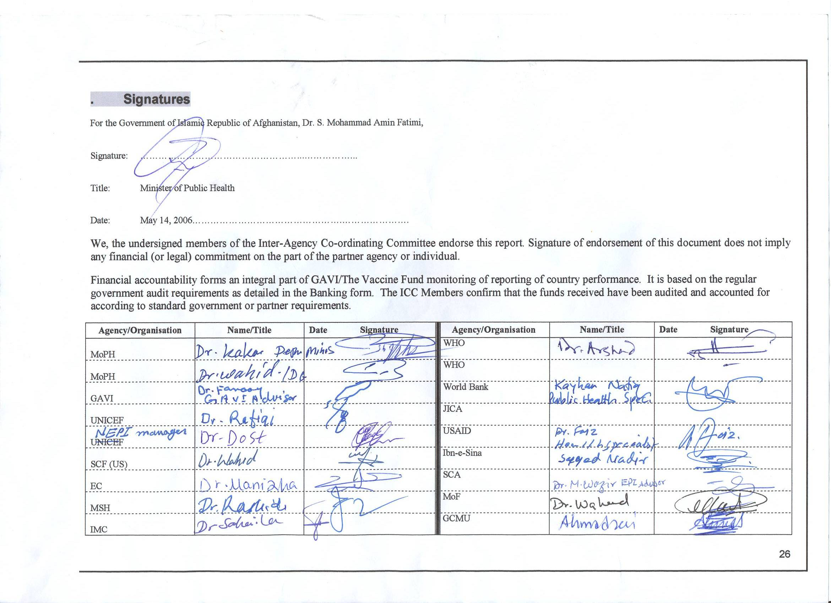

~ End ~

